IEEE P802.11
Wireless LANs
CR on CID 12086
Date: 2022-09-15
Author(s):
Name | Affiliation | Address | Phone | email
Bo Gong | Huawei |  |  | gongbo8@huawei.com

Abstract
This submission contains proposed comment resolutions to comments on P802.11be D2.0.
The changes are based on P802.11be D2.1.1.

This submission provides a resolution to the CID 12086.

Revisions:
- Rev 0: Initial version of the document.

CID 12086
CID | Page/Line | Clause | Comment | Proposed Change | Resolution
12086 | 714.57 | 36.3.13.5 | Based on the description on P714L57 "If the RU or MRU contains a frequency subblock that is not fully occupied (i.e., the frequency subblock consists of 484 or 484+242 occupied tones), that frequency subblock will reach its full value before the other frequency subblocks" the parameter nl in Equation (36-70) needs to show different setting between partially and fully occupied frequency subblock.  For example, need to set nl to 0 for the 484 RU path in the example of Figure (36-52). Otherwise, there are 44xN_BPSCS,u bits not processed on the 484 RU path. | Suggest move nl annotation from Line 61 to immediately following k = 0, 1, ... (Line 42) and modified to "nl = 1 for fully occupied frequency subblock l with nonzero leftover bits, nl = 0 for partially occupied frequency subblock with no leftover bits needed." | Revised.  It is better to illustrate that, a frequency subblock with nonzero leftover bits means fully occupied frequency subblock, and a frequency subblock with no nonzero leftover bits means partially occupied frequency subblock.  Instructions to the Editor:  Please make the changes as shown in 11/22-1652r0

Instructions to the Editor:

Please make the following changes in Line 45, Page 729 in TGbe Draft D2.1.1:

The bits in each block of bits are determined by the segment parser as shown in Equation (36-70).

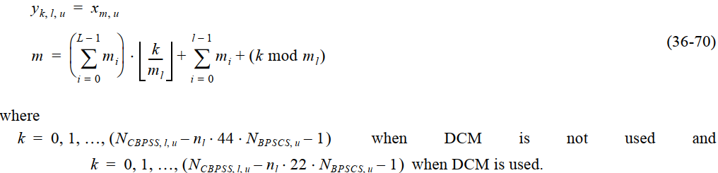
n_{l} n_{l} =1 for fully occupied frequency subblock l with nonzero leftover bits, n_{l} = 0 for partially occupied frequency subblock l with no leftover bits needed.
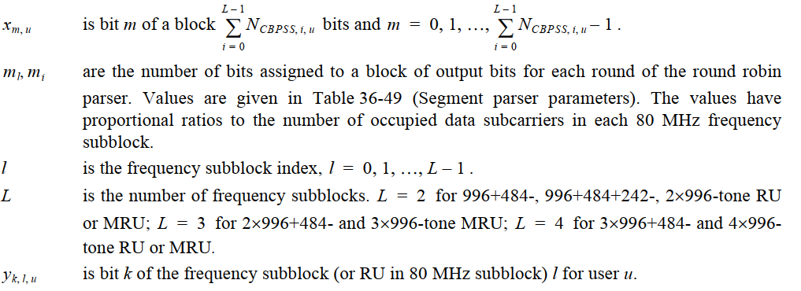

u is the user index, u = 0, 1, …, N_{user} – 1.

