IEEE P802.11
Wireless LANs
LB260-LB267 NO-voters Agreement to Toggle their vote
Date: 2022-09-16
Author(s):
Name | Affiliation | Address | Phone | email
Nikola Serafimovski | pureLiFi Ltd. |  |  | nikola.serafimovski@purelifi.com
Abstract
This document consolidates the emails that confirm the change of “No” voter on P802.11bb drafts from LB260 through to LB267.

Rev.0: initial text

- Adachi, Tomo
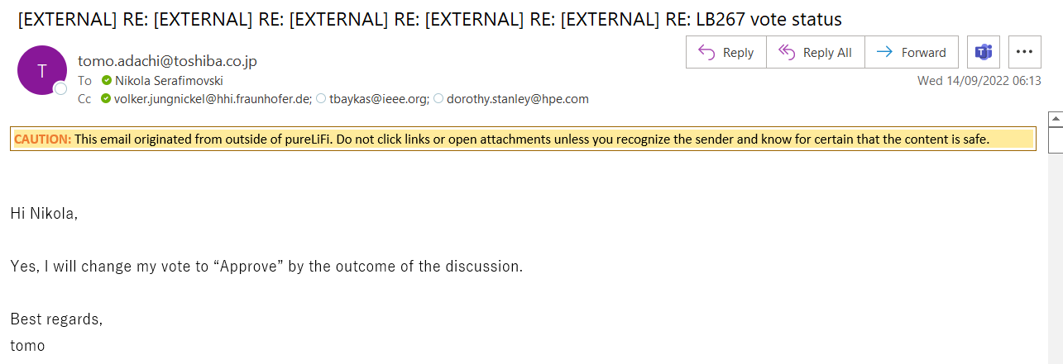

- Andersdotter, Amelia
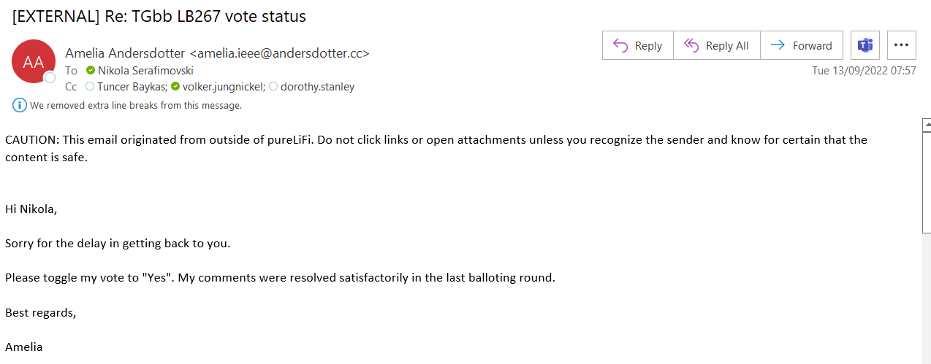

- Asterjadhi, Alfred
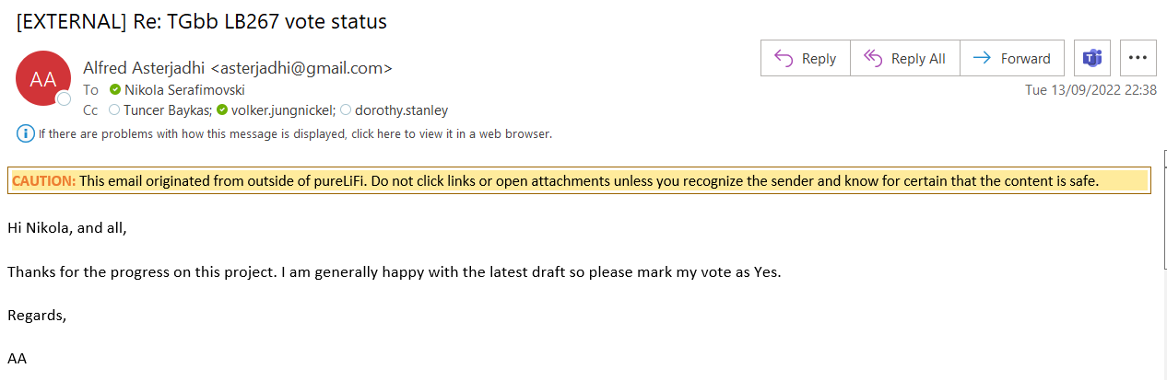

- Emmelmann, Marc
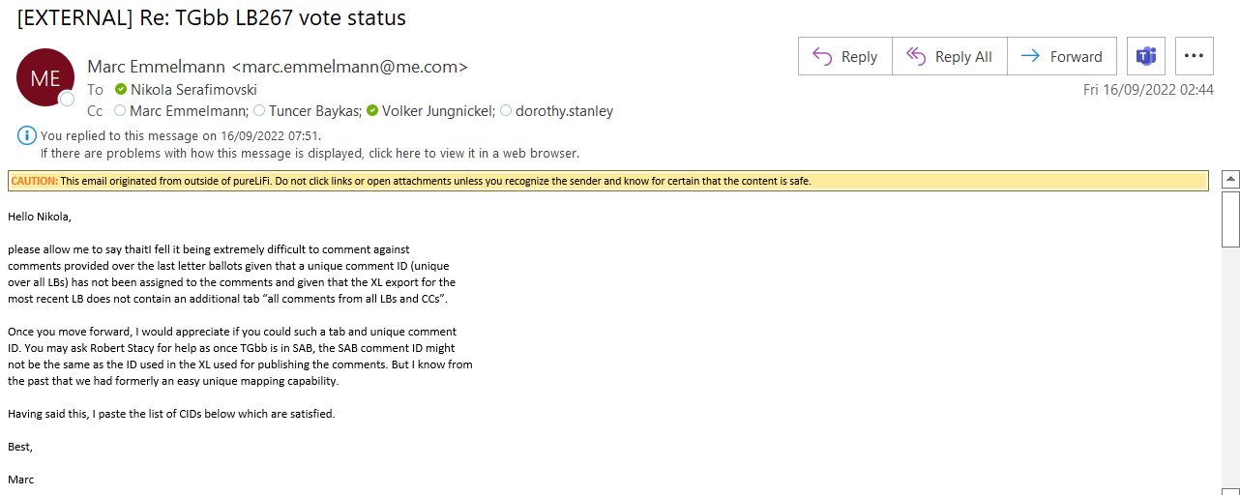

- Hamilton, Mark
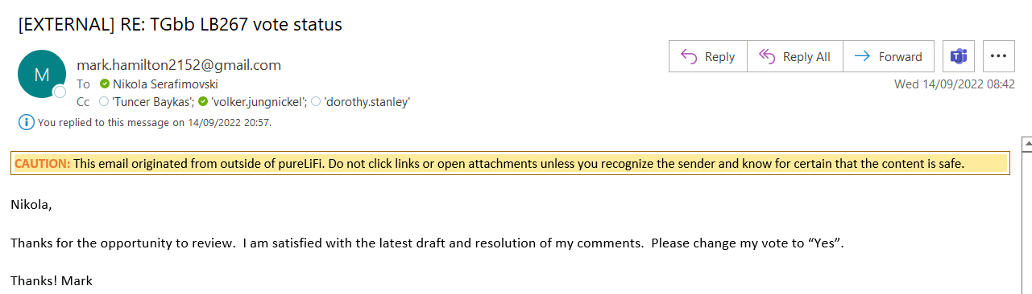

- Jungnickel, Volker
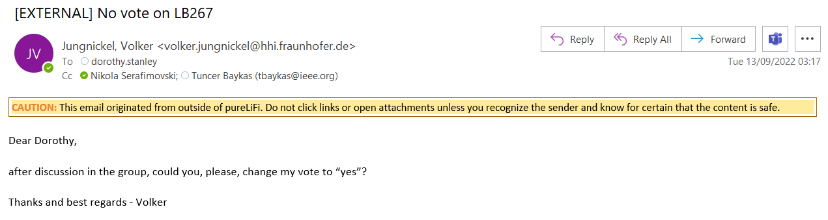

- Rison, Mark
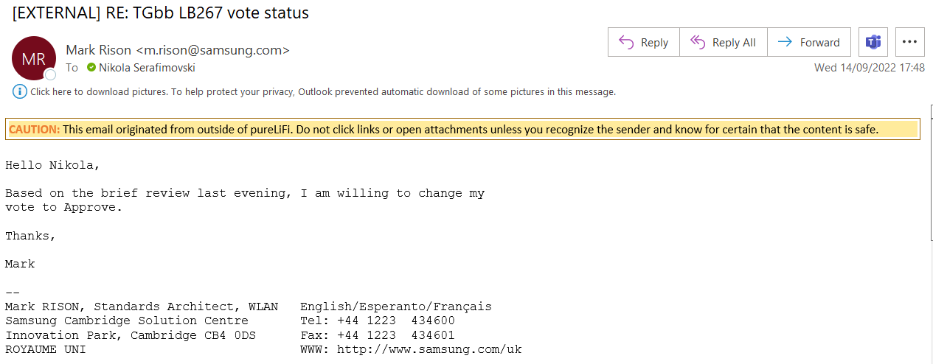

- Smith, Graham
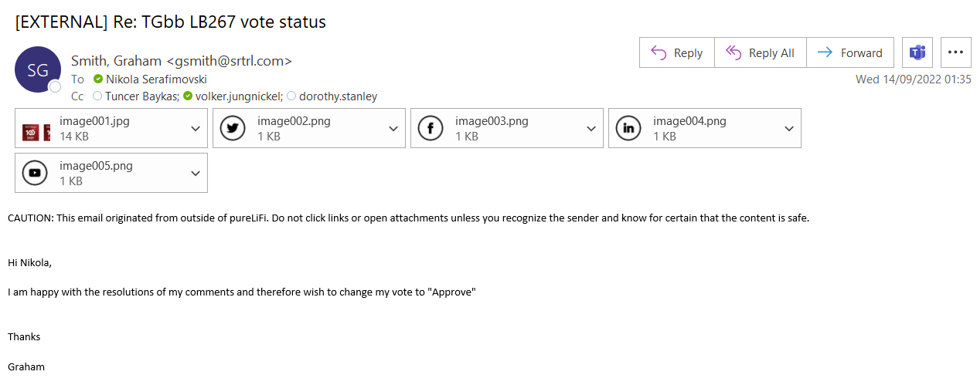

- Stacey, Robert
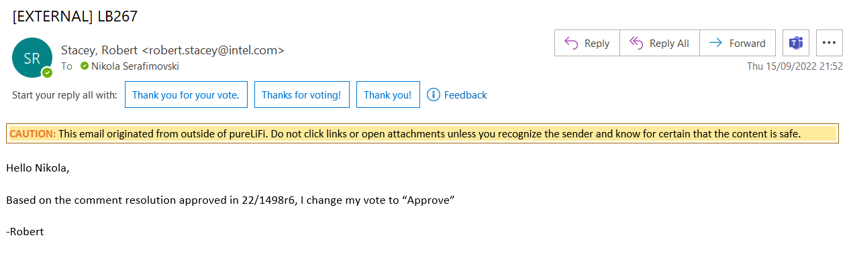

- Sun, Bo
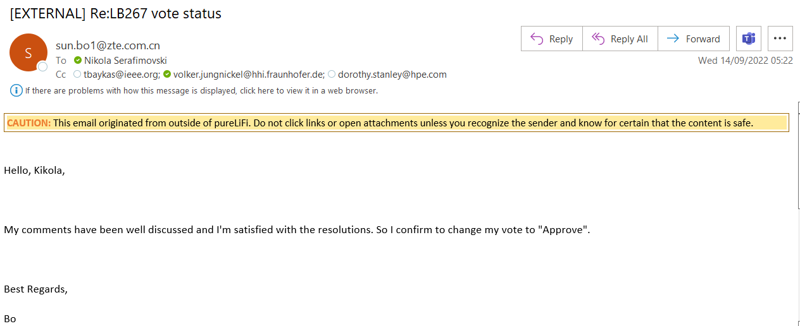

- Torab Jahromi, Payam
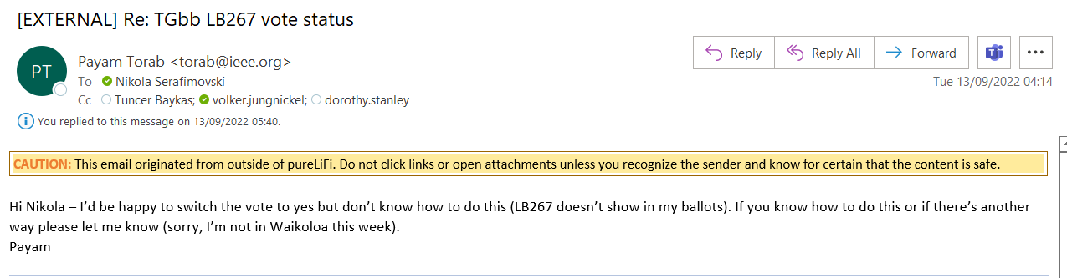

- Van Zelst, Allert
