IEEE P802.11
Wireless LANs
CR on CID 12537
Date: 2022-09-07
Author(s):
Name | Affiliation | Address | Phone | email
Bo Gong | Huawei |  |  | gongbo8@huawei.com

Abstract
This submission contains proposed comment resolutions to comments on P802.11be D2.0.
The changes are based on P802.11be D2.0.

This submission provides a resolution to the CID 12537.

Revisions:
- Rev 0: Initial version of the document.

CID 12537
CID | Page/Line | Clause | Comment | Proposed Change | Resolution
12537 | 786.50 | 36.4.4 | aPSDUMaxLength is computed to 15 523 200 bytes which does not match my computations for the same parameter as indicated in Eq. 36-118 which amounts to 15 523 198 bytes. | Change the value of "aPSDUMaxLength" in Table 36-70 to 15 523 198 | Accepted.

Discussion:

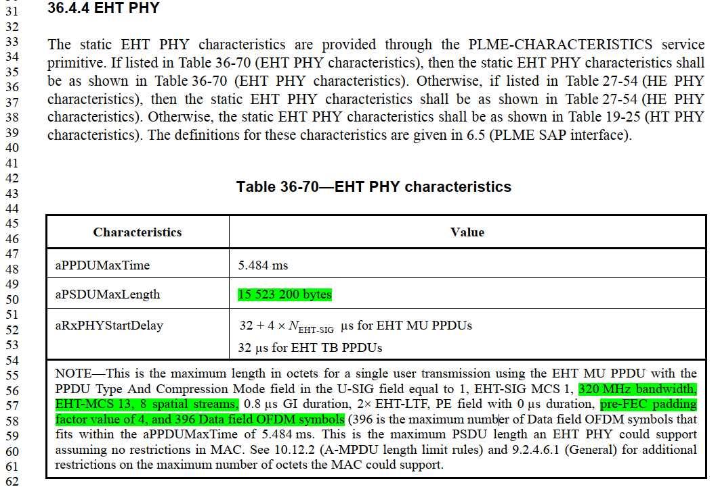

- The maximum length of the PSDU in an EHT MU PPDU can be calculated as the following procedure, which is described in Line 38, Page 785 of TGbe Draft D2.0.

For an EHT MU PPDU, the value of the RXVECTOR parameter PSDU_LENGTH returned for user u is calculated using Equation (36-118),
where
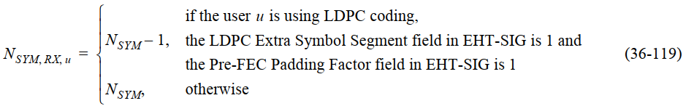
and
.

- According to the given parameters of the EHT MU PPDU, it can be seen that

N_{SYM, RX, u} = N_{SYM} = 396,
N_{DBPS, last, RX, u} = N_{DBPS, u}, since pre-FEC padding factor a_{RX, u} = 4,
N_{DBPS, u} = 313600 for 320MHz bandwidth, EHT-MCS 13, 8 spatial stream,
N_{service} = 16,
Ntail, u = 0 for calculation of the maximum PSDU length.

- Substituting the parameters in procedure (2) to (1), it is obtained that the PSDU length is 15 523 198. It appears that the existing maximum PSDU length in the spec mistakenly ignores the length of the SERVICE field during the calculation.

