IEEE P802.11
Wireless LANs
LB266 CIDs in 9-4-2-313 EHT Capabilities Element
Date: 2022-09-13
Author(s):
Name | Affiliation | Address | Phone | email
Kanke Wu | Qualcomm Inc |  |  | kankew@qti.qualcomm.com
Bin Tian | Qualcomm Inc

Abstract
This submission proposes resolutions for the following 18 comments from CC36 in P802.11be D2.0:
13065, 11305, 12001, 11228, 11306, 11140, 11854, 11229, 12002, 11230,
11231, 11310, 12003, 11311, 11855, 11856, 11233, 10003

This proposed text changes in this document are based on TGbe Draft 2.1

Revisions:

- Rev 0: Initial version of the document.

CID 13065

CID | Clause | Page.Line | Comment | Proposed Change | Resolutions
13065 | 9.4.2.313.3 | 234.01 | Supported Channel Width Set (B1-B7) in HE PHY Capabilities Information field had definitions for 20 MHz-only STA in 2.4/5/6 GHz bands; however, in EHT PHY Capabilities Information field, the 6 bits of Supported Channel Width Set are repurposed for other definitions. Please define 20 MHz-only STA capabilities in EHT PHY Capabilities Information field to accommodate definition of 20 MHz-only STA that might prefer to operate as 20 MHz-only STA in 11be mode, but not in 11ax mode. | As in comment | REJECTED.  The definition of bits in HE Capabilities Element is consistent in EHT and HE. The current indication of supported channel widths by an EHT STA also allows signalling of 20 MHz only devices in 5 and 6 GHz bands. See Table 35-7 for details.
  - Background
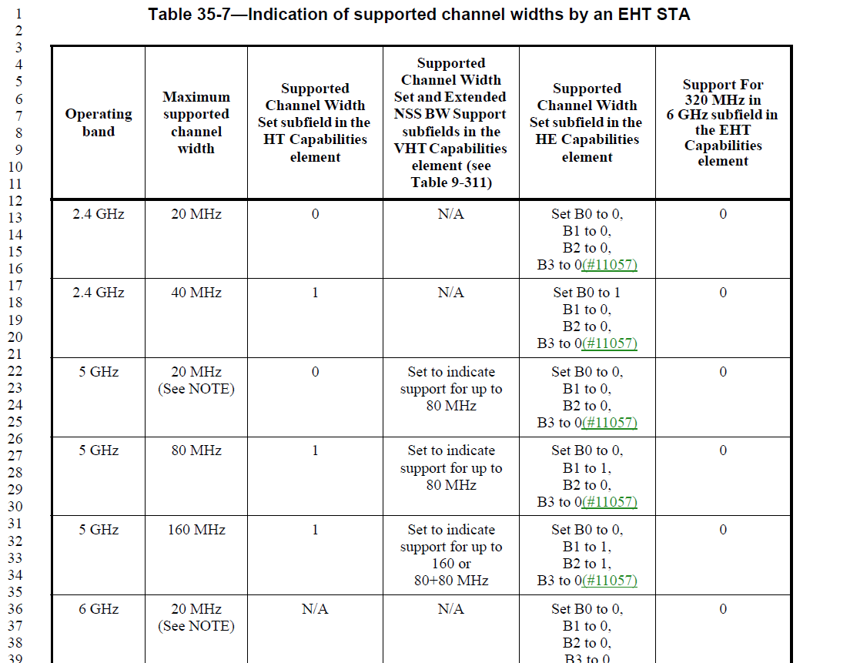
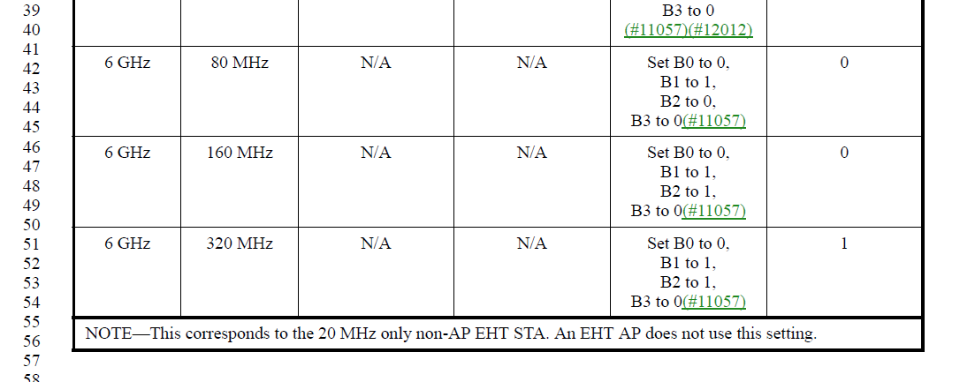

CID 11305, 12001

CID | Clause | Page.Line | Comment | Proposed Change | Resolutions
11305 | 9.4.2.313.3 | 235.26 | Simplify language: "... it indicates the beamformer's capability indicating ...". Same change on lines 32 and 41. | Change sentence to "(...) it indicates the maximum value of the TXVECTOR parameter NUM_STS supported by the beamformer for an EHT sounding NDP . | REVISED  Agree with the commenter’s comment on changing the wording. Similar changes need to be made to the following two fields for consistency.  Instruction to the editor:  Please modify the second column in the table at P238 L25 in D2.1 as indicated in 22/1606r1
12001 | 9.4.2.313.3 | 235.47 | Support for 320 MHz is indicated in the Support For 320 MHz In 6 GHz subfield. | Change "the Supported Channel Width Set field" to "the Support For 320 MHz In 6 GHz subfield". | ACCEPTED  Instruction to the editor:  Please make the changes in the table at P238 L47 in D2.1 as indicated in 22/1606r1
  - Background
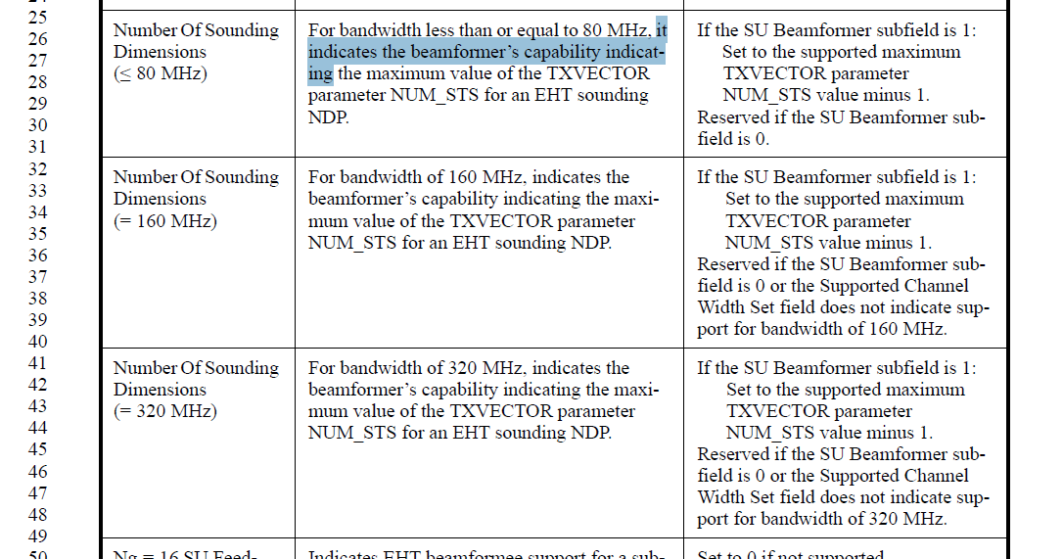
Instruction to the editor:
Please make the modifications in the table at P238 L25 as follows:
Number Of Sounding Dimensions (≤ 80 MHz) | For bandwidth less than or equal to 80 MHz, it indicates the maximum value of the TXVECTOR parameter NUM_STS supported by the beamformer for an EHT sounding NDP. | If the SU Beamformer subfield is 1:  Set to the supported maximum  TXVECTOR parameter  NUM_STS value minus 1.  Reserved if the SU Beamformer sub-field is 0.
Number Of Sounding Dimensions (= 160 MHz) | For bandwidth of 160 MHz, it indicates the maximum value of the TXVECTOR parameter NUM_STS supported by the beamformer for an EHT sounding NDP. | If the SU Beamformer subfield is 1:  Set to the supported maximum  TXVECTOR parameter  NUM_STS value minus 1.  Reserved if the SU Beamformer sub-field is 0 or the Supported Channel Width Set field does not indicate support for bandwidth of 160 MHz.
Number Of Sounding Dimensions (= 320 MHz) | For bandwidth of 320 MHz, it indicates the maximum value of the TXVECTOR parameter NUM_STS supported by the beamformer for an EHT sounding NDP. | If the SU Beamformer subfield is 1:  Set to the supported maximum  TXVECTOR parameter  NUM_STS value minus 1.  Reserved if the SU Beamformer sub-field is 0 or the Support For 320 MHz In 6 GHz subfield in EHT Capabilities Information fielddoes not indicate support for bandwidth of 320 MHz.

CID 11228

CID | Clause | Page.Line | Comment | Proposed Change | Resolutions
11228 | 9.4.2.313.3 | 236.22 | In third column, Add "NOTE--" before "For a non-AP STA, this field...", | Add "NOTE--" before "For a non-AP STA, this field...", | REJECTED  This part of the information is an requirement and should not be put as a note.
  - Background
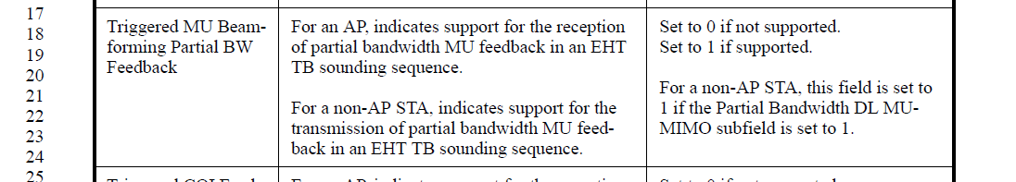

CID 11306

CID | Clause | Page.Line | Comment | Proposed Change | Resolutions
11306 | 9.4.2.313.3 | 236.47 | Change "Indicates that the ..." to "indicates the" | See comment | ACCEPTED
  - Background
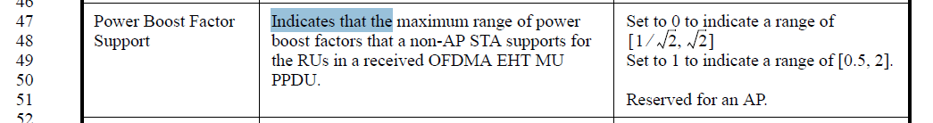

CID 11140, 11854

CID | Clause | Page.Line | Comment | Proposed Change | Resolutions
11140 | 9.4.2.313.3 | 238.40 | The "Support Of MCS 15" is really about support in M-RU. | Change  "Support Of MCS 15"  to  "Support Of MCS 15 in MRU"  at  P233L37  P238L40  P519L8  P526L8 | ACCEPTED  Note to the editor:  The required changes are applicable at  P235L44  P241L40  P530L14  P237L13  In D2.1
11854 | 9.4.2.313.3 | 238.40 | What about baseline RUs (i.e., non-MRUs). Are they covered by this bit as well? Please clarify. | As in comment. | REVISED.  As pointed out by the commenter for CID 11140, this subfield is really about support for MRU cases. The subfield has been renamed to clarify this
  - Background 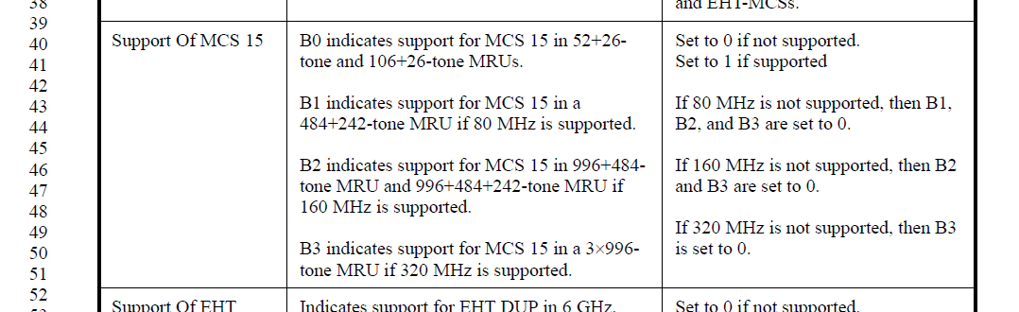

CID 11229, 12002, 11230

CID | Clause | Page.Line | Comment | Proposed Change | Resolutions
11229 | 9.4.2.313.3 | 239.21 | "is greater or equal to four," change to "is greater than or equal to four".. | is greater or equal to four, change to "is greater than or equal to four". | ACCEPTED  Note to the editor:  The required changes are applicable at  P242L21  P242L34  P242L47  P242L61  P243L15  P243L28  In D2.1
12002 | 9.4.2.313.3 | 239.21 | Change "~ greater or equal to four ~" to "~ greater than or equal to four ~". Ditto P239L34, P239L47, P239L61, P240L15, P240L28. | As in comment.
11230 | 9.4.2.313.3 | 240.15 | "is greater or equal to four," change to "is greater than or equal to four". | is greater or equal to four, change to "is greater than or equal to four".

CID 11231, 11310, 12003, 11311

CID | Clause | Page.Line | Comment | Proposed Change | Resolutions
11231 | 9.4.2.313.3 | 240.48 | "Regardless the indication" to "regardless of the indication..." | Regardless the indication to "regardless of the indication...". Also on page241 L7 | ACCEPTED  Note to the editor:  The required changes are applicable at  P243L48  P244L7  In D2.1
11310 | 9.4.2.313.3 | 240.48 | Change "regardless" to "regardless of" | See comment
12003 | 9.4.2.313.3 | 240.48 | Change "~ regardless the indication ~" to "~ regardless of the indication ~". Ditto P241L7. | As in comment.
11311 | 9.4.2.313.3 | 241.07 | Change "regardless" to "regardless of" | See comment

CID 11855

CID | Clause | Page.Line | Comment | Proposed Change | Resolutions
11855 | 9.4.2.313.4 | 241.33 | Wrong reference. Replace with the correct subclause for EHT PHY Capabilities Information field | As in comment. | REVISED.  Agree with the commenter. The reference should be subclause 9.4.2.313.3.  Instruction to the editor:  Please make the changes indicated in 22/1606r1
  - Background
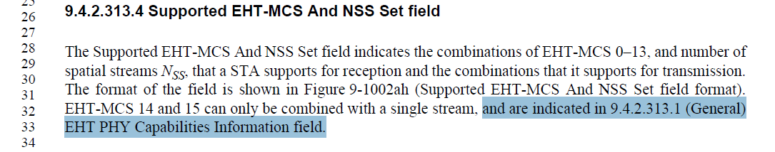
Instruction to the editor:
Please modify the sentence at P244L30 in D2.1 as follows:
EHT-MCS 14 and 15 can only be combined with a single stream, and are indicated in 9.4.2.313.3 ( EHT PHY Capabilities Information field).

CID 11856

CID | Clause | Page.Line | Comment | Proposed Change | Resolutions
11856 | 9.4.2.313.4 | 241.37 | How do RUs mapping between 80MHz and 160 Map in this case? | As in comment. | REJECTED.  The RUs between 80MHz and 160MHz would means that the operating channel width of the STA is greater than or equal to 160 MHz and hence indicated by EHT-MCS Map (BW=160MHz) or EHT-MCS Map (BW=320MHz). Depending on the actual PPDU bandwidth
  - Background
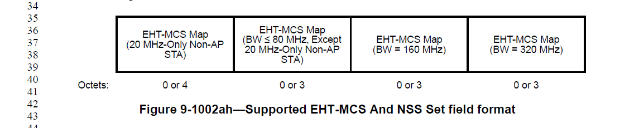

CID 11233

CID | Clause | Page.Line | Comment | Proposed Change | Resolutions
11233 | 9.4.2.313.4 | 242.25 | "RX 4096-QAM" | Change to lowercase Rx | ACCEPTED  The change is consistent with the current subfield name.
  - Background
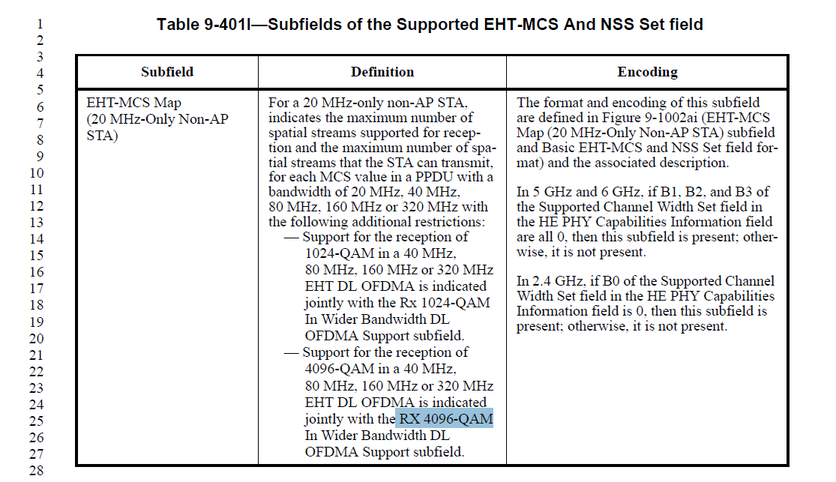

CID 10003

CID | Clause | Page.Line | Comment | Proposed Change | Resolutions
10003 | 9.4.2.313.4 | 245.39 | Figure 9-1002ai When referencing the Basic EHT-MCS And NSS Set field the A in And is generally capitalized when referring to the field. | Change "Basic EHT-MCS and NSS Set" to "Basic EHT-MCS And NSS Set". | ACCEPTED  Note to the editor:  The required changes are applicable at  P248L21  In D2.1
  - Background
  - 