IEEE P802.11
Wireless LANs
LB266 CR on EHT PHY Introduction-2
Date: 2022-09-13
Author(s):
Name | Affiliation | Address | Phone | email
Kanke Wu | Qualcomm Inc |  |  | kankew@qti.qualcomm.com
Bin Tian | Qualcomm Inc

Abstract
This submission proposes resolutions for the following 13 comments from CC36 in P802.11be D2.0:
12575, 11630, 11631, 12576, 12529, 12134, 12547, 11330, 11331, 12518,
12519, 11333, 11334

This proposed text changes in this document are based on TGbe Draft 2.1

Revisions:

- Rev 0: Initial version of the document.

CID 12575

CID | Clause | Page.Line | Comment | Proposed Change | Resolutions
12575 | 36.1.1 | 542.05 | The EHT-MCS 14 means 'BPSK-DCM+DUP', it is not accurate to say 'EHT introduces EHT DUP mode as EHT-MCS 14'. | Revise it to mention the EHT DUP mode is introduced for single user transmission modulated using BPSK-DCM as EHT-MCS 14. | REVISED.  EHT DUP mode is newly introduced in 11be. The current sentence already mentioned this mode is for single user transmission with single spatial stream and LDPC coding. We will modify this sentence to further specify it uses BPSK+DCM as modulation method.  Instruction to the editor:  Please modify P554 L 7-8 in D2.1 as following:  Add “using BPSK-DCM” between “with single spatial stream and LDPC coding” and “in the 6 GHz band” in the sentence.

Background:
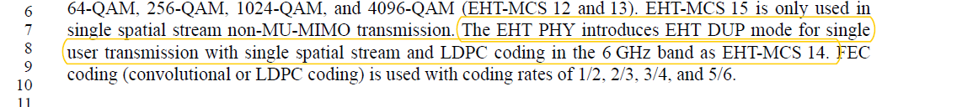

CID 11630, 11631, 12576

CID | Clause | Page.Line | Comment | Proposed Change | Resolution
11630 | 36.1.1 | 542.18 | Redundant sentence. No need to mention it as it directly derived from row 12 | Remove this line | REVISED.  Agree that this sentence is redundant. We will change the description of the main bullet to make it clear BCC is only used in specific situations.  Instruction to the editor:  Please modify P554 L 15 in D2.1 as following:  Add “ONLY” between “BCC coding is” and “supported”.  Delete the following sentence at line 21:
12576 | 36.1.1 | 542.18 | The sentence mentioning 'BCC coding is not supported in EHT PPDUs where...' is kind of redundant. | Delete the sentence, just to revise sentence of the second bullet to ' BCC coding is supported and only supported for EHT PPDUs where all of the following conditions are satisfied: | REVISED.  Agree with the comment in principle. The sentence is revised to reflect this information.  Instruction to the editor:  The resolution to this CID is the same as 11630
11631 | 36.1.1 | 542.11 | Descripction of BCC coding restriction doesn't belong to this section, as this section focuses on what STA needs to support | Keep the text "BCC coding (transmit and receive)" and move the rest before P542L8. It should be part of general description of EHT features | REJECTED  To keep the description consistent with LDPC case and provide complete information, the detailed cases where BCC is used is needed in this introduction section to avoid confusion that BCC may be needed in other cases.

Background:
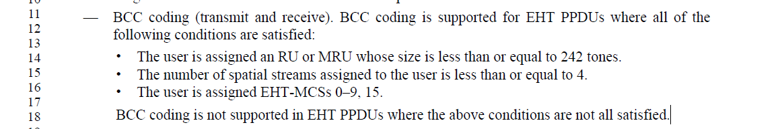

CID 12529

CID | Clause | Page.Line | Comment | Proposed Change | Resolution
12529 | 36.1.1 | 542.35 | "EHT-MCS 15 (transmit and receive) for- 26-, 52-, 106-, 242-, 484-, and 996-tone RU if the STA declares support for larger than 20 MHz  PPDU"-Here to support 996 RU, the STA has to support atleast 80 Mhz Bandwidth. | We propose the change as "26-, 52-, 106-, 242-, 484-, and 996-tone RU if the STA declares support for larger than or equal to 80 MHz PPDU" | ACCEPTED  Note to the editor:  Located at P554L40 in D2.1

Background:
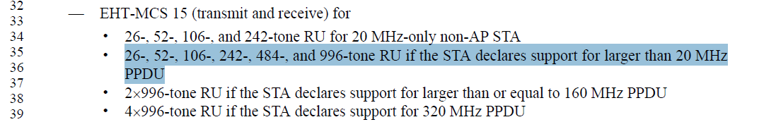

CID 12134

CID | Clause | Page.Line | Comment | Proposed Change | Resolution
12134 | 36.1.1 | 542.42 | what does mean "transmit and receive for single user"? It is better to reword these three bullets for easy of understanding | Change "EHT MU PPDU with a 2xEHT-LTF and 0.8 Î¼s GI duration on the EHT-LTF and Data field OFDM symbols (transmit and receive for single user)." to "EHT MU PPDU addressed to a single user and with a 2xEHT-LTF and 0.8 Î¼s GI duration on the EHT-LTF and Data field OFDM symbols (transmit and receive)."  Change "EHT MU PPDU with a 2xEHT-LTF and 1.6 Î¼s GI duration on the EHT-LTF and Data field OFDM symbols (transmit and receive for single user)." to "EHT MU PPDU addressed to a single user and with a 2xEHT-LTF and 1.6 Î¼s GI duration on the EHT-LTF and Data field OFDM symbols (transmit and receive).  Change "EHT MU PPDU with a 4xEHT-LTF and 3.2 Î¼s GI duration on the EHT-LTF and Data field OFDM symbols (transmit and receive for single user)." to "EHT MU PPDU addressed to a single user and with a 4xEHT-LTF and 3.2 Î¼s GI duration on the EHT-LTF and Data field OFDM symbols (transmit and receive)." | ACCEPTED  Note to the editor:  Located at P554L47 in D2.1

Background:
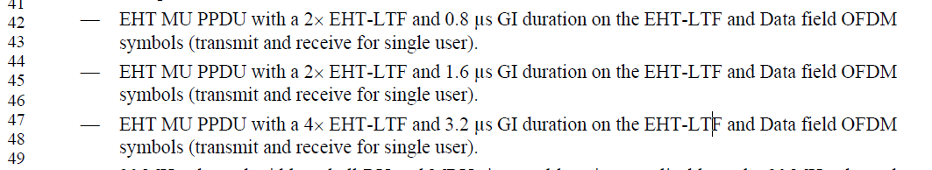

CID 12547

CID | Clause | Page.Line | Comment | Proposed Change | Resolution
12547 | 36.1.1 | 542.60 | This sentence is very vague. It needs to be rewritten to convey the intended meaning clearly. | The sentence may be rewritten as "- EHT-MCSs 8 to 13 (transmit and receive) if the STA is a 20  MHz-only non-AP STA and EHT-MCSs 10 to 13 (transmit and receive) if the STA is not a 20  MHz-only non-AP STA." | ACCEPTED  Note to the editor:  Located at P555L6 in D2.1

Background:
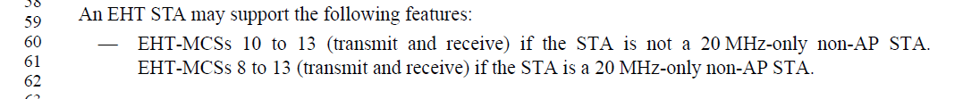

CID 11330

CID | Clause | Page.Line | Comment | Proposed Change | Resolution
11330 | 36.1.1 | 544.04 | Simplify "MU-MIMO reception on an RU or MRU in an EHT TB PPDU where the RU or MRU is of size larger than or equal to 242 tones in the supported bandwidth non-OFDMA transmission (UL MU-MIMO)" to "Receiption of a non-OFDMA EHT MU PPDU unitilizing MU-MIMO (DL MU-MIMO). This change is to align with the Tx requirements (2 bullets above). MU MIMO on >=242 tone RU has already been covered in P541 L 40 | as in the comment | REVISED  Agree with the suggested change. However, the requirement should be for Reception of EHT TB PPDU instead of EHT MU PPDU  Instruction to the editor:  Please modify P556 L8 in D2.1 as outlined in 22-1604r2.

Background:
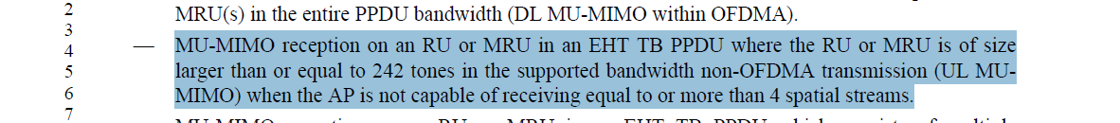
Instruction to the editor: Please modify P556 L8 in D2.1 as below
Reception of a non-OFDMA EHT TB PPDU using MU-MIMO (UL MU-MIMO) where the RU or MRU is of size larger than or equal to 242 tones in the supported bandwidth when the AP is not capable of receiving equal to or more than 4 spatial streams

CID 11331

CID | Clause | Page.Line | Comment | Proposed Change | Resolution
11331 | 36.1.1 | 544.22 | To differentiate from non-OFDMA tranmission, change "where the RU or MRU allocated to the non-AP STA" to "where there are mulitiple RU or MRUs and the one assigned to the non-AP STA". Make similar changes to the next bullet Tx support | as in the comment | REVISED.  Agree with the commenter. We will make similar changes to the next bullet as well.  Instruction to the editor:  Please make the changes indicated in 22-1604r2.

Background:
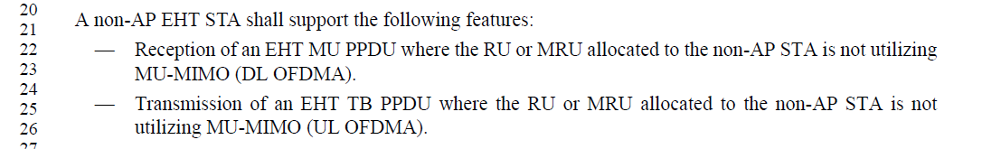
Instruction to the editor:
Please modify P556 L26 in D2.1 as following:
—Reception of an EHT MU PPDU where there are multiple RU or MRUs and the RU or MRU allocated to the non-AP STA is not utilizing MU-MIMO (DL OFDMA).
—Transmission of an EHT TB PPDU where there are multiple RU or MRUs and the RU or MRU allocated to the non-AP STA is not utilizing MU-MIMO (UL OFDMA).

CID 12519, 12518

CID | Clause | Page.Line | Comment | Proposed Change | Resolution
12519 | 36.1.1 | 544.28 | "A non-AP EHT STA shall support the following features:Reception of a non-OFDMA EHT MU PPDU utilizing MU-MIMO (DL MU-MIMO) in the supported bandwidth"-Regarding this, more clarity is needed with respect to AP's bandwidth. | For a 20 Mhz only STA, if the AP's bandwidth is greater than 20 Mhz, then Reception of 242 tone RU EHT MU PPDU is optional. Hence please clarify. | REJECTED  This bullet is specific to non-OFDMA reception. Based on the definition of non-OFDMA EHT PPDU, there is only a single RU or MRU occupying all the nonpunctured 20MHz channels within the PPDU bandwidth. The case mentioned by the commenter would hence be an OFDMA use case and won’t be covered by this requirement.
12518 | 36.11 | 544.35 | "A non-AP EHT STA shall support the following features:MU-MIMO transmission in a non-OFDMA EHT TB PPDU (UL MU-MIMO)."- Regarding this, more clarity is needed with respect to AP's bandwidth. | For a 20 Mhz only STA, if the AP's bandwidth is greater than 20 Mhz, then transmission of 242 tone RU EHT TBPPDU is restricted. Hence please clarify. | REJECTED  This bullet is specific to non-OFDMA transmission. Based on the definition of non-OFDMA EHT PPDU, there is only a single RU or MRU occupying all the nonpunctured 20MHz channels within the PPDU bandwidth. The case mentioned by the commenter would hence be an OFDMA use case and won’t be covered by this requirement.

Background:
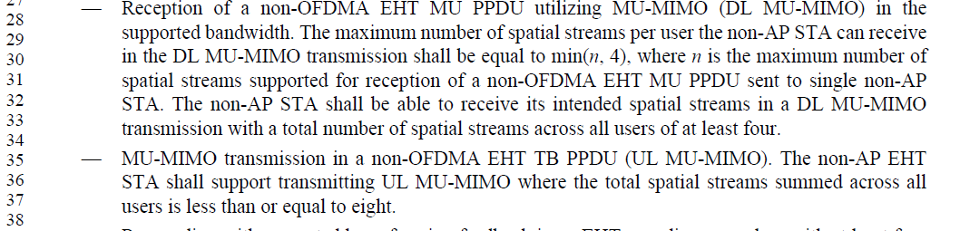
In clause 3 definition of acronyms and abbreviations.
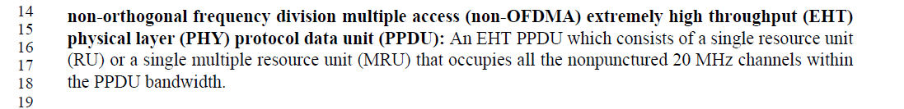

CID 11333

CID | Clause | Page.Line | Comment | Proposed Change | Resolution
11333 | 36.1.1 | 546.10 | Change "when the BSS bandwidth is 320  MHz" to "for a 320 MHz PPDU" | as in the comment | ACCEPTED

Background:
Based on the spec, the bullet above the one mentioned by the commenter already covered other PPDU bandwidths in the 6GHz band. This bullet is only applicable to 320MHz PPDU in the 6GHz band. The suggested change correctly reflects this.
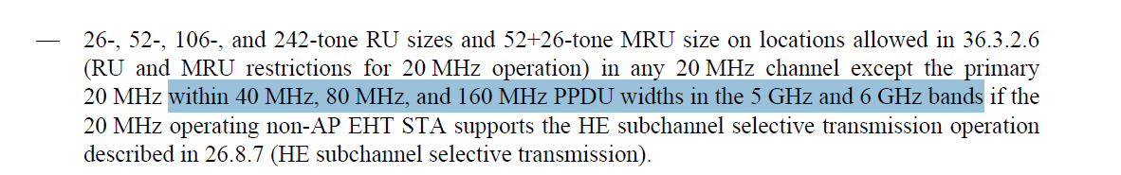
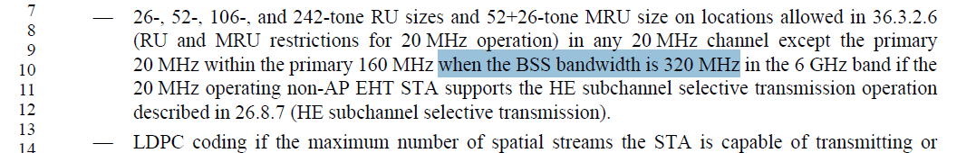

CID 11334

CID | Clause | Page.Line | Comment | Proposed Change | Resolution
11334 | 36.1.1 | 546.14 | "LDPC coding if the maximum number of spatial streams the STA is capable of transmitting or receiving in an EHT MU PPDU is less than or equal to 4, if the non-AP STA is a 20  MHz only non-AP STA that does not support any of EHT-MCS  10, 11, 12 or 13." Too many ifs. May combine them using and/or | as in the comment | REVISED  Agree with the commenter that the current sentence is a bit hard to read.  Instruction to the editor:  Please modify P558 L14 in as in 22-1604r2

Background:
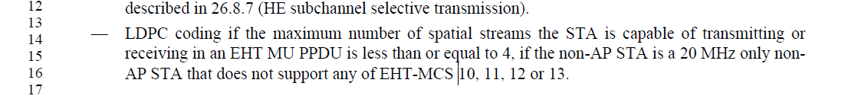
Instruction to the editor:
Please modify P558 L14 in D2.1 as following:
— LDPC coding if the maximum number of spatial streams the STA is capable of transmitting or receiving in an EHT MU PPDU is less than or equal to 4, and the non-AP STA is a 20 MHz only non-AP STA that does not support any of the EHT-MCS 10, 11, 12 or 13.

