IEEE P802.11  
Wireless LANs

|  |  |  |  |  |
| --- | --- | --- | --- | --- |
| CR for CC40 11bf D0.1 Sensing Measurement Report | | | | |
| Date: 2022-09-13 | | | | |
| Author(s): | | | | |
| Name | Affiliation | Address | Phone | email |
| Rojan Chitrakar | Panasonic |  |  | Rojan.chitrakar@sg.panasonic.com |
| Rajat Pushkarna |  |  |  |
|  |  |  |  |  |
|  |  |  |  |  |
|  |  |  |  |  |
|  |  |  |  |  |
|  |  |  |  |  |
|  |  |  |  |  |
|  |  |  |  |  |

Abstract

This submission proposes resolutions of comments received from TGbf comment collection 40 (TGbf Draft 0.1).

* CIDs: 294, 65, 119 (3 CIDs)

Revisions:

* Rev 0: Initial version of the document.
* Rev 1: Revised the Container format based on offline feedback.
* Rev 2: Further revised the Container format based on ad-hoc discussions.
* Rev 3: Revised based on feedback during 20 Oct call.

1. **Introduction**

Interpretation of a Motion to Adopt

A motion to approve this submission means that the editing instructions and any changed or added material are actioned in the TGbf Draft. The introduction and the explanation of the proposed changes are not part of the adopted material.

***Editing instructions formatted like this are intended to be copied into the TGbf Draft (i.e., they are instructions to the 802.11bf editor on how to merge the text with the baseline documents).***

***TGbf Editor: Editing instructions preceded by “TGbf Editor” are instructions to the TGbf editor to modify existing material in the TGbf draft. As a result of adopting the changes, the TGbf editor will execute the instructions rather than copy them to the TGbf Draft.***

|  |  |  |  |  |  |  |  |
| --- | --- | --- | --- | --- | --- | --- | --- |
| CID | Commenter | Clause | Page | Line | Comment | Proposed Change | Resolution |
| 294 | Rojan Chitrakar | 9.4.2.318 | 34 | 01 | Since elements can only carry up to 255 octets, using elements to carry sensing measurement reports will limit the report size to 255 or less. It would be better to use fields instead as is done in HT/VHT/HT/EHT for the beamforming feedback. | Use field(s) to carry to carry the sensing measurement reports instead of element. | **Revised.**  Agree with the comment that it is better to use fields to carry the Sensing Measurement Report. This was discussed in 22/1248r1 and 11bf group agreed to use field(s) to carry the sensing measurement reports instead of element. The related spec text is provided in this CR document.  TGbf editor to make the changes shown in IEEE 11-22-1579r3 under all headings that include CID 294. |
| 65 | Alecsander Eitan | 9.4.2.318 | 34 | 15 | The length of field "Sensing Measurement Report Type" shall be 1 octet | Length shall be 1 octet based on Table 9-401s | **Revised.**  The length of the field is implicitly equal to 3 bits as per Table 9-401s in D0.3.  TGbf editor to make the changes shown in IEEE 11-22-1579r3 under all headings that include CID 65. |
| 119 | Sigurd Schelstraete | 9.4.2.318 | 34 | 15 | Why is the length of the "Sensing Measurement Report Type" subfield TBD? Table 9-491s appears to show 256 possible values (1 byte). | See comment | **Revised.**  The length of the field is implicitly equal to 3 bits as per Table 9-401s in D0.3. The resolution is the same as that for CID 65 in IEEE 11-22-1579r3.  No further changes required from the TGbf editor for CID 119. |

Baseline is TGbfD0.3

Reference for CIDs 65, 119:

SP: Do you agree to incorporate the changes provided in IEEE 11-22-1579r3 for CIDs 294, 65, 119 to the next revision of 802.11bf draft?

**Discussion:** Please refer to 22/1248r1 for discussion related to this topic. The SP to replace the Sensing Measurement Report element with a field was unanimously supported:

Current formats as of D0.3:

Proposed format:

Summary of key points:

1. Sensing Measurement Report element is deleted from the 11bf draft and replaced with a fixed field called **Sensing Measurement Report Container**.

2. The Sensing Measurement Report Container includes following subfields:

* Container Length (CL) (**modified**): indicates the number of octets in the Sensing Measurement Report Container field, including the two octets for the Container Length subfield. **Always present in all Over-the-air (OTA) reports, including segments**.
* Report Type and Segmentation Control (**new**): Carries the Sensing Measurement Report Type and the parameter required for segmentation of reports. **Always present in all Over-the-air (OTA) reports, including segments**.

* + Sensing Measurement Report Type: Indicates the Report Type (e.g., CSI).
  + Report Control Present: Bit to indicate whether the Sensing Measurement Report Control field is present in the Sensing Measurement Report Container.
  + Measurement Setup ID: Identifies the Sensing Measurement Setup. **Propose to move the Measurement Setup ID field here for better organization.**
  + Sensing Transmitter STA ID: ID (e.g., AID/UID) of the Sensing Transmitter.
  + Sensing Receiver STA ID: ID (e.g., AID/UID) of the Sensing Receiver.
  + Measurement Instance ID: Indicates the sensing measurement instance corresponding to the Sensing Measurement Report and identifies the different segments of the same report.
  + Remaining Report segments: Indicates the number of remaining segments for the associated Sensing Measurement Report.
  + First Report Segment: Indicates whether this is the first segment.
* Sensing Measurement Report Control (**Modified**): Carries the parameters required to decode the Sensing Measurement Report and other parameters related to the report. **Only present in the first segment of the Over-the-air (OTA) reports.**

* + Report Control Length (RCL): indicates the number of octets in the Sensing Measurement Report Control field, including the one octets for the Report Control Length subfield. Added for future proofing if new subfields are added to the field in future generations.
  + Presence & Control Bitmap: Includes bits to indicate presence of optional subfields or other control bits (e.g., Last SBP Report) etc.
  + Mandatory fields related to report: CW, Ntx, Nrx, Nb, Ing etc.
  + Optional fields: e.g. Timestamp, RSSI?, Power Control? etc.
* Sensing Measurement Report (existing): Carries the measurement report or its segment. **Always present in all Over-the-air (OTA) reports, including segments**.



Example 1: A 18667 octets long Sensing Measurement Report is split into 2 segments and carried in two Sensing Measurement Report frames. Here, the SBP Initiator supports reception of the largest allowed MPDU size (11454 octets).

Note: The Sensing Measurement Report Control field is only included in the first segment.

Example 2A: Here, the SBP Initiator only supports reception of the smallest allowed MPDU size (3895 octets). In this case if the SBP Responder receives large segments (e.g. > 3895 octets), the SBP Responder would need to re-size the segments when forwarding to the SBP Initiator. Hence, **Segment size is mandated in 11bf to be small enough (e.g., 3750 octets) to fit in a 3895 octets frame. =>** The 18667 octets long Sensing Measurement Report is split into 5 segments and carried in 5 Sensing Measurement Report frames.

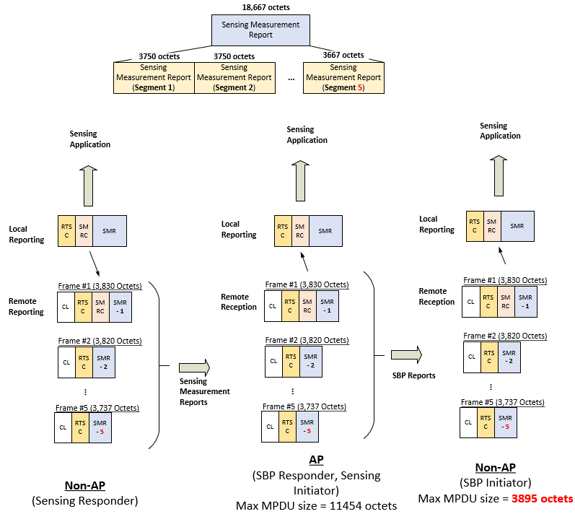

Discussion:

1. **Proposal#1:** **11bf only supports a single segment size. Propose the segment size to be 3750 octets (except the last segment)** so that 3 segments can be carried in a single maximum sized MPDU (11454 octets) even after the overhead of MAC headers and the other header fields.

A potential drawback: Sensing Measurement Reports larger than 3750 octets will trigger segmentation even if there are no SBP procedures running. **Countermeasure**:

For UL (non-AP STA to AP): segment size is implicitly derived from AP’s SBP capability: If AP supports SBP, segment size = smallest size (e.g., 3750 octets); otherwise, segment size = largest possible size (e.g., 11350 octets).

For DL (AP to non-AP STA): Segment size depends on the maximum MPDU length capability of the recipient (e.g., one among 3750, 7880 or 11350 octets).

.

Example 2B: Here, the SBP Initiator only supports reception of the smallest allowed MPDU size (3895 octets). **Segment size is mandated to be small enough (e.g., 3750 octets) to fit in a 3895 octets frame. =>** The 18667 octets long Sensing Measurement Report is split into 5 segments and but carried in 2 Sensing Measurement Report frames: the first frame carrying the first 3 segments and the second frame carrying the last 2 segments. The SBP Responder forward the 5 segments in 5 different SBP Report frames (each carrying one segment).

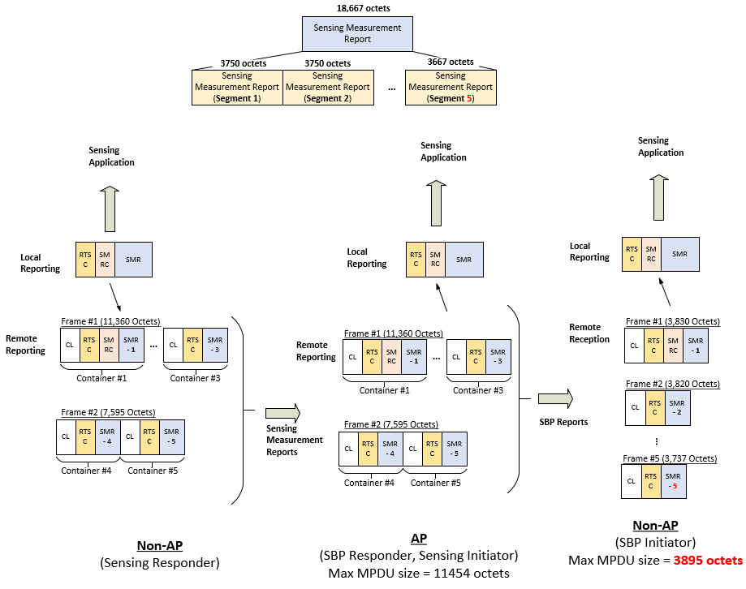

Discussion:

2. **Proposal#2: Whether each segment is carried in a different frame (Example 2A) or multiple segments are carried in a single frame (Example 2B) is left to implementation.**

3. To allow a frame to carry multiple segments, we can relax the rule that the frames carrying the non-last segment have a length equal to the maximum MPDU size supported by the recipient. The frame sizes can be left to implementations. **Proposal#3:** **11bf does not mandate the size of the frames that carry the Sensing Measurement Report or its segments.**

Example 3 (Simplified frame format): A 40416 octets long Sensing Measurement Report is split into 4 segments and carried in four Sensing Measurement Report frames.

Assumption: the recipient STA supports maximum MPDU size of 11454 octets.

~~Note: Each Sensing Measurement Report frame that includes a report segment~~ **~~that is not the last report segment~~** ~~shall have a length equal to the maximum MPDU size supported by the recipient.~~

**SP-1: Which option do you support for Sensing Measurement Report Segment size?**

Option 1: 11bf only supports the smallest segment size (e.g., 3750 Octets).

Option 2: For UL (non-AP STA to AP): If AP supports SBP, segment size = smallest size (e.g., 3750 octets); otherwise, segment size = largest size (e.g., 11350 octets).

For DL (AP to non-AP STA): Segment size depends on the maximum MPDU length capability of the recipient (e.g., one among 3750, 7880 or 11350 octets).

Option 3: Others (e.g., based on negotiation during Sensing Measurement Setup).

Option 4: Abstain.

|  |  |  |  |  |
| --- | --- | --- | --- | --- |
| Parameter | Host field | Size  (bits) | Mandatory or  Optional | Remarks |
| Container Length | Container Length | 16 | M | Size of the Sensing Measurement Report Container |
| Sensing Measurement Report Type | Report Type and Segmentation Control | 3 | M | Indicates the Report Type (e.g., CSI) |
| Measurement Setup ID | 3 | M | the sensing measurement Setup corresponding to the Sensing Measurement Report |
| Measurement Instance ID | 6 | M | the sensing measurement instance corresponding to the Sensing Measurement Report |
| Sensing Transmitter STA ID | 12 | M | ID (e.g., AID/UID) of the Sensing Transmitter. |
| Sensing Receiver STA ID | 12 | M | ID (e.g., AID/UID) of the Sensing Receiver. |
| Remaining Report Segments | 5 | M | the number of remaining segments |
| First Report Segment | 1 | M | Indicates whether this is the first segment. |
| Report Control Length | Sensing Measurement Report Control | 8 | M | Size of the Report Control field |
| Presence & Control Bitmap | 8 | M | indicate presence of optional subfields or other control bits |
| CW | 4 | M | Channel width |
| Ntx | 3 | M | the number of  transmit antennas |
| Nrx | 3 | M | the number of  receive antennas |
| Nb | 1 | M | the number of  bits for each CSI value |
| Ing | 1 | M | the subcarrier  grouping setting |
| Timestamp | ? | M? | Time at which the report was generated |
| RSSI | ? | O |  |
| Power Control | ? | O |  |
| … |  |  |  |
| Sensing Measurement Report | Sensing Measurement Report | variable | M | CSI feedback or it’s segments |
| Note: Report Control field is only present in the first segment. | | | | |

* Elements
* General

***TGbf editor: Delete Sensing Measurement Report element from Table 9-128 (Element IDs):***

|  |  |  |  |  |
| --- | --- | --- | --- | --- |
| * Element IDs | | | | |
| Element | Element ID | Element ID Extension | Extensible | Fragmentable |
| Sensing Measurement Parameters (see 9.4.2.317 (Sensing Measurement Parameters element)) | 255 | <ANA> | Yes | TBD |
|  |  |  |  |  |
| … |  |  |  |  |

***TGbf editor: Delete 9.4.2.318 (Sensing Measurement Report element) and move its content to 9.4.1.xx 2 (Sensing Measurement Report Container field):***

**(CIDs 294)**

**9.6 Action frame format details** **(CIDs 294)**

**9.6.7.1 Public Action frames**

**9.6.7.51 Sensing Measurement Report frame format**

***TGbf editor: Modify the subclause as follows (Track Change ON):***

The Sensing Measurement Report frame is an Action or an Action No Ack of category Public transmitted to provide WLAN sensing measurements. The format of the Sensing Measurement Report frame Action field is defined in Figure 9-1139d (Sensing Measurement Report frame Action field format).

|  |  |  |  |  |
| --- | --- | --- | --- | --- |
|  | Category | Public Action | Dialog Token | Sensing Measurement Report Container(s) |
| Octets: | 1 | 1 | 1 | variable |
| * **Sensing Measurement Report frame Action field format** | | | | |

The Category field is defined in 9.4.1.11 (Action field).

The Public Action field is defined in 9.6.7.1 (Public Action frames).

The Dialog Token field is defined in 9.4.1.12 (Dialog Token field). It is set to a nonzero value chosen by the STA sending the sensing measurement request to identify the request/report transaction.

The Sensing Measurement Report Container field is described in 9.4.1.xx (Sensing Measurement Report Container field).

**9.4 Management and Extension frame body components**

**9.4.1 Fields that are not elements**

***TGbf editor: Please move the contents of 9.4.2.318 (Sensing Measurement Report element) to the end of 9.4.1 (Fields that are not elements) and modify as below (Track Change ON).***

**9.4.1.xx Sensing Measurement Report Container field (CIDs 294, 65)**

**9.4.1.xx.1 General**

The Sensing Measurement Report Container field contains a single sensing measurement report. The format of the Sensing Measurement Report Container field is defined in Figure 9-xxxx (Sensing Measurement Report Container field format). One or more Sensing Measurement Report Container field is included in the Sensing Measurement Report frame, as described in 9.6.7.51 (Sensing Measurement Report frame format), and in the Protected Sensing Measurement Report frame, as described in 9.6.36.2 (Protected Sensing Measurement Report frame).



|  |  |  |  |  |
| --- | --- | --- | --- | --- |
|  | Container Length | Report Type and Segmentation Control | Sensing Measurement Report Control | Sensing Measurement Report |
| Octets: | 2 | 6 | variable | variable |
| **Figure 9-xxxx - Sensing Measurement Report Container field format** | | | | |

The Container Length field indicates the number of octets in the Sensing Measurement Report Container field, including the two octets for the Container Length subfield.

The Report Type and Segmentation Control field provides the information related to the type and segments of the Sensing Measurement Report. The fields of the Report Type and Segmentation Control field are specified in Table 9-xxxx - Report Type and Segmentation Control field.

**Table XXX: Report Type and Segmentation Control field**

|  |  |  |
| --- | --- | --- |
| **Field** | **Size (bits)** | **Definition** |
| Sensing Measurement Report Type | 3 | The Sensing Measurement Report Type field is set to a number that identifies the type of sensing measurement report. The Sensing Measurement Report Type values that have been allocated are shown in Table 9-401s (Sensing Measurement Report Type field definition). |
| Report Control Present | 1 | Set to 1 to indicate that the Sensing Measurement Report Control field is present in the Sensing Measurement Report Container. Otherwise, set to 0. |
| Measurement Setup ID | 3 | Identifies the sensing measurement Setup corresponding to the Sensing Measurement Report |
| Measurement Instance ID | 6 | Identifies the sensing measurement instance corresponding to the Sensing Measurement Report |
| Sensing Transmitter STA ID | 12 | AID or USID of the Sensing Transmitter corresponding to the Sensing Measurement Report |
| Sensing Receiver STA ID | 12 | AID or USID of the Sensing Receiver corresponding to the Sensing Measurement Report |
| Remaining Report Segments | 5 | Indicates the number of remaining report segments for corresponding to the Sensing Measurement Report:  Set to 0 for the last report segment of a segmented report or the only report segment of an unsegmented report.  Set to a value between 1 and 32 for a feedback segment that is not the last report segment of a segmented report. |
| First Report Segment | 1 | Set to 1 for the first report segment of a segmented report or the only feedback segment of an unsegmented report. Otherwise set to 0. |
| Reserved | 5 | Reserved |

|  |  |
| --- | --- |
| * **Sensing Measurement Report Type field definition** | |
| **Value** | **Sensing Measurement Type** |
| 0 | CSI |
| 1-7 | Reserved |

The Sensing Measurement Report Control field contains information necessary to interpret the Sensing Measurement Report field, and the Sensing Measurement Report field is used to report sensing measurement obtained by a sensing receiver.

If the Sensing Measurement Report Type field is 0, the Sensing Measurement Report Control field is defined in 9.4.1.xx.3 (Sensing Measurement Report Control field if the Sensing Measurement Report Type field is 0), and the Sensing Measurement Report field is defined in 9.4.1.xx.4 (Sensing Measurement Report field if the Sensing Measurement Report Type field is 0). The processes of encoding and decoding the CSI sent within a Sensing Measurement Report field is described in 9.4.1.xx.2 (CSI encoding and decoding for Sensing Measurement Report field).

**9.4.1.xx.2 CSI encoding and decoding for Sensing Measurement Report field**

**9.4.1.xx.2a General**

Subclause 9.4.1.xx.2b describes the encoding of the measured CSI which involves scaling and quantizing the measured CSI, for inclusion in the Sensing Measurement Report field. Subclause 9.4.1.xx.2c describes the decoding of the scaled and quantized CSI, received in the Sensing Measurement Report field.

The measured CSI for the t-th transmit antenna, the r-th receive antenna, and the k-th subcarrier is the complex value indicated by $H(t, r, k)$. The real part of the CSI is indicated by $H^{(R)}(t, r, k)$ while the imaginary part of the CSI is indicated by $H^{(I)}(t, r, k)$. The real and imaginary parts of the CSI are represented as 2s complement binary integers.

The encoded version of the CSI is denoted as $H_{e}(t, r, k)$ and decoded version of the CSI is denoted as $H_{d}\left(t, r, k\right).$

**9.4.1.xx.2b CSI Encoding Procedure**

The number of transmit antennas is indicated by $N_{TX}$ and the number of receive antennas is indicated by $N_{RX}$.

1. For a given tuple of transmit and receive antennas, $(t, r)$, the maximum of the absolute value of the real and imaginary parts of the CSI for all subcarriers is calculated using Equation (A).

$m\left(t,r\right)= \max_{k∈\{1, 2, …Nsc\}}{\{\max{\{{|H}^{\left(R\right)}\left(t, r, k\right)|, |H^{(I)}\left(t, r, k\right)|\}\}} }$ (A)

The number of subcarriers, $N_{sc}$ is specified in Table C (Number of Subcarriers as a function of Channel Width and $N_{g}$). This calculation is performed for each tuple of transmit and receive antennas, $(t, r)$, with $t=1, 2, …N_{TX}$ and $r=1, 2, …N_{RX}$.

1. For a given tuple of transmit and receive antennas, $(t, r)$, the positive scaling factor $γ(t, r)$ is selected to avoid overflow when scaling and quantizing the measured CSI using Equations (B) and (C). The value of $m\left(t,r\right)$ may be used in the selection of the $γ(t,r)$ to avoid an overflow. The sensing receiver selects the exact value of the scaling factor.

This calculation is performed for each tuple of transmit and receive antennas, $(t, r)$.

1. Each real and imaginary part of the CSI is scaled and quantized to $N_{b}$ bits using Equations (B) and (C). The value of $N_{b}$ is signaled in the Sensing Measurement Report Control field, and may have a value of 8 or 10 bits.

$H_{e}^{(R)}\left(t, r, k\right)=round\left(\frac{ H^{\left(R\right)}\left(t,r,k\right)}{ γ\left(t,r\right)}\right)$ (B)

$H_{e}^{(I)}\left(t,r, k\right)=round\left(\frac{ H^{\left(I\right)}\left(t,r,k\right)}{γ\left(t,r\right)}\right)$ (C)

**9.4.1.xx.2c CSI Decoding Procedure**

The received encoded CSI is decoded as follows,

1. The received real and imaginary parts of the scaled and quantized CSI, $H_{e}^{\left(R\right)}(t, r, k)$ and $H_{e}^{(I)}\left(t,r, k\right)$, are decoded as a pair of 2s complement numbers and are combined to form the complex CSI, $H_{e}(t, r, k)$.
2. Each CSI value is rescaled according to Equation (D),

$H_{d}\left(t, r, k\right)= γ\left( t,r\right) H_{e}(t, r, k)$ (D)

**9.4.1.xx.3 Sensing Measurement Report Control field if the Sensing Measurement Report Type field is 0**

The Sensing Measurement Report Control field, provides the information needed to process the Sensing Measurement Report field if the Sensing Measurement Report Type field is equal to 0. The Sensing Measurement Report Control field signals the Channel Width, the number of transmit antennas ($N_{TX}$), the number of receive antennas ($N_{RX}$), the number of bits ($N_{b}$) used for each encoded CSI value, and an indicator ($I_{ng}$) of the subcarrier grouping.

The fields of the Sensing Measurement Report Control field if the Sensing Measurement Report Type field is 0 are specified in Table 9-401t.

**Table 9-401t - Sensing Measurement Report Control field if the Sensing Measurement Report Type field is 0**

|  |  |  |  |
| --- | --- | --- | --- |
| **Field** | **Size (bits)** | **Definition** | **Meaning** |
| Report Control Length | 8 | Indicates the number of octets in the Sensing Measurement Report Control field, including the one octet for the Report Control Length subfield | Set to the number of octets in the Sensing Measurement Report Control field |
| Presence & Control Bitmap | 8 | Includes fields to indicate presence of optional subfields in the Sensing Measurement Report Control field, or other control bits | The fields of the Presence and Control Bitmap field are specified in Figure 9-xxxx - Presence and Control Bitmap field |
| CW | 4 | Bandwidth | (Encoding of CW subfield is TBD) |
| $$N_{TX}$$ | 3 | Indicates the number of transmit antennas | Set to the number of transmit antennas minus 1 |
| $$N_{RX}$$ | 3 | Indicates the number of receive antennas | Set to the number of receive antennas minus 1 |
| $$N_{b}$$ | 1 | Indicates the number of bits for each CSI value | Set to 0 for an 8-bit word size;  Set to 1 for a 10-bit word size. |
| $$I_{ng}$$ | 1 | Indicates the subcarrier grouping setting | Set to 0 to indicate a subcarrier grouping of $N_{g}=4$ if there are less than or equal to four transmit antennas.  Set to 0 to indicate a subcarrier grouping of $N_{g}=4$ if there are five or more transmit antennas and the bandwidth is 80 MHz or less.  Set to 0 to indicate a subcarrier grouping $N_{g}=8$ if there are five or more transmit antennas and the bandwidth is 160 MHz.  Set to 1 to indicate a subcarrier grouping of $N_{g}=16$.  NOTE: Ng =16 is optionally supported |
| Reserved | 4 |  | Reserved |

|  |  |  |
| --- | --- | --- |
|  | Last SBP Report | Reserved |
| Bits: | 1 | 7 |
| **Figure 9-xxxx - Presence & Control Bitmap field format** | | |

The Last SBP Report field indicates the last SBP report in the current availability window. The Last SBP Report subfield is set to 1 in an SBP Report frame sent in the SBP reporting procedure, if there is no more SBP Report frame to be sent in the current sensing availability window. Otherwise, it is set to 0. This subfield is reserved if sent in a Sensing Measurement Report frame.

**9.4.1.xx.4 Sensing Measurement Report field if the Sensing Measurement Report Type field is 0**

The size of the Sensing Measurement Report field depends on the values in the Sensing Measurement Report Control field. The Sensing Measurement Report field contains a Sensing Measurement Report information or successive portions thereof in the case of segmented sensing measurement report (see 11.21.18.6.X (Rules for generating segmented sensing measurement report)).

The scaled and quantized CSI values are contained in the Sensing Measurement Report information.

The fields of the Sensing Measurement Report information if the Sensing Measurement Report Type field is 0, are specified in Table B.

Since the scaling and quantization is performed for each TX/RX antenna pair, the scaled and quantized CSI values are ordered by TX/RX pair. The Sensing Measurement field begins with the set of scaling factors for each TX/RX antenna pair.

For each TX/RX-antenna pair there is a 12-bit positive scaling factor. If there is an odd number of scaling factors, then the set of scaling factors is followed by a 4-bit padding subfield.

For each TX/RX-antenna pair the in-phase (real) component of the CSI is entered first and followed by the quadrature (imaginary) component of the CSI. This begins with the lowest frequency subcarrier, and is repeated for each subcarrier. The number of subcarriers ($N_{sc}$) depends on the bandwidth and the value of $N_{g}$. The number of subcarriers is provided in Table C.

The subcarrier indices for $N_{g}=4$ and $N_{g}=16$ are provided in Table 9-91e—Subcarrier indices for compressed beamforming feedback matrix. The subcarrier indices for a channel width of 160 MHz and $N_{g}=8$ are provided in Table D – Subcarrier indices for Sensing CSI field, for Channel Width of 160 MHz and $N_{g}=8$.

Note: The size of the Sensing Measurement Report information if the Sensing Measurement Report Type field is 0, in octets, is given by Equation E,

$CSI Size= \left\lceil 1.5×N_{TX}×N_{RX}\right\rceil + \frac{N_{TX}×N_{RX}×N_{b}×N_{sc}}{4}$ (E)

Note: The size of the Sensing Measurement Report information if the Sensing Measurement Report Type field is 0, increases with the number of transmit antennas, the number of receive antennas, the bandwidth, the smaller subcarrier grouping size, and the larger number of quantization bits for each real and imaginary component of CSI. The smallest Sensing Measurement Report field if the Sensing Measurement Report Type field is 0 is 42 octets, and the largest Sensing Measurement Report field if the Sensing Measurement Report Type field is 0 is 40416 octets.

**Table 9-401u: Sensing Measurement Report information if the Sensing Measurement Report Type field is 0**

|  |  |  |
| --- | --- | --- |
| **Field** | **Size (bits)** | **Meaning** |
| $$γ(1,1)$$ | 12 | Scaling Factor for Transmit Antenna 1 and Receive Antenna 1 |
| $$γ\left(1,2\right)$$ | 12 | Scaling Factor for Transmit Antenna 1 and Receive Antenna 2 |
| $$⋮$$ | $$⋮$$ | $$⋮$$ |
| $$γ(1, N_{RX})$$ | 12 | Scaling Factor for Transmit Antenna 1 and Receive Antenna $N_{RX}$ |
| $$γ(2,1)$$ | 12 | Scaling Factor for Transmit Antenna 2 and Receive Antenna 1 |
| $$γ(2, 2)$$ | 12 | Scaling Factor for Transmit Antenna 2 and Receive Antenna 2 |
| $$⋮$$ | $$⋮$$ | $$⋮$$ |
| $$γ(2, N_{RX})$$ | 12 | Scaling Factor for Transmit Antenna 2 and Receive Antenna $N_{RX}$ |
| $$⋮$$ | $$⋮$$ | $$⋮$$ |
| $$γ(N_{TX}, 1)$$ | 12 | Scaling Factor for Transmit Antenna $N_{TX}$ and Receive Antenna 1 |
| $$γ(N_{TX}, 2)$$ | 12 | Scaling Factor for Transmit Antenna $N_{TX}$ and Receive Antenna 2 |
| $$⋮$$ | $$⋮$$ | $$⋮$$ |
| $$γ(N_{TX}, N_{RX})$$ | 12 | Scaling Factor for Transmit Antenna $N_{TX}$ and Receive Antenna $N_{RX}$ |
| Padding | 0 or 4 | The Padding subfield so that the next subfield is aligned on an octet boundary. |
| $$H_{e}(1,1,k)$$ | $$2×N_{b}×N_{sc}$$ | CSI for Transmit Antenna 1 and Receive Antenna 1, for subcarrier $k∈\{1, 2, …N_{sc}\}$ |
| $$H_{e}(1,2,k)$$ | $${2×N}_{b}×N_{sc}$$ | CSI for Transmit Antenna 1 and Receive Antenna 2, for subcarrier $k∈\{1, 2, …N_{sc}\}$ |
| $$⋮$$ | $$⋮$$ | $$⋮$$ |
| $$H_{e}(1, N_{RX},k)$$ | $$2×N_{b}×N_{sc}$$ | CSI for Transmit Antenna 1 and Receive Antenna $N_{RX}$, for subcarrier $k∈\{1, 2, …N_{sc}\}$ |
| $$H_{e}(2,1,k)$$ | $$2×N_{b}×N_{sc}$$ | CSI for Transmit Antenna 2 and Receive Antenna 1, for subcarrier $k∈\{1, 2, …N_{sc}\}$ |
| $$H_{e}(2,2,k)$$ | $${2×N}_{b}×N_{sc}$$ | CSI for Transmit Antenna 2 and Receive Antenna 2, for subcarrier $k∈\{1, 2, …N_{sc}\}$ |
| $$⋮$$ | $$⋮$$ | $$⋮$$ |
| $$H_{e}(2,N_{RX},k)$$ | $${2×N}_{b}×N_{sc}$$ | CSI for Transmit Antenna 2 and Receive Antenna $N_{RX}$, for subcarrier $k∈\{1, 2, …N_{sc}\}$ |
| $$⋮$$ | $$⋮$$ | $$⋮$$ |
| $$H_{e}(N_{TX}, 1, k)$$ | $$2×N_{b}×N_{sc}$$ | CSI for Transmit Antenna $N_{TX}$ and Receive Antenna 1, for subcarrier $k∈\{1, 2, …N_{sc}\}$ |
| $$H_{e}(N_{TX},2, k)$$ | $$2×N_{b}×N_{sc}$$ | CSI for Transmit Antenna $N_{TX}$ and Receive Antenna 2, for subcarrier $k∈\{1, 2, …N_{sc}\}$ |
| $$⋮$$ | $$⋮$$ | $$⋮$$ |
| $$H_{e}(N_{TX}, N_{RX}, k)$$ | $${2×N}_{b}×N_{sc}$$ | CSI for Transmit Antenna $N_{TX}$ and Receive Antenna $N_{RX}$, for subcarrier $k∈\{1, 2, …N_{sc}\}$ |

**Table 9-401v: Number of Subcarriers as a function of Channel Width and $N_{g}$**

|  |  |  |
| --- | --- | --- |
| **Channel Width** | $$N_{g}$$ | **Number of Subcarriers ($N_{sc}$)** |
| 20 MHz | 4 | 64 |
| 16 | 20 |
| 40 MHz | 4 | 122 |
| 16 | 32 |
| 80 MHz | 4 | 250 |
| 16 | 64 |
| 160 MHz | 8 | 252 |
| 16 | 128 |

**Table 9-401w: Subcarrier indices for Sensing CSI field, for Channel Width of 160 MHz and $N_{g}=8$**

|  |  |  |
| --- | --- | --- |
| **Channel Width** | $$N_{g}$$ | **Subcarrier Indices** |
| 160 MHz | 8 | -1012, -1004, … -20, -12, 12, 20, … 1004, 1012 |

***TGbf editor: Insert the following subclause (excluding the strikethrough text) at the end of 11.21.18.6 (TB sensing measurement instance):***

**11.21.18.6.X Rules for generating segmented sensing measurement report (CIDs 294)**

If a Sensing Measurement Report information exceeds dot11SENSReportSegmentSize, then the Sensing Measurement Report information shall be split into up to thirty-two report segments. ~~Each report segment shall be included in a separate Sensing Measurement Report frame or Protected Sensing Measurement Report frame~~ Each report segment shall be included in a separate Sensing Measurement Report Container and shall contain successive portions of the Sensing Measurement Report information. The Sensing Measurement Report Control field shall be included in the Sensing Measurement Report Container that carries the first report segment and shall not be included in a Sensing Measurement Report Container that carries a report segment other than the first report segment. Each report segment shall be of equal length, the length of each report segment being equal to dot11SENSReportSegmentSize, except the last report segment that may be smaller. ~~Each Sensing Measurement Report frame or Protected Sensing Measurement Report frame that includes a report segment that is not the last report segment shall have a length equal to the maximum MPDU size supported by the recipient.~~ Each report segment is identified by the value of the Remaining Report Segments subfield and the First Report Segment subfield in the Sensing Measurement Report Control field as defined in Table 9-xxxx - Report Type and Segmentation Control field. The other nonreserved subfields of the Report Type and Segmentation Control field shall be the same for all report segments. All report segments shall be sent in a single A-MPDU contained in a PPDU and shall be included in the A-MPDU in the descending order of the values of the Remaining Report Segments subfield.

Annex C

(normative)

ASN.1 encoding of the MAC and PHY MIB

C.3 MIB Detail

***TGbf editor: Change the comment list following the dot11smt definition as follows (not all lines shown, Track Change ON):***

Change the comment list following the dot11smt definition as follows (not all lines shown):

-- **********************************************************************

-- * Major sections

-- **********************************************************************

-- Station ManagemenT (SMT) Attributes

-- DEFINED AS "The SMT object class provides the necessary support

-- at the station to manage the processes in the station such that

-- the station may work cooperatively as a part of an IEEE 802.11

-- network."

dot11smt OBJECT IDENTIFIER ::= { ieee802dot11 1 }

-- dot11smt GROUPS

-- ...

-- dot11SENSStationConfigTable ::= ( dot11smt xxx )

...

-- **********************************************************************

-- * dot11StationConfig TABLE

-- **********************************************************************

***TGbf editor: Insert the following at the end:***

-- **********************************************************************

-- * dot11SENSStationConfigTable TABLE

-- **********************************************************************

dot11SENSStationConfigTable OBJECT-TYPE

SYNTAX SEQUENCE OF Dot11SENSStationConfigEntry

MAX-ACCESS not-accessible

STATUS current

DESCRIPTION

"Station Configuration attributes. In tabular form to allow for multiple

instances on an agent."

::= { dot11smt xxx }

dot11SENSStationConfigEntry OBJECT-TYPE

SYNTAX Dot11SENSStationConfigEntry

MAX-ACCESS not-accessible

STATUS current

DESCRIPTION

"An entry (conceptual row) in the dot11SENSStationConfig Table.

ifIndex - Each IEEE 802.11 interface is represented by an ifEntry. Interface tables in this MIB module are indexed by ifIndex."

INDEX { ifIndex }

::= { dot11SENSStationConfigTable 1 }

Dot11SENSStationConfigEntry::=

SEQUENCE {

dot11SENSReportSegmentSize, Unsigned32 }

dot11SENSReportSegmentSize OBJECT-TYPE

SYNTAX Unsigned32 { 3750 }

UNITS "octets"

MAX-ACCESS read-only

STATUS current

DESCRIPTION

"This is a control variable.

It is written by an external management entity or the SME. Changes take effect as soon as practical in the implementation.

This attribute indicates the size of the Measurement Report Segments"

::= { dot11SENSStationConfigEntry 1 }