IEEE P802.11
Wireless LANs
CR for CC40 11bf D0.1 Sensing Measurement Report
Date: 2022-09-13
Author(s):
Name | Affiliation | Address | Phone | email
Rojan Chitrakar | Panasonic |  |  | Rojan.chitrakar@sg.panasonic.com
Rajat Pushkarna
Abstract
This submission proposes resolutions of comments received from TGbf comment collection 40 (TGbf Draft 0.1).
- CIDs: 294, 65, 119 (3 CIDs)

Revisions:

- Rev 0: Initial version of the document.
- Rev 1: Revised the Container format based on offline feedback.

- Introduction

Interpretation of a Motion to Adopt

A motion to approve this submission means that the editing instructions and any changed or added material are actioned in the TGbf Draft. The introduction and the explanation of the proposed changes are not part of the adopted material.

Editing instructions formatted like this are intended to be copied into the TGbf Draft (i.e., they are instructions to the 802.11bf editor on how to merge the text with the baseline documents).

TGbf Editor: Editing instructions preceded by “TGbf Editor” are instructions to the TGbf editor to modify existing material in the TGbf draft. As a result of adopting the changes, the TGbf editor will execute the instructions rather than copy them to the TGbf Draft.

CID | Commenter | Clause | Page | Line | Comment | Proposed Change | Resolution
294 | Rojan Chitrakar | 9.4.2.318 | 34 | 01 | Since elements can only carry up to 255 octets, using elements to carry sensing measurement reports will limit the report size to 255 or less. It would be better to use fields instead as is done in HT/VHT/HT/EHT for the beamforming feedback. | Use field(s) to carry to carry the sensing measurement reports instead of element. | Revised.  Agree with the comment that it is better to use fields to carry the Sensing Measurement Report. This was discussed in 22/1248r1 and 11bf group agreed to use field(s) to carry the sensing measurement reports instead of element. The related spec text is provided in this CR document.  TGbf editor to make the changes shown in IEEE 11-22-1579r1 under all headings that include CID 294.
65 | Alecsander Eitan | 9.4.2.318 | 34 | 15 | The length of field "Sensing Measurement Report Type" shall be 1 octet | Length shall be 1 octet based on Table 9-401s | Revised.  The length of the field is implicitly equal to 3 bits as per Table 9-401s in D0.3. During related discussion in 22/1458, the group indicated preference to keep the Type field out of the Control field.  TGbf editor to make the changes shown in IEEE 11-22-1579r1 under all headings that include CID 65.
119 | Sigurd Schelstraete | 9.4.2.318 | 34 | 15 | Why is the length of the "Sensing Measurement Report Type" subfield TBD? Table 9-491s appears to show 256 possible values (1 byte). | See comment | Revised.  The length of the field is implicitly equal to 3 bits as per Table 9-401s in D0.3. During related discussion in 22/1458, the group indicated preference to keep the Type field out of the Control field. The resolution is the same as that for CID 65 in IEEE 11-22-1579r1.  TGbf editor to make the changes shown in IEEE 11-22-1579r1 under all headings that include CID 65.
Baseline is TGbfD0.3
Reference for CIDs 65, 119:
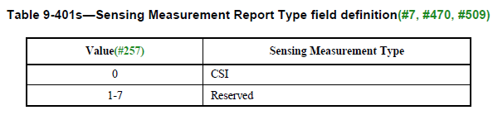

SP: Do you agree to incorporate the changes provided in IEEE 11-22-1579r1 for CIDs 294, 65, 119 to the next revision of 802.11bf draft?

Discussion: Please refer to 22/1248r1 for discussion related to this topic. The SP to replace the Sensing Measurement Report element with a field was unanimously supported:
Current formats as of D0.3:

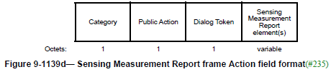

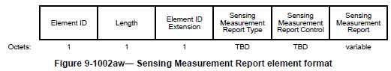

Proposed format:

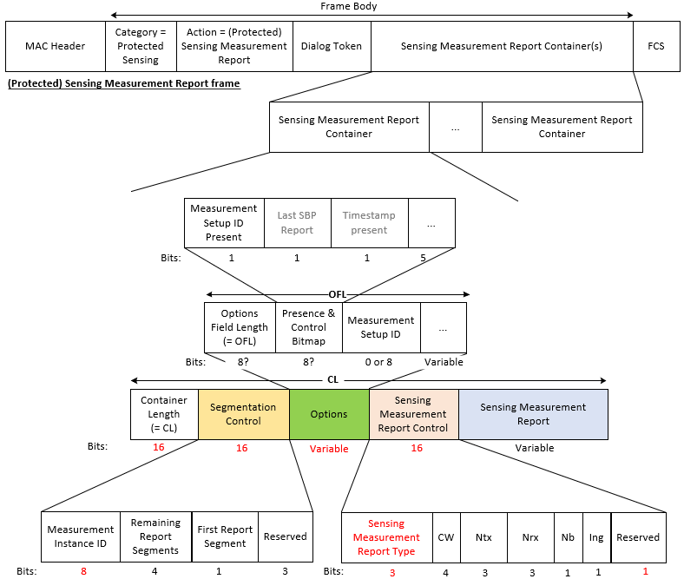
Summary of key points:

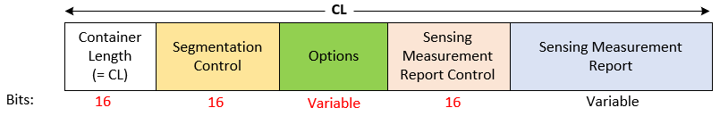

1. Sensing Measurement Report element is deleted from the 11bf draft and replaced with a fixed field called Sensing Measurement Report Container.

2. The Sensing Measurement Report Container includes following subfields:

- Container Length (CL) (modified): indicates the number of octets in the Sensing Measurement Report Container field, including the two octets for the Container Length subfield. Always present in all Over-the-air (OTA) reports, including segments.

- Segmentation Control (new): Carries the parameter required for segmentation of reports. Always present in all Over-the-air (OTA) reports, including segments. Contains following subfields:
  - Measurement Instance ID: Indicates the sensing measurement instance corresponding to the Sensing Measurement Report and identifies the different segments of the same report.
  - Remaining Report segments: Indicates the number of remaining segments for the associated Sensing Measurement Report
  - First Report Segment: Indicates whether this is the first segment

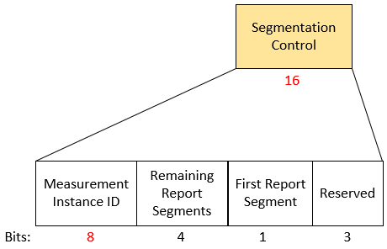

- Options (new): Includes parameters related to the Sensing Measurement Report. Only present in the first segment of the Over-the-air (OTA) reports. Contains following subfields:
  - Options Field Length (OFL): indicates the number of octets in the Options field, including the two octets for the Options Field Length subfield. Added for future proofing if new subfields are added to the Options field in future generations.
  - Presence & Control Bitmap: Includes bits to indicate presence of fields or other control bits (e.g., Last SBP Report) etc.
  - Optional fields e.g. Measurement Setup ID, Timestamp, Transmitter, Receiver IDs etc. Propose to move the Measurement Setup ID field here for better organization.

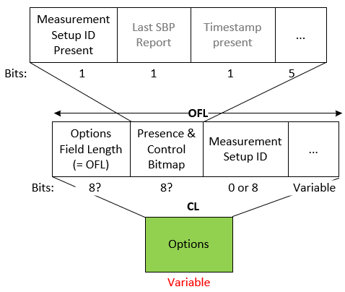
- Sensing Measurement Report Control (existing): Propose to move the Sensing Measurement Report Type field here for better organization. Only present in the first segment of the Over-the-air (OTA) reports.

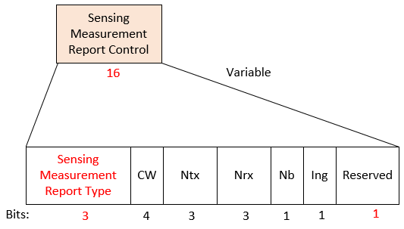
- Sensing Measurement Report (existing): Carries the measurement report or its segment. Always present in all Over-the-air (OTA) reports, including segments.

An Example: A 18667 octets long Sensing Measurement Report is split into 2 segments and carried in two Sensing Measurement Report frames.

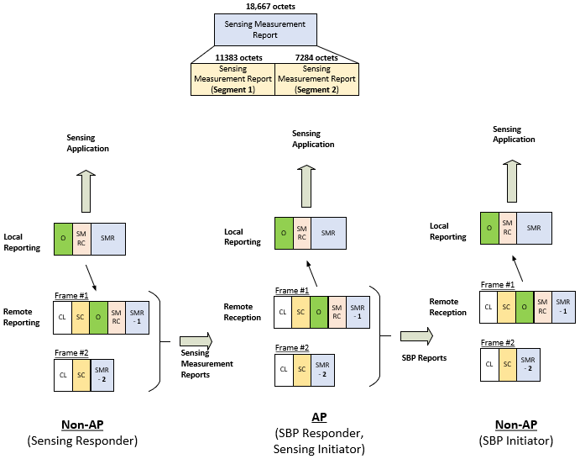

Note: The Options field and the Sensing Measurement Report Control field are only included in the first segment.
An Example (Simplified frame format): A 40416 octets long Sensing Measurement Report is split into 4 segments and carried in four Sensing Measurement Report frames.
Assumption: the recipient STA supports maximum MPDU size of 11454 octets.
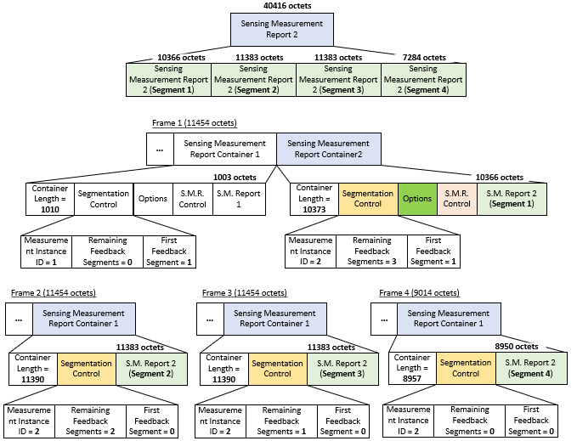

Note: Each Sensing Measurement Report frame that includes a report segment that is not the last report segment shall have a length equal to the maximum MPDU size supported by the recipient.

- Elements
- General
TGbf editor: Delete Sensing Measurement Report element from Table 9-128 (Element IDs):
- Element IDs
Element | Element ID | Element ID Extension | Extensible | Fragmentable
Sensing Measurement Parameters (see 9.4.2.317 (Sensing Measurement Parameters element)) | 255 | <ANA> | Yes | TBD
…

TGbf editor: Delete 9.4.2.318 (Sensing Measurement Report element) and move its content to 9.6.7.51.2 (Sensing Measurement Report):
(CIDs 294)

$$N_{TX}$$
$$N_{RX}$$
$$N_{b}$$
$$I_{ng}$$

$$γ(1,1)$$
$$γ\left(1,2\right)$$
$$⋮$$ | $$⋮$$ | $$⋮$$
$$γ(1, N_{RX})$$
$$γ(2,1)$$
$$γ(2, 2)$$
$$⋮$$ | $$⋮$$ | $$⋮$$
$$γ(2, N_{RX})$$
$$⋮$$ | $$⋮$$ | $$⋮$$
$$γ(N_{TX}, 1)$$
$$γ(N_{TX}, 2)$$
$$⋮$$ | $$⋮$$ | $$⋮$$
$$γ(N_{TX}, N_{RX})$$
$$H_{e}(1,1,k)$$ | $$2×N_{b}×N_{sc}$$
$$H_{e}(1,2,k)$$ | $${2×N}_{b}×N_{sc}$$
$$⋮$$ | $$⋮$$ | $$⋮$$
$$H_{e}(1, N_{RX},k)$$ | $$2×N_{b}×N_{sc}$$
$$H_{e}(2,1,k)$$ | $$2×N_{b}×N_{sc}$$
$$H_{e}(2,2,k)$$ | $${2×N}_{b}×N_{sc}$$
$$⋮$$ | $$⋮$$ | $$⋮$$
$$H_{e}(2,N_{RX},k)$$ | $${2×N}_{b}×N_{sc}$$
$$⋮$$ | $$⋮$$ | $$⋮$$
$$H_{e}(N_{TX}, 1, k)$$ | $$2×N_{b}×N_{sc}$$
$$H_{e}(N_{TX},2, k)$$ | $$2×N_{b}×N_{sc}$$
$$⋮$$ | $$⋮$$ | $$⋮$$
$$H_{e}(N_{TX}, N_{RX}, k)$$ | $${2×N}_{b}×N_{sc}$$

$$N_{g}$$

$$N_{g}$$

9.6 Action frame format details (CIDs 294)

9.6.7.1 Public Action frames

9.6.7.51 Sensing Measurement Report frame format

TGbf editor: Modify the subclause as follows (Track Change ON):

9.6.7.51.1 General
The Sensing Measurement Report frame is an Action or an Action No Ack of category Public transmitted to provide WLAN sensing measurements. The format of the Sensing Measurement Report frame Action field is defined in Figure 9-1139d (Sensing Measurement Report frame Action field format).

 | Category | Public Action | Dialog Token | Sensing Measurement Report Container(s)
Octets: | 1 | 1 | 1 | variable
- Sensing Measurement Report frame Action field format

The Category field is defined in 9.4.1.11 (Action field).
The Public Action field is defined in 9.6.7.1 (Public Action frames).
The Dialog Token field is defined in 9.4.1.12 (Dialog Token field). It is set to a nonzero value chosen by the STA sending the sensing measurement request to identify the request/report transaction.
The Sensing Measurement Report Container is described in 9.6.7.51.2 (Sensing Measurement Report Container).

9.6.7.51.2 Sensing Measurement Report Container (CIDs 294, 65)

9.6.7.51.2.1 General

The Sensing Measurement Report Container contains a single sensing measurement report. The format of the Sensing Measurement Report Container is defined in 9-xxxx (Sensing Measurement Report Container field format). The Sensing Measurement Report Container is included in the Sensing Measurement Report frame, as described in 9.6.7.51 (Sensing Measurement Report frame format), and in the Protected Sensing Measurement Report frame, as described in 9.6.36.2 (Protected Sensing Measurement Report frame).

 | Container Length | Sensing Measurement Report Type | Sensing Measurement Report Control | Sensing Measurement Report
Bits: | 16 | 3 (#65) | 37 | variable
Figure 9-xxxx - Sensing Measurement Report Container format

The Container Length field indicates the number of octets in the Sensing Measurement Report Container field, including the two octets for the Container Length subfield.
The Sensing Measurement Report Type field is set to a number that identifies the type of sensing measurement report. The Sensing Measurement Report Type values that have been allocated are shown in Table 9-401s (Sensing Measurement Report Type field definition).

- Sensing Measurement Report Type field definition
Value | Sensing Measurement Type
0 | CSI
1-7 | Reserved
The Sensing Measurement Report Control field contains information necessary to interpret the Sensing Measurement Report field, and the Sensing Measurement Report field is used to report sensing measurement obtained by a sensing receiver.
If the Sensing Measurement Report Type field is 0, the Sensing Measurement Report Control field is defined in 9.6.7.51.2.3 (Sensing Measurement Report Control field if the Sensing Measurement Report Type field is 0), and the Sensing Measurement Report field is defined in 9.6.7.51.2.4 (Sensing Measurement Report field if the Sensing Measurement Report Type field is 0). The processes of encoding and decoding the CSI sent within a Sensing Measurement Report field is described in 9.6.7.51.2.2 (CSI encoding and decoding for Sensing Measurement Report field).

9.6.7.51.2.2 CSI encoding and decoding for Sensing Measurement Report field

9.6.7.51.2.2a General
Subclause 9.6.7.51.2.2b describes the encoding of the measured CSI which involves scaling and quantizing the measured CSI, for inclusion in the Sensing Measurement Report field. Subclause 9.6.7.51.2.2c describes the decoding of the scaled and quantized CSI, received in the Sensing Measurement Report field.

The measured CSI for the t-th transmit antenna, the r-th receive antenna, and the k-th subcarrier is the complex value indicated by $H(t, r, k)$. The real part of the CSI is indicated by $H^{(R)}(t, r, k)$ while the imaginary part of the CSI is indicated by $H^{(I)}(t, r, k)$. The real and imaginary parts of the CSI are represented as 2s complement binary integers.

The encoded version of the CSI is denoted as $H_{e}(t, r, k)$ and decoded version of the CSI is denoted as $H_{d}\left(t, r, k\right).$

9.6.7.51.2.2b CSI Encoding Procedure
The number of transmit antennas is indicated by $N_{TX}$ and the number of receive antennas is indicated by $N_{RX}$.

- For a given tuple of transmit and receive antennas, $(t, r)$, the maximum of the absolute value of the real and imaginary parts of the CSI for all subcarriers is calculated using Equation (A).

$m\left(t,r\right)= \max_{k∈\{1, 2, …Nsc\}}{\{\max{\{{|H}^{\left(R\right)}\left(t, r, k\right)|, |H^{(I)}\left(t, r, k\right)|\}\}} }$ (A)

The number of subcarriers, $N_{sc}$ is specified in Table C (Number of Subcarriers as a function of Channel Width and $N_{g}$). This calculation is performed for each tuple of transmit and receive antennas, $(t, r)$, with $t=1, 2, …N_{TX}$ and $r=1, 2, …N_{RX}$.

- For a given tuple of transmit and receive antennas, $(t, r)$, the positive scaling factor $γ(t, r)$ is selected to avoid overflow when scaling and quantizing the measured CSI using Equations (B) and (C). The value of $m\left(t,r\right)$ may be used in the selection of the $γ(t,r)$ to avoid an overflow. The sensing receiver selects the exact value of the scaling factor.

This calculation is performed for each tuple of transmit and receive antennas, $(t, r)$.

- Each real and imaginary part of the CSI is scaled and quantized to $N_{b}$ bits using Equations (B) and (C). The value of $N_{b}$ is signaled in the Sensing Measurement Report Control field, and may have a value of 8 or 10 bits.

$H_{e}^{(R)}\left(t, r, k\right)=round\left(\frac{ H^{\left(R\right)}\left(t,r,k\right)}{ γ\left(t,r\right)}\right)$ (B)

$H_{e}^{(I)}\left(t,r, k\right)=round\left(\frac{ H^{\left(I\right)}\left(t,r,k\right)}{γ\left(t,r\right)}\right)$ (C)

9.6.7.51.2.2c CSI Decoding Procedure
The received encoded CSI is decoded as follows,

- The received real and imaginary parts of the scaled and quantized CSI, $H_{e}^{\left(R\right)}(t, r, k)$ and $H_{e}^{(I)}\left(t,r, k\right)$, are decoded as a pair of 2s complement numbers and are combined to form the complex CSI, $H_{e}(t, r, k)$.

- Each CSI value is rescaled according to Equation (D),

$H_{d}\left(t, r, k\right)= γ\left( t,r\right) H_{e}(t, r, k)$ (D)

9.6.7.51.2.3 Sensing Measurement Report Control field if the Sensing Measurement Report Type field is 0

The Sensing Measurement Report Control field, provides the information needed to process the Sensing Measurement Report field if the Sensing Measurement Report Type field is equal to 0. The Sensing Measurement Report Control field signals the Channel Width, the number of transmit antennas ($N_{TX}$), the number of receive antennas ($N_{RX}$), the number of bits ($N_{b}$) used for each encoded CSI value, and an indicator ($I_{ng}$) of the subcarrier grouping.

The fields of the Sensing Measurement Report Control field if the Sensing Measurement Report Type field is 0 are specified in Table A.

Table A: Sensing Measurement Report Control field if the Sensing Measurement Report Type field is 0
Field | Size (bits) | Definition | Meaning
CW | 4 | Bandwidth | (Encoding of CW subfield is TBD)
$$N_{TX}$$ | 3 | Indicates the number of transmit antennas | Set to the number of transmit antennas minus 1
$$N_{RX}$$ | 3 | Indicates the number of receive antennas | Set to the number of receive antennas minus 1
$$N_{b}$$ | 1 | Indicates the number of bits for each CSI value | Set to 0 for an 8-bit word size;  Set to 1 for a 10-bit word size.
$$I_{ng}$$ | 1 | Indicates the subcarrier grouping setting | Set to 0 to indicate a subcarrier grouping of $N_{g}=4$ if there are less than or equal to four transmit antennas.  Set to 0 to indicate a subcarrier grouping of$N_{g}=4$if there are five or more transmit antennas and the bandwidth is 80 MHz or less.  Set to 0 to indicate a subcarrier grouping $N_{g}=8$ if there are five or more transmit antennas and the bandwidth is 160 MHz.  Set to 1 to indicate a subcarrier grouping of $N_{g}=16$.  NOTE: Ng =16 is optionally supported
Reserved | 4 |  | Reserved
Measurement Instance ID | 8 | Indicates the sensing measurement instance corresponding to the Sensing Measurement Report | Set to the measurement instance ID corresponding to the Sensing Measurement Report
Remaining Report segments | 4 | Indicates the number of remaining segments for the associated Sensing Measurement Report | Set to 0 for the last segment of a segmented report or the only  segment of an unsegmented report.  Set to a value between 1 and 15 for a segment that is not the last  segment of a segmented report.
First Report Segment | 1 | Indicates whether this is the first segment | Set to 1 for the first segment of a segmented report or the only  segment of an unsegmented report.  Set to 0 if not the first segment.
Reserved | 8 |  | Reserved

9.6.7.51.2.4 Sensing Measurement Report field if the Sensing Measurement Report Type field is 0

The size of the Sensing Measurement Report field depends on the values in the Sensing Measurement Report Control field. The Sensing Measurement Report field contains a Sensing Measurement Report information or successive portions thereof in the case of segmented sensing measurement report (see 11.21.18.6.X (Rules for generating segmented sensing measurement report)).

The scaled and quantized CSI values are contained in the Sensing Measurement Report information.

The fields of the Sensing Measurement Report information if the Sensing Measurement Report Type field is 0, are specified in Table B.

Since the scaling and quantization is performed for each TX/RX antenna pair, the scaled and quantized CSI values are ordered by TX/RX pair. The Sensing Measurement field begins with the set of scaling factors for each TX/RX antenna pair.

For each TX/RX-antenna pair there is a 12-bit positive scaling factor. If there is an odd number of scaling factors, then the set of scaling factors is followed by a 4-bit padding subfield.

For each TX/RX-antenna pair the in-phase (real) component of the CSI is entered first and followed by the quadrature (imaginary) component of the CSI. This begins with the lowest frequency subcarrier, and is repeated for each subcarrier. The number of subcarriers ($N_{sc}$) depends on the bandwidth and the value of $N_{g}$. The number of subcarriers is provided in Table C.

The subcarrier indices for $N_{g}=4$ and $N_{g}=16$ are provided in Table 9-91e—Subcarrier indices for compressed beamforming feedback matrix. The subcarrier indices for a channel width of 160 MHz and $N_{g}=8$ are provided in Table D – Subcarrier indices for Sensing CSI field, for Channel Width of 160 MHz and $N_{g}=8$.

Note: The size of the Sensing Measurement Report information if the Sensing Measurement Report Type field is 0, in octets, is given by Equation E,

$CSI Size= \left\lceil 1.5×N_{TX}×N_{RX}\right\rceil + \frac{N_{TX}×N_{RX}×N_{b}×N_{sc}}{4}$ (E)

Note: The size of the Sensing Measurement Report information if the Sensing Measurement Report Type field is 0, increases with the number of transmit antennas, the number of receive antennas, the bandwidth, the smaller subcarrier grouping size, and the larger number of quantization bits for each real and imaginary component of CSI. The smallest Sensing Measurement Report field if the Sensing Measurement Report Type field is 0 is 42 octets, and the largest Sensing Measurement Report field if the Sensing Measurement Report Type field is 0 is 40416 octets.

Table B: Sensing Measurement Report information if the Sensing Measurement Report Type field is 0
Field | Size (bits) | Meaning
$$γ(1,1)$$ | 12 | Scaling Factor for Transmit Antenna 1 and Receive Antenna 1
$$γ\left(1,2\right)$$ | 12 | Scaling Factor for Transmit Antenna 1 and Receive Antenna 2
$$⋮$$ | $$⋮$$ | $$⋮$$
$$γ(1, N_{RX})$$ | 12 | Scaling Factor for Transmit Antenna 1 and Receive Antenna $N_{RX}$
$$γ(2,1)$$ | 12 | Scaling Factor for Transmit Antenna 2 and Receive Antenna 1
$$γ(2, 2)$$ | 12 | Scaling Factor for Transmit Antenna 2 and Receive Antenna 2
$$⋮$$ | $$⋮$$ | $$⋮$$
$$γ(2, N_{RX})$$ | 12 | Scaling Factor for Transmit Antenna 2 and Receive Antenna $N_{RX}$
$$⋮$$ | $$⋮$$ | $$⋮$$
$$γ(N_{TX}, 1)$$ | 12 | Scaling Factor for Transmit Antenna $N_{TX}$ and Receive Antenna 1
$$γ(N_{TX}, 2)$$ | 12 | Scaling Factor for Transmit Antenna $N_{TX}$ and Receive Antenna 2
$$⋮$$ | $$⋮$$ | $$⋮$$
$$γ(N_{TX}, N_{RX})$$ | 12 | Scaling Factor for Transmit Antenna $N_{TX}$ and Receive Antenna $N_{RX}$
Padding | 0 or 4 | The Padding subfield so that the next subfield is aligned on an octet boundary.
$$H_{e}(1,1,k)$$ | $$2×N_{b}×N_{sc}$$ | CSI for Transmit Antenna 1 and Receive Antenna 1, for subcarrier $k∈\{1, 2, …N_{sc}\}$
$$H_{e}(1,2,k)$$ | $${2×N}_{b}×N_{sc}$$ | CSI for Transmit Antenna 1 and Receive Antenna 2, for subcarrier $k∈\{1, 2, …N_{sc}\}$
$$⋮$$ | $$⋮$$ | $$⋮$$
$$H_{e}(1, N_{RX},k)$$ | $$2×N_{b}×N_{sc}$$ | CSI for Transmit Antenna 1 and Receive Antenna $N_{RX}$, for subcarrier $k∈\{1, 2, …N_{sc}\}$
$$H_{e}(2,1,k)$$ | $$2×N_{b}×N_{sc}$$ | CSI for Transmit Antenna 2 and Receive Antenna 1, for subcarrier $k∈\{1, 2, …N_{sc}\}$
$$H_{e}(2,2,k)$$ | $${2×N}_{b}×N_{sc}$$ | CSI for Transmit Antenna 2 and Receive Antenna 2, for subcarrier $k∈\{1, 2, …N_{sc}\}$
$$⋮$$ | $$⋮$$ | $$⋮$$
$$H_{e}(2,N_{RX},k)$$ | $${2×N}_{b}×N_{sc}$$ | CSI for Transmit Antenna 2 and Receive Antenna $N_{RX}$, for subcarrier $k∈\{1, 2, …N_{sc}\}$
$$⋮$$ | $$⋮$$ | $$⋮$$
$$H_{e}(N_{TX}, 1, k)$$ | $$2×N_{b}×N_{sc}$$ | CSI for Transmit Antenna $N_{TX}$ and Receive Antenna 1, for subcarrier $k∈\{1, 2, …N_{sc}\}$
$$H_{e}(N_{TX},2, k)$$ | $$2×N_{b}×N_{sc}$$ | CSI for Transmit Antenna $N_{TX}$ and Receive Antenna 2, for subcarrier $k∈\{1, 2, …N_{sc}\}$
$$⋮$$ | $$⋮$$ | $$⋮$$
$$H_{e}(N_{TX}, N_{RX}, k)$$ | $${2×N}_{b}×N_{sc}$$ | CSI for Transmit Antenna $N_{TX}$ and Receive Antenna $N_{RX}$, for subcarrier $k∈\{1, 2, …N_{sc}\}$

Table C: Number of Subcarriers as a function of Channel Width and $N_{g}$
Channel Width | $$N_{g}$$ | Number of Subcarriers ($N_{sc}$)
20 MHz | 4 | 64
 | 16 | 20
40 MHz | 4 | 122
 | 16 | 32
80 MHz | 4 | 250
 | 16 | 64
160 MHz | 8 | 252
 | 16 | 128

Table D: Subcarrier indices for Sensing CSI field, for Channel Width of 160 MHz and $N_{g}=8$
Channel Width | $$N_{g}$$ | Subcarrier Indices
160 MHz | 8 | -1012, -1004, … -20, -12, 12, 20, … 1004, 1012

TGbf editor: Insert the following subclause at the end of 11.21.18.6 (TB sensing measurement instance):

11.21.18.6.X Rules for generating segmented sensing measurement report (CIDs 294)

If the inclusion of a Sensing Measurement Report information would result in a Sensing Measurement Report frame or a Protected Sensing Measurement Report frame that exceeds the maximum MPDU size supported by the recipient (see Table 9-34 (Maximum data unit sizes (in octets) and durations (in microseconds)), then the Sensing Measurement Report information shall be split into up to sixteen report segments. Each report segment shall be included in a separate Sensing Measurement Report frame or Protected Sensing Measurement Report frame and shall contain successive portions of the Sensing Measurement Report information. Each report segment shall be of equal length except the first report segment and the last report segment that may be smaller. Each Sensing Measurement Report frame or Protected Sensing Measurement Report frame that includes a report segment that is not the last report segment shall have a length equal to the maximum MPDU size supported by the recipient. Each report segment is identified by the value of the Remaining Report Segments subfield and the First Report Segment subfield in the Sensing Measurement Report Control field as defined in 9.6.7.51.2.3 (Sensing Measurement Report Control field if the Sensing Measurement Report Type field is 0). The other nonreserved subfields of the Sensing Measurement Report Control field and the Sensing Measurement Report Type subfield shall be the same for all report segments. All report segments shall be sent in a single A-MPDU contained in a PPDU and shall be included in the A-MPDU in the descending order of the values of the Remaining Report Segments subfield.

