IEEE P802.11
Wireless LANs
LB266 CR on EDCA Operation for Restricted TWT
Date: 2022-09-06
Author(s):
Name | Affiliation | Address | Phone | email
Liuming Lu | OPPO |  |  | luliuming@oppo.com

Abstract
This submission proposes resolutions for the following CIDs for TGbe LB266:
12745

Revisions:
- Rev 0: Initial version of the document

Interpretation of a Motion to Adopt

A motion to approve this submission means that the editing instructions and any changed or added material are actioned in the TGbe Draft. This introduction is not part of the adopted material.

Editing instructions formatted like this are intended to be copied into the TGbe Draft (i.e. they are instructions to the 802.11 editor on how to merge the text with the baseline documents).

TGbe Editor: Editing instructions preceded by “TGbe Editor” are instructions to the TGbe editor to modify existing material in the TGbe draft. As a result of adopting the changes, the TGbe editor will execute the instructions rather than copy them to the TGbe Draft.

TGbe editor: The baseline for this document is 11be D2.2.

CID | Commenter | Clause | Pg/Ln | Comment | Proposed Change | Resolution
12745 | Liuming Lu | 35.9.5 | 512.44 | The protection mechanism for r-TWT SPs(especially for non-trigger-enabled SPs) specified in 11be Draft 2.0 seems to be not enough, which would impact the scheduled transmission of latency sensitive traffic during the r-TWT SPs. And the fairness issue also needs to be considered for a r-TWT scheduled and unscheduled STAs. | Suggest to specify a mechanism to support:  1) have r-TWT prioritized EDCA Parameter Set for a r-TWT scheduled STA during the r-TWT SP of which it is a member;  2) have r-TWT deprioritized EDCA Parameter Set for a r-TWT scheduled STA outside the r-TWT SP of which it is a member | Revised  Agree it is necessary to specify a mechanism to differentiate the EDCA Parameter Sets during TWT SPs adopted by the members of the R-TWT SPs and other R-TWT STAs. The MU EDCA Parameter Set is used as a R-TWT deprioritized EDCA Parameter Set for the non-AP STA that supports R-TWT but is not a member of the R-TWT SPs during the R-TWT SPs.  Instruction to the editor, please update the text in the subclause 35.8.4.1 TXOP and backoff procedures rules for R-TWT SPs, as shown in this document (doc.: IEEE 802.11-22/1574 r1).

Discussion:

The protection mechanism of r-TWT SPs specified in 11be Draft D2.2 seems to be not enough, which would impact the scheduled transmition of lantency-sensitve traffic during the r-TWT SPs. For example, the Non-AP EHT STAs may behave as if overlapping quiet intervals do not exist, which means that the unscheduled EHT STAs may contend for channel access during the SPs. And the support for the quiet fuction with the Quiet element is also optional for the legacy STAs, which means that the legacy STAs would also contend for the channel access during the SPs when not supporting the quiet function. Furthermore, the currently specified protection mechanism of R-TWT SPs looks unfair for the legacy STAs supporting Quiet function. Therefore it is considered as a candidate solution to add an optional function for the usage of different EDCA Parameters Sets during the SPs for different roles of EHT STAs including the members of R-TWT SPs and other R-TWT STAs, which can further protect the r-TWT SPs and handle the unfairness issue.
Document (11-21/1913r6) has proposed a candidate mechanism to differentiate the EDCA Parameter Sets during or outside of Restricted TWT SPs adopted by the members of the R-TWT SPs and other R-TWT STAs.

From the online and offline discussion on Document (11-21/1913) the members have expressed their opinions that the candidate solution seems to be too complex and trigger-enabled R-TWT SPs should be preferred. This document proposes an updated solution to resolve the members’ comments. The major updates include:
- To avoid the introduction of new EDCA Parameter Set the MU EDCA Parameter Set is proposed to be used as a R-TWT deprioritized EDCA Parameter Set for the non-AP STA that supports R-TWT but is not a member of the R-TWT SPs during the R-TWT SPs.
- To guanrantee that the AP has higher priority of channel access to gain the TXOP at the start times of R-TWT SPs (especially for trigger-enabled R-TWT SPs) the non-AP STA that supports R-TWT but is not a member of the R-TWT SPs is proposed to use the MU EDCA Parameter Set at the start times of the R-TWT SPs, as shown in the following Figure.

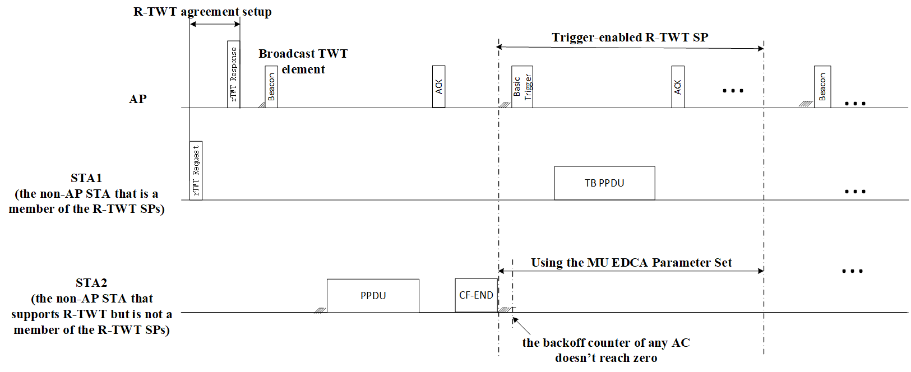

Proposed Text Change:

35.8.4 Channel access rules for R-TWT SPs(#10893)(#11109)
35.8.4.1 TXOP and backoff procedures rules for R-TWT SPs(#10689)(#13838)(#11109)
A non-AP EHT STA with dot11RestrictedTWTOptionImplemented set to true as a TXOP holder shall ensure the TXOP ends before the start time of any (#11109)R-TWT SPs advertised by the associated AP. Before starting transmission of any MPDU, a non-AP EHT STA with dot11RestrictedTWTOptionImplemented set to true that is not a TXOP responder and not a member of the upcoming (#13012)(#10893)R-TWT SP shall check if there is enough time for the frame exchange to complete prior to the start of the R-TWT SP and, if there is not enough time(#11113), then the STA shall defer transmission by selecting a random backoff count using the present CW (without advancing to the next value in the (#11114)sequence). The QSRC[AC] for the MSDU or A-MSDU (#11115)is not affected.
TGbe editor: please insert the following text:

The non-AP STA with dot11RestrictedTWTOptionImplemented set to true that is not a member of the R-TWT SPs should perform the EDCA contention to transmit MSDUs or A-MSDUs during the R-TWT SPs following 10.23.2 (HCF contention based channel access (EDCA)) and 26.2.7 (EDCA operation using MU EDCA parameters) except that:
—no later than the start times of the R-TWT SPs the non-AP STA should update its CWmin[AC], CWmax[AC], AIFSN[AC] state variables to the values contained in the dot11MUEDCATable for all the ACs and update its MUEDCATimer[AC] state variables for all the ACs to the values which lead to the expiration of its corresponding MU EDCA Timers at the time that is as close to the end times of the R-TWT SPs as possible.
—the non-AP STA should start the updated MUEDCATimer[AC] for all the ACs at the start times of the R-TWT SPs and use the updated CWmin[AC], CWmax[AC], AIFSN[AC] state variables for the corresponding AC when invoking an EDCA backoff procedure for any of the AC.

References:
[1] IEEE 11-22-1510-04-00be, TID to Link Mapping for QoS

