IEEE P802.11  
Wireless LANs

|  |  |  |  |  |
| --- | --- | --- | --- | --- |
| Draft Technical Report on support of AMP IoT devices in WLAN | | | | |
| Date: 2022-09-09 | | | | |
| Contributors: | | | | |
| Name | Affiliation | Address | Phone | email |
| Weijie Xu | OPPO | Beijing China |  | xuweijie@oppo.com |
| YiNan Qi | OPPO | London UK |  | v-qiyinan@oppo.com |
| Zhisong Zuo | OPPO | Shenzhen China |  | zuozhisong@oppo.com |
| Chuanfeng He | OPPO | Beijing China |  | [hechuanfeng@oppo.com](mailto:hechuanfeng@oppo.com) |
| Shengjiang Cui | OPPO | Beijing China |  | cuishengjiang@oppo.com |
| Rongyi Hu | OPPO | Beijing China |  | [hurongyi@oppo.com](mailto:hurongyi@oppo.com) |
| Shukun Wang | OPPO | Beijing China |  | wangshukun@oppo.com |
| Zhi Zhang | OPPO | Beijing China |  | zhangzhi@oppo.com |
| Lei Huang | Huawei | Singapore |  | Lei.huang1@huawei.com |
| Boyce Bo Yang | Huawei | Nanjing China |  | yangbo59@huawei.com |
| Chenhe Ji | Huawei | Nanjing China |  | jichenhe@huawei.com |
| Shichao Zhao | Haier | Qingdao China |  | [zhaoshichao@haier.com](mailto:zhaoshichao@haier.com) |
| Zhaojuan Du | Haier | Qingdao China |  | duzhaojuan@haier.com |
| Jiazhi Ni | Tencent | Beijing China |  | andyni@tencent.com |
| Harry Wang | Tencent | Beijing China |  | harryhwang@tencent.com |
| Wenhao Zhan | China Telecom | Guangzhou China |  | zhanwh@chinatelecom.cn |
|  |  |  |  |  |
|  |  |  |  |  |
|  |  |  |  |  |
|  |  |  |  |  |
|  |  |  |  |  |
|  |  |  |  |  |
|  |  |  |  |  |
|  |  |  |  |  |
|  |  |  |  |  |
|  |  |  |  |  |
|  |  |  |  |  |
|  |  |  |  |  |

Abstract

This document is Technical Report on support AMP IoT devices in WLAN, which provides description on use cases, device types, functional requirements, technical feasibility and economic feasibility. Recommendations from AMP IoT TIG are outlined.

Revision History

r0 –July 08, 2022. skeleton of Technical Report on support AMP IoT devices in WLAN.

**Table of Contents**

# ****Introduction****

Note: Introduction of ambient power enabled IoT

In today’s IoT networks, the legacy IoT devices are usually driven by batteries with limited lifespan, which has significantly affected user experience in a negative way. The astronomical growing of IoT network together with the advent of huge amount of IoT devices has pushed the maintaining expenditure, including both labor and battery costs, to a whole new level. Billions of batteries have been disposed every year and only a small part of it can be efficiently recycled, leading to harmful impacts on the ecosystem. In some extreme environmental conditions, maintaining the operation of IoT networks and replacing the batteries can be quite challenging. In this regard, battery-free IoT communication has been proposed and the support of it will improve the network performance and extend the application scenarios. In addition, battery-free communication can be much more environmentally friendly and much safer for the kids and the elders. By removing the battery, the device size and cost can be significantly reduced, thus paving the way to a variety of new applications.

The Wi-Fi IoT network is competitive from the perspective of deployment cost, due to widespread deployment and free use of unlicensed frequency band. However, there are still lots of use cases and applications that can not be met with using existing Wi-Fi IoT technologies in the following circumstances. Firstly, a device driven by a conventional battery is not applicable, e.g., under extreme environmental conditions (e.g., high pressure, extremely high/low temperature, humid environment). Secondly, maintenance-free devices are required (e.g., no need to replace a conventional battery for the device). Finally, ultra-low complexity, very small device size/form factor (e.g., thickness of mm), and longer life cycle etc. are required.

Ambient power-enabled IoT is a promising scheme to enable battery-free communication and fulfil the requirements from various verticals. The operation of such devices relies on the energy harvested from a variety of sources including radio waves, light (solar), motion, heat, etc. Ambient power-enabled IoT is different from 802.11ah and standard Wi-Fi for the following reasons: 1) Wi-Fi devices typically are powered by a battery; 2) the typical ambient power is less than 1 mw (considering the restriction of the size of the device) and is much lower than the power consumption of S1G devices, which is about tens of to hundreds of mw; 3) simple waveforms other than OFDM might be used for reduced complexity and power consumption. Combining ambient power-enabled IoT with Wi-Fi will enable a new kind of IoT service in many to-B and to-C areas, which will be beneficial for the Wi-Fi ecosystem.

# Use Cases

Note: describe the typical use cases for AMP IoT, e.g., IWSN, smart home, logistics/warehouse, agriculture etc.

This clause summarizes the typical use cases enabled by AMP IoT and relevant requirements to fulfill the goals of various services.

## Use Case 1 Smart Manufacturing

Smart manufacturing plays a critical role in increasing productivity and improving sustainability. The key to smart manufacturing is inter-connectivity and inter-operability between assets, storage tanks, materials and other passive objects in factories or industrial areas, enabled by wireless identification and sensing.

Identification is mainly for asset management and worker tracking, where labels can be attached to human beings or assets including production materials, storage tanks, containers, etc. [1] . Following functionalities can be provided

* Inventory check: once these tags are read remotely, the ID of the item to which the tag is attached can be acquired and traced as well as the information associated with the ID, e.g., position, product number, etc. Such information can then be further used for e.g., anti-counterfeiting;
* Attendance check: once a worker enters or leaves a specific area of the factory or a working spot, the tag attached to him can be read and attendance can be automatically checked;
* Real-time inspection and tracing: a product can be assembled and move along multiple steps in a line of machines and workers as shown in Fig. 2.1-1. Real-time inspection and tracing are needed to guarantee that each machine or worker performing a particular job must finish this job before the product moves to the next step in the production line.

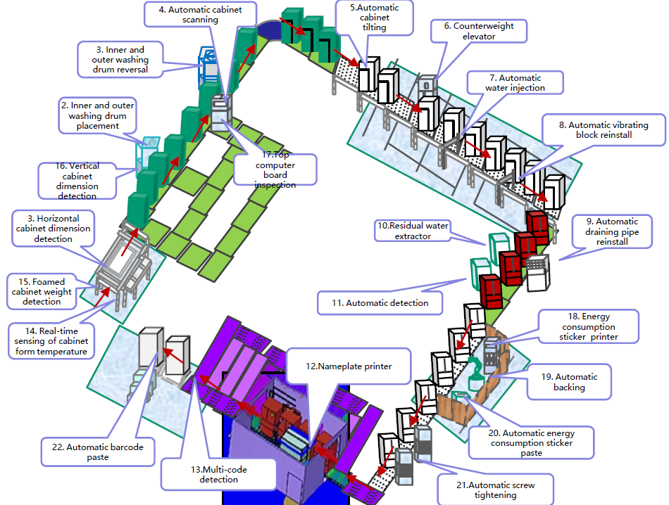

**Fig. 2.1-1 Inspection and tracing in production line**

Environmental sensing and monitoring are needed to collect real-time temperature and humidity information for production lines, computing and data centres and other equipment [1] [2] [3] . The weight and moving speed of a product in a production line can be collected via motion and pressor detection sensors. In addition, to maintain the safety within a factory, gas leakage in gas tanks and pipelines can also be detected by such sensing networks.

This use case requires ultra-small size, ultra-low cost and power consumption labels so that they can be deployed in very high density and the battery-less devices can enable maintenance-free operation. The following requirements are identified:

* Maintenance-free for long service life;
* Battery-less (i.e., no conventional battery is used);
* Coverage: up to 30 m for indoor case, up to 100 m for outdoor case;
* Data rate: up to 100 kbps.

## Use Case 2 Data Center

Data center illustrated in Fig. 2.2-1 is the bedrock of modern ICT infrastructure, running software and processing data. The management network is essential to improve the reliability and efficiency, thus guarantees its safe and reliable operating conditions. Data centers are unique from all other building types, that need to be managed intelligently and comprehensively via following functionalities [2] :

* Environmental monitoring to capture data on temperature, pressure, humidity and air flow etc., and highlight potential inefficiencies;
* Facility monitoring to provide visibility into the entire power chain from the generator down to a specific outlet on an intelligent cabinet power unit, and diagnose potential facility problems;
* Asset management to maintain a centralized database that houses all of the IT and facility asset information including where the asset is located and how it is connected to other assets.

Asset management of data center is similar to smart manufacturing and the main objective is to keep an up-to-date record of all hardware and software within the data center and track the real time visibility and availability of the asset via label identification. Environment and facility monitoring in data center can also be done via wireless sensor network to monitor the real time operation, data and events of the DC facility, e.g., power consumption, water supply, AC etc. and respond to alerts and events, and issue tickets.

 

**Fig. 2.2-1 Asset management in Data Center**

This use case has the same requirements as smart manufacturing:

* Maintenance-free for long service life;
* Battery-less (i.e., no conventional battery is used);
* Coverage: up to 30 m for indoor case, up to 100 m for outdoor case;
* Data rate: up to 100 kbps.

## Use Case 3 Logistics/Warehouse

In logistics, inventory check is needed to view all products and identify any missing assets and discrepancies within inventory[4] Packages are stored in containers such as cartons and cartons are normally piled in a warehouse. A pile of cartons in a single storage location is more than 10 m long and up to 8 m high. The cartons are labelled for goods tracking and there could be hundreds of labels in a single storage location. It is inevitable that labelling does not follow standard procedure, thus it is possible that not all labels face the same direction. It is quite time consuming and inefficient to scan these labels manually. Inventory check needs to be completed with high accuracy and in short time. In this regard, manual operation is clearly not preferred. Labels can be attached to the cartons when the cartons are transferred, stored, loaded/unloaded as shown in Fig. 2.3-1. Such tags can provide high sensitivity and omni-directionality so that they can be read remotely from multiple directions.

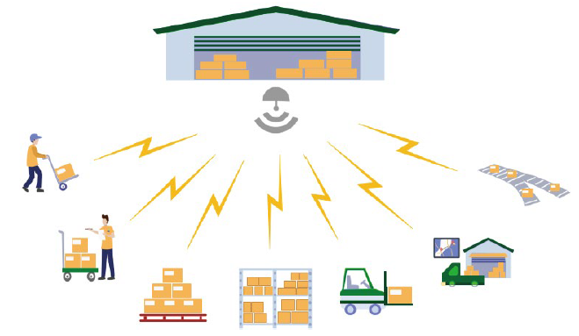

**Fig. 2.3-1 Logistics/warehouse**

Warehouses and distribution centers are usually equipped with sorting systems where random flows of items are sorted into orders for shipping. Sorting of the goods should be performed both when the goods are received and when the orders are prepared for sending out. In a sorting system, goods are usually placed in labelled containers and the container specifications can be either uniform, e.g., cartons and wooden trays, or non-uniform, e.g., packing bags. Information needed for sorting, such as the clients and the place of destination is associated with such labels that should be read when goods are sorted and prepared for transportation to the final destination. Two adjacent containers should be distinguished so that the target container is not misidentified with the adjacent container by the sorting system. For non-uniform container specifications, e.g., a packing bag, scanning from all possible sides should also be supported. Roller conveyors are widely used in sorting systems as shown in Fig. 2.3-2 and the tags attached to the containers may move at a speed of 1.5-2 m/s.

In sorting systems the following functionalities should be provided:

* Accurate label identification for closely adjacent items on the conveyor system;
* Fast label identification of the items on the conveyor belt that moves at a speed of 1.5-2 m/s;
* Real-time monitoring and related information acquisition for the items on the conveyor system;
* Environmental monitoring of temperature, humidity, etc. for specific items such as cold-chain transportation goods.

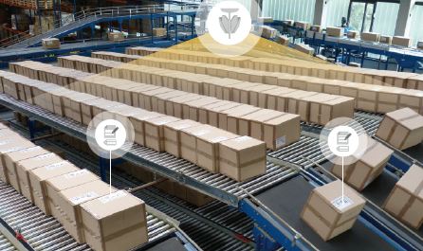

**Fig. 2.3-2 Label reading in sorting system**

The following requirements are identified,

* Ultra-low cost and ultra-small size for extremely high-density deployment;
* Maintenance-free and battery-less for long service time;
* 99.5% identification accuracy;
* Moving speed up to 2 m/s;
* Minimum distance to distinguish adjacent items: 0.5 m
* Coverage: up to 10-30 m for indoor case

## Use Case 4 Smart Home

In a smart home, many devices such as smartphones, tablets, door locks, thermostats, home monitors, etc. are connected with each other. Low energy consumption and maintenance-free devices should be used for sensing and monitoring as shown in Fig. 2.4-1 [3] . For home environment sensing, such as temperature, humidity, etc., once the sensed information is collected by a controlling node, the heater, air-conditioner and (de)humidifier can be switched on/off automatically accordingly to adjust the temperature and humidity to a comfortable level. Such devices can also be used for home safety. For example, once gas leakage happens, a gas detector can send an alert to warn the home owner. Similarly, if a smoke detector senses there is a fire, it can automatically send the alert. In addition, motion detector is needed to detect the intruders and send alert to the home owner. Another important functionality needed is to locate keys, wallets and other personal belongs with attached labels.

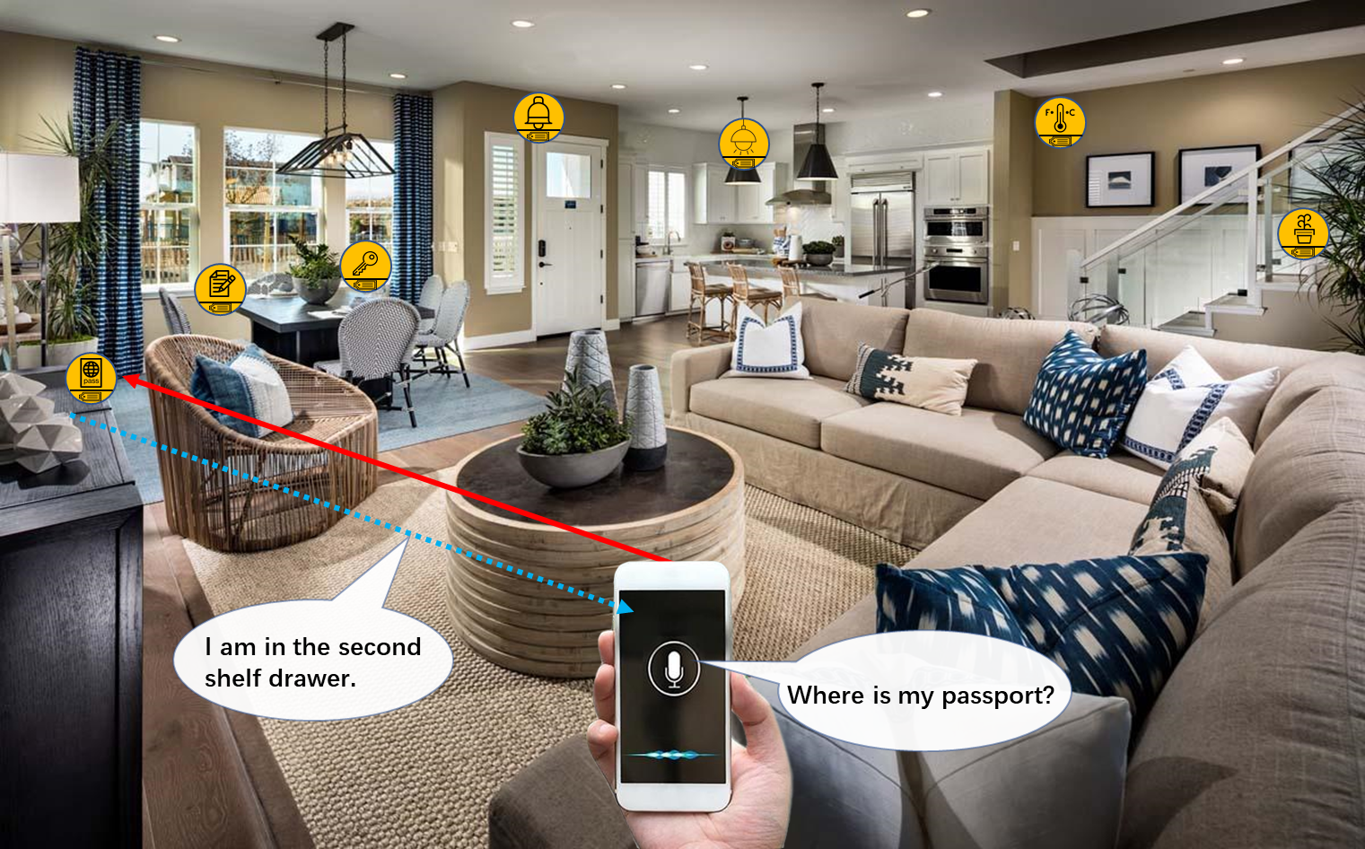

**Fig. 2.4-1 Smart home**

The requirements for smart home use case are identified as follows,

* Low complexity and small size, e.g., thickness of 1 mm and area of several cm2;
* Long service life., e.g., more than 10 years;
* No need to replace/recharge a conventional battery, e.g., maintenance-free
* Coverage up to 10 m
* Positioning accuracy of 1~3 m

## Use Case 5 Smart Agriculture

Smart agriculture focuses on providing the industry with the infrastructure to leverage advanced technology for tracking, monitoring, automating and analyzing operations. Similar to smart home, low energy consumption and maintenance-free devices can be used for sensing and monitoring, such as monitoring of soil moisture, soil fertility, temperature, wind speed, plant growth etc. [3] . For example, once the soil moisture is sensed, the irrigation system can be controlled to increase or decrease the supply of water to land or crops. Asset management for agricultural facilities can also be done by reading the labels attached to those facilities remotely.



**Fig. 2.5-1 Smart agriculture**

The main difference between smart agriculture and smart home is that smart agriculture needs to handle outdoor sensing and monitoring so that a much wider coverage should be maintained. Due to the much wider coverage, the number of connected devices can be hundreds to thousands. The requirements for smart agriculture use case are as follows,

* Battery-less, thus no need to use a battery;
* Low complexity and small size, e.g., thickness of 1 mm and area of no larger than several cm2;
* Coverage: up to 30m for indoor case, up to 200 m for outdoor case;
* Processing (i.e., reading IDs) hundreds to thousands of devices per second.

## Use Case 6 Indoor Positioning

For indoor positioning, reference tags with known location can be densely deployed indoor to establish a navigating and positioning system that has a wide range of potential applicable scenarios such as giant shopping malls, parking, smart factories, warehouses, etc. [4] . Shopping centers offer a wide range of services and products, including large supermarkets, a collection of retail stores, restaurants, banks, theatres, fitness and leisure facilities, underground parking areas, professional offices and other establishments. Many giant shopping centers have been established all over the world, each can occupy an area of tens to hundreds of thousands m2, composed of one or multiple buildings, each of which has multiple-story both over and underground. While enjoy various services, people often have troubles in finding a vacant parking spot or his/her own car, a target shop/restaurant or a target item in a supermarket. The reference tags can be evenly distributed with 2-meter intervals within the entire shopping center on each floor and in each room as shown in Fig. 2.6-1. Indoor positioning can be enabled by a handheld device (e.g., smartphone), which can communicate with and position the reference tags.

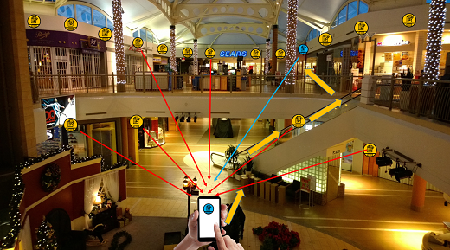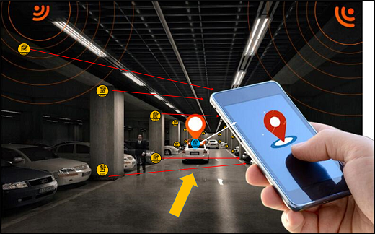

**Fig. 2.6-1 Indoor positioning for shopping center and parking**

Such navigating and positioning system can also be used in the aforementioned use cases, e.g., smart manufacturing in factories, logistics/warehouse and smart home. In smart manufacturing, a product on the production line or conveyor system should be positioned precisely in order to identify in which step the product is. In the industrial area, there are some dangerous zones with toxic materials that are harmful to the health of the workers. Labels can be attached to workers and when they enter the dangerous zones, a safety alert can be immediately sent based on the real-time position of the workers. For logistics/warehouse, inventory and attendance check can rely on such navigating and positioning system to locate the item or personnel.

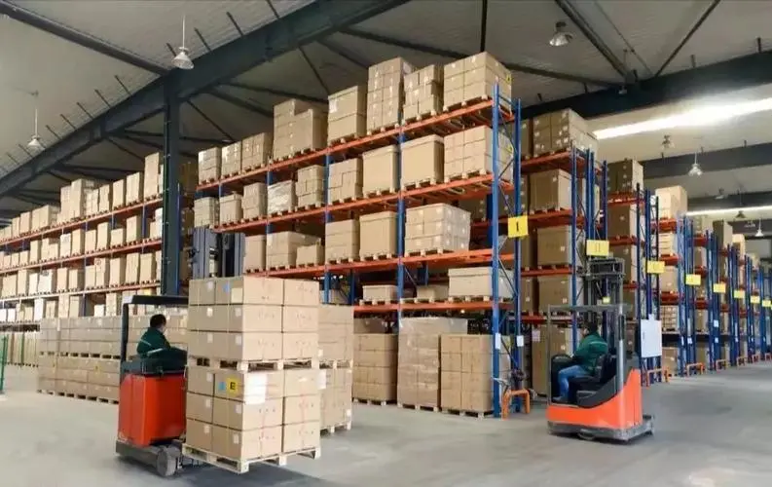

**Fig. 2.6-2 Indoor positioning for smart manufacturing and warehouse**

The following requirements are identified for indoor positioning,

* Small size, maintenance-free, battery-free, and ultra-low-cost IoT devices;
* Coverage: 10-30 meters for indoor (a product line has an area of 25 thousand m2)
* Positioning accuracy: 1~3 m horizontal accuracy and 1~2 m vertical accuracy
* Moving speed: 1.5-2 m/s

# AMP IoT device type and functional requirements

Note: discuss possible IoT device type and corresponding functional requirements, e.g., support energy harvesting, operation band(s), backward compatibility and co-existence with legacy 802.11 technologies, power consumption requirement, KPI requirements (e.g., coverage/data rate) etc.

To support afore mentioned diverse use cases of AMP IoT, multiple device types should be introduced. This clause gives definitions of AMP IoT device types. For a particular device type, the specific functional requirements are given accordingly.

In the first category use cases like logistics/Warehouse and Smart Home, object identification is the main purpose of the AMP IoT devices. The essential information transmitted to the AP reader is the ID of devices/tags. Only lower peak data rate (e.g., less than 100kbps) is required for these use cases. The devices can be attached to the objects all over the area. The number of devices could be very large. Thus, simple maintenance and maintenance-free is also necessary. In some of use cases requiring sensor data reporting, such as smart home, environmental monitoring etc. Only small packet (e.g., less than 200 bits) and infrequent (e.g., one packet per minute) sensor data reporting is needed. In those cases, it requires the devices to have ultra- low complexity, ultra-power consumption and very small form factor and to be battery-less (i.e., not using conventional battery).

But in some other use cases, e.g., smart manufacturing and smart agriculture, Higher data volume and frequent data exchange is demanded in those scenarios. The communication between the AP reader and devices is more complex. Those AMP IoT devices act as Sensors, Monitors and Actuators. It may also require higher data volume bi-direction transmission between AP reader and devices. The required data rate may be close to the existing IoT technologies. Therefore, higher capabilities which are similar as the current WiFi devices are needed. However, for these use cases, it also expects a maintenance-free IoT network (e.g., without replacing the battery), which is not be able to achieve with the current technologies. Therefore, it calls for another type of IoT devices which has high capability but optimized for the power consumption and sustainability to adapt to ambient power usage and achieve battery-less.

Therefore, at least the above 2 types, which form the “low-end” and the “high-end” device types, are envisioned for the AMP IoT devices[5] . More device types can be considered once identified during study phase.

## AMP-only IoT device

The AMP-only IoT device targets for the first category of use cases. It has ultra-low complexity, ultra-power consumption and very small form factor and to be battery-less (i.e., not using conventional battery). It can have no power storage or have limited power storage (e.g., using a capacitor).

* AMP-only IoT device has ultra-low complexity and ultra-low power consumption
  + The required data rate for identification is very low (e.g., less than 100kpbs). The device shall be designed as simple as possible as to fulfill the required data rate and communication distance. A much lower capability than the current WiFi devices is expected.
  + In order to achieve battery-less, it will use ambient power to drive itself and to communicate with the AP. The available ambient power would be very low as discussed in session 4.1, thus it requires much lower power consumption than the existing WiFi devices.
  + In most of the target use cases, it shall have a small size, which restrict the size of antenna and the energy harvester.
* AMP-only IoT device can have no power storage or have very limited power storage.
  + For some of the target use case, the device can’t support power storage due to restriction such as the complexity, the acceptable cost and the constraint of the device size.
  + For some other use cases, the device can have very limited power storage to achieve more functions (e.g., connect to a sensor), higher performance (e.g., longer communication distance), or adapt to some kinds of unstable ambient power (e.g., to store unstable solar power).
* AMP-only IoT device can be used for light-weight applications, such as identification, positioning, infrequent and small sensor data reporting.

For AMP-only IoT device, the potential functional requirements include:

* Supported operation band.

It may be helpful to achieve low complexity and low power consumption by

lower frequency band. This is due to its small channel bandwidth and good propagation property in lower frequency band. Therefore, sub 1GHz shall be considered with high priority. The 2.4GHz can also be considered since it is the mature frequency band widely used.

* Constraints of power consumption.

Since ambient power is used and energy harvester with small size can be utilized due to the small size restriction of the device, the power can be harvested is very limited. Therefore, ultra-low power consumption, e.g., less than 1 mill-Watt can be considered as the design target for AMP IoT.

* Coexistence.

Irrespective of sub1GHz or 2.4GHz, AMP-only IoT device will share same frequency band(s) with legacy WiFi devices. Therefore, backward compatibility and coexistence with legacy devices shall be supported. The regulation of these frequency band(s) shall be followed.

* Support energy harvesting.

In order to achieve battery-less (i.e., not using conventional battery), it will use ambient power to drive itself and to communicate with the AP. Therefore, it shall support energy harvesting for the AMP-only devices. For different use cases, different ambient power may be available thus different energy harvester can be supported based on the suitable ambient power for a specific use case.

* Coverage

As discussed in the use cases and requirements in session 2, up to 30m for indoor scenario and up to 100m for outdoor scenario are required.

## AMP-assisted IoT device

For AMP-assisted IoT device, higher capabilities which is similar as the current WiFi devices can be expected. The key design target is to achieve a maintenance-free IoT network (e.g., without replacing the battery) which can provide relatively high performance, which is similar as what the current WiFi devices can provide. It shall be optimized for the power consumption and sustainability to adapt to ambient power usage and achieve battery-less.

* AMP-assisted IoT device may be similar as legacy 802.11 (e.g., 802.11n/11ah) device, it can reuse the current PHY design but with enhanced MAC features to well adapt to operation with kinds of ambient power. Advanced power saving should be considered as the ambient power is very limited. The enhanced power management can be considered to adapt for the unstable and uncontrollable ambient power.
* AMP-assisted IoT device can have higher power storage capability than AMP-only IoT device. Although the power consumption of AMP-assisted IoT device can be further optimized on top of the current WiFi devices, its power consumption level will be much high than AMP-only IoT devices, e.g., tens of mill-walt to hundreds of mill-walt during transmission and reception. The typical power storge capacity is comparable to the existing IoT or other electrical devices, 300mAh.

The potential functional requirements for AMP-assisted IoT device include:

* Supported operation band:

With similar capabilities as the current WiFi devices, it is easy for AMP-assisted IoT device to operate on the current frequency bands such as 2.4GHz and sub 1GHz. For example, if it is optimized on top of the 802.11ah devices which using sub 1GHz, the AMP-assisted IoT device can also use sub 1GHz

* Support energy harvesting

In order to achieve maintenance free, it will use ambient power to sustain itself and to communicate with the AP. In order to fulfill the required higher power consumption compared with that of AMP-only devices, the energy harvester shall be able to provide a higher output power, e.g., more than 10mill-walt.

* Coverage

Similar coverage as the current WiFi devices can be expected, e.g., up to 30m for indoor case and up to 200m for outdoor case (note that for 802.11ah, it can be up to 1km).

# Technical Feasibility

Note: discuss potential candidate techniques to fulfil the function requirements and aspects on feasibility including how to maintain backward compatibility and co-existence with legacy 802.11 devices, evaluation of link budget (for potential different IoT device types), impact on PHY and MAC etc.

## Ambient power and energy storage

Note: To be updated

## Challenges of support AMP IoT devices

AMP IoT devices has the distinguished characteristics such as: battery-less, ultra-low cost, small size, maintenance-free and long-life cycle. It has the immense potential to fulfill the unmet requirement from various of verticals and open one new market for IEEE. In order to support AMP IoT devices in Wi-Fi system, there may be some challenges[5] .

The first challenge is that AMP IoT devices with extremely-low complexity need to be supported. The reason for this requirement is that for most of concerned use case, the devices shall have ultra-low cost, small size. In addition, it is beneficial to achieve ultra-low power consumption for a device with extremely-low complexity. In order to achieve extremely-low complexity, it requires the AMP IoT device to have simplified RF chain, baseband architecture and limited memory. It shall try to eliminate the unnecessary component element. In addition, the communication between the AMP IoT device and the AP shall be designed as simplified as possible. For example, only simple waveform is supported and the AMP IoT device may not be able to support OFDM since it requires relatively complicated baseband calculation.

The second challenge is that AMP IoT devices with ultra-low power consumption need to be supported. Since ambient power is used and only small size energy harvester can be utilized due to the small size restriction of the device, the power can be harvested is very limited. For example, as summarized in session 4.1, only several to tens of micro-Watt power can be harvested using wireless radio waves and less than 1 mill-Watt power can be harvested using solar panel of 1cm2. Therefore, ultra-low power consumption, e.g., less than 1 mill-Watt can be considered as the design target for AMP IoT (i.e., for AMP-only IoT device).

The third challenge is that power-hungry operation needs to be supported due to non-ideal power supply using energy harvester. In typical use cases, only small amount of power can be harvested and the ambient power is unstable. Therefore, the device shall be able to adapt to such power-hungry condition and support further power saving and proper power management.

Finally, although the device is with much lower capability, when operating in legacy WiFi frequency band e.g., sub1GHz or 2.4GHz, compatibility and coexistence with legacy Wi-Fi system is still required. It requires the AMP IoT device to follow the regulation for these unlicensed frequency bands and use the frequency bands in a fair way with other WiFi system. For example, it shall meet the PSD requirement and the maximum transmission EIRP requirement.

## Potential candidate techniques

In order to tackle the challenge to support AMP IoT devices in WLAN. Several candidate techniques are initially investigated[5] .

* **Narrow bandwidth operation**

It is beneficial to support low complexity and low power consumption with narrow bandwidth operation. The complexity of both RF and baseband is significantly simplified compared with wideband operation, e.g., 20MHz in 2.4GHz. In addition, it is necessary to achieve ultra-low power consumption with narrow bandwidth operation, e.g., the circuit can work with much lower frequency cycle and limited calculation is needed for narrow bandwidth transmission and reception. From the perspective of the data rate requirement, it is feasible to use very narrow bandwidth to fulfil a target peak data rate 100kpbs, which is sufficient for most of the use cases, as discussed in session 2.

One of the Target frequency bands could be Sub 1GHz, i.e., the same band as 802.11ah, where the channel bandwidth can be as small as 1MHz. Therefore, in Sub1GHz, the device can be designed with an operation bandwidth of less than or equal to 1MHz. In other frequency band, e.g., 2.4GHz, where only 20MHz channel bandwidth is allowed, IoT device using narrow bandwidth can still be supported.

In order to support narrow bandwidth operation, UL/DL PPDU format which enables transceiver operating using narrow bandwidth shall be defined. Please note that it has already support 4MHz DL PPDU for WUR. On the other hand, a wideband preamble for backward compatibility shall be supported for AMP IoT, as discussed in the following.

Therefore, potential new PPDU format, as shown in Figure 4.3-1, can be considered to support narrow bandwidth operation for AMP IoT. In the new PPDU format, there is a legacy preamble portion and an AMP portion. Within the AMP portion, there can be AMP preamble, AMP header and the payload part. The legacy preamble has same bandwidth as the channel bandwidth in the target operation band while the AMP portion can have a smaller bandwidth that is suitable to meet requirement of peak data rate, e.g., 200KHz in a 1MHz channel bandwidth in sub1GHz.



Figure 4.3-1 Potential new PPDU format enable narrow bandwidth operation

* **Simpler waveform/modulation/coding scheme**

In order to achieve ultra-low power consumption and ultra-low complexity, simple waveform and coding scheme are needed. OFDM is the main waveform used in WiFi technologies. With OFDM, it can achieve high spectrum efficiency and high peak data rate using wide bandwidth. But on the other hand, it is difficult to use OFDM to achieve ultra-low power since the needs of the required operation such ADC, data buffering, FFT, channel estimation etc. In addition, it has a clear lower complexity boundary which is much higher than it is required for AMP IoT. Therefore, OFDM may not be suitable for AMP IoT and much simple waveform is required for AMP IoT.

OOK/FSK may be a promising waveform for AMP IoT. With OOK modulation, it enables ultra-low complexity data transmission/reception. In the receiver, envelope detection can be used and complicated baseband digital processing is replaced with simple analog envelope detection circuit thus it can achieve ultra-low power (e.g., several micro walt to tens of micro walt) with very simple implementation [7] [8] [9] . For the transmitter, it can also achieve ultra-low power transmission (e.g., around 200 micro walt) even with an active OOK/FSK transmitter[10] [11] [12] . In addition, OOK/FSK can be generated using backscattering. In this way, it can further significantly reduce the device complexity and power consumption (please see the detail in the following part). Therefore, with OOK/FSK, it can achieve the potential target ultra-low power consumption, e.g., lower than 1 mill-Walt.

Another merit is that OOK has already been supported in 802.11ba for WUR thus less PHY specification impact to introduce OOK for AMP IoT can be expected.

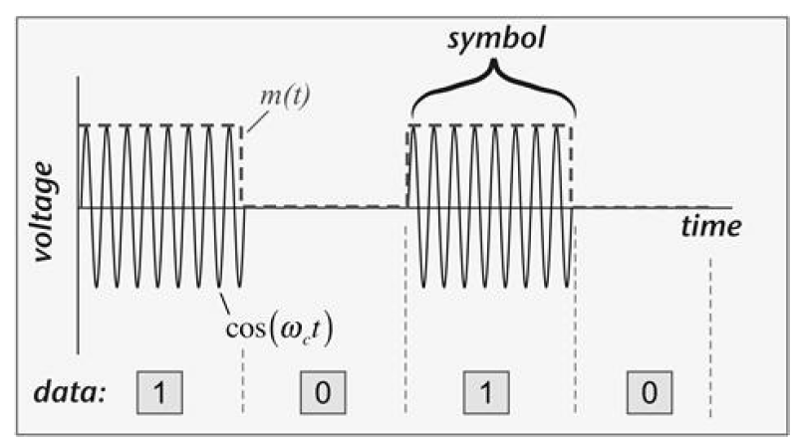 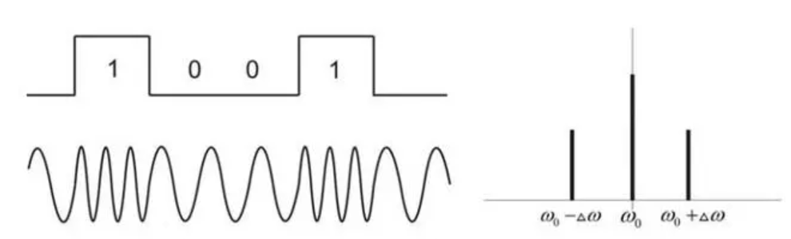

Figure 4.3-2 OOK modulation Figure 4.3-3 FSK modulation

* **Backscattering**

In a backscattering communication system, as illustrated in Figure 4.3-4, load modulation is usually used. The load modulation technology mainly includes two methods: resistance-based load modulation and capacitor-based load modulation. For resistance-based load modulation, a resistor which is called a load modulation resistor, is connected in parallel to the load. The resistor is turned on or turned off according to the clock of the data stream, and the switch is controlled by the binary data encoding. For capacitor-based load modulation, a capacitor is connected in parallel with the load to replace the load modulation resistor.



Figure 4.3-4 Backscattering communication

Taking resistance-based modulation which can achieve ASK modulation as an example, as shown in Figure 4.3-5, the device can switch between absorption state and reflection state by adjusting the load reflection coefficient. In the absorption state, the device achieves impedance matching thus the input RF signal is completely absorbed by the terminal. Hence, the signal received by the reader will be at low-level, which indicates a bit '0'. On the contrary, in the reflection state, the device adjusts the circuit impedance that leads to a mismatch of the impedance thus a part of the RF signal is reflected. Then the signal received by the reader will be at high-level which indicates a bit '1'.

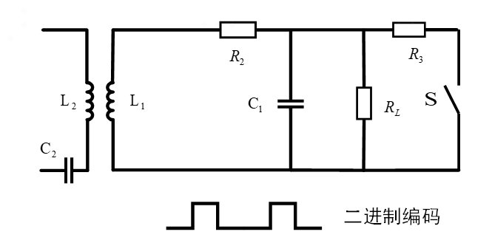

Figure 4.3-5 Resistance-based modulation

Similarly, the device can also change the response frequency of the circuit by adjusting the capacitance of the circuit in order to realize FSK modulation. FSK has better BER performance than ASK. It is often used to realize frequency division multi-access.

Therefore, backscattering communication achieves extremely low-complexity signal modulation and transmission via impedance modulation. The backscatter terminal does not require complex RF structures, such as PA, high-precision oscillator, duplexer, and high-precision filter. There is also no need for complex baseband processing, complex channel estimation and equalization operations. In addition, one distinguished characteristic is it doesn’t need to generate a high frequency carrier but instead uses the incoming carrier as the carrier for backscattering transmission. Therefore, it is a promising scheme to enableultra-low complexity and ultra-low power consumption (e.g., lower than 1 mill-Walt).

In addition, it is beneficial to use backscattering to support co-existence with legacy devices, e.g., by backscattering the preamble send by the AP, as discussed in session 4.4.2.

For backscattering, since it uses the carrier signal from the AP. The carrier signal has to propagate within both the DL and UL: the carrier signal is sent from the AP to the device and the device backscatter the signal back to the AP. Hence, the communication distance will be limited which may not be sufficient for some use cases requiring relative long communication distance. LNA can be used to boost the backscattering signal [13] [14] . And the integration of LNA (low noise amplifier, LNA) in AMP IoT with high sensitivity receiver can effectively make up the communication distance of backward link (see session 4.4.1 for more details).

* **Light-weight MAC protocol design and enhanced power saving/management**

In order to achieve ultra-low power consumption and ultra-low complexity, further simplified MAC on top of 802.11 ah is needed, e.g., to introduce simplified MAC PPDU format, to further simplify the communication process between AP and AMP IoT devices, to introduce efficient access control mechanisms etc.

Schemes to support ultra-low power operation by considering the constraint of the power supply from energy harvester also needs to be considered. Currently, TWT/RAW, Energy limited operation, PS-poll etc are introduced in WiFi for power saving. On top of these mechanisms, it can be investigated whether there are additional methods for further power saving.

In addition, schemes to adaptation to operation with ambient power by taking into account the characteristics of ambient power source, e.g., not stable, limited amount of harvested power. Efficient power management scheme can also be considered.

On the other hand, there may be lowerpeak data rata requirement for AMP-IoT devices as discussed in session 2, which provide a good perquisite to optimize power consumption and power management for AMP IoT.

* **Support coexistence schemes with legacy devices**

It is important to maintain coexistence with legacy WiFi for AMP IoT. See session 4.4.2 for the details.

* **Potential Technologies for AMP-only IoT devices**

As discussed in session [], it targets for use cases that requires ultra-low complexity, ultra-low power consumption and maintenance-free for AMP-only IoT devices. Based on the discussion above, it can be summarized there may be two possible techniques combination for AMP-only IoT devices.

1. **Combination 1: Ultra-low power receiver + Backscattering**

It can utilize techniques such as narrow bandwidth operation for AMP portion (e.g., 187.5 kHz in sub-1 GHz), simpler waveform/modulation/coding scheme (e.g., OOK/FSK), backscattering, simplified MAC protocol design and enhanced power saving/management.

1. **Combination 2: Ultra-low power receiver + Ultra-low power active transmitter**

It can utilize techniques such as narrow bandwidth operation for AMP portion (e.g., 187.5 kHz in sub-1 GHz), simpler waveform/modulation/coding scheme (e.g., OOK/FSK), simplified MAC protocol design and enhanced power saving. The difference with the above combination 1 is the AMP IoT device has an active transmitter with ultra-low power consumption.

* **Potential Technologies for AMP-assisted IoT devices**

For AMP-assisted IoT devices, it targets uses case where similar performance as legacy WiFi SAT are needed but it shall support ambient power. It requires schemes to adaptation to operation with ambient power by taking into account the characteristics of ambient power source, e.g., not stable, limited amount of harvested power (but it can be higher than use case for AMP-only IoT devices). The key enhancement for AMP-assisted IoT devices is further power saving and power management enhancement. Therefore, the possible techniques combination for AMP-assisted IoT devices is:

1. **Combination 3: Follow legacy PHY design with MAC enhancement**

The AMP IoT device has similar capability as legacy STA, but possibly with simplified MAC protocol design and/or enhanced power saving/management.

## Feasibility of supporting AMP IoT devices in WLAN

### Link budget for different AMP IoT device types

In order to evaluate the coverage performance of AMP IoT. Link budget analysis is performed. AMP-only device as discussed in session 3 are assumed since it can have similar coverage as the current WiFi device for AMP-assisted IoT devices. The frequency band are assumed sub 1GHz and 2.4GHz respectively. Three types of AMP IoT device with backscatter transmitter are assumed:

* Case 1: energy is harvested from RF and without power storage
* Case 2: energy is harvested from RF and with power storage
* Case 3: energy is harvested from light and with power storage

In case 1, AMP-only IoT device has no capability of power storage and the device shall operate using the instantaneously harvested power. Typically, with the current implementation, the minimum received RF power shall be no less than -20dBm to power up the device.

In case 2, AMP-only IoT device has the capability of power storage and the device can work using the RF power that is harvested and stored. Hence, the minimum received RF power can be relaxed to -30dBm, with which although the instantaneously harvested power is not sufficient to drive the device but it can be accumulated in the power storage unit.

In case 3, other kinds of ambient powers are assumed, e.g., it is assumed light in this case. It doesn’t rely on RF power for energy harvesting. Therefore, the minimum received signal strength can be further relaxed, in the evaluation, it is assumed as -45dBm which is the receiver sensitivity of AMP IoT device. As discussed in 4.2, in order to achieve a long communication distance in the UL, an LNA with 30 dBm gain is assumed to amplify the backscattering signal.

Please note that Friis equation is applied in the link budget evaluation.

The evaluation results for case 1/2/3 at sub1 GHz and 2.4GHz are illustrated as in Table below.

**Table 4.4 -1 Link budget at sub 1GHz for case 1/2/3**

|  |  |  |  |
| --- | --- | --- | --- |
|  | **Case1** | **Case2** | **Case3** |
| Frequency (MHz) | **920** | **920** | **920** |
| EIRP of AP (dBm) | 30 | 30 | 30 |
| Receiver sensitivity of AP (dBm) | -95 (Note 1) | -95 | -95 |
| Antenna gain of IoT device (dBi) | 2 | 2 | 2 |
| Minimum receiving power for IoT device (dBm) | -20 (Note 2) | -30 (Note 2) | -45 (Note 3) |
| Maximum communication distance from AP to IoT device (m) | 10.33 | 32.67 | 183.71 |
| Backscattering loss at IoT device (dB) | 5 | 5 | 5 |
| Low Noise Amplifier factor (dB) | 0 | 0 | 30 (Note 4) |
| Maximum communication distance from IoT device to AP (m) | 103.31 | 32.67 | 183.71 |
| *Notes:   1. Reuse the receiver sensitivity of 802.11 ah AP 2. The minimum required signal power for an IoT device is -20dBm when the IoT device can’t store power itself. It can be -30dBm when the IoT device has the capability of power storage. 3. -45 dBm is assumed as the sensitivity of ultra-low power receiver[7] [8] [9] . 4. LNA with 30 dBm gain is assumed to boost the backscattering signal, it can have ultra-low power consumption [13] [14] . | | | |

**Table 4.4-2 Link budget at 2.4GHz for case 1-3**

|  |  |  |  |
| --- | --- | --- | --- |
|  | **Case1** | **Case2** | **Case3** |
| Frequency (GHz) | **2.4** | **2.4** | **2.4** |
| EIRP of AP (dBm) | 27 | 27 | 27 |
| Receiver sensitivity of AP (dBm) | -95 (Note 1) | -95 | -95 |
| Antenna gain of IoT device (dBi) | 2 | 2 | 2 |
| Minimum receiving power for IoT device (dBm) | -20 (Note 2) | -30 (Note 2) | -45 (Note 3) |
| Maximum communication distance from AP to IoT device (m) | 2.8 | 8.87 | 49.85 |
| Backscattering loss at IoT device (dB) | 5 | 5 | 5 |
| Low Noise Amplifier factor (dB) | 0 | 0 | 30 (Note 4) |
| Maximum communication distance from IoT device to AP (m) | 39.60 | 12.52 | 70.42 |
| *Notes:   1. Reuse the receiver sensitivity of 802.11 ah AP 2. The minimum required signal power for an IoT device is -20dBm when the IoT device can’t store power itself. It can be -30dBm when the IoT device has the capability of power storage. 3. -45 dBm is assumed as the sensitivity of ultra-low power receiver. 4. LNA with 30 dBm gain is assumed to boost the backscattering signal, it can have ultra-low power consumption. | | | |

One additional type of AMP IoT device with an active transmitter is assumed:

* Case 4: energy is harvested from light and with power storage, using active transmitter

In case 4, other kinds of ambient powers are assumed., it is assumed light in this case. Similarly, -45dBm is assumed as the receiver sensitivity of AMP IoT device. The difference with case 3 is that an active transmitter is used and the maximum transmission power is assumed as -15dBm. Please note that, with such an active transmitter, the power consumption can still be lower than 1mw[10] [11] [12] .

The evaluation results are illustrated as below.

**Table 4.4-3 Link budget at sub 1GHz and 2.4GHz for case 4**

|  |  |  |
| --- | --- | --- |
|  | **Case4** | **Case4** |
| Frequency (GHz) | **920** | **2.4** |
| EIRP of AP (dBm) | 30 | 30 |
| Receiver sensitivity of AP (dBm) | -95 | -95 |
| Antenna gain of IoT device (dBi) | 2 | 2 |
| Minimum receiving power for IoT device (dBm) | -45 | -45 |
| Maximum communication distance from AP to IoT device (m) | 183.71 | 70.42 |
| Maximum transmission power of IoT device (dBm) | -15(Note) | -15(Note) |
| Maximum communication distance from IoT device to AP (m) | 259.49 | 99.47 |
| *Notes: Ultra-low power active transmitter is assumed. | | |

From the link budget results, it can be observed that:

* When RF power is adopted, the communication distance of downlink is bottleneck due to RF energy harvesting.
* With RF power harvesting and at 2.4GHz, the communication distance of downlink would be too limited if the device has no power storage.
* Energy harvesting from other ambient power source can support a medium downlink coverage (up to 180 meters at sub1 GHz and up to 50 meters at 2.4GHz) for AMP IoT device.
* An low power LNA can efficiently boost the UL coverage.
* With an active low power transmitter, a relative larger uplink coverage can be achieved (up to180 meters at sub1GHz and up to 70 meters at 2.4GHz).

### Co-existence with legacy 802.11 systems

As discussed in session 3, AMP IoT will operate at 1GHz or 2.4GHz, the co-existence with legacy 802.11 technologies should be studied to maintain backward compatibility[6] . It requires the AMP IoT device to follow the regulation for these unlicensed frequency bands and use the frequency bands in a fair way with other WiFi system. For example, it shall meet the PSD requirement and the maximum transmission EIRP requirement.

The following issues are identified for the co-existence of AMP IoT and legacy 802.11 systems.

* AMP IoT device would have to support only simple waveform due to its ultra-low complexity requirement, such as ASK modulated waveform, which is different from OFDM waveform used by legacy Wi-Fi system in Sub 1GHz or 2.4GHz. How to support co-existence if new waveform for AMP IoT is used should be studied.
* When AMP IoT and legacy 802.11 systems share the same frequency band, a uniform CSMA/CA mechanism should be used between them. It is a challenge for AMP-only IoT device to support CSMA/CA due to its ultra-low complexity. For example, it is difficult or impossible for AMP-only IoT device to transmit and detect legacy preamble for carrier sensing. In addition, the power consumed for CSMA/CA operation may not be tolerable for AMP IoT devices in order to achieve ultra-low power consumption.

In order to solve the co-existence issue, proper mechanism which takes both the regulation requirement and the constraints of AMP IoT devices into consideration shall be studied.

AMP PPDU format should be defined for AMP IoT. The co-existence issues as mentioned above shall be considered when designing the AMP PPDU format. In the following Figure 4.4-1, one example AMP PPDU format is illustrated. In the PPDU format, there is a legacy preamble portion and an AMP portion.

The preamble portion is transmitted for carrier sensing by legacy 802.11 devices. With this preamble, the legacy 802.11 devices can detect the transmission from AMP IoT devices. For AMP-only IoT devices operating in Sub 1GHz, the AMP PPDU format contains 802.11ah preamble (e.g., including LTF, STF, SIG portion), followed by the AMP portion. For AMP-only IoT devices operating in 2.4GHz, the AMP PPDU format contains legacy preamble (e.g., L-STF, L-LTF, L-SIG), followed by AMP portion.

However, it would be a challenge for AMP-only IoT device to generate the OFDM based preamble with a low complexity transmitter which can only generate simple waveform such as OOK. Backscattering can be one method to realize the transmission of legacy preamble from AMP-only IoT device. The AP can help to generate a preamble and send it to the AMP-only IoT device. Then the device backscatters the preamble. Immediately after the preamble, the AMP-only IoT device transmits the AMP portion. Therefore, the whole AMP PPDU format can be transmitted by the AMP-only IoT device. This procedure is shown in the following Figure.



Figure 4.4-1 Preamble transmission using backscattering

Although AMP-only IoT device can send legacy preamble through backscattering, it remains difficult for AMP-only IoT device to perform channel access due to its ultra-low power and low complexity receiver.

TXOP sharing, which has been defined in 802.11ah, can be reused for the channel access for AMP-only IoT device. AP can be responsible for channel occupation with normal channel access procedure. Then, the AP can share its TXOP to AMP-only IoT device when there is uplink transmission. With is method, AMP-only IoT device does not have to perform channel access by itself.

The AMP PPDU with the AMP portion can be only received by the AP that is able to support AMP IoT. As shown in Figure 4.3-1, the bandwidth of AMP portion can be narrower than that of the preamble part and simple waveform (e.g., OOK) will be adopted for the AMP portion. For a AP, it is beneficia to ease the implementation if the legacy OFDM transmitter can be reused to transmit the AMP PPDU format which contains a AMP portion.

### Carrier generation for backscattering

As discussed in 4.2, backscattering would be a promising technique to achieve ultra-low power consumption and ultra-low complexity for AMP IoT. However, continuous wave, e.g., sine wave, is used as the carrier for backscattering in a typical backscattering system. If backscattering is introduced for AMP IoT , the following need to be considered:

* The carrier shall be able to provide enough RF power to drive the IoT devices
  + The higher the power, the longer the communication distance. Based on the evaluation in 4.3.1, a high power is needed in order to provide a sufficient communication distance.
* There is PSD restricted by regulation, e.g. 10 /MHz (or /17 dBm in China for device with high antenna gain) at 2.4GHz.
  + It means that a narrow bandwidth signal can not provide sufficient power for backscattering. For example, a carrier narrower than 1MHz can only provide a signal lower than 10dB at 2.4GHz.
* The maximum transmission power of Wi-Fi devices, e.g. 20/27dBm
* Backward compatibility shall be maintaining as much as possible considering the impact of specification and implementation

For a typical OFDM transmitter, it may not be able to generate a sine wave with a narrow bandwidth.

There may be two potential carrier signals for AMP IoT devices.

* Carrier signal with narrower bandwidth, e.g., a sine wave
* Carrier signal spanning a wider bandwidth, e.g., the signal spanning across the 20MHz channel bandwidth at 2.4GHz

It seems that carrier signal spanning a wider bandwidth is more appropriate to serve as the carrier signal for backscattering. It allows higher RF power with wider transmission bandwidth due to the maximum PSD restriction. It can also improve the RF energy transfer (i.e., the diversity gain) and energy harvesting efficiency with a carrier signal spanning a wider bandwidth [15] . A carrier signal spanning a wider bandwidth is illustrated in the following Figure 4.4-2.

In addition, from perspective of backward compatibility, it is also beneficial to carrier signal spanning a wider bandwidth as the legacy transmitter can be reused.



Figure 4.3-2 Carrier signal spanning wider bandwidth within a channel bandwidth

## Prototype

Note: To be updated

# Economic Feasibility

Note: discuss the economic feasibility of AMP IoT.

# Summary and recommendations

# References

1. IEEE 802.1122/1339r0, Use Cases of smart manufacturing
2. IEEE 802.1122/1341r1, Use Cases of Data Center Infrastructure Management.
3. IEEE 802.11-22/0963r0, Use Cases for AMP IoT Devices.
4. IEEE 802.11-22/1559, Updated Use Cases for AMP IoT Devices.
5. IEEE 802.11-22/0962r0, Potential Techniques to Support AMP IoT Devices in WLAN
6. IEEE 802.11-22/970r0, Feasibility of supporting AMP IoT devices in WLAN
7. J. Im, H. -S. Kim and D. D. Wentzloff, "A 470µW −92.5dBm OOK/FSK Receiver for IEEE 802.11 WiFi LP-WUR," ESSCIRC 2018 - IEEE 44th European Solid State Circuits Conference (ESSCIRC), 2018, pp. 302-305, doi: 10.1109/ESSCIRC.2018.8494331.
8. J. Im, H. Kim and D. D. Wentzloff, "A 217µW −82dBm IEEE 802.11 Wi-Fi LP-WUR using a 3rd- Harmonic Passive Mixer," 2018 IEEE Radio Frequency Integrated Circuits Symposium (RFIC), 2018, pp. 172-175, doi: 10.1109/RFIC.2018.8428988.
9. R. Liu et al., "An 802.11ba-Based Wake-Up Radio Receiver With Wi-Fi Transceiver Integration," in IEEE Journal of Solid-State Circuits, vol. 55, no. 5, pp. 1151-1164, May 2020, doi: 10.1109/JSSC.2019.2957651.
10. K. Tang et al., "A 75.3 pJ/b Ultra-Low Power MEMS-Based FSK Transmitter in ISM-915 MHz Band for Pico-IoT Applications," 2021 IEEE International Symposium on Circuits and Systems (ISCAS), 2021, pp. 1-4, doi: 10.1109/ISCAS51556.2021.9401715
11. M. S. Jahan, J. Langford and J. Holleman, "A low-power FSK/OOK transmitter for 915 MHz ISM band," 2015 IEEE Radio Frequency Integrated Circuits Symposium (RFIC), 2015, pp. 163-166, doi: 10.1109/RFIC.2015.7337730.
12. J. Bae and H. Yoo, "A low energy injection-locked FSK transceiver with frequency-to-amplitude conversion for body sensor applications," 2010 Symposium on VLSI Circuits, 2010, pp. 133-134, doi: 10.1109/VLSIC.2010.5560325
13. J. Kimionis, A. Georgiadis, Sangkil Kim, A. Collado, K. Niotaki and M. M. Tentzeris, "An enhanced-range RFID tag using an ambient energy powered reflection amplifier," 2014 IEEE MTT-S International Microwave Symposium (IMS2014), 2014, pp. 1-4, doi: 10.1109/MWSYM.2014.6848653.
14. D Matos, R Correia,NB Carvalho, ”Dual-Band FET-Based Reflection Amplifier for Backscatter Modulator Performance Enhancement” URSI Radio Science Letters, 202
15. Clerckx B, Huang K, Varshney L R, et al. Wireless power transfer for future networks: Signal processing, machine learning, computing, and sensing[J]. IEEE Journal of Selected Topics in Signal Processing, 2021, 15(5): 1060-1094.