IEEE P802.11
Wireless LANs
CR on 9.4.2.313.4 Supported EHT-MCS And NSS Set field
Date: 2022-08-15
Author(s):
Name | Affiliation | Address | Phone | email
Bo Gong | Huawei |  |  | gongbo8@huawei.com

Abstract
This submission contains proposed comment resolutions to comments on P802.11be D2.0.
The changes are based on P802.11be D2.0.

This submission provides a resolution to the following 5 CIDs:
- 11101, 11232, 11312, 12546, 13053.

Revisions:
- Rev 0: Initial version of the document.

CID 11101
CID | Page/Line | Clause | Comment | Proposed Change | Resolution
11101 | 242.10 | 9.4.2.313.4 | An AP always uses the "EHT-MCS Map (BW <= 80 MHz, Except 20 MHz-Only Non-AP STA)" - see P243L13. | Add at P242L10, last column of Table 9-401l (in between the first and second paragraphs):  "For a non-AP STA:"  Add at P242L21, last column of Table 9-401l:  "Not present for an AP." | Accepted.

Background:

Subfield | Definition | Encoding
EHT-MCS Map  (20 M-Only Non-AP STA) | For a 20 M-only non-AP STA, indi- cates the maximum number of spatial streams supported for reception and the maximum number of spatial streams that the STA can transmit, for each MCS value in a PPDU with a bandwidth of 20 M, 40 M, 80 M,  160 M or 320 M with the following additional restrictions:  - Support for the reception of  1024-QAM in a 40 M, 80 M,  160 M or 320 M EHT DL  OFDMA is indicated jointly with the Rx 1024-QAM In Wider Bandwidth DL OFDMA Support subfield.  - Support for the reception of 4096-QAM in a 40 M, 80 M,  160 M or 320 M EHT DL  OFDMA is indicated jointly with the RX 4096-QAM In Wider Bandwidth DL OFDMA Support subfield. | The format and encoding of this subfield are defined in Figure 9-1002ah (EHT-MCS Map (20 M-Only Non-AP STA) subfield and Basic EHT-MCS and NSS Set field for- mat) and the associated description.  For a non-AP STA:  In 5 G and 6 G, if B1, B2, and B3 of the Supported Channel Width Set field in the HE PHY Capabilities Information field are all 0, then this subfield is present; other- wise, it is not present.  In 2.4 G, if B0 of the Supported Channel Width Set field in the HE PHY Capabilities Information field is 0, then this subfield is present; otherwise, it is not present.  Not present for an AP.

CID 11232
CID | Page/Line | Clause | Comment | Proposed Change | Resolution
11232 | 241.32 | 9.4.2.313.4 | "EHT-MCS  14 and 15 can only be combined with a single stream, and are indicated in 9.4.2.313.1 (General) EHT PHY Capabilities Information field." wrong clause is being referred | Change tag "9.4.2.313.1 (General)  EHT PHY Capabilities Information field." to "9.4.2.313.3 (EHT PHY Capabilities Information Field)" | Accepted.

Background:

9.4.2.313.4 Supported EHT-MCS And NSS Set field
The Supported EHT-MCS And NSS Set field indicates the combinations of EHT-MCS 0–13, and number of spatial streams NSS, that a STA supports for reception and the combinations that it supports for transmission. The format of the field is shown in Figure 9-1002ah (Supported EHT-MCS And NSS Set field format). EHT-MCS 14 and 15 can only be combined with a single stream, and are indicated in 9.4.2.313.3 (EHT PHY Capabilities Information field).

CID 11312
CID | Page/Line | Clause | Comment | Proposed Change | Resolution
11312 | 241.32 | 9.4.2.313.4 | Correct reference | Change 9.4.2.313.1 to 9.4.2.313.3 | Revised.  Change tag "9.4.2.313.1 (General)" to "9.4.2.313.3 (EHT PHY Capabilities Information Field)"  Note to the Editor : The resolutions for CID 11232 and CID 11312 are the same.

CID 12546
CID | Page/Line | Clause | Comment | Proposed Change | Resolution
12546 | 246.13 | 9.4.2.313.4 | The entry 0 in Table 9-401m is given the value "Not Supported" which is vague and might confuse the reader. | change the value to "Reserved" | Rejected  The entry 0 means the specified MCS set is not supported, while the value that is reserved indicates a maximum Nss of greater than eight spatial streams.

CID 13053
CID | Page/Line | Clause | Comment | Proposed Change | Resolution
13053 | 245.44 | 9.4.2.313.4 | There is no Rx/Tx Max NSS EHT-MCS 0-7 sub-fields defined in EHT-MCS Map field | Should be changed to MCS 0-9 instead | Revised  Reflect the detailed explanation.  Instructions to the editor  Please make the changes as shown in 11/22-1551r0

Discussion:

The EHT-MCS Map subfield for 20 MHz-Only Non-AP STA in Figure 9-1002i includes the following 8 subfileds:
- Rx Max Nss That Supports EHT-MCS 0–7
- Tx Max Nss That Supports EHT-MCS 0–7
- Rx Max Nss That Supports EHT-MCS 8–9
- Tx Max Nss That Supports EHT-MCS 8–9
- Rx Max Nss That Supports EHT-MCS 10–11
- Tx Max Nss That Supports EHT-MCS 10–11
- Rx Max Nss That Supports EHT-MCS 12–13
- Tx Max Nss That Supports EHT-MCS 12–13

The EHT-MCS Map subfield for the condition that the BW is less than 80 MHz and the STA is not a 20 MHz-Only Non-AP STA, and for the condition that the BW is equal to 160 MHz, and for the condition that the BW is equal to 320 MHz in Figure 9-1002j includes the following 6 subfileds:
- Rx Max Nss That Supports EHT-MCS 0–9
- Tx Max Nss That Supports EHT-MCS 0–9
- Rx Max Nss That Supports EHT-MCS 10–11
- Tx Max Nss That Supports EHT-MCS 10–11
- Rx Max Nss That Supports EHT-MCS 12–13
- Tx Max Nss That Supports EHT-MCS 12–13

Thus, the illustrations for Rx/Tx Max Nss That Supports EHT-MCS 0–7, Rx/Tx Max Nss That Supports EHT-MCS 8–9, Rx/Tx Max Nss That Supports EHT-MCS 0–9, Rx/Tx Max Nss That Supports EHT-MCS 10–11, Rx/Tx Max Nss That Supports EHT-MCS 12–13 are needed.

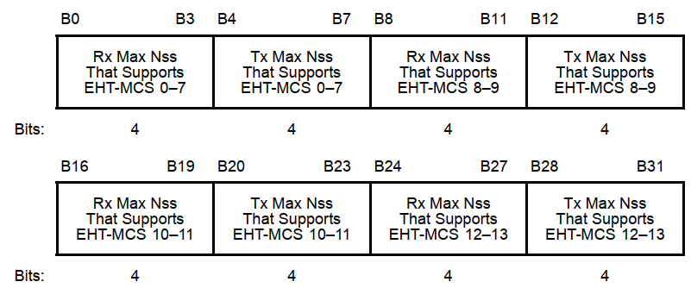
Figure 9-1002ai—EHT-MCS Map (20 MHz-Only Non-AP STA) subfield and Basic EHT-MCS and NSS Set field format

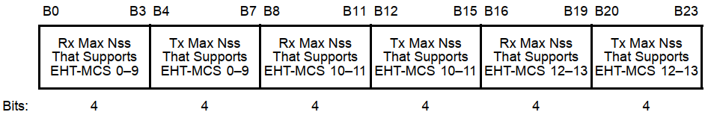
Figure 9-1002aj—EHT-MCS Map (BW ≤ 80 MHz, Except 20 MHz-Only Non-AP STA), EHTMCS Map (BW = 160 MHz), and EHT-MCS Map (BW = 320 MHz) subfield format

Instructions to the Editor:

Please make the following changes in Line 46, Page 245 in TGbe Draft D2.0:

The Rx Max Nss That Supports EHT-MCS 0–7 and Tx Max Nss That Supports EHT-MCS 0–7 subfields are encoded according to Table 9-401m (Encoding of the maximum number of Nss for a specified MCS value).

The Rx Max Nss That Supports EHT-MCS 8–9 and Tx Max Nss That Supports EHT-MCS 8–9 subfields are encoded according to Table 9-401m (Encoding of the maximum number of Nss for a specified MCS value).

The Rx Max Nss That Supports EHT-MCS 0–9 and Tx Max Nss That Supports EHT-MCS 0–9 subfields are encoded according to Table 9-401m (Encoding of the maximum number of Nss for a specified MCS value).

The Rx Max Nss That Supports EHT-MCS 10–11 and Tx Max Nss That Supports EHT-MCS 10–11 subfields are encoded according to Table 9-401m (Encoding of the maximum number of Nss for a specified MCS value).

The Rx Max Nss That Supports EHT-MCS 12–13 and Tx Max Nss That Supports EHT-MCS 12–13 subfields are encoded according to Table 9-401m (Encoding of the maximum number of Nss for a specified MCS value).

