IEEE P802.11
Wireless LANs
Text for EDCAF Selection Issue on Start Time Sync Access
Date: 2022-11-14
Author(s):
Name | Affiliation | Address | Phone | email
Juseong Moon | Korea National University of Transportation |  |  | jsmoon0211@ut.ac.kr
Ronny Yongho Kim | Korea National University of Transportation |  |  | ronnykim@ut.ac.kr
Hyojin Jung | Hyundai Motor Company |  |  | hyojin@hyundai.com
Abstract
This submission proposes comment resolution for CID 12414 received in LB266.

With start time sync PPDUs access defined in 802.11be Draft 2.2, a STA can select only one EDCAF among multiple EDCAFs with backoff counter reached zero.
In case of transmitting from the selected one EDCAF among EDCAFs with backoff counter 0, backoff shall be invoked for the not selected EDCAFs

In this contribution, operation for unselected EDCAFs in start time sync PPDUs access will be discussed.

Related Comment
12414 | Juseong Moon | Yes | 35.3.16.6 | 458.14 | When there are multiple EDCAF backoff counters that already reached zero and one EDCAF is chosen with implementation specific method, it is not clear what the expected behavior for the rest of EDCAFs with zero backoff counter. Do they re-invoke the backoff procedure with doubled CW value assuming an internal collision? Clear description on the post procedure of implementation specific one EDCAF selection is required. | Revised.  Agreed in principle.  EDCAFs with keeping counter zero shall invoke EDCA backoff when medium is changed from idle to busy.  TGbe Editor: Apply the change tagged with #12414.

Discussion
In 802.11be draft 2.2, subclause 35.3.16.6

A STA of an MLD operating on a link that is part of an NSTR link pair for that MLD shall follow the channel access procedure described below:
3) A STA with backoff counter that has already reached zero and that choose not to transmit following condition 1b) may perform a new backoff procedure following deferral as described in 10.23.2.4 (Obtaining an EDCA TXOP) and 10.3.4.3 (Backoff procedure for DCF) before being allowed to initiate transmission on a link following condition 1a). In such a case, CW[AC] and QSRC[AC] are left unchanged.
(…)
A STA with backoff counter that has already reached zero on a link and has a frame available for transmission shall follow channel access procedures described in 10.23.2.4 (Obtaining an EDCA TXOP) after it detect medium transition from busy to idle.

With text above, collision of following cases may occur.
1. Inter-STA collision
2. Internal-STA collision (internal collision)
Also, it harms fairness of EDCA
EDCA is optimized for fairness but keeping backoff counter zero with multiple EDCAF may harm fairness of EDCA.

<Example for start time sync PPDUs access – EDCAF selection (1)>

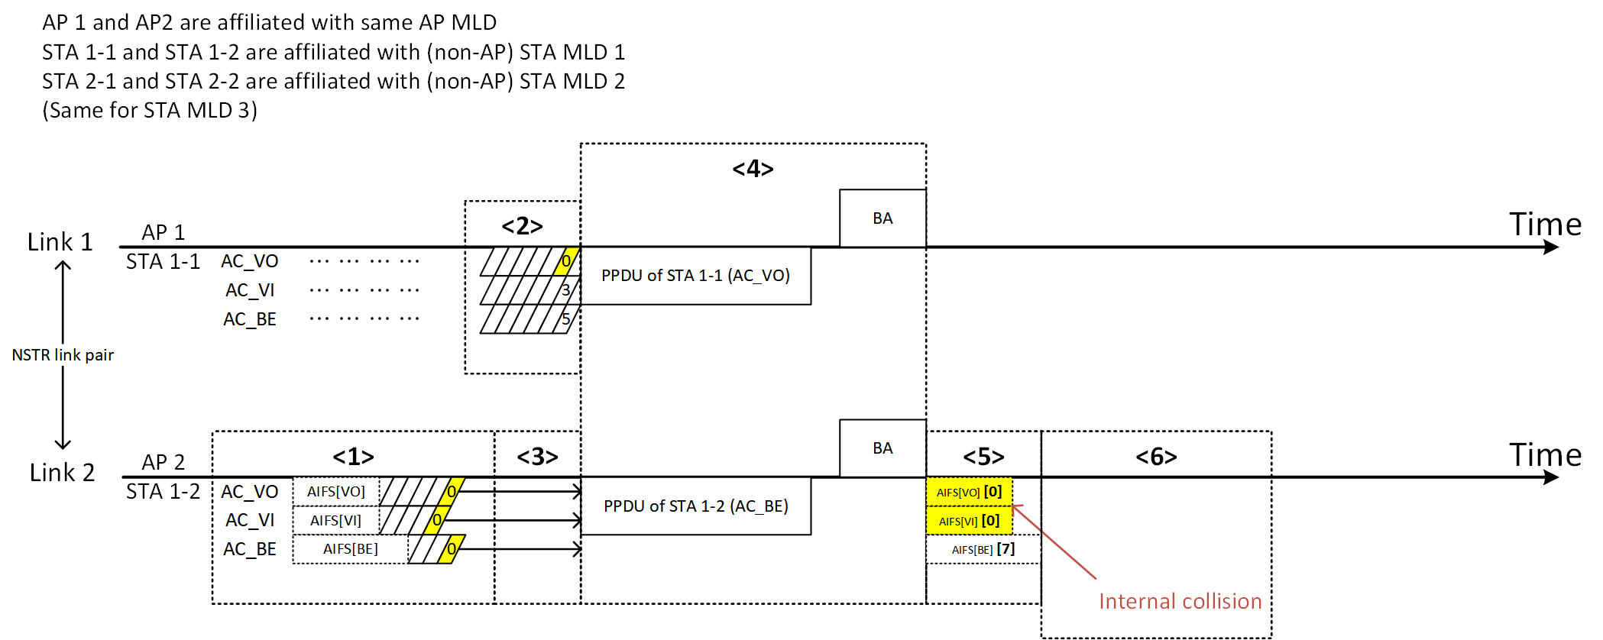

<1> STA 1-2's EDCAFs are keeping their backoff counter with zero and waiting for obtaining TXOP of STA 1-1 in link 1.
In 802.11be Draft 2.2, subclause 35.3.16.6 (Start time sync PPDUs access)
A STA affiliated with an MLD operating on a link that is part of an NSTR link pair for that MLD shall follow the channel access procedure described below:
2) When the backoff counter of the STA reaches zero, it may choose to not transmit and keep its backoff counter at zero. A STA with backoff counter that has already reached zero may initiate transmission only following condition 1b).
*Remark: In this example, AC_VI and AC_VO’s AIFS[AC] (or AIFSN[AC]) are assumed to be same. Default AIFSN of AC_VI and AC_VO are same in baseline.

<2> STA 1-1's AC_VO EDCAF obtained TXOP.
In 802.11be Draft 2.2, subclause 35.3.16.6 (Start time sync PPDUs access)
A STA affiliated with an MLD operating on a link that is part of an NSTR link pair for that MLD shall follow the channel access procedure described below:
- The STA may initiate transmission on a link when the medium is idle as indicated by the physical and virtual CS mechanism and one of the following conditions is met:
b) The backoff counter of the STA is already zero, and the STA operating on the other link of NSTR link pair of the affiliated MLD obtains an EDCA TXOP following the procedure in 10.23.2.4 (Obtaining an EDCA TXOP).

<3> EDCAFs with backoff counter already reached zero, shall select only one implementation specific EDCAF. In this example, AC_BE is selected by STA 1-2 in an implementation specific method.

In 802.11be Draft 2.2, subclause 35.3.16.6 (Start time sync PPDUs access) is defined for an implementation specific selection.
A STA that chooses not to transmit after the backoff counter reached zero on a link of NSTR link pair may have one or more EDCAF backoff counters with value zero on that link. The STA that initiates transmission on that link following condition a) or b), and has one or more EDCAF backoff counters that already reached zero shall choose only one EDCAF for the transmission. The basis for selection is implementation specific.

<4> STA MLD is doing start time sync PPDUs access in link 1 and link 2. Other EDCAFs, that are not selected for transmission, consider medium as busy state.

<5> Transmitted AC (AC_BE)'s EDCAF will invoke new backoff by subclause 10.23.2.2(EDCA backoff procedure) of 802.11-2020 because final PPDU of TXOP is transmitted. Which operation will be applied to not transmitted AC(s)?:
In subclause 35.3.16.6(Start time sync PPDUs access) of 802.11be D2.2, there are rules for synchronized transmission. This subclause is not defined from per EDCAF’s perspective but defined from per-STA’s perspective.
In 802.11be Draft 2.2, subclause 35.3.16.6 (Start time sync PPDUs access)

A STA affiliated with an MLD operating on a link that is part of an NSTR link pair for that MLD
shall follow the channel access procedure described below:
1) The STA may initiate transmission on a link when the medium is idle as indicated by the physical and virtual CS mechanism and one of the following conditions is met:
a) The STA obtained an EDCA TXOP following the procedure in 10.23.2.4 (Obtaining an EDCA TXOP).
b) The backoff counter of the STA is already zero, and the STA operating on the other link of NSTR link pair of the affiliated MLD obtains an EDCA TXOP following the procedure in 10.23.2.4 (Obtaining an EDCA TXOP).
2)...
3) A STA with backoff counter that has already reached zero and that chose not to transmit following condition 1b) may perform a new backoff procedure following deferral as described in 10.23.2.4 (Obtaining an EDCA TXOP) and 10.3.4.3 (Backoff procedure for DCF) before being allowed to initiate transmission on a link following condition 1a). In such a case, CW[AC] and QSRC[AC] are left unchanged

The condition 3) cannot be applied to multiple EDCAFs with backoff counter zero case.

[Reason 1: When subclause 35.3.16.6 is applied as per-STA operation]
STA1-2 has transmitted following condition 1b) in step <4> in example sequence.
Therefore, STA 1-2 will not enter condition 3).

[Reason 2: When subclause 35.3.16.6 is applied as per-EDCAF operation]
STA 1-2's AC_BE choose transmit following condition 1b). And other ACs are just can not transmit because of busy medium. This is not condition 3), EDCAFs chose not to transmit with condition 1b).

After medium state is changed from busy to idle, following the text of subclause 35.3.16.6 will be applied to both cases.
A STA with backoff counter that has already reached zero on a link and has a frame available for transmission shall follow channel access procedures described in 10.23.2.4 (Obtaining an EDCA TXOP) after it detects medium transition from busy to idle.

So, not transmitted ACs’ EDCAFs will not invoke new backoff, because subclause 10.23.2.4(Obtaining EDCA TXOP) of 802.11-2020 does not define rules for invoke new backoff. Not transmitted ACs’ EDCAFs will keep backoff counter with zero.
STA 1-2’s AC_BE’s EDCAF invoked backoff and picked backoff counter 7. AC_VI and AC_VO’s EDCAF are keeping their backoff counter with zero.

<6> After AIFS[AC], internal collision will occur between AC_VI and AC_VO.
(They have same backoff counter zero and will try transmitting after AIFS[AC] slot boundary)

<Example for start time sync PPDUs access – EDCAF selection (2)>

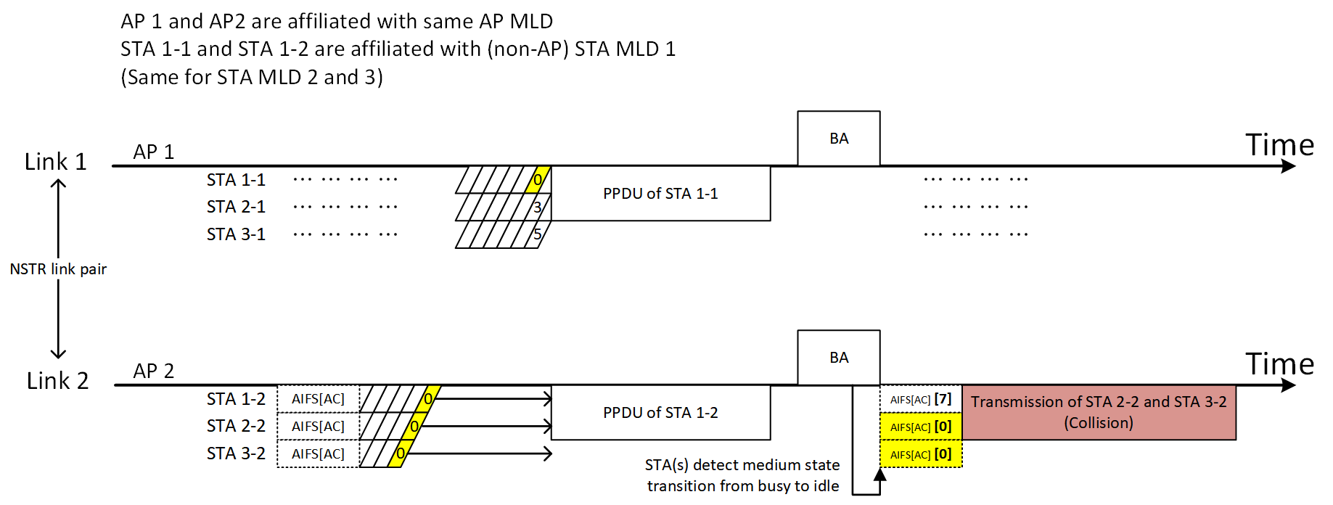
When there are multiple NSTR STA MLDs trying synchronized PPDU transmission, collision problem might be more severe.
Like aforementioned collision example, inter STA collision may occur. Multiple NSTR STA MLDs may perform start time sync PPDUs transmission at the same time. In this case, multiple STAs may have multiple zero backoff counters with same AC while waiting for the other STA’s TXOP acquisition operating on the other link of NSTR link pair of the affiliated MLD. STA 1-1 and STA 1-2 has successfully transmitted PPDUs in a sync manner. EDCAFs of STA 2-2 and STA 3-2 has been waiting with backoff counter zero.

In this example, STA 2-2 and STA 3-2 will collide following the text of subclause 35.3.16.6 below (in bold and italic). If a lot of STAs are contending for medium in start time sync PPDUs access, collision probability will increase.

A STA with backoff counter that has already reached zero on a link and has a frame available for transmission shall follow channel access procedures described in 10.23.2.4 (Obtaining an EDCA TXOP) after it detects medium transition from busy to idle.

<Proposed Method>

To solve this issue, EDCA backoff shall be invoked after medium state is changed to busy from idle. EDCA backoff may be invoked with Previous CW[AC] and QSRC[AC].

Proposed Changes to IEEE 802.11be D2.2

TGbe editor: change the following paragraph in P496L1 of 11be draft 2.2 as:

A STA with backoff counter that has already reached zero on a link and has a frame available for transmission shall (#12414)invoke backoff described in 10.23.2.2 (EDCA backoff procedure) with event a) after it detects medium transition from idle to busy and it shall follow channel access procedures described in 10.23.2.4 (Obtaining an EDCA TXOP) after it detects medium transition from busy to idle

