IEEE P802.11  
Wireless LANs

|  |  |  |  |  |
| --- | --- | --- | --- | --- |
| LB266 CR for CID 14051 | | | | |
| Date: 2022-08-16 | | | | |
| Author(s): | | | | |
| Name | Affiliation | Address | Phone | email |
| Ruchen Duan | Samsung |  |  | r.duan@samsung.com |
| Wook Bong Lee |  |  |  |
| Srinivas Kandala |  |  |  |
| Ravi Gidvani |  |  |  |

Abstract

This submission proposes a resolution for the following CID for TGbe LB266:

14051

Revisions:

* Rev 0: Initial version of the document

Interpretation of a Motion to Adopt

A motion to approve this submission means that the editing instructions and any changed or added material are actioned in the TGbe Draft. This introduction is not part of the adopted material.

***Editing instructions formatted like this are intended to be copied into the TGbe Draft (i.e. they are instructions to the 802.11 editor on how to merge the text with the baseline documents).***

***TGbe Editor: Editing instructions preceded by “TGbe Editor” are instructions to the TGbe editor to modify existing material in the TGbe draft. As a result of adopting the changes, the TGbe editor will execute the instructions rather than copy them to the TGbe Draft.***

***TGbe editor: The baseline for this document is 11be D2.0.***

|  |  |  |  |  |  |
| --- | --- | --- | --- | --- | --- |
| **CID** | **Clause** | **Pg/Ln** | **Comment** | **Proposed Change** | **Resolution** |
| 14051 | 9.3.1.8 | 134 | Add fast link adabtation feedback mechanism in block ack. As proposed in 20/0047r0 Feedback Enhancement and 20/1035r1 Follow up on Feedback Enhancement. | As commented. Can update the block ack frame related content, or create new subclause for it. | Revised.  Agree with the commenter.  **Instruction to the editor**, ***please make the following changes with the CID tag 14051 (doc.: IEEE 802.11-22/1531).*** |

**Discussion:**

As described in the SFD straw pall (11/20-1935[1]), the following content was agreed:

## 10.2 Link adaptation feedback

**Straw poll #409**

Do you support link adaptation feedback, from a non-AP STA to its associated AP, in EHT R2?

* The format and contents of the feedback is TBD (e.g., MCS, SNR, etc)
* The feedback might reflect differences between SU MIMO and MU MIMO ***[#SP409]***

[21/0102r5 (Considerations on Capabilities and Operation Mode: MU-MIMO, Wook Bong Lee, Samsung), SP#1a, No objection]

**Recap:**

In the previous discussion [2] and [3], it is suggested to attach the link adaptation feedback with BA.



Performance gain was shown in [4] for fast link adaptation feedback.





First, we propose to add HLA/ELA [5] in the Block ACK frame.

We propose three methods as in below.

* Option 1. Allowing a Control Wrapper frame for EHT STA, especially for the Block ACK frame. Note that HE STA shall not send a Control Wrapper frame to another HE STA.
* Option 2. Allowing a Control frame can carry +HTC == 1 so that HTC can be added in the Block ACK frame.
* Option 3. Use the reserved bits in BA control to indicate the present of HT Control frame in BA.

Second, corresponding method should be also applicable to BAR.

Thirdly, since not all EHT STA can understand the new format, we proposed to add a new EHT MAC capability for it. We proposed to add ‘ELA with BA’ subfield.

***Proposed change #1***

***Option 1***

**9.2.4.6 HT Control field**

**9.2.4.6.1 General**

The HT Control field is always present in a Control Wrapper frame and is present in QoS Data, (11ax)QoS Null, and Management frames as determined by the +HTC subfield of the Frame Control field as defined in 9.2.4.1.10 (+HTC subfield).

**10.9 Control Wrapper operation**

A STA supporting the HT Control field that receives a Control Wrapper frame shall process it as though it received a frame of the subtype of the wrapped frame. the subtype of the wrapped frame. **An HE STA shall not send a Control Wrapper frame to another HE STA.**

***TGbe Editor: Insert the following content at after 10.8 HT Control field operation:***

**10.9 Control Wrapper operation**(CID 14051)

An EHT STA may send a Control Wrapper frame to another EHT STA which has ELA with BA subfield in its EHT MAC Capabilities Information field to be 1 if a block ack is presented in this frame.

***Option 2***

In Draft P802.11REVme_D1.3, Frame Control field for Subtype subfield that is not 6 is defined as:

“For a frame carried in (#1426)a non-S1G PPDU, when the Type subfield is not 1 or the Subtype subfield is not 6, the remaining subfields within the Frame Control field are To DS, From DS, More Fragments, Retry, Power Management, More Data, Protected Frame, and +HTC. In this case, the format of the Frame Control field is shown in Figure 9-3 (Frame Control field format in non-S1G PPDUs when Type subfield is not equal to 1 or Subtype subfield is not equal to 6).”

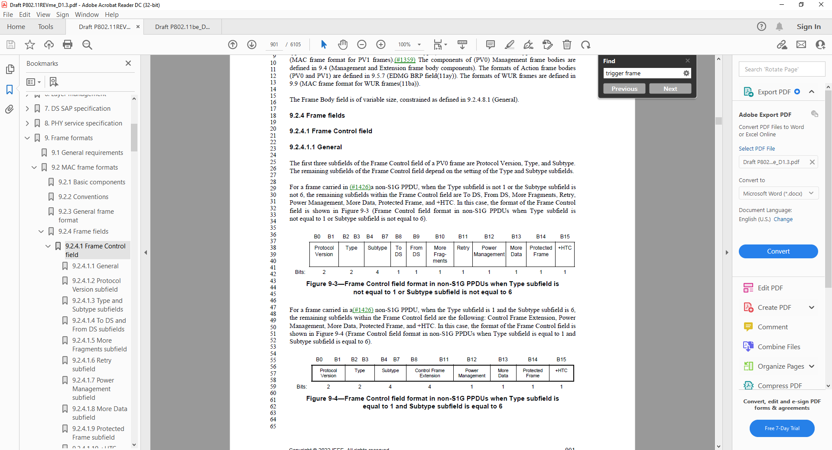

And in 9.2.4.1.10 +HTC subfield

“The +HTC subfield is set as follows:

— It is set to 1 in a QoS Data or Management frame transmitted with the FORMAT parameter of the TXVECTOR set to HT_GF, HT_MF, VHT or S1G to indicate that the frame contains an HT Control field.

— It is set to 1 in an RTS frame transmitted with the FORMAT parameter of the TXVECTOR set to S1G to indicate that the intended recipient of the frame has permission to extend the TXOP as described in 10.54.5.4 (Relay-shared TXOP protection mechanisms).

— It is set to 1 in a QoS Data or Management frame transmitted by a CMMG STA to indicate that the frame contains a CMMG variant HT Control field.

— It is set to 1 in a QoS Data, QoS Null, or Management frame transmitted by an HE STA to another HE STA to indicate that the frame contains an HT Control field.(11ax)

**Otherwise, the +HTC subfield is set to 0.**

NOTE—The +HTC subfield is always set to 0 for frames transmitted by a DMG STA.

Therefore, for the case when Type subfield is 1 and Subtype field is not 6, the +HTC field is defined for Frame Control field with its value always set to be 0. “

To enable the ELA transmission with BA, another solution contains the following changes:

***TGbe Editor: Insert the following content in 9.2.4.1.10 +HTC subfield, before “Otherwise, the +HTC subfield is set to 0.”:***

* It is set to 1 in a control frame with Frame Control field Type field to be 1 and Subtype subfield to be 8 to indicate the frame contains an HT Control field if the receiver of the BA has ELA with BA subfield in its EHT MAC Capabilities Information field to be 1. The only variant that can be contained in this HT control field is an ELA subfield as described in 9.2.4.6a.x (ELA Control).

***TGbe Editor: Change Figure 9-37 (Figure 9-37—Frame Control field subfield values within Control frames carried in a non S1G PPDU) as follows:***

|  |  |  |  |  |  |  |  |  |  |  |  |
| --- | --- | --- | --- | --- | --- | --- | --- | --- | --- | --- | --- |
|  | B0     B1 | B2     B3 | B4     B7 | B8 | B9 | B10 | B11 | B12 | B13 | B14 | B15 |
|  | Protocol Version | Type (Control) | Subtype | To DS (0) | From DS (0) | More Frag (0) | Retry (0) | Power Management | More Data | Protected Frame (0) | +HTC ~~(0)~~ |
| Bits: | 2 | 2 | 4 | 1 | 1 | 1 | 1 | 1 | 1 | 1 | 1 |
| * Frame Control field subfield values within Control frames carried in a non‑S1G PPDU | | | | | | | | | | | |

***TGbe Editor: Change Figure 9-52 (BlockAck frame format) as follows:***

|  |  |  |  |  |  |  |  |  |  |
| --- | --- | --- | --- | --- | --- | --- | --- | --- | --- |
|  | Frame Control | | Duration | RA | TA | HT Control | BA Control | BA Information | FCS |
| Octets: | 2 | | 2 | 6 | 6 | 0 or 4 | 2 | variable | 4 |
|  | | * BlockAck frame format | | | | | | | |

***Option 3***

Use the reserved bits to indicate the present of ELA subfield in BA.

The BA control format for ax and be is as follows:

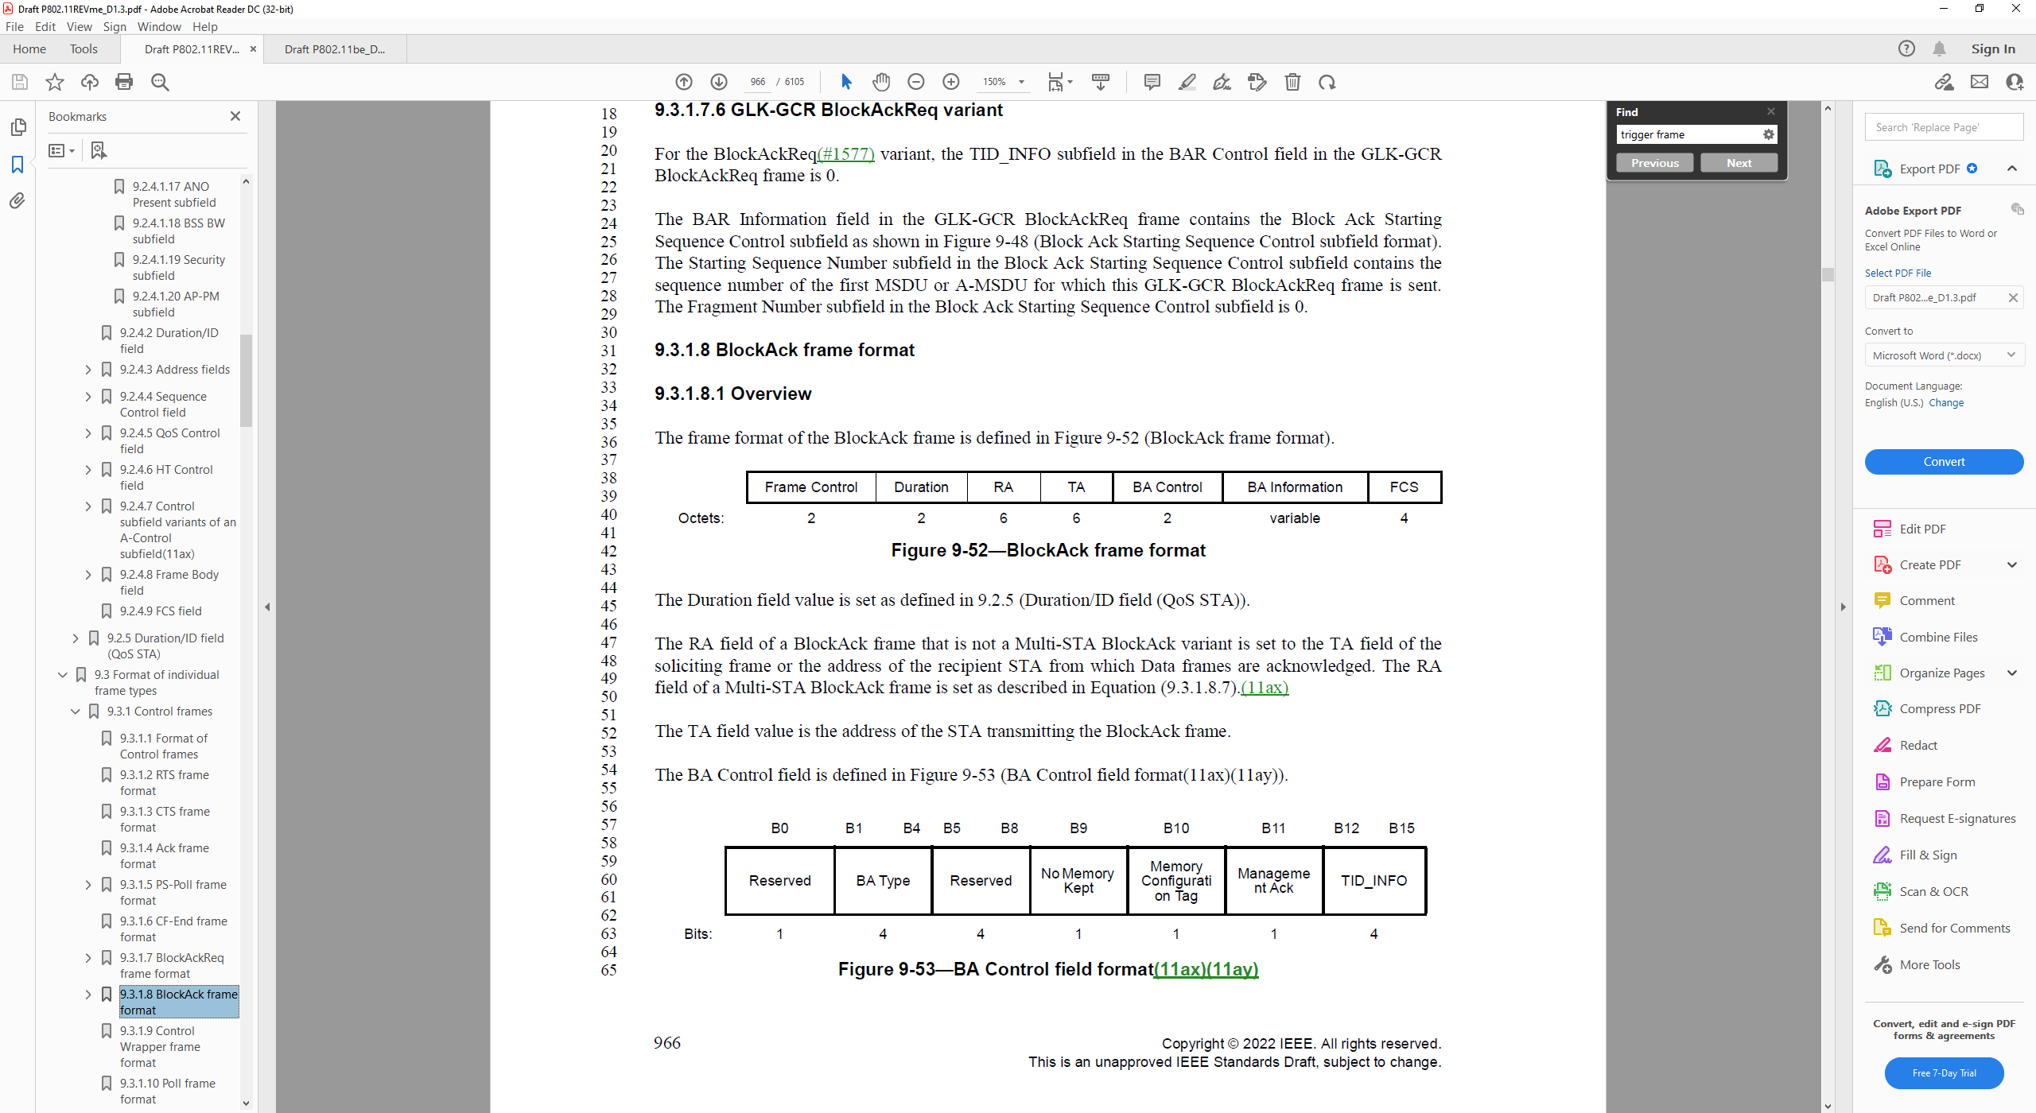

And the BA type subfield has the following value

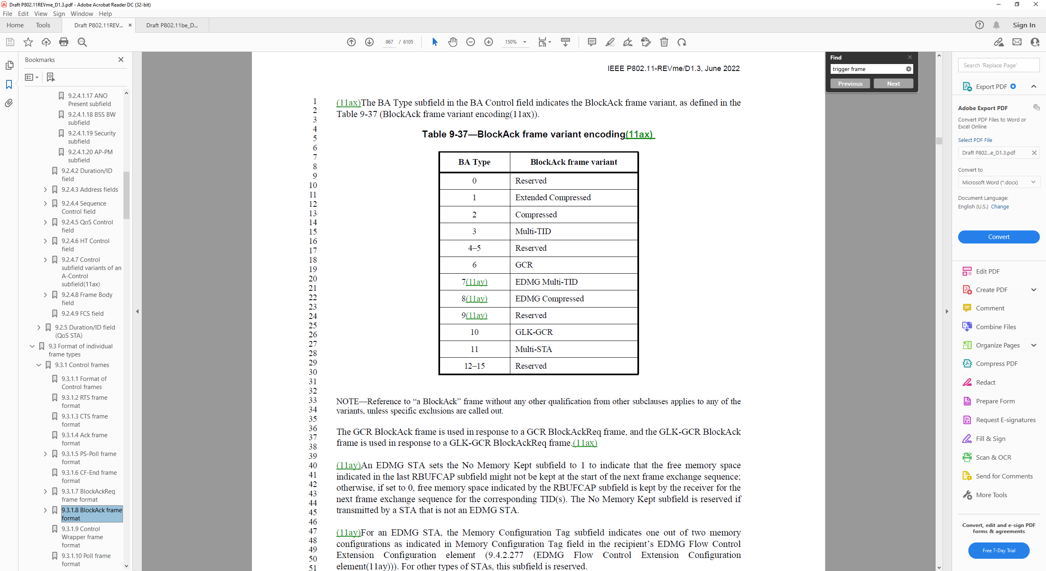

To enable the ELA subfield transmission with BA and BAR, the following change can be added to P134, 9.3.1.8.1 Overview:

***TGbe Editor: Change Figure 9-52 (BlockAck frame format) as follows:***

|  |  |  |  |  |  |  |  |  |  |
| --- | --- | --- | --- | --- | --- | --- | --- | --- | --- |
|  | Frame Control | | Duration | RA | TA | BA Control | HT Control | BA Information | FCS |
| Octets: | 2 | | 2 | 6 | 6 | 2 | 0 or 4 | variable | 4 |
|  | | * BlockAck frame format | | | | | | | |

***TGbe Editor: Change Figure 9-53 (BA Control field format) as follows:***

|  |  |  |  |  |  |  |  |  |
| --- | --- | --- | --- | --- | --- | --- | --- | --- |
|  | B0 | B1 B4 | B5 | B6 B8 | B9 | B10 | B11 | B12 B15 |
|  | Reserved | BA Type | +HTC | Reserved | No Memory Kept | Memory Configuration Tag | Management Ack | TID_INFO |
| Bits: | 1 | 4 | 1 | 3 | 1 | 1 | 1 | 4 |
| * BA Control field format(11ax)(11ay) | | | | | | | | |

***TGbe Editor: Insert the following paragraph after the third paragraph after Table 9-37 (BlockAck frame variant encoding) (“For an EDMG STA, ...”):***

The +HTC subfield is set to 1 to indicate the present of an HT control subfield after BA control if the receiver of the BA has its ELA with BA subfield in the EHT MAC Capabilities Information field to be 1. The HT control frame can only contain ELA subfield.

---- End of proposed change #1 ----

***Proposed change #2***

BAR frame can be used to solicit the ELA contained in BA. This request the following changes based on which option is preferred:

***Option 1***

***TGbe Editor: Insert the following content at after 10.8 HT Control field operation:***

**10.9 Control Wrapper operation**(CID 14051)

An EHT STA may send a Control Wrapper frame to another EHT STA which has ELA with BA subfield in its EHT MAC Capabilities Information field to be 1 if a block ack or block ack request is present in this frame.

***Option 2***

***TGbe Editor: Insert the following content in 9.2.4.1.10 +HTC subfield, before “Otherwise, the +HTC subfield is set to 0.”:***

* It is set to 1 in a control frame with Frame Control field Type field to be 1 and Subtype subfield to be 8 or 9 to indicate the frame contains an HT Control field if the receiver of the BA/BAR has its ELA with BA subfield in the EHT MAC Capabilities Information field to be 1. The only variant that can be contained in this HT control field is an ELA subfield as described in 9.2.4.6a.x (ELA Control). (CID 14051)

***TGbe Editor: Change Figure 9-46 (***BlockAckReq frame format***) as follows:***

|  |  |  |  |  |  |  |  |  |
| --- | --- | --- | --- | --- | --- | --- | --- | --- |
|  | Frame Control | Duration | RA | TA | HT Control | BAR Control | BAR Information | FCS |
| Octets: | 2 | 2 | 6 | 6 | 0 or 4 | 2 | variable | 4 |
| * BlockAckReq frame format(CID 14051) | | | | | | | |

***Option 3***

***TGbe Editor: Change Figure 9-46 (BlockAck frame format) as follows:***

|  |  |  |  |  |  |  |  |  |  |
| --- | --- | --- | --- | --- | --- | --- | --- | --- | --- |
|  | Frame Control | Duration | RA | TA | BAR Control | | HT Control | BAR Information | FCS |
| Octets: | 2 | 2 | 6 | 6 | 2 | 0 or 4 | | variable | 4 |
| * BlockAckReq frame format(CID 14051) | | | | | | | | |

***TGbe Editor: Change Figure 9-47 (BAR Control field format) as follows:***

|  |  |  |  |  |  |
| --- | --- | --- | --- | --- | --- |
|  | B0 | B1 B4 | B5 | B6 B11 | B12 B15 |
|  | Reserved | +HTC | LA Request | Reserved | TID_INFO |
| Bits: | 1 | 4 | 1 | 6 | 4 |
| * BAR Control field format(11ax)(CID 14051) | | | | | |

***TGbe Editor: Insert the following paragraph after the third paragraph after Table 9-36 (BlockAckReq frame variant encod-ing(11ax)) (“DMG STAs use only the Compressed BlockAckReq ...”):***

The +HTC subfield is set to 1 to indicate the present of an HT control subfield after BAR control if the receiver of the BAR has its ELA with BA subfield in the EHT MAC Capabilities Information field to be 1. The HT control frame can only contain ELA subfield. (CID 14051)

---- End of proposed change #2 ----

***Proposed change #3***

***TGbe Editor: Change Figure 9-1002ae (EHT MAC Capabilities Information field format) as follows:***

B0 B1 B2 B3 B4

|  |  |  |  |  |
| --- | --- | --- | --- | --- |
| EPCS Priority Access Supported | EHT OM Control Support | Triggered TXOP Sharing Mode 1 Support | Triggered TXOP Sharing Mode 2 Support | Restricted TWT Support |

|  |  |  |  |  |  |  |  |
| --- | --- | --- | --- | --- | --- | --- | --- |
| Bits: | 1 |  | 1 |  | 1 | 1 | 1 |
|  | B5 | B6 |  | B7 | B8 | B9 | B10 |

|  |  |  |  |  |
| --- | --- | --- | --- | --- |
| SCS Traffic Description Support | Maximum MPDU Length | Maximum  A-MPDU Length Exponent Extension | EHT TRS Support | TXOP Return Support In TXOP Sharing Mode 2 |

Bits: 1 2 1 1 1

|  |  |  |  |  |
| --- | --- | --- | --- | --- |
|  | B11 | B12 |  | B15 |

|  |  |
| --- | --- |
| ELA with BA | Reserved |

Bits: 1 ~~5~~4

**Figure 9-1002ae—EHT MAC Capabilities Information field format**(CID 14051)

***TGbe Editor: Change Table 9-401k (Subfields of the EHT MAC Capabilities Information field) as follows:***

**Table 9-401k—Subfields of the EHT MAC Capabilities Information field**(CID 14051)

|  |  |  |
| --- | --- | --- |
| **Subfield** | **Definition** | **Encoding** |
| … | … | .. |
| ELA with BA | Indicates support for transmitting and reception of a BlockAck frame in which ELA subfield is present. | Set to 1 to indicate that the STA is capable of transmitting/reception of the BlockAck/BlockAckRequest frame in which ELA subfield is present.  Set to 0 otherwise. |

---- End of proposed change #3 ----

**Reference:**

**[1] 11-20-1935-66-00be-compendium-of-straw-polls-and-potential-changes-to-the-specification-framework-document-part-2, Edward Au (Huawei)**

**[2] 11-20/0047r1, “Feedback Enhancement”**

**[3] 11-20/1035r1, “Follow up on Feedback Enhancement”**

**[4] 11-20/1005r1, “Yet Another Fast Link Adaptation Attempt”**

**[5] 11-22/1317r1, “CR on CID 10116”**