IEEE P802.11
Wireless LANs

LB266 CR on subclause 36.3.19 Transmit specification
Date: 2022-09-01
Author(s):
Name | Affiliation | Address | Phone | email
Yapu Li | OPPO |  |  | liyapu1@oppo.com
Xiaogang Chen | ZEKU

Abstract
This submission contains proposed comment resolutions to the following CID based on P802.11be D2.1.1.

CID 11300, 11301, 11973, 11303, 11634, 11635, 12346, 12348, 12349

Revisions:

- Rev 0: Initial version of the document.
-

CID 11300

CID | Page.  Line | Clause | Comment | Proposed Change | Resolution
11300 | 747.41 | 36.3.19.1.2 | Change "puncture" to "puncturing" | See comment | Revised  Agree in principle.  For consistency, change “preamble puncture” to “preamble puncturing”.  Instructions to the editor:  Please change “preamble puncture” to “preamble puncturing” in subclause 36.3.19.1 Transmit spectral mask.
Discussion

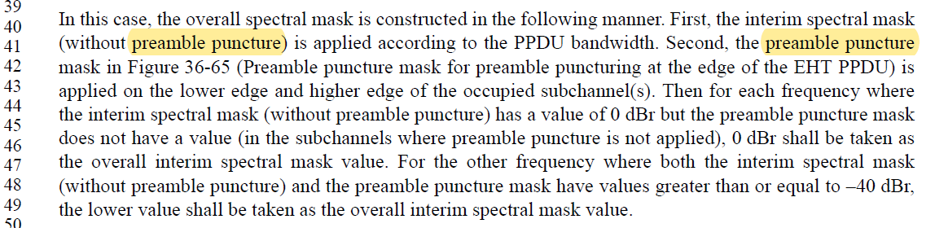

By Referring to subclause 36.3.12.11 EHT preamble of preamble punctured EHT MU PPDU, it’s better to unified to “preamble puncturing”.

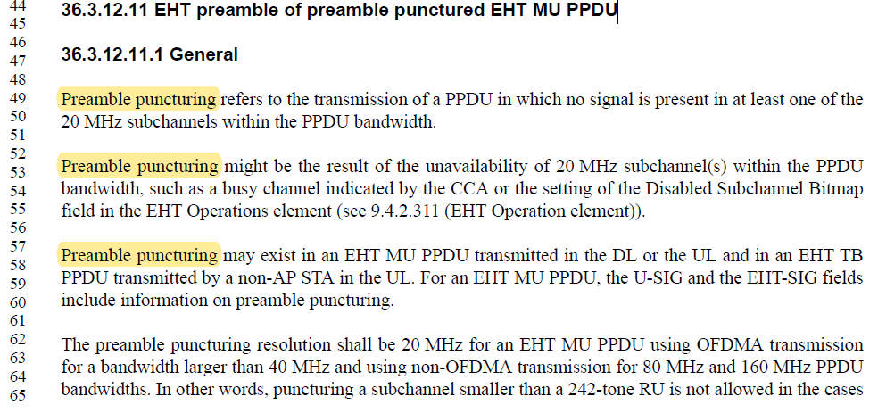

CID 11301, 11973

CID | Page.  Line | Clause | Comment | Proposed Change | Resolution
11301 | 748.37 | 36.3.19.1.2 | Typo: "When there are two or more contiguous 20MHz subchannels are punctured ..." | Change to "When two or more contiguous 20  MHz subchannels are punctured" | Accepted  Note to the Editor: The corresponding sentence is on P764L37 of D2.1.1
11973 | 748.37 | 36.3.19.1.2 | Remove the words "there are" | As in comment | Accepted  Note to the Editor: The corresponding sentence is on P764L37 of D2.1.1
Discussion
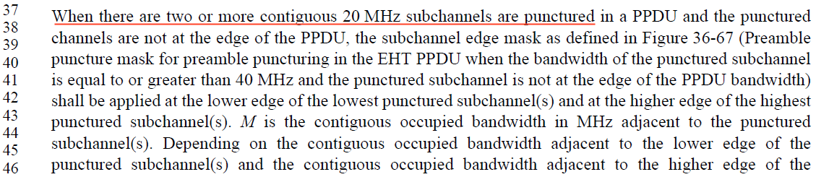

CID 11303

CID | Page.  Line | Clause | Comment | Proposed Change | Resolution
11303 | 760.32 | 36.3.19.4.3 | The term "frequency segment" used to refer to modes like 80+80, ... which are no longer defined in EHT. There are no longer multiple frequency segments. (We still have a block called segment parser, but it really parses 80 MHz frequency subblocks.) | Remove averaging over frequency segments | Revised  Agree in principle.  Instructions to the editor:  Please make the changes to the spec as shown in 11/22-1513r0 under CID 11303
Discussion

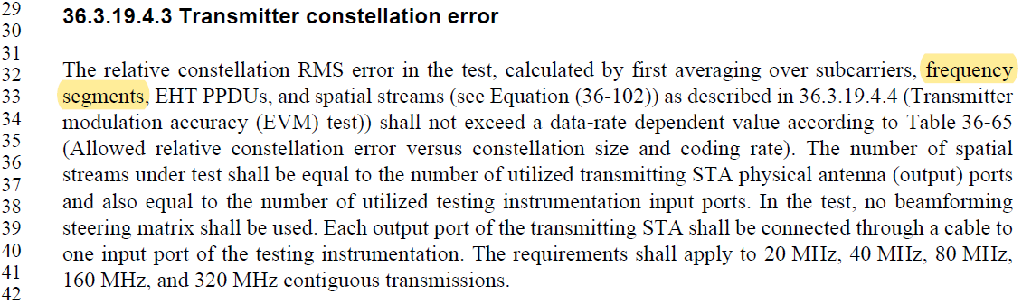

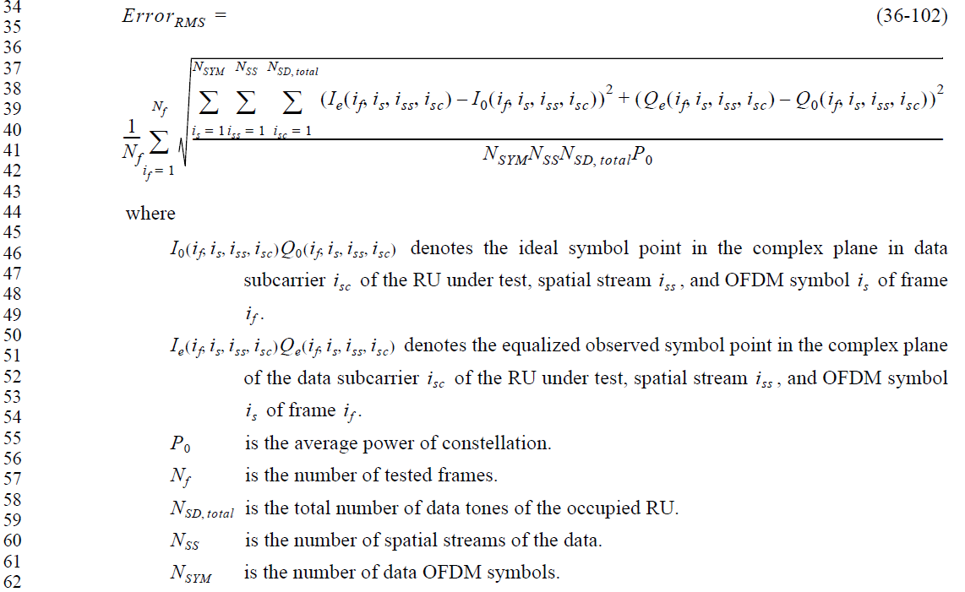

TGbe editor:
Please make the following changes in Page 776 Line 32 in D2.1.1:
36.3.19.4.3 Transmitter constellation error

The relative constellation RMS error in the test, calculated by first averaging over subcarriers,
EHT PPDUs, and spatial streams (see Equation (36-102)) as described in 36.3.19.4.4 (Transmitter

CID 11634, 11635

CID | Page.  Line | Clause | Comment | Proposed Change | Resolution
11634 | 754.50 | 36.3.19.2 | BPSK modulated PPDU is not clear definition. Does it mean MCS0 only or it might be MCS14/15 as well. Need to clarify | Specify allowed MCSs | Rejected  The original intension of BPSK modulated EHT PPDU is used to test the spectral flatness. As long as it's BPSK modulation, it doesn't matter which MCS to use.
11635 | 755.12 | 36.3.19.2 | BPSK modulated PPDU is not clear definition. Does it mean MCS0 only or it might be MCS14/15 as well. Need to clarify | Specify allowed MCSs | Rejected  The original intension of BPSK modulated EHT PPDU is used to test the spectral flatness. As long as it's BPSK modulation, it doesn't matter which MCS to use.

Discussion
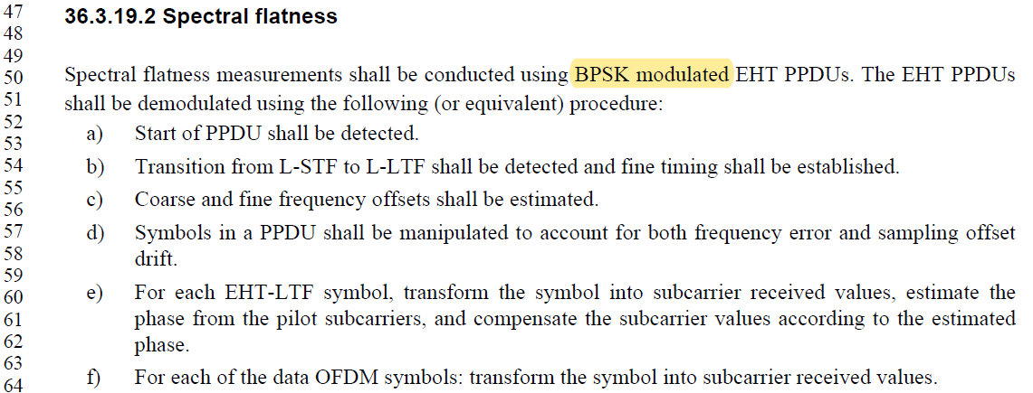

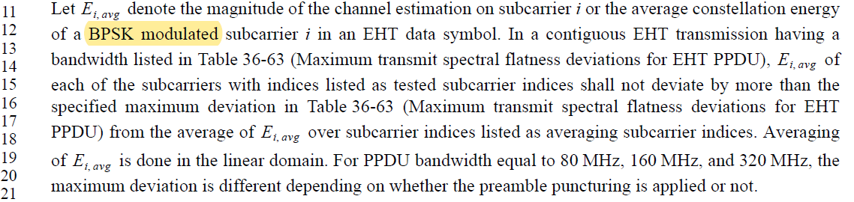

CID 12346, 12348, 12349

CID | Page.  Line | Clause | Comment | Proposed Change | Resolution
12346 | 768.31 | 36.3.20.2 | "The PSDU length shall be 2048 octets for BPSK modulation with DCM and 4096 octets for all other moduations". There is no good reason for singling out DCM in this way. It is simpler and better to state a unified reference length. | Change to "The PSDU length shall be 2048 octets" (i.e., delete the rest of the sentence). | Rejected  The different PSDU length, depending on whether DCM used is inherited from 11ax.
12348 | 770.22 | 36.3.20.4 | "for a PSDU length of 2048 octets for BPSK modulation with DCM or 4096 octets for all oter modulations". There is no good reason for singling out DCM in this way. It is simpler and better to state a unified reference length. | Change to "for a PSDU length of 2048 octets" (i.e., delete the rest of the sentence). | Rejected  The different PSDU length, depending on whether DCM used is inherited from 11ax.
12349 | 770.42 | 36.3.20.5 | for a PSDU length of 2048 octets for BPSK modulation with DCM or 4096 octets for all oter modulations. There is no good reason for singling out DCM in this way. It is simpler and better to state a unified reference length. | Change to "for a PSDU length of 2048 octets" (i.e., delete the rest of the sentence). | Rejected  The different PSDU length, depending on whether DCM is inherited from 11ax.
Discussion

