IEEE P802.11
Wireless LANs
LB266 Resolution for non-zero backoff (CIDs 10702, 10697)
Date: September 22, 2022
Author(s):
Name | Affiliation | Address | Phone | email
Liangxiao Xin | Sony |  |  | Liangxiao.Xin@sony.com

Abstract
This submission proposes resolutions for following 2 CIDs received for TGbe LB266:
10702, 10697

Revisions:
- Rev 0: Initial version of the document.
- Rev 1: Added proposed text change in the spec

Interpretation of a Motion to Adopt

A motion to approve this submission means that the editing instructions and any changed or added material are actioned in the TGbe Draft. This introduction is not part of the adopted material.

Editing instructions formatted like this are intended to be copied into the TGbe Draft (i.e. they are instructions to the 802.11 editor on how to merge the text with the baseline documents).

TGbe Editor: Editing instructions preceded by “TGbe Editor” are instructions to the TGbe editor to modify existing material in the TGbe draft. As a result of adopting the changes, the TGbe editor will execute the instructions rather than copy them to the TGbe Draft.

PART A: Signaling length of Common Info field and STA Info field
CID | Commenter | Clause | Comment | Proposed Change | Resolution
10702 | Liangxiao Xin | 35.17.3.2 | It is not clear how to provide prioritized access for EPCS traffic using EPCS EDCA parameters. How EPCS EDCA parameters gives higher priority than regular EDCA parameter of AC_VO? | Commenter will bring a contribution for the resolution of this CID. | Revised  Agree with the commenter. Provide non-zero backoff procedure with AIFSN=1 to have higher priority than AC_VO
10697 | Liangxiao Xin | 35.9.4 | Should give higher priority of member STAs and scheduling AP to gain the channel access during R-TWT SP compared with OBSS STAs. | A backoff procedure with higher priority needs to be added. Commenter will bring a contribution for the resolution of this CID | Revised  Agree with the commenter. Provide non-zero backoff procedure with AIFSN=1 to have higher priority than AC_VO

Discussion

Introduction
- TGbe defines latency sensitive traffic and EPCS traffic which require higher priority than regular traffic.
- However, those two types of traffic still use regular EDCA for channel contention, which makes it vulnerable to the OBSS channel contention.
  - Channel access mechanisms for latency sensitive traffic and EPCS traffic only take effect inside BSS.
  - OBSS, especially legacy OBSS, can still use EDCAF of AC_VO to contend the channel and ignore the existence of the mechanisms for latency sensitive traffic and EPCS traffic.
- In order to provide higher priority to latency sensitive traffic and EPCS traffic, a channel access mechanism with higher priority than AC_VO is needed.
- We propose a non-zero backoff procedure to bound the contention time and have higher priority than legacy backoff procedure, such as AC_VO.
Problem of legacy backoff procedure
- Contention time has significant impact on the worst-case latency.
- Contention time is denoted as the time from starting backoff until access the channel
- The number of backoff slots during contention time is randomized due to the CW.
- The contention time is not bounded because there are cases that the backoff counters do not count down between two consecutive TXOPs of other STAs.
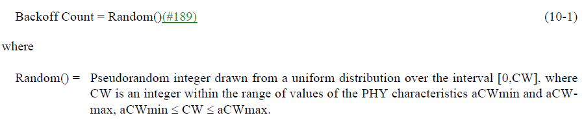
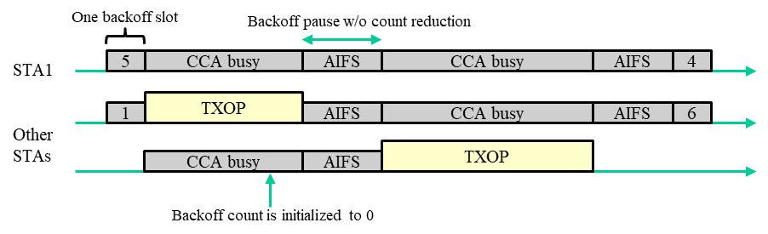
- The problem occurs because the backoff count can be initialized to be 0
  - For the same EDCAF, if another STA initializes its backoff count = 0, it gains the channel access and transmits first. Then, STA 1 enters CCA busy without counting down its backoff counter.

Non-zero backoff
- When setting the backoff counter, the number of backoff slots is always greater than 0.
  - STA1 counts down backoff counter at least by 1 between two consecutive TXOPs of other STAs.
  - The contention time is bounded by # backoff slots * (TXOP_limit + aAIFSTime + aSlotTime)
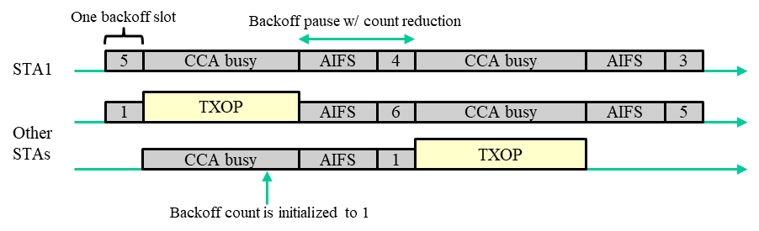
- The non-zero backoff procedure can set its AIFSN = 1.
  - For legacy backoff, AIFSN >=2 because its AIFS time has to be greater than PIFS.
  - In non-zero backoff, AIFSN = 1 is possible because AIFS is always followed by at least one backoff slot.
    - Min non-zero backoff time = aAIFSTime(AIFSN=1) + aSlotTime = aAIFSTime(AIFSN=2) = Min legacy backoff time of AC_VO > aPIFSTime

Simulation
- Simulation Setting
  - Two BSSs, each BSS has one AP and four STAs
  - STAs in BSS1 and BSS2 transmits AC_VO traffic to AP1, AP2, respectively.
    - Packet size = 1000 bytes
    - MCS = 64QAM_5/6
    - Channel bandwidth = 80MHz
  - Non-zero backoff: the backoff count is set between [1, CW[AC_VO]+1]
  - Legacy backoff: the backoff count is set between [0, CW[AC_VO]]
  - TXOP limit = 3ms
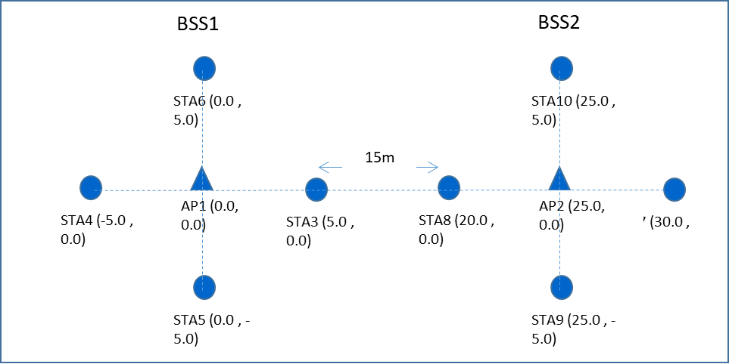

Simulation Result 1
- Each STA of BSS1 and BSS2 generates 30 pkts burst traffic every 0.012s
- We repeated simulation for 100 times. In each simulation,
  - The traffic start time of each STA is randomly distributed
- The simulation result shows non-zero backoff with AIFSN=1 can improve the 95-pc latency and jitter of the network.
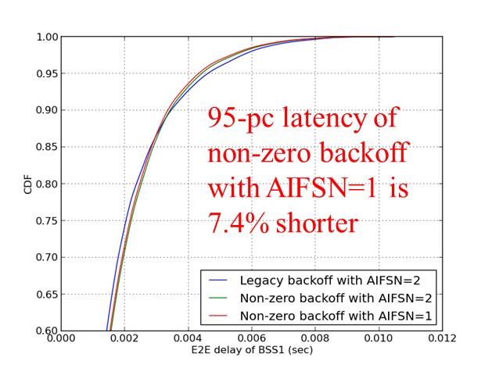

 | legacy backoff with AIFSN=2 | non-zero backoff with AIFSN=2 | non-zero backoff with AIFSN=1
95-pc latency | 5.44 ms | 5.16 ms | 5.04 ms
Avg latency | 1.61 ms | 1.68 ms | 1.65 ms
Jitter (SD) | 1.39 ms | 1.33 ms | 1.31 ms

Simulation Result 2
- Each STA of BSS1 and BSS2 generates 30 pkts burst traffic every 0.015s
- Besides, there is one more node transmit saturated AC_BK traffic to AP2.

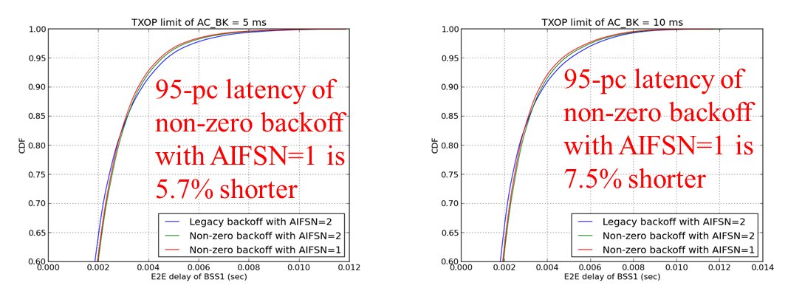

 | legacy backoff with AIFSN=2 | non-zero backoff with AIFSN=2 | non-zero backoff with AIFSN=1
95-pc latency (TXOP limit of AC_BK = 5 ms) | 4.71 ms | 4.53 ms | 4.44 ms
95-pc latency (TXOP limit of AC_BK = 10 ms) | 5.05 ms | 4.80 ms | 4.67 ms

Simulation 3
- Each STA of BSS1 and BSS2 generates 30 pkts burst traffic every 0.012s
  - LHS figure: STAs of BSS1 use non-zero backoff with AIFSN=1 while STAs of BSS2 use legacy backoff with AIFSN=2.
  - RHS figure: STAs of BSS1 use non-zero backoff with AIFSN=2 while STAs of BSS2 use legacy backoff with AIFSN=2.
- The simulation results show that the non-zero backoff with AIFSN =1 has higher priority than legacy backoff (AC_VO).
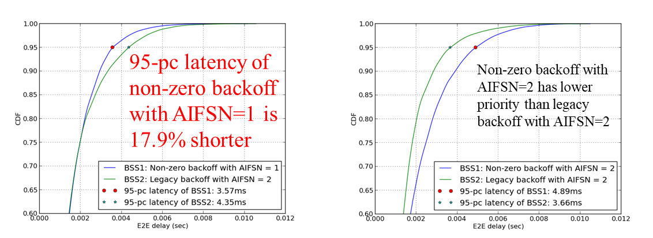

TGbe editor: The baseline for this document is 11be D2.1

9.4.2.313.2 EHT MAC Capabilities Information field

TGbe editor: update the below figure

B0 B1 B2 B3 B4
EPCS Priority Access Supported | EHT OM Control Support | Triggered TXOP Sharing Mode 1 Support | Triggered TXOP Sharing Mode2 Support | Restricted TWT Support
Bits: 1 1 1 1 1
B5 B6 B7 B8 B9 B10
SCS Traffic  Description Supported | Maximum MPDU Length | Maximum  A-MPDU Length Exponent | EHT TRS  Support | TXOP Return Support In TXOP Sharing Mode 2
Bits: 1 2 1 1 1
B11 B12 B15
Non-zero Random Backoff Supported | Reserved
Bits: 1 4

Figure 9-1002ae— EHT MAC Capabilities Information field format

TGbe editor: add the new row below to the table

Table 9-401k—Subfields of the EHT MAC Capabilities Information field (continued)
Subfield | Definition | Encoding
Non-zero random backoff Supported | For a STA, indicates support for generating a backoff count with a pseudorandom integer drawn from a uniform distribution over the interval [1,CW+1]. | If the +HTC-HE Support subfield is 1:  Set to 1 if the STA supports the non-zero random backoff procedure.  Set to 0 otherwise.  Reserved if the +HTC-HE Support subfield is 0.

TGbe editor: add the new subclause below

35.x Non-zero Random Backoff Procedure

An EHT STA that supports the non-zero random backoff procedure shall follow the rules as described in 10.3.3 (Random backoff procedure) except that
- The EHT STA shall use Equation (x-xx) to generate a random backoff count for an additional deferral time before transmitting if it uses non-zero random backoff procedure.
- The EHT STA shall use Equation (10-1) described in 10.3.3 (Random backoff procedure) to generate a random backoff count for an additional deferral time before transmitting otherwise.

Backoff Count = | NonzeroRandom() | (x-xx)
where
NonzeroRandom() = | Pseudorandom integer drawn from a uniform distribution over the interval [1,CW+1], where CW is an integer within the range of values of the PHY characteristics aCWmin and aCWmax, aCWmin ≤ CW ≤ aCWmax.

If an EHT non-AP STA affiliated with a non-AP MLD that supports the non-zero random backoff procedure, then its associated AP affiliated with an AP MLD or any other AP affiliated with the same AP MLD may transmit a unicast frame carrying an EDCA Parameter Set element with the minimum value of the AIFSN subfield set to 1 to the corresponding EHT non-AP STA affiliated with the non-AP MLD to enable the non-zero backoff procedure of the EHT non-AP STA.
Upon receipt of the EDCA Parameter Set element, the EHT non-AP STA that supports the non-zero random backoff procedure shall use non-zero random backoff procedure for an AC if the EHT non-AP STA updates its EDCA parameter of that AC with AIFSN[AC]=1 according to the EDCA Parameter Set element.

