IEEE P802.11
Wireless LANs
CR on 36.2.3 TRIGVECTOR parameters
Date: 2022-08-16
Author(s):
Name | Affiliation | Address | Phone | email
Bo Gong | Huawei |  |  | gongbo8@huawei.com

Abstract
This submission contains proposed comment resolutions to comments on P802.11be D2.0.
The changes are based on P802.11be D2.0.

This submission provides a resolution to the following CIDs:
- 10956, 12181, 12866 11216, 11217

Revisions:
- Rev 0: Initial version of the document.

CID 10956
CID | Page/Line | Clause | Comment | Proposed Change | Resolution
10956 | 561.17 | 36.2.3 | 320-1 MHz should have been changed to 320 MHz-1. | Change 320-1 MHz to 320 MHz-1. Change 320-2 MHz to 320 MHz-2. | Accepted

CID 12181
CID | Page/Line | Clause | Comment | Proposed Change | Resolution
12181 | 561.18 | 36.2.3 | TRIGVECTOR provides information for AP PHY to receive the PPDU, which does NOT distinguish between 320 MHz-1 and 320 MHz-2. | merge the two rows of "CBW320-1" and "CBW320-2" into one row of "CBW320". | Rejected  For a trigger frame, the bandwidth of the solicited TB PPDU from the addressed EHT STA (i.e., the bandwidth in the U-SIG field of the EHT TB PPDU) is indicated jointly by the UL BW subfield and the UL BW Extension subfield, where the 320 MHz-1 and 320 MHz-2 are distinguished. Since the TRIGVECTOR provides the PHY of the AP with the parameters needed to receive an EHT TB PPDU, it is better to clarify the bandwidth of 320 MHz-1 and 320 MHz-2 for convenience of reception.

CID 12866
CID | Page/Line | Clause | Comment | Proposed Change | Resolution
12866 | 561.18 | 36.2.3 | TRIGVECTOR does not cover 320 MHz-1 and 320 MHz-2. |  | Rejected  For a trigger frame, the bandwidth of the solicited TB PPDU from the addressed EHT STA (i.e., the bandwidth in the U-SIG field of the EHT TB PPDU) is indicated jointly by the UL BW subfield and the UL BW Extension subfield, where the 320 MHz-1 and 320 MHz-2 are distinguished. Since the TRIGVECTOR provides the PHY of the AP with the parameters needed to receive an EHT TB PPDU, it is better to clarify the bandwidth of 320 MHz-1 and 320 MHz-2 for convenience of reception.

Discussion:

For a trigger frame, the bandwidth of the solicited TB PPDU from the addressed EHT STA (i.e., the bandwidth in the U-SIG field of the EHT TB PPDU) is indicated jointly by the UL BW subfield and the UL BW Extension subfield, where the 320 MHz-1 and 320 MHz-2 are distinguished. Since the TRIGVECTOR provides the PHY of the AP with the parameters needed to receive an EHT TB PPDU, it is better to clarify the bandwidth of 320 MHz-1 and 320 MHz-2 for convenience of reception.
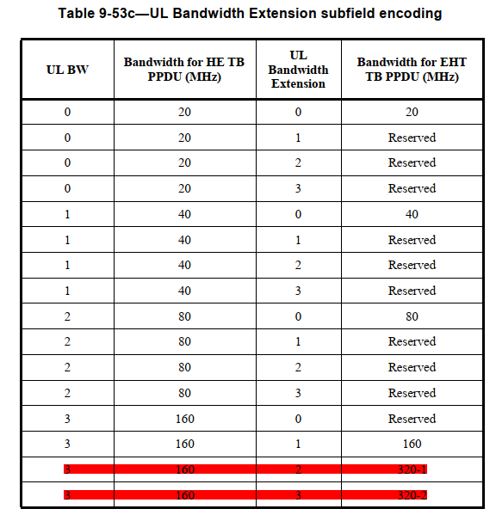
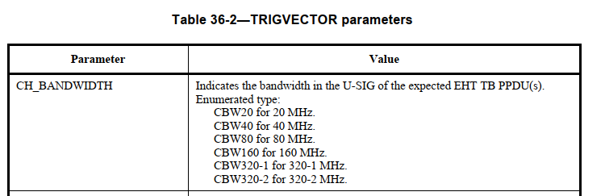

CID 11216
CID | Page/Line | Clause | Comment | Proposed Change | Resolution
11216 | 613.59 | 36.2.3 | HE variant User Info field subclause number is not matching | the " HE variant User Info field" on page165 should be numbered as 9.3.1.22.3 | Rejected  In Page 613, Line 59, there exists no HE variant User Info field. In Page 165, the subclause number of HE variant User Info field is 9.3.1.22.3, which is correct.

CID 11217
CID | Page/Line | Clause | Comment | Proposed Change | Resolution
11217 | 614.07 | 36.2.4 | EHT variant User Info field subclause number is not matching | the " EHT variant User infor fidle" on page 170 should be numbered as 9.3.1.22.4 | Rejected  In Page 614, Line 7 and subclause 36.2.4, there exists no EHT variant User Info field. In Page 170, there exists no subclause number of EHT variant User Info field.

