IEEE P802.11
Wireless LANs
CR on 36.3.13.5 Segment Parser
Date: 2022-09-05
Author(s):
Name | Affiliation | Address | Phone | email
Bo Gong | Huawei |  |  | gongbo8@huawei.com

Abstract
This submission contains proposed comment resolutions to comments on P802.11be D2.0.
The changes are based on P802.11be D2.0.

This submission provides a resolution to the following 5 CIDs:
- 10374, 10397, 11293, 11294, 13112

Revisions:
- Rev 0: Initial version of the document.

CID 10374
CID | Page/Line | Clause | Comment | Proposed Change | Resolution
10374 | 715.31 | 36.3.13.5 | Figure 36-52 is not clear, although I guess it may be an example of 484+2*996. It is better to add descriptions on what is m0, m1 and m2 in this example or what is the MRU in this example. Otherwise, it is diffcult to read. | Add descriptions that this is an example of the 484+2*996 case. | Revised  The title of Figure 36-52 should be changed to ‘Illustration of the proportional round robin parser with leftover bits processing for MRU 484+2*996’.  Instructions to the editor  Please make the changes as shown in 11/22-1469r0

Instructions to the Editor:

Please make the following changes in Line 16, Page 715 in TGbe Draft D2.0:

Illustration of the proportional round robin parser with leftover bits processing for MRU 484+2×996 is shown in Figure 36-52 (Illustration of the proportional round robin parser with leftover bits processing for MRU 484+2×996 ).

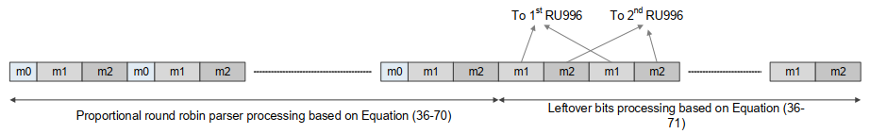

Figure 36-52—Illustration of the proportional round robin parser with leftover bits processing for MRU 484+2×996

CID 10397
CID | Page/Line | Clause | Comment | Proposed Change | Resolution
10397 | 715.36 | 36.3.13.5 | Compared with Figure 36-54, the descriptions around the block "LDPC tone mapper" in Figure 36-53 is missing, such as the DTM. | Add the missed descriptions around the block "LDPC tone mapper" shown in Figure 36-54 but not in 36-53. | Revised  The DTM value should be added around the block ‘LDPC tone mapper’ in Figure 36-53.  Instructions to the editor  Please make the changes as shown in 11/22-1469r0

Background:

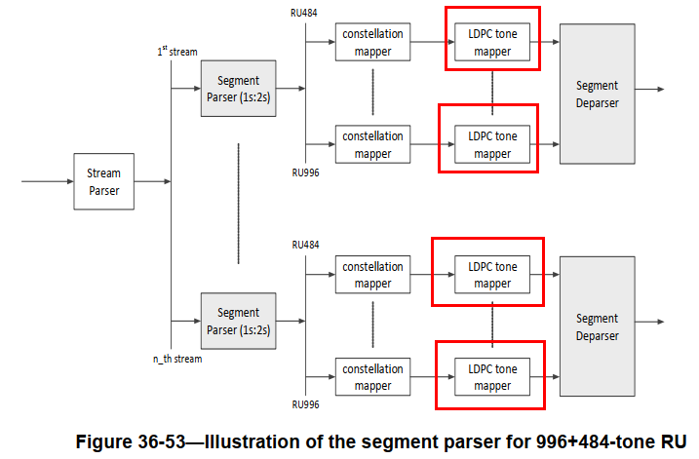

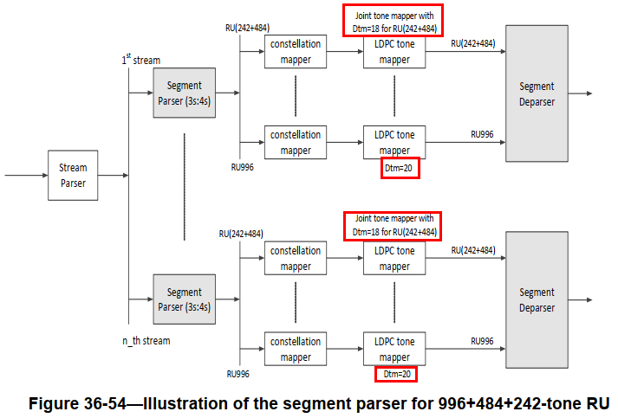

Instructions to the Editor:

Please insert ‘DTM = 12’ in the position of the red framework and insert ‘DTM = 20’ in the position of the red circle in Figure 36-53 in Line 36, Page 715 in TGbe Draft D2.0:

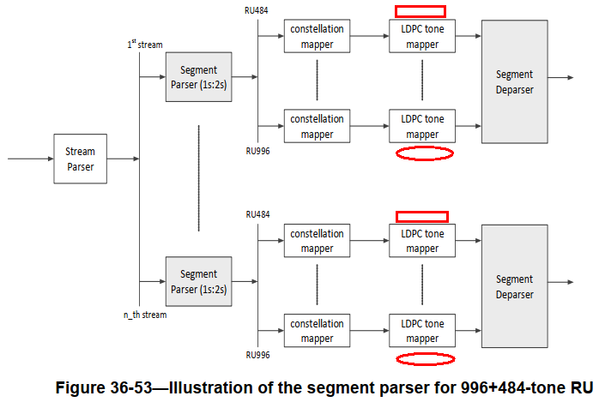

CID 11293
CID | Page/Line | Clause | Comment | Proposed Change | Resolution
11293 | 714.61 | 36.3.13.5 | "For the other frequency subblocks, the number of leftover bits as defined in Table 36-49 (Segment parser parameters) not equal to 0,". Missing verb. | Change "not equal to 0" to "are not equal to zero" | ACCEPTED

CID 11294
CID | Page/Line | Clause | Comment | Proposed Change | Resolution
11294 | 714.63 | 36.3.13.5 | "proportional round robin parser will continue to process the leftover bits as Equation (36-71)." (36-71) does not describe parsing, it only defines new values for m and k. | Change sentence to "proportional round robin parser (36-70) will continue to process the leftover bits, using the values of m and k given in Equation (36-71). | ACCEPTED

Background:

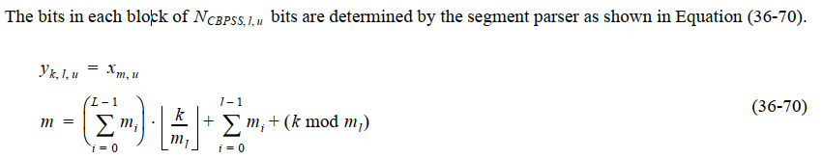

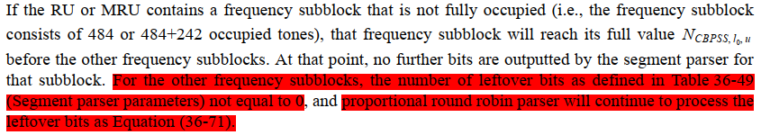

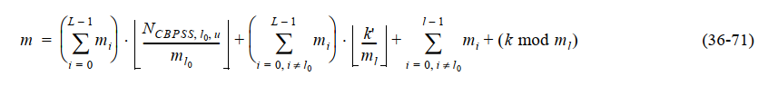

CID 13112

CID | Page/Line | Clause | Comment | Proposed Change | Resolution
13112 | 714.09 | 36.3.13.5 | Leftover bits should be applied to fully occupied frequency subblocks only. | Change "Leftover bits per frequency subblock" to "Leftover bits per fully occupied frequency subblock." | ACCEPTED

Background:

