IEEE P802.11
Wireless LANs
CR for Setup CIDs Part II
Date: 2022-10-02
Author(s):
Name | Affiliation | Address | Phone | email
Zinan Lin | InterDigital |  |  | zinan.lin@interdigital.com
Mahmoud Kamel | InterDigital
Abstract

This submission present proposed resolutions for the following 3 CIDs: 661, 662, , 899

The proposed changes are based on 802.11bf/D0.3.

Revision history:

r0 – initial version

r1 – editorial change and the resolution update of CID 899
r2 – move CID 671 to 11-22/1803

CID | Commenter | Clause | Page(C) | Line(C) | Comment | Proposed Change
661 | Osama Aboulmagd |  | 13 | 16 | The definition of Sensing Responder is not clear. It is defined as "A STA that participates in a WLAN sensing..." However the nature of this participation is not articulated. As it stands now the definition is really fuzzy and doesn't add much. | Define the role of the Sensing Receiver.

Resolution: Rejected.

Discussion: Assume the comment is on page 16 not on page 13. The comment and the proposed change do not match. The comment is talking about the definition of Sensing Responder but the proposed change is talking about the sensing receiver.

CID | Commenter | Clause | Page(C) | Line(C) | Comment | Proposed Change
662 | Osama Aboulmagd |  | 13 | 9 | In many places of the baseline the terms "Initiator" and "Responder" were sufficient to describe in the intended function. What does adding "receiver "and "transmitter" is required for sensing. | The TG needs to discuss the need for the terms "Transmitter" and "Receiver" and delete them if they serve no essential function

Resolution: Rejected

Discussion: There is no term “Initiator”, “Responder”, “Receiver” and “Transmitter” on P13L9 of 802.11bf D0.1. Furturemore, as indicated on P88L56 (802.11bf D0.3), “A STA acting as a sensing responder may participate in a sensing measurement instance as a sensing transmitter, a sensing receiver, or both a sensing transmitter and a sensing receiver”. As shown on P17 of 802.11bf D0.3, “ a sensing transmitter: A station (STA) that transmits PPDUs used for sensing measurements in a WLAN sensing procedure”; “sensing receiver: A station (STA) that receives PPDUs sent by a sensing transmitter and obtains measurements in a WLAN sensing procedure”.

Therefore, the terms of “sensing transmitter” and “sensing receiver” are needed.
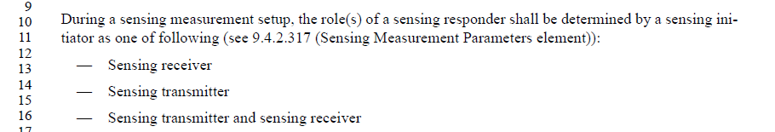

CID | Commenter | Clause | Page | Comment | Proposed Change
899 | Zinan Lin | 9.4.2.317 | 33.08 | It does not depict the frame that includes the Sensing Measurement Parameters element? | The Sensing Measurement Paramters element is included in the Sensing Measurement Request frame, as described in 9.6.7.49 (Sensing Measurement Setup Request frame format), and in the Sensing Measurement Setup Response frame, as described in 9.6.7.50 ( Sensing Measurement Response frame).

Resolution: Rejected

Discussion: Element Inclusion Convenstions are indicated in 11-09/1034r20 802.11 Style Guide as follows. Therefore, to follow 802.11 style guide, there is no need to list the frames that can carry the element in the subclause of the definition of the element.

