IEEE P802.11
Wireless LANs
CR for Setup CIDs Part II
Date: 2022-10-02
Author(s):
Name | Affiliation | Address | Phone | email
Zinan Lin | InterDigital |  |  | zinan.lin@interdigital.com
Mahmoud Kamel | InterDigital
Abstract

This submission present proposed resolutions for the following 4 CIDs: 661, 662,671, 899

The proposed changes are based on 802.11bf/D0.3.

Revision history:

r0 - initial version

CID | Commenter | Clause | Page(C) | Line(C) | Comment | Proposed Change
661 | Osama Aboulmagd |  | 13 | 16 | The definition of Sensing Responder is not clear. It is defined as "A STA that participates in a WLAN sensing..." However the nature of this participation is not articulated. As it stands now the definition is really fuzzy and doesn't add much. | Define the role of the Sensing Receiver.

Resolution: Rejected.

Discussion: Assume the comment is on page 16 not on page 13. The comment and the proposed change do not match. The comment is talking about the definition of Sensing Responder but the comment is talking about the sensing receiver.

CID | Commenter | Clause | Page(C) | Line(C) | Comment | Proposed Change
662 | Osama Aboulmagd |  | 13 | 9 | In many places of the baseline the terms "Initiator" and "Responder" were sufficient to describe in the intended function. What does adding "receiver "and "transmitter" is required for sensing. | The TG needs to discuss the need for the terms "Transmitter" and "Receiver" and delete them if they serve no essential function

Resolution: Rejected

Discussion: There is no term “Initiator”, “Responder”, “Receiver” and “Transmitter” on P13L9 of 802.11bf D0.1. Furturemore, as indicated on P88L56 (802.11bf D0.3), “A STA acting as a sensing responder may participate in a sensing measurement instance as a sensing transmitter, a sensing receiver, or both a sensing transmitter and a sensing receiver”. As shown on P17 of 802.11bf D0.3, “ a sensing transmitter: A station (STA) that transmits PPDUs used for sensing measurements in a WLAN sensing procedure”; “sensing receiver: A station (STA) that receives PPDUs sent by a sensing transmitter and obtains measurements in a WLAN sensing procedure”.

Therefore, the terms of “sensing transmitter” and “sensing receiver” are needed.
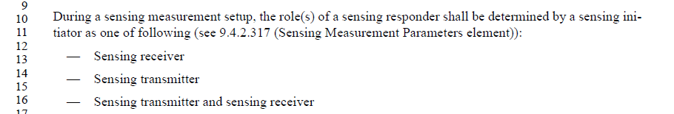

CID | Commenter | Clause | Page(C) | Line(C) | Comment | Proposed Change
671 | Osama Aboulmagd |  | 33 |  | Two Figure 1-41a and 11-41b has the same title. The TG needs to discuss using only one Figure to make the point

Resolution: Revised

Discussion: 802.11bf D0.3 has updated the illustration of Figure 11-41a and Figure 11-41b as follows:

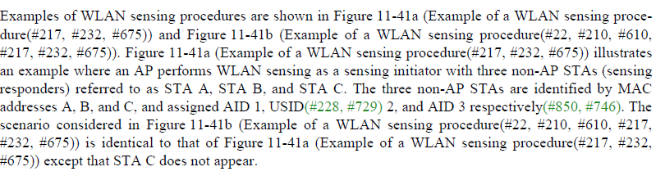

However, the titles of Figure 11-41a and Figure 11-41b are the same. To differentiate the titles of these figures, it would be good to rename the titles of these two figures.

TGbf editor: please make the following change
CID #671:
- change the title of Figure 11-41a as Example of a WLAN sensing procedure with STA A, STA B and STA C.
- change the title of Figure 11-41b as Example of a WLAN sensing procedure with STA A and STA B

CID | Commenter | Clause | Page | Comment | Proposed Change
899 | Zinan Lin | 9.4.2.317 | 33.08 | It does not depict the frame that includes the Sensing Measurement Parameters element? | The Sensing Measurement Paramters element is included in the Sensing Measurement Request frame, as described in 9.6.7.49 (Sensing Measurement Setup Request frame format), and in the Sensing Measurement Setup Response frame, as described in 9.6.7.50 ( Sensing Measurement Response frame).

Resolution: Revised

TGbf editor: please make the following change

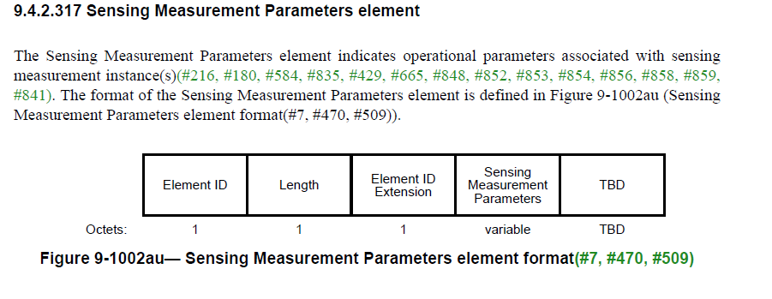
Please add the following sentence in the end of the paragraph P48L30 of 802.11bf D0.3

(#899) The Sensing Measurement Parameters Element is included in the Sensing Measurement Request frame,
as described in 9.6.7.49 (Sensing Measurement Setup Request frame format), and in the Sensing Setup Response frame, as described in 9.6.7.50 ( Sensing Measurement Setup Response frame format).

