IEEE P802.11
Wireless LANs
LB266: CR for P2P Support in R-TWT
Date: 2022-09-04
Author(s):
Name | Affiliation | Address | Phone | email
Muhammad Kumail Haider | Meta | 1180 Discovery Wy, Sunnyvale, CA |  | haiderkumail@fb.com
Chunyu Hu | Meta
Chitto Ghosh | Meta
Binita Gupta | Meta
Morteza Mehrnoush | Meta

Abstract
This submission proposes resolutions for the following CIDs (12) for TGbe LB266:
13013, 11706, 12837, 12834, 13226, 13306, 13641, 12777, 12787, 12720, 10063, 13086

Revisions:
- Rev 0: Initial version of the document
- Rev 1: Some changes based on offline comments deferred #12787, 12720 on member request, rebased on 11beD2.1.1 and added resolution to related CIDs 10063, 13086

Interpretation of a Motion to Adopt

A motion to approve this submission means that the editing instructions and any changed or added material are actioned in the TGbe Draft. This introduction is not part of the adopted material.

Editing instructions formatted like this are intended to be copied into the TGbe Draft (i.e. they are instructions to the 802.11 editor on how to merge the text with the baseline documents).

TGbe Editor: Editing instructions preceded by “TGbe Editor” are instructions to the TGbe editor to modify existing material in the TGbe draft. As a result of adopting the changes, the TGbe editor will execute the instructions rather than copy them to the TGbe Draft.

TGbe editor: The baseline for this document is P802.11be D2.1.1 and P802.11meD1.3

CID | Commenter | Clause | Pg/Ln | Comment | Proposed Change | Resolution
13013 | Chunyu Hu | 35.9.4.1 | 511.51 | The r-TWT usage can be extended to better support and protect the direct (tethered) link to deliver latency sensitive traffic. | As in comment | Revised  Agreed in principle with providing support for p2p in R-TWT.  TGbe editor, please make change as shown in 22/1463r2 tagged by #13013.
11706 | Abdel Karim Ajami | 9.4.2.199 | 206.24 | To assist latency sensitive traffic of p2p link, it may be useful to allow a STA to negotiate R-TWT schedule for p2p | As in the comment | Revised  Agreed in principle.  TGbe editor, please make change as shown in 22/1463r2 tagged by #13013.
12837 | Laurent Cariou | 35.9.4 | 510.55 | A network's ability to serve time-sensitive traffic is affected by unmanaged P2P transmission. While 11be has defined tools such as TXS to manage P2P transmissions on same channel, there is no requirement for the AP or STA to use this feature. As such any STA can simply transmit P2P traffic on the same channel at which an AP has setup r-TWT SPs and disrupt the latter. | Define a mechanism such that the network advertizes channels with sufficient BW in which it promises not to operate and which can be used for P2P transmission. In exchange, the P2P STAs either do not operate on the channels/ service periods in which the network is serving low latency traffic or operates in them using after being scheduled by the AP(e.g., TXS). | Revised  Agreed in principle. We add rules in this doc for scheduled access by AP using TXS mechanism during R-TWT SPs.  TGbe editor, please make change as shown in 22/1463r2 tagged by #12837.
12834 | Laurent Cariou | 9.4.2.199 | 206.23 | With widespread usage of XR traffic, P2P transmissions requiring low latency will likely be sgnificant. At the same time the network also needs to protect other transmissions within its BSS from being interrupted by P2P transmissions. However, r-TWT does not explicitly mention whether the SP is to be used for P2P traffic. | Clarify whether P2P transmissions are covered in the case when Broadcast TWT Reccomendation field value = 4. If not, cover this. Also add corresponding signaling from a non-AP STA requesting an AP to allocate resources for P2P traffic. | Revised  Agreed in principle. Resolution to #13013 and #12837 satisfy this comment as well.  TGbe editor, please make change as shown in 22/1463r2 tagged by #13013 and #12837.
13226 | Binita Gupta | 35.9.4.2 | 510.51 | There are many AR/VR and cloud gaming use cases with topologies where latency sensitive traffic for the application is transmitted over a peer-to-peer/tethered link between a non-AP STA and a peer STA. To provide improved e2e performance for such applications, it is desirable to enhance rTWT to support LST over the p2p link so that rTWT benefit of TxOP protection can also be leveraged for LST transmitted on the p2p link and AP can schedule TxOP sharing (using MU RTS TXS Trigger) for p2p traffic during rTWT SPs requiring support for p2p traffic. | Add support for p2p traffic for rTWT and TxOP Sharing for p2p link during rTWT SPs. | Revised  Agreed in principle. Resolution to #13013 and #12837 satisfy this comment as well.  TGbe editor, please make change as shown in 22/1463r2 tagged by #13013 and #12837.
13306 | Muhammad Kumail Haider | 35.9.5 | 511.17 | STAs should be able to use r-TWT operation to provide protection for latency sensitive traffic on their p2p links as well, as it aligns with 802.11be direction to expand support for low-latency traffic and support p2p link traffic. Support of a STA's p2p traffic during r-TWT SPs should be expanded and necessary provisions made. | Add a new Broadcast Recommendation value to explicitly indicate p2p traffic delivery during r-TWT SPs and add necessary provisions/traffic delivery rules in 35.9 | Revised  Agreed in principle. Resolution to #13013 and #12837 satisfy this comment as well.  TGbe editor, please make change as shown in 22/1463r2 tagged by #13013 and #12837.
13641 | Rubayet Shafin | 35.9.5 | 510.51 | P2P STAs should be able to use a r-TWT schedule to communicate over the P2P link. However, the AP-side and STA-side procedures to enable the use of r-TWT for P2P communication is currently missing in the 11be spec. | Please add text in the spec related to procedures to enable r-TWT operation for P2P communications. | Revised  Agreed in principle. Resolution to #13013 and #12837 satisfy this comment as well.  TGbe editor, please make change as shown in 22/1463r2 tagged by #13013 and #12837.
12777 | Romain GUIGNARD | 9.4.2.199 | 207.29 | The restricted TWT Traffic Info field is used during the TWT agreement setup to specify which TID(s) are identified as latency sensitive traffic streams in the UL and DL direction. However, it is not stated how to specify which TID(s) are latency sensitive in P2P case. | Could you please define signaling to support P2P case in TWT agreement setup or could you clarify the usage of the existing signaling for the P2P case? | Revised  Signaling to support p2p case in R-TWT membership setup is defined.  TID indication on p2p link for R-TWT operation is not needed as p2p traffic does not go through the AP-STA link.  TGbe editor, please make change as shown in 22/1463r2 tagged by #13013 and #12837.
10063 | Morteza Mehrnoush | 35.9 | 510.51 | The current TDLS setup doesn't accommodate the r-TWT schedule among the peer STAs so that the rTWT SP can be scheduled and announced directly between the TDLS peer STAs. This is specially helpful when two TDLS peer STAs switching to off-channel and AP doesn't have knowledge of the traffic between TDLS peer STAs. Please define such a procedure in the spec. | as in comment | Revised  Signaling to support p2p case in R-TWT membership setup is defined, which includes support for STA’s traffic on TDLS link with a peer STA.  The baseline allows two TDLS STAs to setup a schedule not necessarily through the AP. The specific scenario of TDLS STAs switching to off-channel is not relevant to R-TWT operation in 11be.  TGbe editor, please make change as shown in 22/1463r2 tagged by #13013 and #12837.
13086 | Chittabrata Ghosh | 35.9 | 510.51 | The current TDLS setup doesn't accommodate the r-TWT schedule among the peer STAs so that the rTWT SP can be scheduled and announced directly between the TDLS peer STAs. This is specially helpful when two TDLS peer STAs switching to off-channel and AP doesn't have knowledge of the traffic between TDLS peer STAs. Please define such a procedure in the spec. | as in comment | Revised  Signaling to support p2p case in R-TWT membership setup is defined, which includes support for STA’s traffic on TDLS link with a peer STA.  The baseline allows two TDLS STAs to setup a schedule not necessarily through the AP. The specific scenario of TDLS STAs switching to off-channel is not relevant to R-TWT operation in 11be.  TGbe editor, please make change as shown in 22/1463r2 tagged by #13013 and #12837.
12787 | Romain GUIGNARD | 35.9.4 | 510.51 | The broadcast TWT setup is performed between a requesting STA and the AP. In case of P2P communication during a SP between the requesting STA and its peer STA, it is not clear how this peer STA is enrolled in the bTWT agreement. Indeed, if the peer STA is not informed about the TWT agreement, the peer STA could be in doze state and not be able to receive the data from the requesting STA. | The standard should propose a mean to inform a P2P communication receiver STA that it will be involved as a receiver during a bTWT SP. | Revised  Signaling to request/grant membership in R-TWT schedules for p2p use is defined in this CR doc.  However, how p2p peer STAs communicate over the p2p link, and how they switch PS states is beyond the scope of 802.11be standard. Note that p2p receiver STA need not be an EHT STA.  TGbe editor, please make change as shown in 22/1463r2 tagged by #13013 and #12837.
12720 | Pascal VIGER | 35.9.4 | 511.40 | The transmission of direct link frames is possible by using MU-RTS TXS Trigger frames in an r-TWT period. As already done for UL/DL, please consider a restricted P2P Link bitmap for such a P2P latency sensitive traffic. | as per comment | Rejected  A restricted P2P Link bitmap, as indicated in the comment, does not exist in current spec. UL/DL TID Bitmaps do exist; however, a similar bitmap for TIDs on p2p link is not needed because the p2p traffic does not go through the AP-STA link. Therefore, TID indication for p2p link for R-TWT operation is not needed.

Discussion:
Multiple motions passed in 802.11be reflect group’s support to facilitate a STA’s peer-to-peer traffic in 802.11be:
- The 802.11be amendment shall define mechanism(s) for an AP to assist a STA that communicates with another STA (Motion 22, 19/1755r2)
- 802.11be supports defining a procedure for an AP to share time resource obtained in a TXOP for peer-to-peer (STA-TO-STA) frame exchanges
  - Whether it is in R1 or R2 is TBD (Motion 111, #SP0611-24)
Several scenarios like mobile gaming and AR/VR encompass a topology where latency sensitive traffic goes from a mobile device to the AP via a peer STA. In such cases, it is critical to support the STA’s p2p traffic as well to ensure better end-to-end latency performance and user-experience. Therefore, in alignment with the direction agreed by the group in above motions, and several comments received in LB266, we propose to add explicit indication for a STA’s p2p traffic in R-TWT operation by defining a new Broadcast TWT Recommendation value 5.
- With this new value, a STA can explicitly indicate to the AP that it has p2p traffic as well, and request resources during the R-TWT setup. Further, in announcements, AP can also specifically advertise schedule(s) during which it is willing to support p2p traffic.
- With this new value, the traffic prioritization rules defined in 11beD2.0 SC 35.9.5 remain intact. In addition, the AP allocates resources for a STA’s p2p traffic as well.
- In particular, we propose that in an R-TWT SP with Broadcast TWT Recommendation value 5, the AP schedules at least one MU RTS TXS Trigger frame with Sharing Mode 2 (if both AP and STA support this procedure), such that it allocates some time (at AP’s discretion) for STA’s p2p traffic as well.

Use-Case Example:
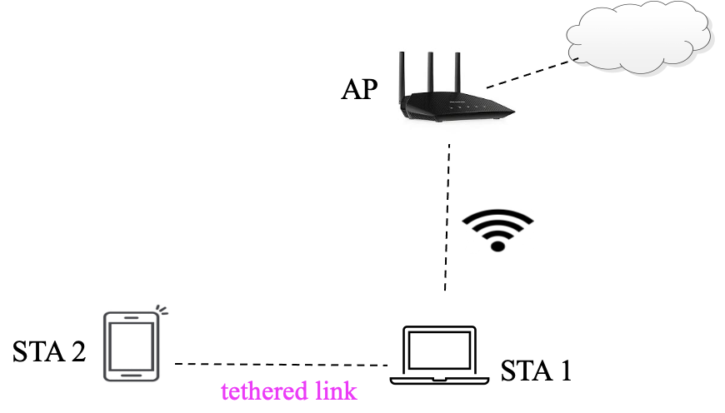
In this example, STA1 is associated with AP in an infrastructure BSS, while STA2 connects to the cloud through STA1 via a p2p link (tethered link). The p2p link and AP-STA1 link are co-channel, and traffic over the p2p is not necessarily forwarded from via the AP (e.g., STA1 does rendering computation for STA2). Further, STA2 is not associated with/in range of the AP but it may be in range of other STAs in the BSS.
Our proposal for adding Broadcast TWT Recommendation value 5 and TXS provisions for p2p traffic helps support the STA1’s Latency Sensitive Traffic (LST) with STA2. In particular:
- p2p traffic also benefits from R-TWT SP start boundary protection
- Some LST on p2p link may be to/from cloud (e.g., cloud gaming or various VR applications) and going through STA1. As such, using a single R-TWT SP for UL/DL + p2p traffic is a huge advantage for STA1’s power saving and overall latency performance of application
The diagram below shows an example of how MU-RTS TXS Trigger frame with Sharing Mode 2 can be used by STA1 for its p2p traffic exchange with STA2.
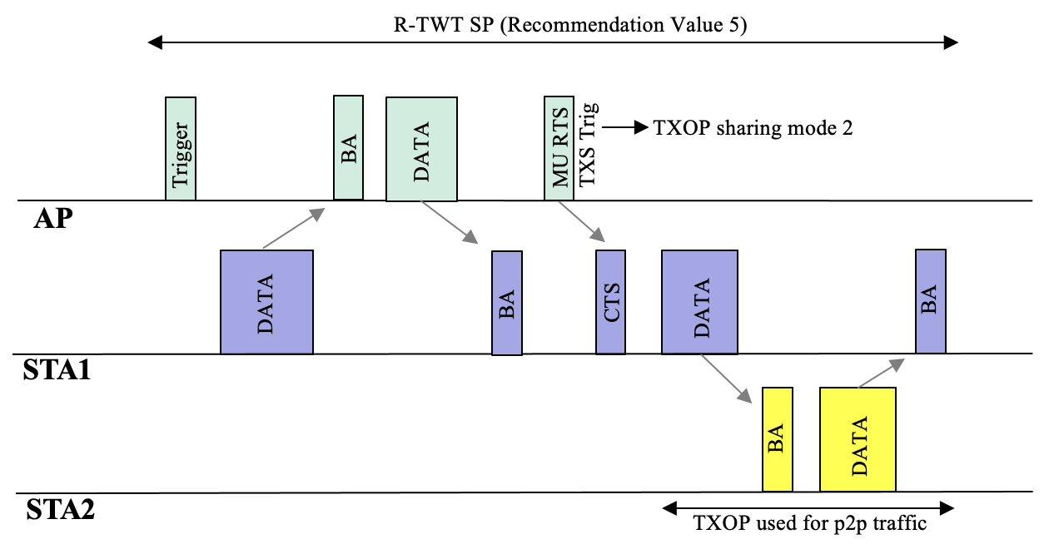
  - At R-TWT SP start, AP first solicits STA1’s UL traffic of R-TWT TID(s) using Basic Trigger frame (could trigger multiple STAs)
  - After receiving BA from STA1, AP sends DATA of R-TWT TID(s) in DL, followed by BA from STA1
  - AP then sends an MU RTS TXS Trigger to STA1 with TXOP Sharing Mode 2
  - STA1 uses allocated TXOP to exchange LST on Link2 with STA2.

9. Frame formats
9.4.2.199. TWT element
TGbe editor: modify 20th paragraph of 9.4.2.199 (last paragraph on Page 1610 of REVmeD1.3) (﻿The TWT Flow Identifier…) as follows:
﻿The TWT Flow Identifier subfield contains a 3-bit value that identifies the specific information for this TWT request uniquely from other requests made between the same TWT requesting STA and TWT responding STA pair. The Broadcast TWT Recommendation subfield contains a value that indicates recommendations on the types of frames that are transmitted by TWT scheduled STAs and scheduling AP during the broadcast TWT SP, encoded according to the Broadcast TWT Recommendation field for a broadcast TWT element as ﻿defined in Table 9-332 (Broadcast TWT Recommendation field for a broadcast TWT element(11ax)). The Broadcast TWT Recommendation is reserved if transmitted by a TWT scheduled STA(#13013), except when the STA is also an R-TWT scheduled STA, in which case it may set the Broadcast TWT Recommendation field to 0, 4 or 5.

TGbe editor: change Table 9-339 (not all rows shown) and the paragraph below it of P802.11beD2.1.1 as follows:
Table 9-339—Broadcast TWT Recommendation field for a broadcast TWT element

Broadcast TWT Recommendation field value | Description when transmitted in a broadcast TWT element
… | …
4 | The corresponding broadcast TWT SP is referred to as an R-TWT SP.  During an R-TWT SP, the AP and member R-TWT scheduled STAs prioritize their transmission of QoS Data frames that are latency sensitive traffic (see 35.9 (Restricted TWT (R-TWT))).  ﻿
(#13013)5 | The corresponding broadcast TWT SP is referred to as an R-TWT SP.  During an R-TWT SP with Broadcast TWT Recommendation value 5, the AP and member R-TWT scheduled STAs prioritize their transmission of QoS Data frames that are latency sensitive traffic between them, as well as those between a member R-TWT scheduled STA and its peer STA(s), as described in 35.9 (Restricted TWT (R-TWT)).
(#13013)5 6–7 | Reserved
A broadcast TWT parameter set that has the Broadcast TWT Recommendation field value equal to 4 (#13013)or 5 is referred to as a restricted TWT parameter set.
TGbe editor: insert the following new paragraph after the paragraph (The Restricted TWT DL TID Bitmap and Restricted TWT UL TID Bitmap subfields) in P802.11beD2.1.1, as follows:
(#13013)NOTE: In a restricted TWT parameter set included in a TWT element in a TWT setup frame, if the Broadcast TWT Recommendation field is set to 5 and all bits in the Restricted TWT DL TID Bitmap and Restricted TWT UL TID Bitmap subfields are set to 0, the corresponding R-TWT schedule is intended to prioritize the transmission of QoS Data frames that are latency sensitive traffic between the member R-TWT scheduled STA and its peer STA(s), as described in 35.9 (Restricted TWT (R-TWT)).

35.9 Restricted TWT (R-TWT)

35.9.4 Channel access rules for R-TWT SPs
35.9.4.1 TXOP rules for R-TWT SPs
TGbe editor: insert the following new paragraph at the end of 35.9.4.1 of P802.11be D2.1.1, as follows:
(#12837)During an R-TWT SP for which the R-TWT scheduled STA sets up its membership in an R-TWT schedule with the Broadcast TWT Recommendation field set to 5, if both the R-TWT scheduling AP and the R-TWT scheduled STA have the Triggered TXOP Sharing Mode 2 Support subfield in the EHT Capabilities element set to 1, the R-TWT scheduling AP shall schedule for transmission at least one Trigger frame addressed to the R-TWT scheduled STA that is an MU RTS TXS Trigger frame with the TXOP Sharing Mode subfield set to 2 (see 35.2.1.2 Triggered TXOP sharing procedure).

