IEEE P802.11
Wireless LANs
[CR for CC40 Instance TTT Sensing Measurement Report Type Field Length]
Date: 2022-06-12
Author(s):
Name | Affiliation | Address | Phone | email
Junghoon Suh | Huawei |  |  | junghoon.suh@huawei.com
Stephen McCann | Huawei |  |  | stephen.mccann@huawei.com
Abstract
This submission proposes resolutions for the follwing CC40 CIDs: 65 and 119. The proposed changes are based on IEEE 802.11bf D0.1 [1].

Revisions:

- Rev 0: Initial version of the document.
- Rev 1:

CID 65 and 119

CID | Page | Clause | Comment | Proposed Change | Resolution
65 | 34.15 | 9.4.2.318 | The length of field "Sensing Measurement Report Type" shall be 1 octet | Length shall be 1 octet based on Table 9-401s | Revised  Change the Length to 3 Bits  Note to editor: Please incorporate the changes in https://mentor.ieee.org/802.11/dcn/22/11-22-1459-00-00bf-cr-for-cc40-instance-sm-report-type-field-length.docx
119 | 34.15 | 9.4.2.318 | Why is the length of the "Sensing Measurement Report Type" subfield TBD? Table 9-491s appears to show 256 possible values (1 byte). | See comment | Revised  Change the Length to 3 Bits  Note to editor: Please incorporate the changes in https://mentor.ieee.org/802.11/dcn/22/11-22-1459-00-00bf-cr-for-cc40-instance-sm-report-type-field-length.docx

Proposed Resolution: Revised

Discussion: There are two places for the Sensing Measurment Report Type to be indicated in the Sensing. One is the Sensing Measurement Set-up frame, and the other is the Sensing Measurement Report frame. We reached the consensus to set the length of the Sensing Measurement Report Type subfield to 3 bits in the 22/1206r3. We need to align the length of the subfield in Figure 9-1002aw as well.

Option 1: There is a proposal in 22/1248r1 to replace the Sensing Measurement Report element by the Sensing Measurement Report field, which enables the length unit of the subfield to bits. Hence, the Figure 9-1002aw can be given as following,

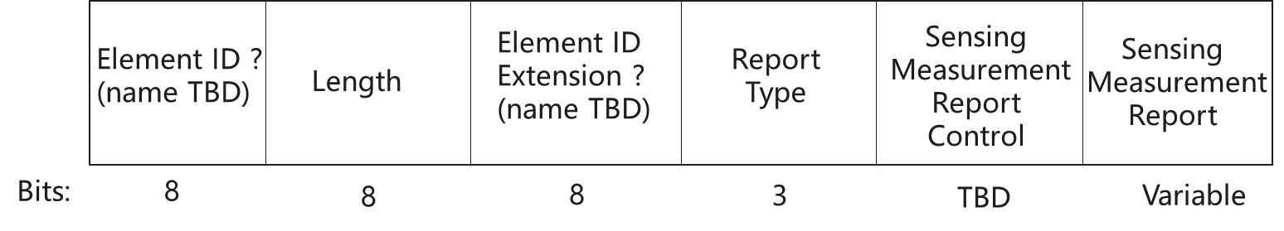
Figure 9-1002aw --- Sensing Measurement Report field format

Option 2: We can just set the Sensing Measurement Report Type to 3 bits and the rest to Reserved in the element. So, the Figure for this format can be given as following,

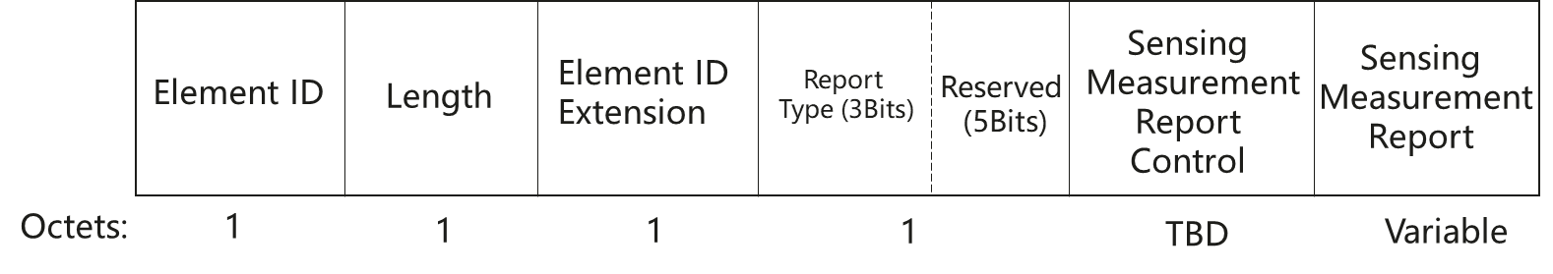
Figure 9-1002aw --- Sensing Measurement Report element format

Option 3: We can merge the Sensing Measurment Report Type element with Sensing Measurement Report Control element. So, the Figure for this format can be given as following,

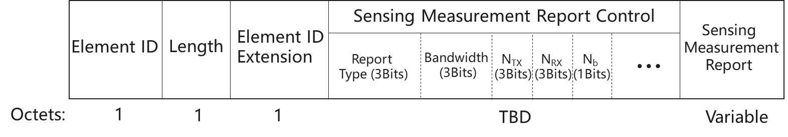
Figure 9-1002aw --- Sensing Measurement Report element format

TGbf editor: please modify the following Figure 9-1002aw in D0.1

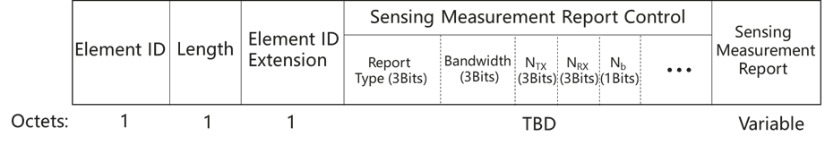
Figure 9-1002aw --- Sensing Measurement Report element format

References:
[1] 802.11bf D0.1

