IEEE P802.11
Wireless LANs
Resolutions to Editorial Comments in SA3
Date: 2022-09-11
Author(s):
Name | Affiliation | Address | Phone | email
Yujin Noh | LG Electronics |  |  | yujin.noh at lge.com
Stephan Sand | German Aerospace Center (DLR) |  |  | stephan.sand at dlr.de
Abstract
This submission shows
- Comments from TGbd draft 6.0.
- Resolutions applied to TGbd draft 6.0.
- 3 CIDs:
7000, 7002, 7003

Revisions:
- Rev 0: Initial version of the document.
- Rev 1: updated for further discussion
- Rev 2: text proposal to add ANA

CID | P.L | Comment | Proposed Change | Resolution
NO CID | 39.34 | There is an unassigned <ANA> value in 11bd D6.0 at P39L34. Need to process the <ANA> assignment/request during the process preparing D7.0. | As in comment | This is the text proposal

Text Proposal to fill <ANA> at P39L34 as shown.

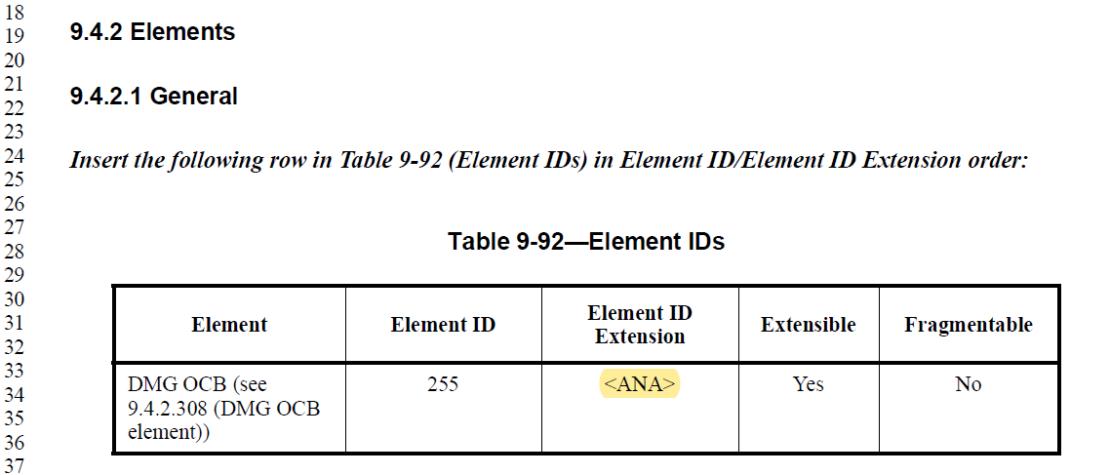

115 has been assigned, and D7.0 shows

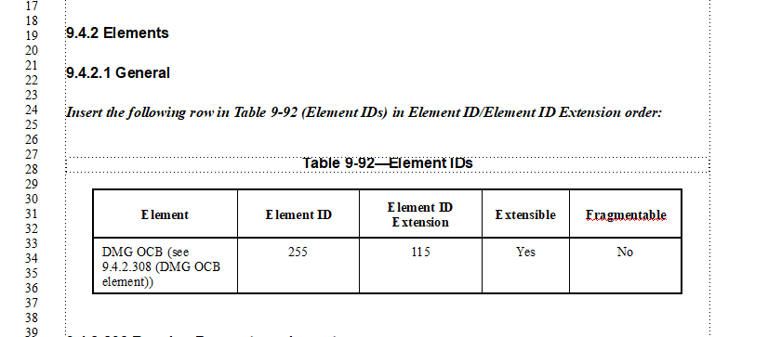

CID | P.L | Comment | Proposed Change | Resolution
7002 | 1.07 | 11bd D6.0 is currently based on 11az D4.0. However, 11az is curently on D6.0 and D5.0 has been available for some months. Please update 11bd so that it refers to the latest version of 11az D6.0 | As in comment | Accepted.
Discussion

In 11bd D6.0 as shown
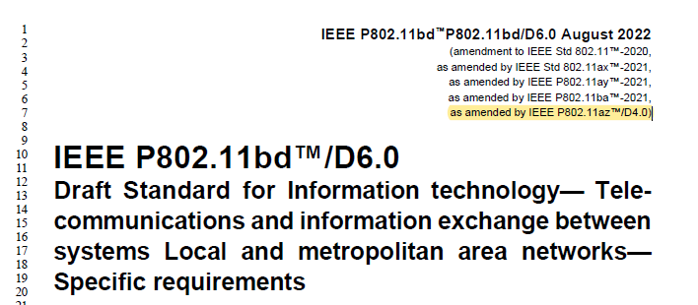

In 11bd D7.0 will shown as below.
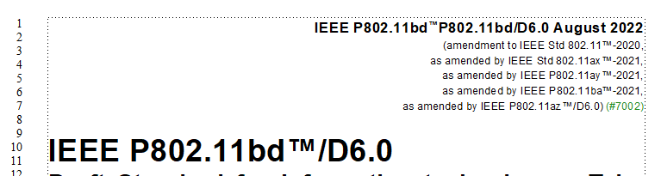

CID | P.L | Comment | Proposed Change | Resolution
7000 | 130.59 | In 11az D6.0 "Next Generation Positioning" has been changed to "Enhanced Positioning" and "NGP" to "EP". Please update all references in 11bd D6.0 accoringly. Note this comment might be out of scope as it addresses an issue with 11az D6.0, but 11bd D6.0 is still based on 11az D4.0. | As in comment | Revised.  To TGbd Editor:  “Next Generation Positioning” is updated to “Enhanced Positioning” at P130L59  “NGP” is updated to “EP” at P130L62.  “NGPM4.1” is updated to “EPM4.1” at P130L65 and P131L6.  Option 2) Rejected.  This comment will be passed to the IEEE-SA editor for consideration during publication editing.
Discussion

In 11bd D6.0 as shown

In 11az D6.0 as shown
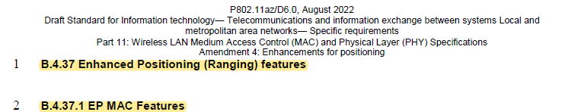

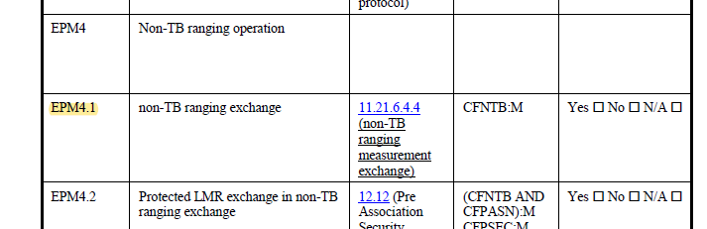

In 11bd D7.0 will shown as below.

CID | P.L | Comment | Proposed Change | Resolution
7003 | 68.23 | The capabilities of a transmit STA should be compatible to those of the addressed STA (i.e., the receiving STA) | Add "common between the transmit and the receive STA" to the end of the sentence. | Rejected.  Higher layer aspects are out of the scope of this standard.  Due to the vehicular environment, we may not know which NGV STAs are around to receive packets. Therefore, most packets will be broadcast.  The higher layer may learn through a local dynamic map (LDM), which stations are around and obtain their capabilities and decide to which other stations it may communicate or not.  So there is the possibility that it may communicate to a subgroup but not to all NGV STAs in its vicinity. This change may exclude this possibility as not all NGV STAs may have the same capabilities.
Discussion

In 11bd D6.0 as shown


