IEEE P802.11  
Wireless LANs

|  |  |  |  |  |
| --- | --- | --- | --- | --- |
| HT Transmit Spectrum Mask Alignment | | | | |
| Date: 2022-12-6 | | | | |
| Author(s): | | | | |
| Name | Affiliation | Address | Phone | email |
| Dong Wei | NXP |  |  | dong.wei@nxp.com |
| Rui Cao | NXP |  |  | rui.cao_2@nxp.com |

Abstract

In this document, we point out a discrepancy between the HT transmit spectral mask floor and the VHT/HE/EHT transmit spectral mask floor, and propose that the former be updated to be consistent with the latter. This document attempts to resolve CIDs 3778 and 3779.

|  |  |  |  |  |  |  |
| --- | --- | --- | --- | --- | --- | --- |
| **CID** | **Clause Number(C)** | **Page(C)** | **Line(C)** | **Clause** | **Comment** | **Proposed Change** |
| 3779 | 19.3.18.1 | 3301 | 30 | 19.3.18.1 | The spectrum mask floor definition for HT PPDU in 2.4GHz is different from 5GHz, i.e. -40dBr at 5GHz bands, but -45dBr for 2.4GHz. However, for 11a/g 20MHz PPDU, and 20MHz/40MHz PPDU in later standards (11ax and 11be), the spectrum mask floor is defined to be consistently at -40dBr for both 2.4GHz and 5/6GHz bands. With that, the spec definition is inconsistent to have -45dBr only for HT PPDU in 2.4GHz band. | Unify the HT mask floor definition to be -40dBr in 2.4GHz band the same as other PPDU formats. |
| 3778 | 19.3.18.1 | 3300 | 43 | 19.3.18.1 | The spectrum mask floor definition for HT PPDU in 2.4GHz is different from 5GHz, i.e. -40dBr at 5GHz bands, but -45dBr for 2.4GHz. However, for 11a/g 20MHz PPDU, and 20MHz/40MHz PPDU in later standards (11ax and 11be), the spectrum mask floor is defined to be consistently at -40dBr for both 2.4GHz and 5/6GHz bands. With that, the spec definition is inconsistent to have -45dBr only for HT PPDU in 2.4GHz band. | Unify the HT mask floor definition to be -40dBr in 2.4GHz band the same as other PPDU formats. |

**Discussion**

The following discrepancy in REVme/D2.0 is observed:

* In Clause 19.3.18.1 (Transmit spectrum mask) of REVme/D2.0, while the HT transmit spectrum mask floor for a 20 MHz or 40 MHz channel in the 2.4 GHz band is specified as **-45 dBr** (see, for example, Figure 19-17), the HT transmit spectrum mask floor for a 20 MHz or 40 MHz channel in the 5 GHz band is specified as **-40 dBr** (see, for example, Figure 19-19).
* In Clause 21.3.17.1 (Transmit spectrum mask) and Clause 27.3.19.1 (Transmit spectral mask) of REVme/D2.0, and in Clause 36.3.19.1 (Transmit spectral mask) of 11be_D2.1, the VHT/HE/EHT transmit spectrum mask floor for a 20 MHz or 40 MHz channel in both the 2.4 GHz band the 5 GHz band is specified as **-40 dBr** (see, for example, Figure 27-47).

Table 1 summarizes this inconsistency.

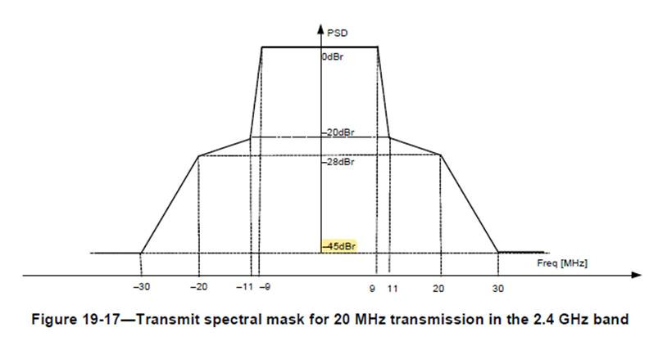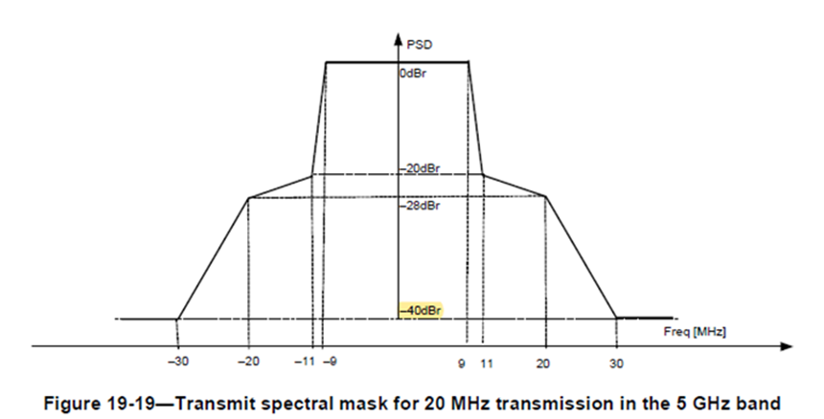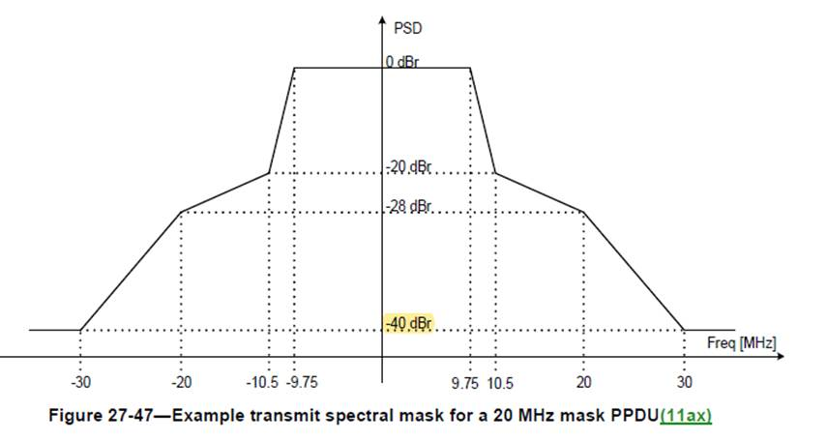

Table 1 – Transmit spectral mask floor of various PHYs

|  |  |  |  |  |  |  |  |  |
| --- | --- | --- | --- | --- | --- | --- | --- | --- |
| **PHY** | **HT** | | **VHT** | | **HE** | | **EHT** | |
| **Channel** | **20 MHz** | **40 MHz** | **20 MHz** | **40 MHz** | **20 MHz** | **40 MHz** | **20 MHz** | **40 MHz** |
| **2.4 GHz band** | –45 dBr | –45 dBr | –40 dBr | –40 dBr | –40 dBr | –40 dBr | –40 dBr | –40 dBr |
| **5 GHz band** | –40 dBr | –40 dBr | –40 dBr | –40 dBr | –40 dBr | –40 dBr | –40 dBr | –40 dBr |

We propose that the HT transmit spectrum mask floor for a 20 MHz or 40 MHz channel in the 2.4 GHz band be aligned with that of VHT/HE/EHT. Since the transmit power of HT devices is limited by the –45 dBr floor, the increase of spectrum mask floor results in the increase of transmit power for lower MCS. This leads to increased range and bigger BSS.

**Proposed Text Changes:**

*Instruction to TGme Editor: Update Clause 19.3.18.1 of REVme D2.0 as shown below.*

**19.3.18.1 Transmit spectrum mask**

For the 2.4 GHz band, when transmitting in a 20 MHz channel, the transmitted spectrum shall have a 0 dBr (dB relative to the maximum spectral density of the signal) bandwidth not exceeding 18 MHz, –20 dBr at 11 MHz frequency offset, –28 dBr at 20 MHz frequency offset, and the maximum of –40 dBr and –53 dBm/MHz at 30 MHz frequency offset and above. The transmitted spectral density of the transmitted signal shall fall within the spectral mask, as shown in Figure 19-17 (Transmit spectral mask for 20 MHz transmission in the 2.4 GHz band). The measurements shall be made using a 100 kHz resolution bandwidth and a 30 kHz video bandwidth.

For the 2.4 GHz band, when transmitting in a 40 MHz channel, the transmitted spectrum shall have a 0 dBr bandwidth not exceeding 38 MHz, –20 dBr at 21 MHz frequency offset, –28 dBr at 40 MHz offset, and the maximum of –40 dBr and –56 dBm/MHz at 60 MHz frequency offset and above. The transmitted spectral density of the transmitted signal shall fall within the spectral mask, as shown in Figure 19-18 (Transmit spectral mask for a 40 MHz channel in the 2.4 GHz band).

*Instruction to TGme Editor: Replace “-45 dBr” in Figure 19-17 with “-40 dBr”.*

*Instruction to TGme Editor: Replace “-45 dBr” in Figure 19-18 with “-40 dBr”.*