IEEE P802.11
Wireless LANs
LB266 CR for CID 13840
Date: 2022-08-31
Author(s):
Name | Affiliation | Address | Phone | email
Shawn (Sanghyun) Kim | WILUS Inc. | 216 Hwangsaeul-ro, Seongnam-si, Gyeonggi-do, Korea |  | shawn.kim@wilusgroup.com
Greg Geonjung Ko |  |  |  | greg.ko@wilusgroup.com
John  (Ju-Hyung) Son |  |  |  | john.son@wilusgroup.com
Jin Sam Kwak |  |  |  | jinsam.kwak@wilusgroup.com
This document proposes resolution for CID 13840 received in LB266. (changes relative to 11be_D2.1 and REVme_D1.3)

Revisions:
- Rev0: Initial version of the document.

CID | Page | Line | Clause | Comment | Proposed Change | Resolution
13840 | 404 | 49 | 35.3 | There are some radio measurement procedures that are affected by the constraints of the measuring STA.  For example, a STA operating on an NSTR link might see busy channel more frequently than the other STA due to in-device interference. | To avoid errors in measurement results, it is necessary to provide radio measurement procedures for the EHT STAs that have constraints. (e.g. operating on an NSTR link pair, operating on an EMLSR link pair etc.,) | Revised.  Agree with the commenter. The resolution modifies the radio measurement procedure for a STA affiliated with an MLD to avoid errors in measurement results.  TGbe editor: please make the changes below in https://mentor.ieee.org/802.11/dcn/22/11-22-1426-02-00be-LB266-cr-for-cid-13840.docx

Discussion:
The radio measurement result reported by a STA affiliated with an MLD (e.g., operating on an NSTR link pair, operating on an EMLSR link pair etc.,) might be erroneous.
- An idle channel might be measured as a busy channel by the STA due to in-device interference.
- An idle channel (noise level is lower than -62 dBm) might be measured as a busy channel by the STA due to lower ED threshold (dot11MSDOFDMEDthreshold) when the STA has nonzero MediumSyncDelay timer.

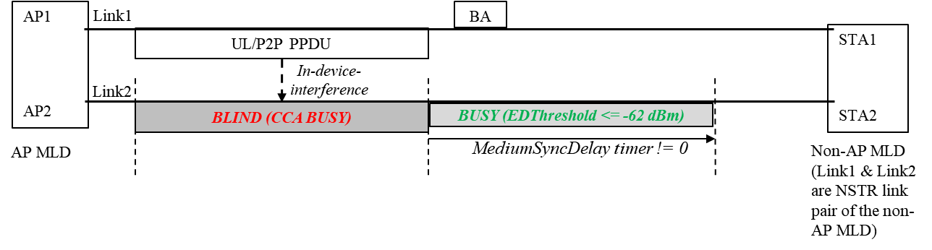

- Example (CCA report)
If an AP issues a CCA request to a non-AP STA operating on a NSTR link pair, the non-AP STA may respond with the CCA report indicating higher value in the CCA Busy Fraction field than the other neighbor STAs. (Please see (9.4.2.21.3 CCA report) and (11.10.20 CCA request and report))
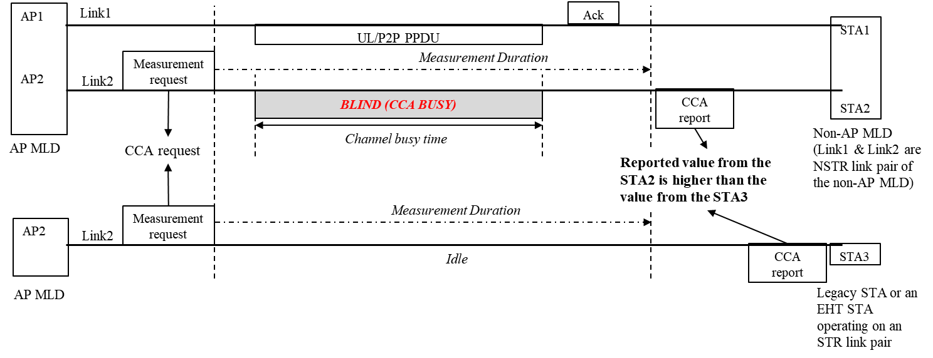

Even a STA operating on an STR link pair may report measurement results that contain errors, when the STA has measured a non-operating channel and the non-operating channel is a channel affected by the interference from the other STA of the same MLD. In addition, the STR STA may report higher noise level in Noise Histogram report (11.10.9.4) of the operating channel(STR link) due to the in-device interference. This is because the interference from the other link may affect measurement results, while the interference can be small enough to consider the link pair as an STR link pair.

Therefore, a measuring STA affiliated with an MLD should consider its constraints when performing the radio measurement.

Proposed change:

- Filtering of the invalid measurement duration
A measuring STA should selectively use the measured data by considering activity of the other STA affiliated with the same MLD when it measures the channel to avoid the problem described above. In other words, a measuring STA should only use valid (measured) data in calculation of the measurement result for evaluating the channel or for reporting the measurement result to the requesting STA.
To do that, a measuring STA should consider the duration in which there was no activity affecting the measurement result by the other STA affiliated with the same MLD as valid measurement duration and consider the remaining duration as invalid measurement duration.
* Example of the invalid duration
- ‘the duration that the other STA affiliated with the same MLD has performed transmission’ for the STA affiliated with an MLD
- ‘the duration that the measuring STA has lost CCA performance due to frame exchanges on the other EMLSR/EMLMR link of the same MLD’ for the STA operating on an EMLSR/EMLMR link

Additionally, a measuring STA that is performing the CCA measurement or the channel load measurement shall measure the channel state using dot11OFDMEDThreshold even the STA has nonzero MediumSyncDelay timer, i.e., the STA does not use dot11MSDOFDMEDthreshold for the radio measurement procedure.

- Example with the proposed change (CCA report)
A measuring STA affiliated with an MLD excludes the duration that overlapped with the TX time of the other STA affiliated with the same MLD from the ‘Measurement Duration’.
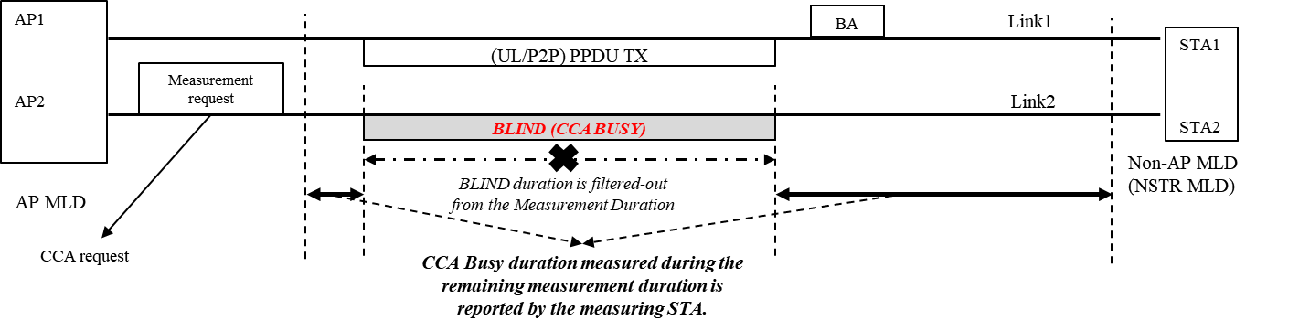
The measuring STA reports the measurement result generated during the valid measurement duration and reports the valid measurement duration by using the Measurement Duration field of the Measurement Report field.
If the valid measurement duration is shorter than 1 TU, the measuring STA shall set Refused subfield in the Measurement Report Mode field to 1. In this case, the measuring (reporting) STA does not include the Measurement Report field in the Measurement Report element.
- Note that the Measurement Duration field in the baseline is in units of TUs, the reporting STA should round down the valid measurement duration to the nearest integer.

- Measurement requesting STA
If there is invalid measurement duration, the measuring STA will report result of the requested measurement for the shorter measurement duration than the duration the requesting STA has requested. The difference in the requested measurement duration and the reported(valid) measurement duration is inevitable for excluding the invalid duration.

Therefore, a requesting STA shall set the Duration Mandatory subfield in the Measurement Request element to 0 when it transmits the element to the STA affiliated with the MLD (Please see 9.4.2.20 (Measurement Request element) and 11.10.4 (Measurement duration)).

Proposed resolution:

9.4.2.21 Measurement Report element
9.4.2.21.1 General
TGbe editor: Please insert the following paragraph and NOTE 1, NOTE 2 and NOTE 3 as the 1st paragraph in this subclause as shown below:
A STA affiliated with an MLD and that is transmitting the Measurement Report element reports the measurement results that have been measured during the valid measurement duration.
NOTE 1 - The whole or the part of the measurement duration of the STA affiliated with the MLD might be invalid if the STA has lost CCA performance or has been affected by the interference generated by the other STA(s) affiliated with the same MLD.
NOTE 2 – The valid measurement duration depends on the measurement type. The entire measurement duration is valid unless otherwise specified for the measurement type.
NOTE 3 – The STA affiliated with an MLD supports radio measurement request subject to the capabilities and the rules as defined in the 11.10 (Radio measurement procedures).

TGbe editor: Please update the following paragraph in this subclause as shown below:
The Measurement Report Mode field (shown in Figure 9-276 (Measurement Report Mode field format)) is used to indicate the reason for a failed or rejected measurement request. The Measurement Report Mode is a bit field with the following subfields(#291) defined:
— Late subfield(#291) indicates whether this STA is unable to carry out a measurement request because it received the request after the requested measurement time. The Late subfield(#291) is set to 1 to indicate the request was too late. The Late subfield(#291) is set to 0 to indicate the request was received in time for the measurement to be executed. The Late subfield(#291) only applies to spectrum management measurement and is set to 0 in all measurement report elements for radio measurement types (see Table 9-161 (Measurement Type field definitions for measurement reports)).
— Incapable subfield(#291) indicates whether this STA is incapable of generating a report of the type specified in the Measurement Type field that was previously requested by the destination STA of this Measurement Report element. The Incapable subfield(#291) is set to 1 to indicate the STA is incapable. The Incapable subfield(#291) is set to 0 to indicate the STA is capable or the report is autonomous.
— Refused subfield(#291) indicates whether this STA is refusing or has failed to generate a report of the type specified in the Measurement Type field that was previously requested by the destination STA of this Measurement Report element. The Refused subfield (#291)is set to 1 to indicate the STA is refusing or has failed. The Refused subfield(#291) is set to 0 to indicate the STA is not refusing or has failed or the report is autonomous.
— All other bits are reserved
A STA affiliated with an MLD shall consider a measurement that it has performed as failed measurement when the valid measurement duration is shorter than 1 TU.

9.4.2.21.3 CCA report
TGbe editor: Please update the following paragraphs in this subclause as shown below:
The Channel Number field contains the channel number to which the CCA report applies where the Channel Number is a value from the Channel set column in Table E-4 (Global operating classes), in a row having the same value in the Channel spacing (MHz) column as the width of the primary channel.
The Measurement Start Time field is set to the TSF at the time (± 32 $μ$s) at which the CCA report measurement started.
The Measurement Duration field transmitted by a STA is set to the duration over which the CCA report was measured, expressed in TUs.
The Measurement Duration field transmitted by a STA affiliated with an MLD is set to the value that is obtained by rounding down the valid measurement duration over which the CCA report was measured, expressed in TUs.
The CCA Busy Fraction field contains the fractional duration over which CCA indicated the channel was busy during the valid measurement duration. The resolution of the CCA busy measurement is in microseconds. The CCA Busy Fraction value is defined as
$$\left\lceil \frac{255×t_{busy}}{1024×t_{MD}}\right\rceil$$

Where
$t_{busy}$ is the duration CCA indicated channel was busy ($μ$s)
$t_{MD}$ is the valid measurement duration (TUs)
A STA affiliated with an MLD and that is performing the CCA measurement shall consider the duration that it has lost medium synchronization as invalid measurement duration even the duration is shorter than aMediumSyncThreshold (see 35.3.16.8 (Medium access recovery procedure)).

36.3.20.6.3 CCA sensitivity for the primary 20 MHz channel(#11304)
TGbe editor: Please update the following paragraphs in this subclause as shown below (from the 3rd paragraphs):
The receiver shall issue a PHY-CCA.indication primitive with the STATUS parameter set to BUSY for any
signal that exceeds the threshold below in the primary 20 MHz channel within a period of aCCATime after
the signal arrives at the receiver’s antenna(s):
— a value specified by dot11MSDOFDMEDthreshold if any MediumSyncDelay timer at that STA has
not expired (see 35.3.16.8 (Medium access recovery procedure)) and the STA is not performing the radio measurement (see 11.10 (Radio measurement procedures))
— (#12350)–62 dBm otherwise.
(#12350)NOTE— –62 dBm is 20 dB above the minimum modulation and coding rate sensitivity (–82 + 20 = –62
dBm).

9.4.2.21.5 Channel Load report
TGbe editor: Please update the following paragraphs in this subclause as shown below (from the 5th paragraphs):

The Measurement Duration field transmitted by a STA is set to the duration over which the Channel Load report was measured, in units of TUs.
The Measurement Duration field transmitted by a STA affiliated with an MLD is set to the value that is obtained by rounding down the valid measurement duration over which the Channel Load report was measured, in units of TUs.
The Channel Load field contains the proportion of valid measurement duration for which the measuring STA determined the channel to be busy. Procedure for Channel Load measurement and definition of channel load values are found in 11.10.9.3 (Channel load report).

11.10.9.3 Channel load report
TGbe editor: Please update the following paragraphs in this subclause as shown below (from the 2nd paragraphs):
…
Channel Load = $\left\lfloor \frac{channel busy time}{MeasurementDuration×1024}×255\right\rfloor$

where channel busy time is defined to be the number of microseconds during which the CS mechanism, as defined in 10.3.2.1 (CS mechanism), has indicated a channel busy indication for the requested channel width, and
MeasurementDuration is the valid measurement duration over which the duration that the measuring STA has perform the channel load measurement.

A STA affiliated with an MLD and that is performing the Channel load measurement shall consider the duration that it has lost medium synchronization and the duration that it has nonzero MediumSyncDelay timer as invalid measurement duration even the duration that it has lost medium synchronization is shorter than aMediumSyncThreshold (see 35.3.16.8.2 (MediumSyncDelay OFDM ED based recovery procedure)).

9.4.2.21.6 Noise Histogram report
TGbe editor: Please update the following paragraphs in this subclause as shown below (from the 5th paragraphs):
The Measurement Duration field transmitted by a STA is set to the duration over which the Noise Histogram report was measured, in units of TUs.
The Measurement Duration field transmitted by a STA affiliated with an MLD is set to the value that is obtained by rounding down the valid measurement duration over which the Noise Histogram report was measured, in unit of TUs.
The Antenna ID field is set to the identifying number for the antenna(s) or DMG antenna(s) used for this measurement. The antenna ID or DMG antenna ID is defined in 9.4.2.39 (Antenna element).
The ANPI field is set to the average noise plus interference power value measured during the valid measurement duration over which the indicated measurement duration while the indicated channel is idle as described in 11.10.9.4 (Noise Histogram report).

11.10.9.4 Noise Histogram report
TGbe editor: Please update the following paragraphs in this subclause as shown below (from the 2nd paragraphs):
To compute the IPI densities, a STA shall measure the amount of time, in microseconds, during which the IPI is in each IPI range specified in Table 9-164 (IPI Definitions for a Noise Histogram report). These IPI measurements shall be taken over the entire associated channel bandwidth, and during the requested measurement duration except for those time intervals during which the NAV is not equal to 0 (when virtual CS mechanism indicates channel busy), or during which frame transmission or reception is occurring, or invalid measurement duration. The IPI densities are then computed for each of the nine possible IPI values using:

IPI Density = 255×DIPI1024×DM-TNAV-TTX-TRX-TINVALID
Where
$D_{IPI}$ is the duration receiving at the specified IPI value ($μ$s)
$D_{M}$ is the measurement duration (TU)
$T_{NAV}$ is the total time that NAV is nonzero during the Measurement Duration ($μ$s)
$T_{TX}$ is the frame transmission time during the Measurement Duration ($μ$s)
$T_{RX}$ is the frame reception time during the Measurement Duration ($μ$s)
TINVALID is the total time that measurement was invalid during the Measurement Duration (μs)

A STA affiliated with an MLD and that is performing the Noise histogram measurement shall consider the duration that it has lost CCA performance or has been affected by the interference generated by the other STA(s) affiliated with the same MLD as the invalid measurement duration.

The sum of the IPI densities is approximately 255. If either the NAV is nonzero, or if there is frame transmission, or if there is frame reception, or if there is invalid measurement duration throughout the entire measurement duration period, no reportable IPI values are measured, and all IPI Densities shall be set to 0 in the Measurement Report element.
A STA shall include in the Noise Histogram report an average noise power indicator (ANPI) value representing the average noise plus interference power on the measured channel at the antenna connector during the measurement duration. The STA may use Noise Histogram IPI density values to calculate ANPI. The IPI densities in the Noise Histogram report may be used to calculate an average noise power for the channel during the measurement duration. This calculated average IPI power value may be reported as the value for ANPI. Any equivalent method to measure ANPI may also be used. ANPI power is defined in dBm using the same accuracy as defined for RCPI.
ANPI may be calculated in any period and at any time by filtering all PHY IPI values in a MAC filter to exclude IPI values received when NAV is nonzero or received during the invalid measurement duration. These filtered IPI values represent idle channel noise and may be stored in a first-in-first-out (FIFO) buffer to facilitate ANPI calculation over a fixed number of IPI samples. ANPI may be so calculated upon receipt of any frame and may be used with RCPI to calculate RSNI for any received frame. Any equivalent method to measure ANPI may also be used to calculate RSNI for any received frame.

9.4.2.21.4 RPI histogram report
TGbe editor: Please update the following paragraphs in this subclause as shown below (from the 4th paragraphs):

The Measurement Duration field transmitted by a STA is set to the duration over which the RPI Histogram report was measured, expressed in TUs.
The Measurement Duration field transmitted by a STA affiliated with an MLD is set to the value rounded down the valid duration over which the RPI Histogram report was measured, expressed in TUs.

11.10.12 Measurement of the RPI histogram
TGbe editor: Please update the following paragraphs in this subclause as shown below:
RPI Density = $\left\lceil \frac{255×D_{RPI}}{1024×D_{M}}\right\rceil$

where
$D_{RPI}$ is the duration receiving at the specified RPI value ($μ$s)
$D_{M}$ is the valid measurement duration (TU)
A STA affiliated with an MLD and that is performing the measurement of the RPI histogram may consider the duration that is overlapped with a transmission performed by the other STA affiliated with the same MLD as invalid measurement duration if the transmission is expected to cause interference on the RPI histogram measurement procedure.
The sum of the RPI densities is approximately 255, but could be up to 262 because of rounding effects.

11.10.4 Measurement duration
TGbe editor: Please insert the following paragraph as the 4th paragraph in this subclause:
A requesting STA affiliated with an MLD shall set the Duration Mandatory subfield of the Measurement Request element to 0 when it transmits the Measurement Request element to a reporting STA affiliated with an MLD.
TGbe editor: Please update the following paragraph in this subclause and insert NOTE as shown below:
If the Duration Mandatory subfield(#291) is 1 in the Measurement Request Mode field(#555) of a measurement request, the requested STA, if it accepts the request, shall perform the measurement over the Measurement Duration specified in the request. If the STA is unable to commit to making the measurement over the requested duration, it shall refuse the request by sending a measurement report in which the Refused subfield(#291) in the Measurement Report Mode field is set to 1. If the requested STA is affiliated with an MLD and the duration that it has performed the requested measurement includes invalid measurement duration, it shall respond to the request by sending a measurement report in which the Refused subfield in the Measurement Report Mode field is set to 1. The measurement duration in the measurement report is equal to the requested measurement duration.
NOTE – A requested STA that is affiliated with an MLD might receive Measurement Request element with Duration Mandatory subfield 1 from the other STA that does not know the requested STA is affiliated with an MLD.

If the Duration Mandatory subfield(#291) is 0 in the Measurement Request Mode field(#555) of a measurement request, the requested STA, if it accepts the request, shall attempt a measurement using the requested duration as a maximum measurement duration, and may report results with an actual measurement duration less than the requested duration. The duration over which the measurement was made will be included in the measurement duration field of the measurement report.

11.10.5 Station responsibility for conducting measurements
A radio measurement-capable STA shall decode and interpret each Radio Measurement Request frame that it receives and shall assess the contents against its capabilities and the impact on its own performance. A measurement request may be refused by the receiving STA by sending a Radio Measurement Report frame in which the Refused subfield(#291) in the Measurement Report Mode field is set to 1. The reasons for refusing a measurement request are outside the scope of this standard but may include reduced quality of service, unacceptable power consumption, measurement scheduling conflicts, or other significant factors.
In assessing the performance impact of each Measurement Request element, a STA may use application specific knowledge or other knowledge to limit the time it spends away from the operating channel. In doing so, the STA may either:
— Reject any Measurement Request element in which the Duration Mandatory subfield(#291) is 1 and that has a mandatory measurement duration exceeding the maximum allowed off-operating channel time, or
— Measure for a reduced duration if the Duration Mandatory subfield(#291) is 0.
A STA shall cancel all in-process radio measurements and shall delete all pending, unprocessed radio measurement requests upon receipt of a Disassociation frame or upon (re)association with a BSSID different from its most recent association.
TGbe editor: Please insert the following paragraph as the last paragraph in this subclause:
A STA affiliated with an MLD shall cancel all in-process radio measurements and shall delete all pending, unprocessed radio measurement requests if any one of the following conditions is met:
- Its affiliated MLD received a Disassociation frame from the associated AP MLD
- Its operating link is excluded from the setup links as described in 35.3.5.1 (Multi-link (re)setup procedure)
- Its operating link is disabled as described in 35.3.7.3 (Affiliated AP link disablement and enablement) or 35.3.7.1.3 (Negotiation of TID-to-link mapping)
- Its associated AP is removed by the AP MLD as described in 35.3.6.2.2 (Removing affiliated APs)

SP: Do you agree to the resolution provided in doc 11-22/1426r1 for the following CID for inclusion in the latest 11be draft?
- 13840

