IEEE P802.11
Wireless LANs
Resolution for comments related to various aspects of multi-link operation
Date: August 16, 2022
Author(s):
Name | Affiliation | Address | Phone | email
Abhishek Patil | Qualcomm Inc. |  |  | appatil@qti.qualcomm.com
Alfred Asterjadhi
George Cherian
Duncan Ho
Yanjun Sun
Gaurang Naik
Abdel Karim

Abstract
This submission proposes resolutions for the following 20 comments received for TGbe LB266:
12370 11917 13152 13717 10299 11185 10597 13918 10896 12280 13600 13008 13426 13427 14116 13009 12230 13821 13765 12764

Revisions:
- Rev 0: Initial version of the document.

TGbe editor: Please note baseline is 11be D2.1.1 and doc 11-22/1182r10

Interpretation of a Motion to Adopt

A motion to approve this submission means that the editing instructions and any changed or added material are actioned in the TGbe Draft. This introduction is not part of the adopted material.

Editing instructions formatted like this are intended to be copied into the TGbe Draft (i.e., they are instructions to the 802.11 editor on how to merge the text with the baseline documents).

TGbe Editor: Editing instructions preceded by “TGbe Editor” are instructions to the TGbe editor to modify existing material in the TGbe draft. As a result of adopting the changes, the TGbe editor will execute the instructions rather than copy them to the TGbe Draft.

CID | Commenter | Pg/Ln | Section | Comment | Proposed Change | Resolution
12370 | Rojan Chitrakar | 11.20.6.5 | 329.15 | TDLS off-channel switching to 6 GHz needs to ensure the requested off-channel is safe to be used (e.g. there are no licensed users operating on the channel etc.). | Add rules to ensure that non-AP STA checks that the off-channel in 6 GHz is safe to be used. E.g., one option is to get permission from its associated AP on the existing channel, whether it is allowed to switch to the new off-channel. | Revised  Agree with the comment. Baseline spec provides a procedure (see 11.21.15 (Channel usage procedures) & 9.4.2.85 (Channel Usage element)) for a non-AP STA to consult its associated AP to establish TDLS link on an off-channel. This procedure is already used for establishing a wideband off-channel direct link (see 11.20.6.5.3).  A new paragraph is added to 11.20.6.2 to clarify that if a non-AP STA operating in 6 GHz intends to setup an off-channel direct link on a 6 GHz channel, it needs to use the procedures described in 11.21.15 to determine a suitable 6 GHz channel.  Note, this issue needs to be fixed in baseline (REVme) spec as well, since it also applies to an HE 6 GHz non-AP STAs. The commenter is encouraged to submit a comment in REVme.  TGbe editor, please make changes as shown in 11-22/1422r0 tagged 12370
11917 | Alfred Asterjadhi | 11.20.6.5.1 | 329.23 | A TDLS STA that sets up operation with a 320 MHz off-channel needs to first operate in the 6 GHz band. I believe TDLS STAs cannot operate in the 6 GHz band without the supervision of an AP. | As in comment. | Revised  Agree with the comment. A non-AP STA operating in 6 GHz that intends to setup an off-channel direct link on a 6 GHz channel needs to use the procedures described in 11.21.15 to determine a suitable 6 GHz channel.  The resolution is same as CID 12370.  TGbe editor, please make changes as shown in 11-22/1422r0 tagged 12370
13152 | Mark RISON | 11.20.6.5.1 | 329.24 | "a 40 MHz, 80 MHz, 160 MHz, or 80+80 MHz off-channel TDLS direct  link for VHT and HT STAs" -- this is a technical change to HT STAs that is nothing to do with EHT. Any such change should be done in REVme not 11be | Revert the insertion of "and HT" | Accepted  Agree with the comment.  TGbe editor, delete ‘and HT’ from the first paragraph of 11.20.6.5.1 [P333L25 of TGbe D2.1.1]
13717 | Yunbo Li | 11.20.6.5.1 | 329.25 | "a 40 MHz, 80 MHz, 160 MHz, or 80+80 MHz off-channel TDLS direct link for VHT and HT  STAs", HT STAs don't support a bandwidth that larger than 40MHz. | changes to "a 40 MHz, 80 MHz, 160 MHz, or 80+80 MHz off-channel TDLS direct link for VHT STAs, or a 40 MHz off-channel TDLS direct link for HT STAs". | Revised  Agree with the comment. The reference to HT STA is being deleted from the TGbe spec as a resolution to CID 13152.  TGbe editor, please make changes as proposed in the resolution for CID 13152
10299 | Michael Montemurro | 35.3.1 | 405.11 | How does this requirement related to the synchronization requirements in 11.1.3? Are affiliated APs subject to this requirement or those requirements? Presumably its this requirement plus the requirements in 11.1.3. Also 'timers of any two" should be "timers between any two" | Consider adding the synchronization requirements in 11.1.3 to the cited paragraph as well (at least by reference). Also change "timers of any two" to "timers between any two". | Revised  Agree in principle. The text is updated to clarify that a STA affiliated with an MLD follow the procedure described in 11.1.3 to provide and maintain synchronization. The exiting text ‘… between TSF timers of any two APs …’ seems correct and hence the proposed change is not made.  TGbe editor, please make changes as proposed in the resolution for CID 10299
10896 | Akira Kishida | 35.3.12.2 | 441.42 | "A non-AP MLD shall be able to perform basic operations (such as ... time synchronization ... by monitoring Beacon frames via one or more of its affiliated STAs ..." is not clear. For AP MLD, section 35.3.1 describes "An AP MLD or an NSTR mobile AP MLD shall correct the clock drift to be within +/-30 Î¼s between TSF timers of any two APs affiliated with the AP MLD or the NSTR mobile AP MLD." However, there is no decription for non-AP MLD. | Add the following language in 35.3.1:  "A non-AP MLD shall maintain a common TSF timer. Each STA affiliated with the non-AP MLD shall correct the clock drift to be within +/-30  Î¼s between its TSF timer and the common TSF timer." | Revised  A non-AP STA affiliated with a non-AP MLD derives its timing information by receiving TSF information from the associated AP operating on the same link. And since the TSF offsets between APs affiliated with an AP MLD is constant and within +/- 30us, a non-AP MLD can derive the TSF at each AP by receiving the TSF of one AP. In other words, a non-AP MLD doesn’t need to apply any correction. A NOTE is added to clause 35.3.1 to provide this clarification.  TGbe editor, please make changes as proposed in the resolution for CID 10896
12280 | KENGO NAGATA | 35.3.12.2 | 441.42 | "A non-AP MLD shall be able to perform basic operations (such as ... time synchronization ... by monitoring Beacon frames via one or more of its affiliated STAs ..." is not clear. For AP MLD, section 35.3.1 describes "An AP MLD or an NSTR mobile AP MLD shall correct the clock drift to be within +/-30 Î¼s between TSF timers of any two APs affiliated with the AP MLD or the NSTR mobile AP MLD." However, there is no decription for non-AP MLD. | Add the following language in 35.3.1:  "A non-AP MLD shall maintain a common TSF timer. Each STA affiliated with the non-AP MLD shall correct the clock drift to be within +/-30  Î¼s between its TSF timer and the common TSF timer." | Revised  Same resolution as CID 10896  TGbe editor, please make changes as proposed in the resolution for CID 10896
11185 | Joseph Levy | 35.3.2.1 | 405.51 | An AP affiliated with an AP MLD is not defined, An affiliated STA is defined, but that definitions does not define affiliated AP or an AP affiliated within AP MLD. To minimize beacon overhead, it was agreed that AP MLDs will not transmit beacons, and that "legacy APs" contained in the same physical device as the AP MLD would transmit beacons containing the MLD Basic Multi-Link element as described in 35.3.2 and 35.3.4. This should be clearly stated in this clause. Please add the necessary description to make it clear that logical entity that transmits Beacon frames and Probe Response frames that contain a AP MLD's Basic Multi-Link element are the collocated "legacy" APs and the AP MLD. | As in comment. | Revised  The cited paragraph was revised as a resolution to several comments and the updated text appears in D2.1.1. The issues point out by this comment are no longer applicable to the revised text in D2.1.1. Therefore, no further changes are needed to address this comment.  TGbe editor, same resolution as CID 10303 (already implemented in D2.1.1)
10597 | Abhishek Patil | 35.3.2.1 | 406.11 | Clarify that an AP MLD assigns a unique link ID to each link on which its affiliated APs operate on and that the link ID is continuous. There can be a gap in the link ID space if the AP MLD performs ML reconfiguration procedure which results in removal of an affiliated AP. However, if the same AP (BSSID) is added back to the same channel, then the AP MLD assigns the same link ID as before. | As in comment | Revised  Agree with the comment. Many MLO features use a link ID bitmap to identify one or more intended links. Therefore, and efficient assignment of Link ID is critical. The text is updated as proposed by the comment.  TGbe editor, please make changes as proposed in the resolution for CID 10597
13918 | Ming Gan | 35.3.12.1 | 441.09 | buffered BUs indication in the TIM is MLD level, please remove "mapped to Link 1" | please remove "mapped to Link 1" | Revised  Agree with the comment. The cited paragraph is updated to clarify that the example is for default mapping or the case where all TIDs are mapped to the same subset of links. The term ‘mapped to Link 1’ is deleted.  TGbe editor, please make changes as proposed in the resolution for CID 13918
13600 | Yongho Seok | 35.3.12.2 | 441.51 | "...by monitoring Beacon frames via one or more of its affiliated STAs on their respective enabled links."  Monitoring one or more links does not limit to single link listening operation, in "a non-AP MLD can receive basic information about the AP MLD and all the APs affiliated with the AP MLD on a single link"  Change to "...about the AP MLD and all the APs affiliated with the AP MLD on one or more link(s)". | As in the comment. | Accepted
13426 | Liwen Chu | 35.3.20 | 470.20 | This "shall" statement is not necessary since it can be acquired by "shall" requirement that two AP of an AP MLD can't have overlapped channel and the Multiple BSSID definition | change it to a note | Revised  The “shall” statement is necessary to clarify the key reason why APs in an MBSSID set cannot belong to the same MLD. The cited paragraph is updated to highlight the difference in properties and configuration of APs in a Multiple BSSID set and APs affiliated with the same AP MLD.  TGbe editor, please make changes as proposed in the resolution for CID 13426
13427 | Liwen Chu | 35.3.20 | 470.24 | This "shall" statement is not necessary since it can be acquired by "shall" requirement that two AP of an AP MLD can't have overlapped channel and the co-host AP definition | change it to a note | Revised  The “shall” statement is necessary to clarify the key reason why APs in a co-hosted BSSID set cannot belong to the same MLD. The cited paragraph is updated to highlight the difference in properties and configuration of APs in a co-hosted BSSID set and APs affiliated with the same AP MLD.  TGbe editor, please make changes as proposed in the resolution for CID 13427
14116 | Li-Hsiang Sun | 35.3.21.2 | 471.12 | "When a non-AP MLD that has performed multi-link setup with an AP MLD establishes a single link TDLS direct link on one of its links"  How does a TDLS MLD verify the TDLS link is actually a setup link of the TDLS peer since the AP does not examine the link identifier of the setup up frames | Extend link identifier element to include a MIC that is generated by the GTK/IGTK of the link.  The responding MLD may ignore the setup frames if MIC does not check | Rejected  Baseline spec (11.20.3) requires a TDLS STA to respond only if the BSSID in the Link Identifier element matches the associated AP.
13009 | Chunyu Hu | 35.3.21.2 | 471.15 | Wr.t. the the single link TDLS, does it both ends to be a STA affiliated with the non-AP MLD? | Add text to be clear. | Revised  Agree with the comment. A NOTE is added to 35.3.21.1 to clarify that a single link TDLS can be established between a STA affiliated with a non-AP MLD and another STA that need not be affiliated with a non-AP MLD.  TGbe editor, please make changes as proposed in the resolution for CID 13009
12230 | Stephen McCann | 35.3.21.2 | 471.22 | It may be worthwhile clarifiying that TDLS discovery and TDLS setup are separate frame exchanges. | Change the initial part of the first sentence from:  "TDLS discovery and setup between a non-AP MLD and a peer STA..." to  "TDLS discovery and setup (discovery frame exchange followed by setup frame exchange) between a non-AP MLD and a peer STA". | Accepted
13821 | Yuchen Guo | 35.3.21.2 | 471.53 | Need to clarify how to set the AP MLD MAC Address field in the TDLS discovery request/response frames and TDLS setup request/response/confirm frames | As in the comment | Rejected  Clause 9.4.2.312.5 already specifies that the AP MLD MAC Address field contains the MLD MAC Address of the AP MLD with which the non-AP MLD has performed multi-link setup. Therefore, no further clarifications are needed.
12764 | Patrice Nezou | 35.3.21.1 | 471.05 | A "single link TDLS direct link" is not very clear because TDLS is a setup protocol for P2P transmissions. | Replace the expression with " a single link P2P connection"As in comment | Rejected  The subclause describes operations that are specific to TDLS. Therefore, the TDLS terminology is correct.
13765 | Yuchen Guo | 11.2 | 328.06 | There is a practical need for the TDLS transmission between two STAs that are associated with different APs of the same Multiple BSSID set, but the current TDLS operation does not support that | Please add the procedure to enable the scenario | Rejected  The associated AP (i.e., the common AP) provides the security context for TDLS establishment (i.e., the AP’s BSSID is used in the TPK generation). Furthermore, TDLS discovery request and TDLS setup (req/resp/confirm) frames are type Data and they traverse the associated AP MLD (which will be different for each AP in a multiple BSSID set). In addition, there are other mechanisms (such as Wi-Fi Direct) that do not rely on being associated with the same AP and could be used for the use case the comment has in mind.
13008 | Chunyu Hu | 35.3.20 | 470.18 | It would be helpful to show an example in a diagram how a non-trivial configuration of AP MLD where some affiliated Aps are member/non-member of a multiple BSSID set, and some are transmitted/non-transmitted Aps, how a beacon/probe response/ML probe response would contain. | See comment. | Revised  Agree with the comment. Changes show high-level summary of the elements that are carried in relevant mgmt. frames to provide information related to MLO discovery and setup.  TGbe editor, please make changes as proposed in the resolution for CID 13008

11.20.6.2 General behavior on the off-channel
TGbe editor: Please add the following paragraph as the last paragraph of this subclause as shown below:
[12370]A 6 GHz non-AP STA, that intends to establish an off-channel direct link on a 6 GHz channel, shall follow the procedures described in 11.21.15 (Channel usage procedures) to identify a suitable 6 GHz channel.

35.3.1 General
TGbe editor: Please update the following paragraph this subclause as shown below:
[10299]Each STA affiliated with an MLD shall follow the procedures in 11.1.3. An AP MLD shall correct the clock drift to be within ±30 μs between TSF timers of any two APs affiliated with it.
[10896]NOTE – An AP affiliated with an AP MLD provides TSF offset in the complete profile of a reported AP (see 9.4.2.312.2.4 (Link Info field of the Basic Multi-Link element)). A non-AP MLD can determine the TSF information of all the APs affiliated with an AP MLD when it receives a frame carrying TSF of any one AP affiliated with that AP MLD (also see 35.3.12.2).

35.3.3.2 Link ID
TGbe editor: Please update the following paragraph in this subclause as shown below:
A link ID is a numeric value that corresponds to a tuple consisting of Operating Class, Operating Channel, and BSSID of the AP affiliated with the AP MLD. An AP MLD shall assign a unique link ID, that is lower than 15, to each of its affiliated APs and shall not change the assigned link IDs during the lifetime of each of the BSSes setup by the AP MLD. [10597]An AP MLD shall assign link IDs with starting value of 0 and consecutively increasing order. If an affiliated AP that was previous removed (see 35.3.6.2.2 (Removing affiliated APs)) is added back to the same channel as before (see 35.3.6.2.1 (Adding new affiliated APs)), then the AP MLD shall reassign the previously assigned link ID to the added AP.

35.3.12.1 General
TGbe editor: Please update the following paragraph in this subclause as shown below:
Figure 35-16 (Each non-AP STA affiliated with a non-AP MLD maintains its own power state) illustrates the power save operation for each non-AP STA affiliated with a non-AP MLD during multi-link operation. [13918]The example assumes all TIDs are mapped to all or a subset of links. As depicted in the figure, during the initial portion of the illustration, both STAs affiliated with the non-AP MLD are in active mode and are involved in frame exchange with the respective APs on the links. Each non-AP STA affiliated with the non-AP MLD indicates that it is in active mode by setting to 0 the Power Management subfield (namely PM bit in the figure) in the Frame Control field of a transmitted frame. At some point in time, STA 2 affiliated with the non-AP MLD operating on Link 2 indicates to AP 2 that it is entering power save mode (i.e., sets PM bit to 1) and transitions to doze state after the successful frame exchange. STA 2 remains in doze state for the rest of the illustration. After a period of time, STA 1 enters power save mode (i.e., sets PM bit to 1) after the successful frame exchange. While operating in power save mode, STA 1 wakes up to receive the Beacon frame transmitted by AP 1 and determines that AP MLD has BUs[13918] for the non-AP MLD. Based on this determination, STA 1 indicates to AP 1 that it has transitioned to awake state by transmitting a PS-Poll or U-APSD trigger frame on Link 1. STA 1 participates in frame exchange with AP 1 while in awake state.

    - Multi-link operation in a multiple BSSID set or co-hosted BSSID set
TGbe editor: Please update the following paragraphs in this subclause as shown below:
[13426]Each AP in a multiple BSSID set is a member of a different ESS while all APs affiliated with the same AP MLD belong to the same ESS (see 35.3.1 and AA.3). Therefore, an AP MLD shall not have more than one affiliated AP amongst APs that are members of the same multiple BSSID set.

[13427]Each AP in a co-hosted BSSID set is a member of a different ESS while all APs affiliated with the same AP MLD belong to the same ESS (see 35.3.1 and AA.3). Therefore, an AP MLD shall not have more than one affiliated AP amongst APs that are members of the same co-hosted BSSID set.

35.3.21.1 General
TGbe editor: Please add the following NOTE after the 1st paragraph in this subclause as shown below:
[13009]NOTE – The single link TDLS direct link can be established between a non-AP STA affiliated with a non-AP MLD and another non-AP STA that might not be affiliated with a non-AP MLD.

x-x-x-x-x-x- Start of changes for CID 13008 -x-x-x-x-x-x
35.3.4.6 Frame exchange sequences during MLO discovery and multi-link setup
TGbe editor: Please add the following paragraphs and figures after Figure 35-8 in this subclause as shown below:
Figure 35-xx1 (Content of Management frames transmitted by a STA affiliated with a non-AP MLD during MLO discovery and multi-link setup) illustrates the contents of a Probe Request frame (both forms), Authentication frame, and (Re)Association Request frame transmitted by a STA affiliated with a non-AP MLD.
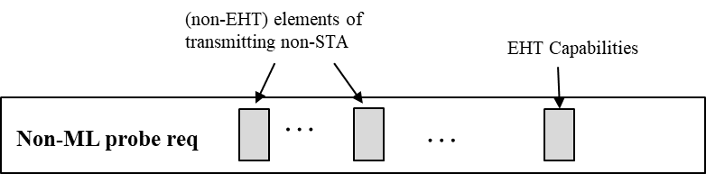
- Contents of Probe Request frame that is not a multi-link probe request
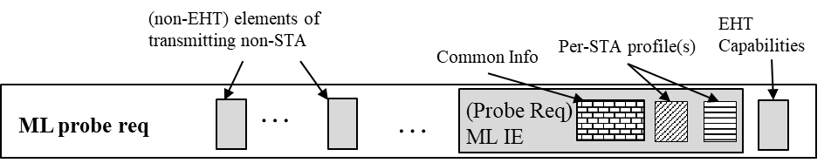
- Contents of a multi-link probe request
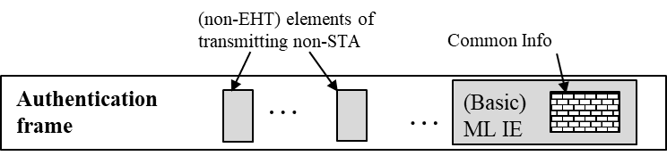
- Content of Authentication frame
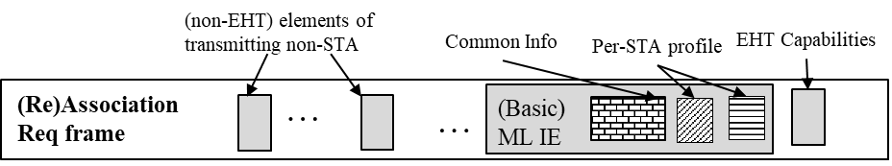
- Content of (Re)Association Request frame
Figure 35-xx1: Content of Management frames transmitted by a STA affiliated with a non-AP MLD during MLO discovery and multi-link setup
Figure 35-xx2 (Content of Management frames transmitted by an affiliated AP that is not a member of a multiple BSSID set during MLO discovery and multi-link setup) illustrates the contents of a Beacon frame, Probe Response frame, Authentication frame, and (Re)Association Response frame transmitted by an AP affiliated with an AP MLD, that is not a member of a multiple BSSID set.
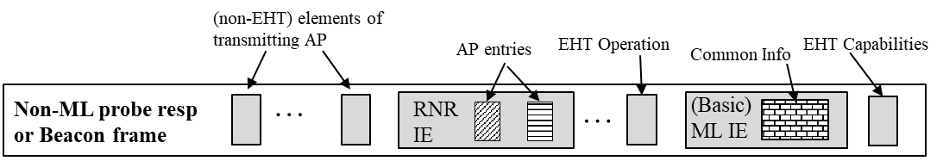
- Contents of Beacon frame or Probe Response frame that is not a multi-link probe response
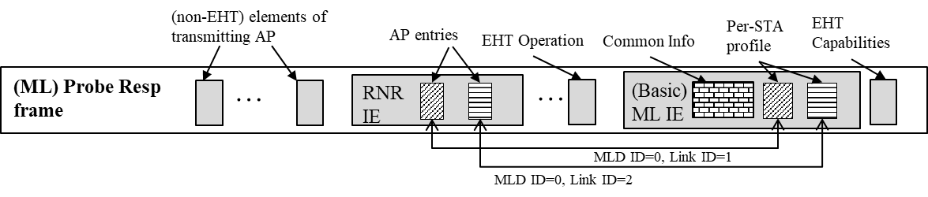
- Contents of a multi-link probe response
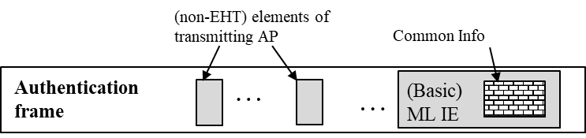
- Content of Authentication frame
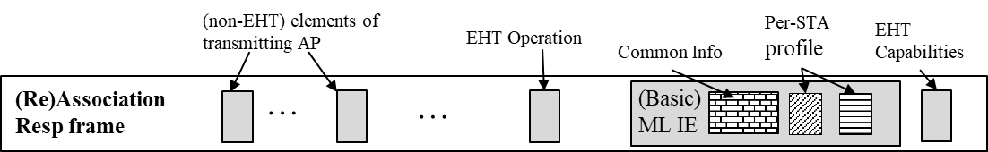
- Contents of (Re)Association Response frame
Figure 35-xx2: Content of Management frames transmitted by an affiliated AP that is not a member of a multiple BSSID set during MLO discovery and multi-link setup
TGbe editor: Please add the following paragraphs and figures at the end of in this subclause as shown below:
In the example shown in Figure 35.xx3 (Content of Management frames transmitted by an AP affiliated with an AP MLD that is a member of multiple BSSID set during MLO discovery and multi-link setup):
- The reporting AP corresponds to the transmitted BSSID in a multiple BSSID set.
- There are three BSSIDs active in the multiple BSSID set: transmitted BSSID (index 0) and two nontransmitted BSSIDs corresponding to (BSSID) index 3 and (BSSID) index 5 respectively.
- Each AP corresponding to a BSSID within the multiple BSSID set is affiliated with a different AP MLD.
- Each AP MLD has two affiliated APs: One a member of the multiple BSSID set and the other operating on a different link.
- The Beacon and Probe Response frames transmitted by the AP corresponding to the transmitted BSSID include a Reduced Neighbor Report (RNR) element carrying three TBTT Information fields each corresponding to an AP that is operating on a different link and affiliated with a different AP MLD.
- The Beacon frames and Probe Response frames, that are not a multi-link probe response, transmitted by the AP corresponding to the transmitted BSSID include a Basic Multi-Link element.
- The Beacon frames and Probe Response frames transmitted by the AP corresponding to the transmitted BSSID also includes Multiple BSSID element.
- The Nontransmitted BSSID Profile subelement, carried in the Multiple BSSID element, for each AP corresponding to the nontransmitted BSSID includes a Basic Multi-Link element. This is shown in Figure 35.xx3(a).
  - The Per-STA Profile subelement of the Basic Multi-Link element corresponding to a reported AP is not included in the element unless conditions specified in 35.3.11 (Channel switching, enhanced channel switching, and channel quieting) are satisfied for that reported affiliated AP.
When the multi-link probe request is addressed to the AP corresponding to the transmitted BSSID, the multi-link probe response is transmitted by the AP corresponding to the transmitted BSSID and includes the Basic Multi-Link element containing the Per-STA Profile subelement carrying information of the AP that is operating on another link and is affiliated with AP MLD to which the AP corresponding to the transmitted BSSID is affiliated with. This is shown in Figure 35.xx3(b).
When the multi-link probe request is addressed to the AP corresponding to a nontransmitted BSSID, the multi-link probe response is transmitted by the AP corresponding to the transmitted BSSID and includes the Basic Multi-Link element, outside the Multiple BSSID element, containing the Per-STA Profile subelement carrying information of the AP that is operating on another link and is affiliated with AP MLD to which the AP corresponding to the nontransmitted BSSID is affiliated with. This is shown in Figure 35.xx3(c).
The Authentication frame and (Re)Association Request/Response frame exchange occurs between the STA affiliated with the non-AP MLD and the AP in the multiple BSSID set (corresponding to either the transmitted BSSID or the nontransmitted BSSID) that is affiliated with the AP MLD with which the non-AP MLD intends to perform multi-link setup. This is shown in Figures 35.xx3(d) and 35.xx3(e).
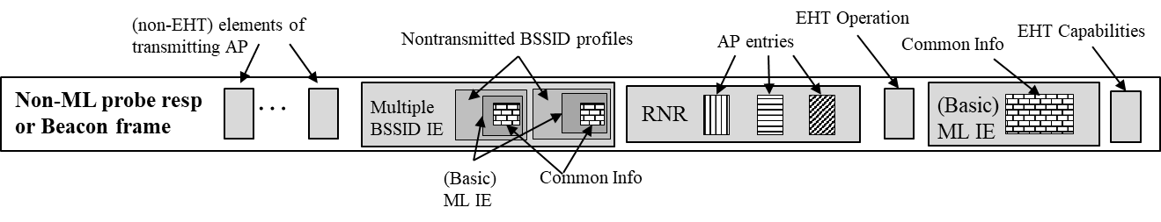
- Content of Beacon frame or Probe Response frame that is not a multi-link probe response transmitted by AP corresponding to transmitted BSSID
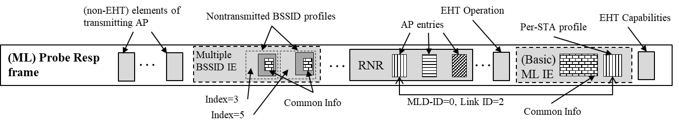
- Contents of a multi-link probe response when soliciting frame was directed to transmitted BSSID
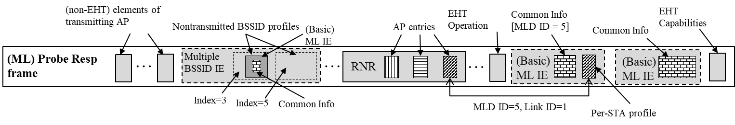
- Contents of a multi-link probe response when soliciting frame was directed to nontransmitted BSSID corresponding to index 5
- Content of Authentication frame
- (Re)Association Response frame transmitted by nontransmitted BSSID corresponding to index 5
Figure 35-xx3: Content of Management frames transmitted by an AP affiliated with an AP MLD that is a member of multiple BSSID set during MLO discovery and multi-link setup

35.3.20 Multi-link operation in a multiple BSSID set or co-hosted BSSID set
TGbe editor: Please update the following paragraphs in this subclause as shown below:

When an AP corresponding to a transmitted BSSID in a multiple BSSID set transmits a Multi-Link probe response in response to a Multi-Link probe request directed to an AP corresponding to a nontransmitted BSSID in the same multiple BSSID set (see 35.3.4.2 (Use of Multi-Link probe request and response)), the Probe Response frame shall also include Basic Multi-Link element corresponding to the AP MLD, with which the transmitted BSSID is affiliated with, outside the Multiple BSSID element and the Basic Multi-Link element shall not carry complete profile for any of the reported APs and shall not include the MLD ID subfield in the Common Info field.
NOTE 2—When an AP corresponding to a transmitted BSSID in a multiple BSSID set transmits a Multi-Link probe response in response to a Multi-Link probe request directed to an AP corresponding to a nontransmitted BSSID in the same multiple BSSID set, the Probe Response frame:
- carries Basic Multi-Link element, outside the Multiple BSSID element, containing a profile of the requested AP(s) affiliated with the AP MLD with which the AP corresponding to that nontransmitted BSSID is affiliated with and the MLD ID subfield of the Common Info field of the Basic Multi-Link element is set to the BSSID Index of the nontransmitted BSSID.
- can include Basic Multi-Link element corresponding to the AP MLD(s) of other APs corresponding to the nontransmitted BSSIDs in the multiple BSSID set. Such Basic Multi-Link element(s) do not carry complete profile for any reported AP(s) and are carried in the corresponding nontransmitted BSSID profile(s) contained in the multiple BSSID element.
- carries Reduced Neighbor Report element containing information of the other AP(s) affiliated with the transmitting AP’s (transmitted BSSID’s) AP MLD and the information of other AP(s) affiliated with the AP MLD(s) of all the nontransmitted BSSIDs in the same multiple BSSID set by following the rules in 35.3.4.1 (AP behavior).

x-x-x-x-x-x- End of changes for CID 13008 -x-x-x-x-x-x

