IEEE P802.11
Wireless LANs
TGbe LB266 CR for 35.3.2.4.2
(Inheritance in the per-STA profile of Probe Request Multi-Link element)
Date: 2022-09-06
Author(s):
Name | Affiliation | Address | Phone | email
SunHee Baek | LG Electronics | 19, Yangjae-daero 11gil, Seocho-gu, Seoul 137-130, Korea |  | sunhee.baek@lge.com
Insun Jang |  |  |  | insun.jang@lge.com
Jinsoo Choi |  |  |  | js.choi@lge.com

Abstract
This submission proposes resolutions for the following 8 CIDs received for TGbe LB266:
- 10307, 11408, 12512, 12513, 12514, 13893, 14109, 14110

Revisions:
- Rev 0: Initial version of the document.

Interpretation of a Motion to Adopt

A motion to approve this submission means that the editing instructions and any changed or added material are actioned in the TGbe Draft. This introduction is not part of the adopted material.

Editing instructions formatted like this are intended to be copied into the TGbe Draft (i.e. they are instructions to the 802.11 editor on how to merge the text with the baseline documents).

TGbe Editor: Editing instructions preceded by “TGbe Editor” are instructions to the TGbe editor to modify existing material in the TGbe draft. As a result of adopting the changes, the TGbe editor will execute the instructions rather than copy them to the TGbe Draft.

CID | Commenter | Clause  (Page.Line) | Comment | Proposed Change | Resolution
10307 | Michael Montemurro | 35.3.2.4.2  (411.3) | This requirement is difficult to parse and understand. Please consider re-wording to make the requirement clearer. | Commenter is willing to collaborate on a submission with a set of changes. | Revised.  Agree with the commenter. The changes are applied below.  TGbe editor, please make changes as shown in doc 11-22/1401r0 tagged as CID 10307
12512 | Jeongki Kim | 35.3.2.4.2  (411.5) | In "If a non-AP STA affiliated with a non-AP MLD requests the same partial profile for an AP to which it sends a Multi-Link probe request and for another AP affiliated with the same AP MLD as the AP and that is requested in the Multi-Link probe request....", change "the AP and that is" to "the AP that is". | As in comment | Revised.  Agree with the commenter. The changes are applied below.  TGbe editor, please incorporate the changes as shown in doc 11-22/1401r0 tagged as CID 10307
11408 | Gaurang Naik | 35.3.2.4.2  (411.26) | It is not clear which AP is referred to in '... with element ID "b", which is requested for the AP'. | Revise as 'which is requested for the AP to which the Probe Request frame is sent.' | Revised.  Agree with the commenter. But, The changes are applied below.  TGbe editor, please make changes as shown in doc 11-22/1401r0 tagged as CID 11408
12513 | Jeongki Kim | 35.3.2.4.2  (411.18) | Indicated text ("element ID a) seems like be not aligned with the Figure 35-5 (element ID 10, value a).  change "element ID"a"" to "element ID "10"" or update the related fields the Figure 35-5 | change "(ID =10, value =a)" to "(ID=a, value=10)" in line 35 on page 411 in Figure 35-5. | Rejected.  Request element has fixed value, 10, as element ID defined in Table 9-128 (Element IDs). So in “(ID=10, value=a)”, “ID=10” means Request element ID is 10 and “value=a” means request element ID is value “a” to differentiate the other requested element ID (e.g., b).
12514 | Jeongki Kim | 35.3.2.4.2  (411.50) | Figure 35-5 should be updated.  change "(ID =10, value =b)" to "(ID=b, value=10)" in line 50 on page 411 in Figure 35-5. | As in comment | Rejected.  Request element has fixed value, 10, as element ID defined in Table 9-128 (Element IDs). So in “(ID=10, value=b)”, “ID=10” means Request element ID is 10 and “value=b” means request element ID is value “b” to differentiate the other requested element ID (e.g., a).
13893 | Ming Gan | 35.3.2.4.2  (411.24) | if complete profile subfield is set to 0, then does inheritance rule apply? | update the condition for applying Inheritance rule or change this sentence | Revised.  D2.1.1 already captures what this comment points out. When Complete Profile Requested subfield set to 0, the inheritance rule is defined in P425L1 of D 2.1.1.  TGbe editor, No further changes are required for addressing this CID.
14109 | Li-Hsiang Sun | 35.3.2.4.2  (411.4) | "requests the same partial profile for an AP to which it sends a Multi-Link probe request"  But in the baseline 11.1.4.3.9 contents of a probe response indicated "Elements that would have been included even in the absence of Request element, Extended Request element, or Vendor Specific Request element shall be included."  Does the "partial profile" apply to the fields/elements of Probe response frame body outside ML element (i.e. reporting link)?  For example, if a ML probe request is sent to a non-TXBSSID with a request element not requesting a Multiple BSSID element, does the ML probe response body include Multiple BSSID element? | The body of ML probe response outside ML element should always be complete profile | Revised.  D2.1.1 already captures what this comment point out. The probe response body always includes the complete profile outside ML element.  About the case based on the commenter’s example, the ML probe response body includes Multiple BSSID element.  TGbe editor, No further changes are required for addressing this CID.
14110 | Li-Hsiang Sun | 35.3.2.4.2  (411.23) | In the example, if the ML probe response body (for reporting link) has a partial profile, what is the rule of inheritance for APz ? Does non-AP MLD reconstructs a complete profile based on the partial profile of the reporting link, then apply inheritance to Apz? | If the body of ML probe response outside ML element is a partial profile, specify the rule for inheritance | Rejected.  The probe response body always includes complete profile of reporting AP, not partial profile, and the inheritance rule for complete profile is followed based on current 11be spec. So, in the example, AP z should inherit the complete profile in probe response body.

Propose:
TGbe editor: Please note that the baseline is 11be D2.1.1.
35.3.3.5.2 Inheritance in the per-STA profile of Probe Request Multi-Link element

TGbe editor: Please change following paragraphs as follows

(#10307)When a non-AP STA affiliated with a non-AP MLD requests a partial profile for another AP(AP1) affiliated with the same AP MLD as an AP(AP2) receiving the Multi-Link probe request (see 35.3.4.2 (Use of Multi-Link probe request and response)) and the same partial profile for the AP(AP2), the non-AP STA may include the (Extended) Request element only in the Probe Request frame body, and this element will be inherited for the other requested AP even if it is not carried in the Per-STA Profile subelement corresponding to the other requested AP, following the rules defined in 35.3.4.2 (Use of Multi-Link probe request and response).

Figure 35-5 (Example of inheritance in a Request element for Multi-Link probe request) illustrates a Multi-Link probe request transmitted by a non-AP STA that is affiliated with a non-AP MLD. The non-AP STA requests partial profile for three APs and complete profile for one AP, where all APs are affiliated with the same AP MLD. The non-AP STA includes a Request element in the Probe Request frame body requesting the element with element ID “a” for the AP to which the Probe Request frame is sent. The frame carries a Probe Request Multi-Link element that includes three Per-STA Profile subelements requesting information for AP x, AP y, AP z.

For AP x, the non-AP STA requests the element with element ID “a”, which is the same as the element requested for the AP. Hence, the Complete Profile Requested subfield for the per-STA profile x is set to 0 and the per-STA profile does not include the Request element in the STA Profile field by inheritance rule. For AP y, the non-AP STA requests the element with element ID “b”, which is (#11408)different from the requested element for the AP (i.e., element ID “a”). Hence, the Complete Profile Requested subfield for the per-STA profile y is set to 0 and the per-STA profile includes the Request element in the STA Profile field (#11408)which indicates element ID “b”. The non-AP STA requests the complete profile for AP z. The Complete Profile Requested subfield for the per-STA profile z is set to 1 and the per-STA profile does not include any elements in the STA Profile field.

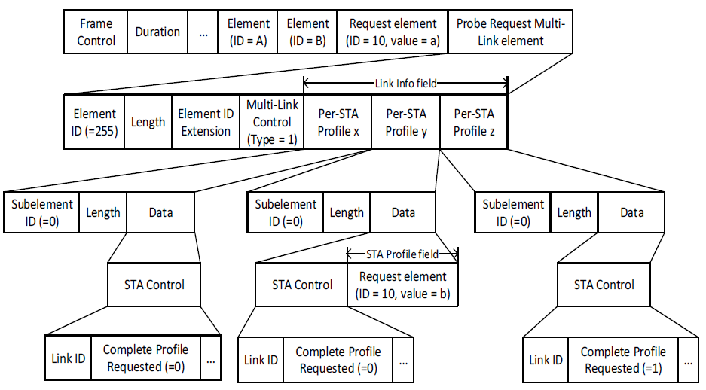
Figure 35-5—Example of inheritance in a Request element for Multi-Link probe request

