IEEE P802.11
Wireless LANs
LB266 CIDs 11530 and 11850
Date: 2022-08-23
Author(s):
Name | Affiliation | Address | Phone | email
Sigurd Schelstraete | MaxLinear |  |  | sschelstraete@maxlinear.com
Abstract
This submission proposes resolutions for the following CIDs:
- 11530 and 11850

CIDs

CID | Clause Number(C) | Page | Comment | Proposed Change | Proposed Resolution
11530 | 10.15 | 297.38 | it is unclear whether dot11HELDPCcodinginplayloadimplmented is for the transmitting or receiving STA. Please clarify | as in comment | Revised.  Editor’s instructions: apply “Proposed text changes” given in 802.11-22/1391r0
11850 | 10.15 | 297.35 | I thought LDPC was mandatory for EHT STAs. Please check PHY subclauses and ensure consistency with the normative behavior defined in those subclauses. | As in comment. | Revised.  No action needed. Review of relevant PHY subclauses shows they are consistent with the statements in Clause 10.15.  (See analysis in 802.11-22/1391r0 for details)

Discussion

Both comments refer to the following Clause:

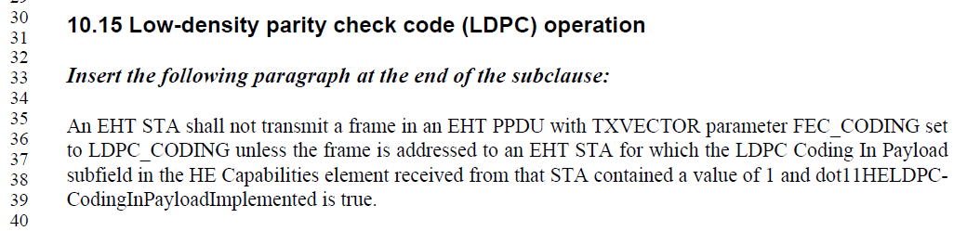

CID 11530:
Since dot11HELDPCcodinginplayloadimplemented is a MIB variable, it is local to the device and the value will not be known to any other STA. Therefore, when referring to the MIB variable in the context of the transmission of a frame, it would apply to the device doing the transmission.

Text modification is proposed below to clarify this.

CID 11850:
802.11be specifies the following w.r.t. support of LDPC (see D2.1, Clause 36.1.1, page 554, line 23):

An EHT STA shall support the following features:
(…)
- LDPC coding (transmit and receive) in all supported EHT PPDU types, RU and MRU sizes, and number of spatial streams if a STA satisfies any of the following conditions:
  - The STA declares support of transmission and reception in channel bandwidths greater than 20 MHz.
  - The STA declares support for transmitting or receiving more than 4 spatial streams.
  - The STA declares support for at least one of EHT-MCSs 10, 11, 12, (#12528)13, and 14 (trans-mit and receive).

This means LDPC is still optional if none of these conditions are true, which could happen for a 20 MHz-only STA supporting less than or equal to 4 SS and not supporting EHT MCS 10, 11, 12 or 13.

This is also stated separately in 36.3.13.3.3:

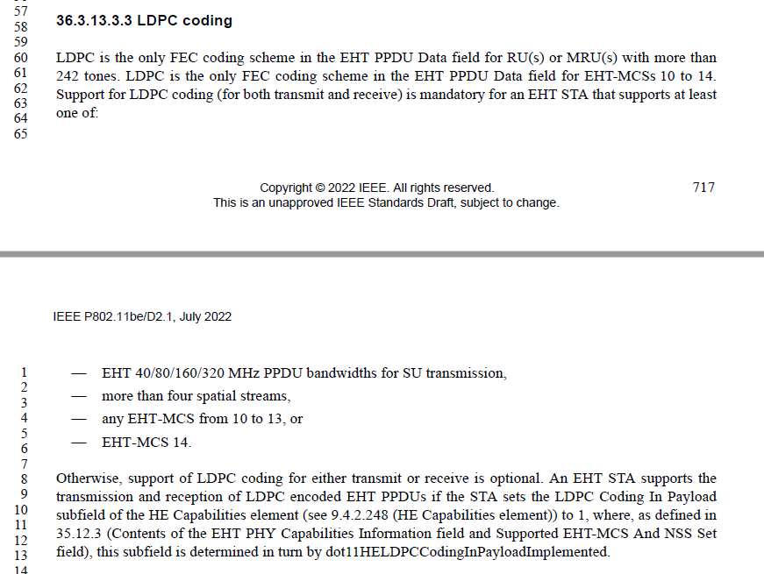

No action needed.

Proposed text changes

10.15 Low-density parity check code (LDPC) operation

Insert the following paragraph at the end of the subclause:

An EHT STA shall not transmit a frame in an EHT PPDU with TXVECTOR parameter FEC_CODING set to LDPC_CODING unless the frame unless the following conditions are met:
- The value of dot11HELDPCCodingInPayloadImplemented for the EHT STA is true
- The frame is addressed to an EHT STA for which the LDPC Coding In Payload subfield in the HE Capabilities element received from that STA contained a value of 1
is addressed to an EHT STA for which the LDPC Coding In Payload subfield in the HE Capabilities element received from that STA contained a value of 1 and dot11HELDPCCodingInPayloadImplemented is true.

