IEEE P802.11
Wireless LANs
LB266 Annex B CIDs
Date: 2022-08-23
Author(s):
Name | Affiliation | Address | Phone | email
Sigurd Schelstraete | MaxLinear |  |  | sschelstraete@maxlinear.com
Abstract
This submission proposes resolutions for the following CIDs:
- 10391 and 11226

CIDs

CID | Clause Number | Page | Comment | Proposed Change | Proposed Resolution
10391 | AnnexB | 811.60 | should be "... tone RU" instead of "... tone-RU" | Change "... tone-RU" into "... tone RU" | Accepted
11226 | B.4.3 | 805.49 | 80 MHz support is not required for 2.4 GHz. | Make CFEHT80 be conditional mandatory on CFEHT5G or CFEHT6G. | Revised  Agree in principle with commenter.  Editor’s instruction: apply changes as proposed in 802.11-22/1390r0

Discussion

The CIDs apply to the following places in the draft:

CID 10391:

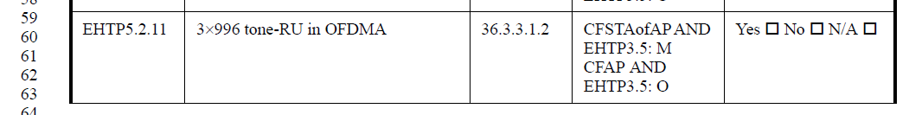

This is editorial and proposed resolution is accepted.

CID 11226:
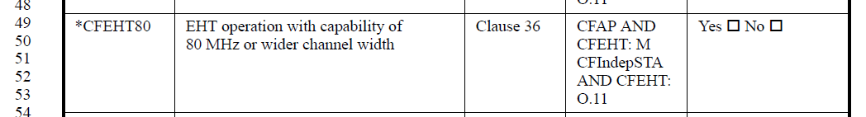

As currently written, this states that 80 MHz is mandatory if the device is an AP and it supports EHT. In reality, 80 MHz is not required when operating in 2.4 GHz, only in 5 GHz and 6 GHz.
To correctly capture this, the proposed resolution is to make the following changes to the Table on page 817 of D2.1:

*CFEHT80 | EHT operation with capability of  80 MHz or wider channel width | Clause 36 | CFAP AND CFEHT AND CFEHT5G: M  CFAP AND CFEHT AND CFEHT6G: M  CFIndepSTA AND CFEHT: O.11 | Yes ☐ No ☐

