IEEE P802.11
Wireless LANs
Resolutions for Technical Comments on SBP – Part 1
Date: 2022-08-25
Author(s):
Name | Affiliation | Address | Phone | email
Claudio da Silva | Meta Platforms, Inc |  |  | claudiodasilva@fb.com
Abstract
This submission proposes resolutions to technical comments submitted in CC40 on SBP.

CIDs: 730, 818, 413, 78, 266, 526, 79, 268, 530

CID | Clause | Page | Comment | Proposed change
730 | 4.3.21.26 | 17.41 | The text indicates "SBP enables a non-AP STA to obtain sensing measurements of the channel between an AP and one or more non-AP STAs or between a receive antenna and a transmit antenna of an AP" as it implies that SBP can also be used for radar sensing in 60GHz | Please clarify
818 | 4.3.21.26 | 17.41 | and/or condition implies monostatic type sensing, which is not applicable for all AP STA types. | Change text to: "SBP enables a non-AP STA to obtain sensing measurements of the channel between an AP and one or more non-AP STAs or between a receive antenna and transmit antenna of a DMG AP."

Proposed resolution: Revised

Discussion: The paragraph referred to by the commenter was modified by the resolution of comments 387, 582, 873, 135, and 677 (22/1261r3).

Modifications: Editor – Change 4.3.21.26 as follows:
SBP enables a non-AP STA to obtain sensing measurements of the channel between an AP and one or more non-AP STAs or between a receive antenna and a transmit antenna of an AP. With the execution of the SBP procedure, it is possible for a non-AP STA to obtain sensing measurements useful to estimate features such as range, velocity, and motion of objects in an area of interest(#111). request an AP to perform WLAN sensing on its behalf.

Note to editor: This is the same as comment resolution for CIDs 387, 582, 873, 135, and 677.

CID | Clause | Page | Comment | Proposed change
413 | 4.3.21.26 | 17.40 | The SBP feature does not warrant a full subclause in clause 4. | remove subclause 4.3.21.26. Add the following at the end of subclause 4.3.21.25: "A non-AP STA may obtain such measurements using the SBP procedure."

Proposed resolution: Revised

Discussion: The idea of incorporating SBP into the WLAN sensing procedure (specifically, placing SBP under the WLAN sensing procedure clause) was discussed in 22/1175r1 as part of CID 317. The following discussion can be found in 22/1175r1:

“SBP procedure” is different from “WLAN sensing procedure”, although SBP procedure has WLAN sensing component embedded in it. So, in that sense, SBP is not a feature of WLAN sensing (e.g., SBP does not have session setup, measurement setup etc.). SBP Procedure invokes WLAN sensing procedure at the AP (SBP responder) and has some additional signaling. Hence, it is appropriate to have the section “SBP procedure” outside of “WLAN sensing procedure”.

TGbf approved in motion 123 the resolution proposed in 22/1175r1 which maintains WLAN sensing and SBP as distinct procedures (and in different sub-clauses).

In addition, the paragraph referred to by the commenter was modified by the resolution of comments 387, 582, 873, 135, and 677 (22/1261r3).

Modifications: Editor – Change 4.3.21.26 as follows:
SBP enables a non-AP STA to obtain sensing measurements of the channel between an AP and one or more non-AP STAs or between a receive antenna and a transmit antenna of an AP. With the execution of the SBP procedure, it is possible for a non-AP STA to obtain sensing measurements useful to estimate features such as range, velocity, and motion of objects in an area of interest(#111). request an AP to perform WLAN sensing on its behalf.

Note to editor: This is the same as comment resolution for CIDs 387, 582, 873, 135, and 677.

CID | Clause | Page | Comment | Proposed change
78 | 9.6.7.54 | 60.40 | Measurement Setup ID field size | In 9.3.1.25.5 (and other places) the Measurement Setup ID is 1 octet (8 bits). However in 9.6.7.54 it is TBD. If the technical decision is that it is 8 bits then this should be in all places.
266 | 9.6.7.54 | 60.40 | In the figure Figure 9-1002bn the length of the Measurement Setup ID is 8bits for DMG, but in figure 9-1139g the length of the MSID is TBD, please make it consistently | as in comment
526 | 9.6.7.54 | 60.40 | Change TBD size of Measurement setup ID in figure 9-1139g with 1 octet and describe the detailed configuration of the Measurement setup ID | As in comment

Proposed resolution: Revised

Discussion: The modifications suggested below reflect the resolution of CIDs 75, 260, 378, 515, 76, 261, 518 as defined in 22/1168r5, approved by TGbf in Motion 121.
For reference, using D0.1,
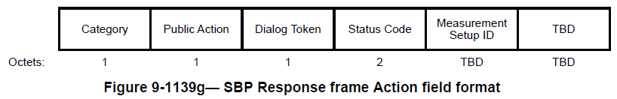

Also for reference, from 22/1168r5,
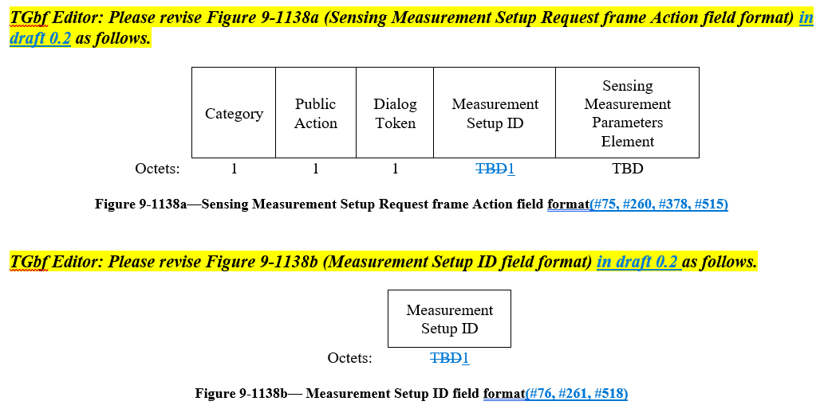

Modifications: Editor – Change the length of the Measurement Setup ID field in Figure 9-1139h (SBP Response frame Action field format) (D0.2) to 1.
Editor – Change the Measurement Setup ID (72.36-40, D0.2) field description as follows:

The Measurement Setup ID field is defined in Figure 9-1138b (Measurement Setup ID field format) and is set to the Measurement Setup ID value corresponding to the sensing measurement setup(#861) initiated by the AP that accepts the corresponding SBP request. The Measurement Setup ID field is present in an SBP Response frame only if the Status Code field is equal to SUCCESS.

CID | Clause | Page | Comment | Proposed change
79 | 9.6.7.55 | 61.11 | Measurement Setup ID field size | In 9.3.1.25.5 (and other places) the Measurement Setup ID is 1 octet (8 bits). However in 9.6.7.55 it is TBD. If the technical decision is that it is 8 bits then this should be in all places.
268 | 9.6.7.55 | 61.11 | In the figure Figure 9-1002bn the length of the Measurement Setup ID is 8bits for DMG, but in figure 9-1139h the length of the MSID is TBD, please make it consistently | as in comment
530 | 9.6.7.55 | 61.11 | Change TBD size of Measurement setup ID in figure 9-1139h with 1 octet and describe the detailed configuration of the Measurement setup ID. | As in comment

Proposed resolution: Revised

Discussion: The modifications suggested below reflect the resolution of CIDs 75, 260, 378, 515, 76, 261, 518 as defined in 22/1168r5, approved by TGbf in Motion 121.
For reference, using D0.1,
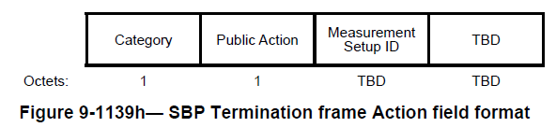

Also for reference, from 22/1168r5,

Modifications: Editor – Change the length of the Measurement Setup ID field in Figure 9-1139i (SBP Termination frame Action field format) (D0.2) to 1.
Editor – Change the Measurement Setup ID (72.64-65, D0.2) field description as follows:

The Measurement Setup ID field is set to the Measurement Setup ID value corresponding to the sensing measurement setup(#861) that was initiated by the SBP procedure, which is intended to be terminated. The Measurement Setup ID field is defined in Figure 9-1138b (Measurement Setup ID field format).

