IEEE P802.11
Wireless LANs
CC40 CR for Topic Setup – Part 1
Date: 2022.09.01
Author(s):
Name | Company | Address | Phone | email
Mengshi Hu | Huawei Technologies | H3, Huawei Base, Bantian, Longgang, Shenzhen, Guangdong, China, 518129 |  | humengshi@huawei.com
Rui Du
Narengerile
Lei Huang
Anirud | NIST
Abstract
This submission contains the proposed comment resolutions for the following 8 CIDs in the Topic “Setup” shown in 22/0820 IEEE 802.11bf CC40 comments.

CIDs 146, 379, 516, 517, 536, 716, 779, 880,

Revision Notes
R0 | Initial revision

CID 146 & 536 & 716 & 779 & 880
Page.  Line | Clause Number | Comment | Proposed Change | Resolution
67.13  (CID 146) | 9.4.1.9 | In Table 9-78 Status codes: a) Status code REQUEST_REJECTED(TBD) is not listed, b) Status code DENIED_SENSING_MEASUREMENT_SETUP is listed in the table, however there is no reference to this code anywhere in the draft. | a) Add REQUEST_REJECTED(TBD) code to the table, and b) add reference in the text to the code DENIED_SENSING_MEASUREMENT_SETUP | REVISED.  Regarding Comment a, “REQUEST_DECLINED” (Status code = 37) is used. Thus, there is no need to add a new one (See CID 177 in 22/1175r1 for details). Regarding Comment b, “REQUEST_DECLINED” is used to replace the “DENIED_SENSING_MEASUREMENT_SETUP”.  Instructions to the editor:  Please make the changes as shown under CID 880 in 11-22/1387r1.
67.22  (CID 536) | 11.21.18.4 | Delete the TBD and Define the Status code for this case. To define the status code for this, we can consider that reuse the none allocated value in the current table. | As in comment | REVISED.  Agree with the commenter in principle. In 802.11be Draft 0.2, one of the two TBDs in the paragraph has been deleted. The other one is deleted this time.  Instructions to the editor:  Please make the changes as shown under CID 880 in 11-22/1387r1.
67.18  (CID 716) | 11.21.18.4 | Seems like a non-intuitive mapping to use the code 0 to denote SUCCESS | This is just an observation. I expect changing this may have more implication so it is just provided as an observation | REVISED.  Code 0 for SUCCESS is used in Table 9-78 in 802.11 REVme. In 802.11bf Draft 0.2, the description has been changed into “set the Status Code field to SUCCESS”.  Note to the editor: No further change is needed.
67.21  (CID 779) | 11.21.18.4 | Instead of defining a new Status code, the responder may simply provide the reccomended parameters along with a "Rejected" status code. | As in comment. | REJECTED.  three status codes are used here:  - SUCCESS  - REQUEST_DECLINED  - PREFERRED_MEASUREMENT_SETUP_PARAMETERS_SUGGESTED  The third one is used to indicate the rejection with some preferred parameters, while the second one is used to indicate the rejection without preferred parameters. Since they have different meaings, it is better to keep them there.
67.21  (CID 880) | 11.21.18.4 | Remove TBD. Change the sentence to "The sensing responder may set the Status Code to a non-zero value (PREFERRED_  MEASURMENT_SETUP_PARAMETERS_SUGGESTED) which provides its preferred sensing measurement parameters in the Sensing Measurement Setup Response frame." | as in comment | REVISED.  In 802.11be Draft 0.2, one of the two TBDs in the paragraph has been deleted. The other one is deleted this time.  Instructions to the editor:  Please make the changes as shown under CID 880 in 11-22/1387r1.

Instructions to the editor: please make the following changes to Page 82, Line 53 in the subclause 11.21.18.4 Sensing measurement setup in D0.2 as shown below:

- Status codes
Status code | Name | Meaning
<ANA> | PREFERRED_MEASUREMENT_SETUP_PARAMETERS_SUGGESTED | The sensing measurement setup has not been established because the request cannot be honored; however, suggested sensing measurement setup parameters are provided.

Instructions to the editor: please make the following changes to Page 82, Line 53 in the subclause 11.21.18.4 Sensing measurement setup in D0.2 as shown below:
After receiving the Sensing Measurement Setup Request frame, the sensing responder shall transmit a Sensing Measurement Setup Response frame to the sensing initiator which transmitted the Sensing Measurement Setup Request frame, according to the following rules (see Table 9-78 (Status codes) for details):
— If the sensing responder accepts the requested sensing measurement setup parameters in the received Sensing Measurement Setup Request frame, it shall set the Status Code field to SUCCESS in the Sensing Measurement Setup Response frame.
— If the sensing responder declines the requested sensing measurement setup parameters in the received Sensing Measurement Setup Request frame but provides its preferred sensing measurement parameters in the Sensing Measurement Setup Response frame, it shall set the Status Code field to PREFERRED_MEASUREMENT_SETUP_PARAMETERS_SUGGESTED in the Sensing Measurement Setup Response frame.
— If the sensing responder declines the requested sensing measurement setup parameters in the received Sensing Measurement Setup Request frame without providing its preferred sensing measurement parameters in the Sensing Measurement Setup Response frame, it shall set the Status Code field to REQUEST_DECLINED in the Sensing Measurement Setup Response frame.

Discussion:
The following three status codes are used for the (DMG) Measurement Setup procedure ((DMG) Sensing Measurement Setup Response frame):
- SUCCESS
- DECLINED_SENSING_MEASURE MENT_SETUP (can be replaced by “REQUEST_DECLINED” (Status code = 37))
- PREFERRED_MEASUREMENT_SETUP_PARAMETERS_SUGGESTED
The REQUEST_DECLINED is used in the SBP procedure (SBP Reponse frame).

The following shows the text in Page 67, Line 13 in Draft 0.1.
After receiving the Sensing Measurement Setup Request frame, the sensing responder shall transmit a Sensing Measurement Setup Response frame to the sensing initiator which transmitted the Sensing Measurement Setup Request frame, according to the following rules:
— If the sensing responder accepts the requested sensing measurement setup parameters in the received Sensing Measurement Setup Request frame, it shall set the Status Code field to 0 (SUCCESS) in the Sensing Measurement Setup Response frame.
— Otherwise, the sensing responder shall set the Status Code field to TBD in the Sensing Measurement Setup Response frame. The sensing responder may set the Status Code to TBD (PREFERRED_MEASURMENT_SETUP_PARAMETERS_SUGGESTED) and provide its preferred sensing measurement parameters in the Sensing Measurement Setup Response frame.
The following shows the text in 1245.
Otherwise, the sensing responder shall set the Status Code field to DECLINED_SENSING_MEASUREMENT_SETUP or PREFERRED_MEASUREMENT_SETUP_PARAMETERS_SUGGESTED in the Sensing Measurement Setup Response frame. If the Status Code field is set to PREFERRED_MEASUREMENT_SETUP_PARAMETERS_SUGGESTED, the sensing responder shall provide its preferred sensing measurement parameters in the Sensing Measurement Setup Response frame.
Discussion ends.

CID 379
Page.  Line | Clause Number | Comment | Proposed Change | Resolution
58.41 | 9.6.7.50 | The size of Status Code should be determined | As in the comment. | REVISED.  Because the Staus Code field is used and the encoding table is Table 9-78—Status codes, this field should be 2 octets to be consistent with that in 802.11REVme.  Instructions to the editor:  please make the following changes to Page 69, Line 62 in the subclause 9.4.1.9 Status Code field in D0.2 as shown below:  Change the “TBD” corresponding to the Status Code field to 2.

Discussion:
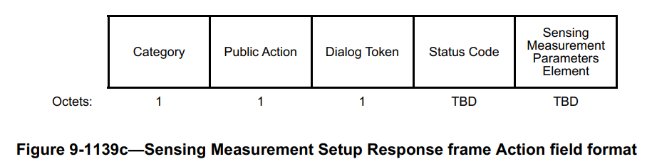
Discussion ends.

CID 516 & 517
Page.  Line | Clause Number | Comment | Proposed Change | Resolution
57.50 | 9.6.7.49 | According to the band (ex., sub 7 GHz or 60GHz) for the sensing measurement, one of the Sensing Measurement Setup Elements does not need. For example, in the sub-7GHz band, the DMG Sensing Measurement Setup Element can be omitted to reduce the signaling overhead. | Change the TBD with 0/TBD for the DMG Sensing Measurement Setup Element and Sensing Measurement Setup Element in Figure 9-1138a | REVISED.  The Sensning Measurement Setup Request frame defined in 802.11bf draft 0.1 has been divided into two frames in 802.11bf draft 0.2 (Sensning Measurement Setup Request frame and DMG Sensning Measurement Setup Request frame). Thus, no further change is needed.  Note to the editor: No further change is needed.
57.50 | 9.6.7.49 | In Figure 9-1138a, two Sensing Measurement Setup Elements are included in the sensing measurement setup request frame. however, according to the band for processing the sensing measurement, one of them is unnecessary. So to indicate the presence of an element, we consider the presence bit in this frame. | Add the indication bit to note the presence of the sensing measurement parameter element for each band. | REVISED.  The Sensning Measurement Setup Request frame defined in 802.11bf draft 0.1 has been divided into two frames in 802.11bf draft 0.2 (Sensning Measurement Setup Request frame and DMG Sensning Measurement Setup Request frame). Thus, no further change is needed.  Note to the editor: No further change is needed.
Discussion:
In 802.11bf Draft 0.1, the Sensning Measurement Setup Request frame is shown below:
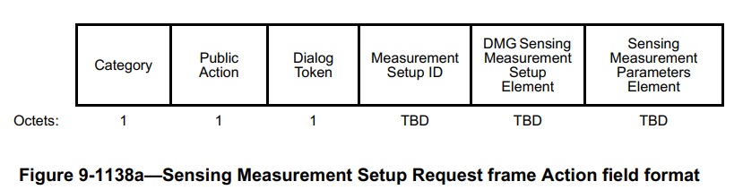
In 802.11bf Draft 0.2, the Sensning Measurement Setup Request frame is divided into two frames shown below:
- Sensing Measurement Setup Request frame:
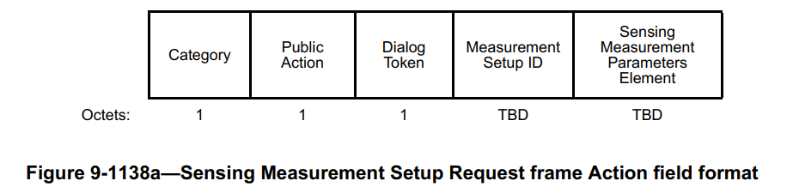
- DMG Sensing Measurement Setup Request frame:
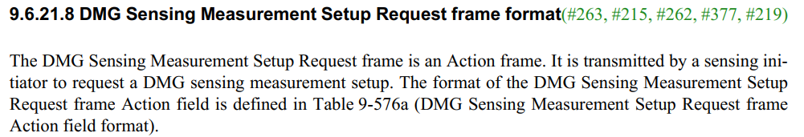
Discussion ends.

