IEEE P802.11
Wireless LANs
LB266 CR for PHY RU or MRU Index
Date: 2022.08.17
Author(s):
Name | Company | Address | Phone | email
Mengshi Hu | Huawei Technologies | H3, Huawei Base, Bantian, Longgang, Shenzhen, Guangdong, China, 518129 |  | humengshi@huawei.com
Ross Jian Yu
Ming Gan
Edward Au
Stephen McCann
Yanjun Sun | Qualcomm
Abstract
This submission contains the proposed comment resolutions of the following CID in 22/0971 IEEE 802.11be LB266 comments, in the subclause 9.3.1.22.4 EHT variant User Info field.

CIDs 10406

Revision Notes
R0 | Initial revision

CID 10406
Page.  Line | Clause Number | Comment | Proposed Change | Resolution
146.13 | 9.3.1.22.2 | Although people may guess out the difference between the PHY RU/MRU index and RU/MRU index, it is better to add defination for them or show the difference explictly. | Add definations on PHY RU/MRU index and RU/MRU index. For example, the PHY RU/MRU index further considers the X1 or N. | REVISED.  Agree with the commenter that the meaning of PHY RU/MRU should be explained.  Instructions to the editor:  Please make the changes as shown under CID 10406 in 11-22/1364r0.

Instructions to the editor: please make the following changes to Page 165, Line 38 in the subclause 9.3.1.22.2 Common Info field in D2.1.1 as shown below:
(#10406) NOTE 4 — The PHY RU or MRU index in this table indicates the allocated RU or MRU index defined in 36.3.2 (Subcarrier and resource allocation), while the RU or MRU index indicated by the PS160 subfield and the RU Allocation subfield is the allocated RU or MRU index when its size is greater than 2×996, and is a relative allocated RU or MRU index when its size is less than or equal to 2×996. In the case of the RU or MRU size less than or equal to 2×996, the RU or MRU index in this table indicates the PHY RU or MRU index along with:
- N indicated by Table 9-53b (Lookup table for X1 and N), if the RU or MRU size is less than or equal to 996.
- X1 indicated by Table 9-53b (Lookup table for X1 and N), if the RU or MRU size is greater than 996.

Discussion:
“PHY RU or MRU” only occurs in the following places in 11be D2.1.1:
[Page 161, Line 5]
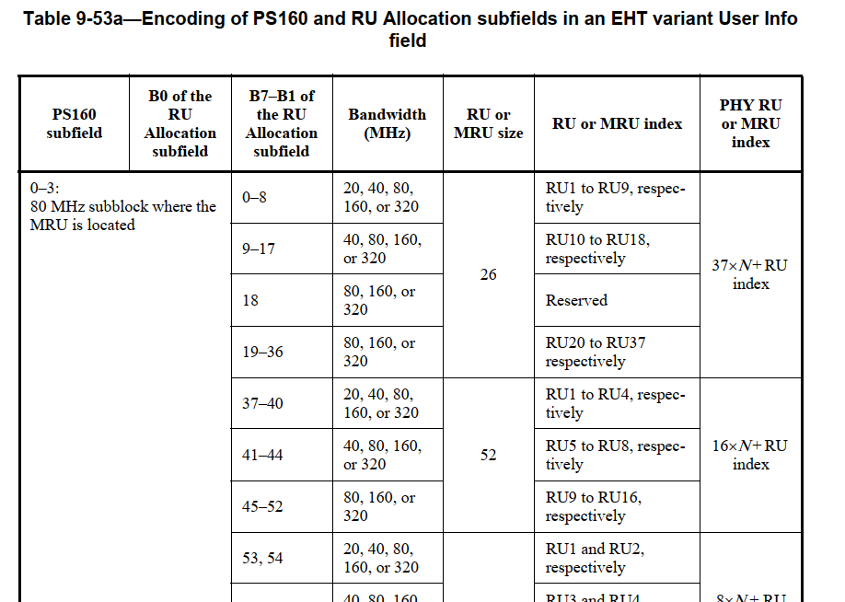
[Page 166 Line 57]
The 80 MHz subblock is derived based on the corresponding PHY RU or MRU index column in Table 9-53a (Encoding of PS160 and RU Allocation subfields in an EHT variant User Info field).
[Page 167 Line 1]
If the bandwidth indicates 20 MHz, the mapping of the PHY RU index to RU is defined in Table 27-7 (Data and pilot subcarrier indices for RUs in a 20 MHz HE PPDU and in a non-OFDMA 20 MHz HE PPDU) in increasing order.
If the bandwidth indicates 40 MHz, the mapping of the PHY RU index to RU is defined in Table 27-8 (Data and pilot subcarrier indices for RUs in a 40 MHz HE PPDU and in a non-OFDMA 40 M HE PPDU) in increasing order.
…
If the bandwidth indicates 320 MHz, the mapping of the PHY RU index to RU is defined in Table 36-7 (Data and pilot subcarrier indices for RUs in a 320 MHz EHT PPDU) in increasing order.
…
However, if we go to Table 36-7, there is no “PHY RU or MRU index” there, and the PHY RU or MRU such as the 26-tone RU 50 still uses the description “RU index” in Table 36-7. Thus, it is confusing what the RU or MRU index is and what the PHY RU or MRU index is:
- The RU or MRU index in Table 36-x is equal to the PHY RU or MRU index in Table 9-53a.
- The RU or MRU index in Table 9-53a is the relative RU or MRU instead of the allocated RU or MRU index.
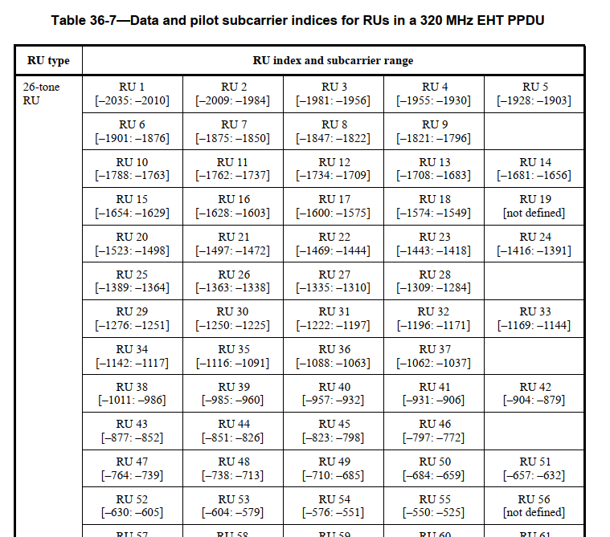
According to the draft, sometimes RU or MRU index is used to describe the relative RU or MRU index, and sometimes it is used to describe the absolute RU or MRU index. On the basis of this, in Table 9-53a, the PHY RU or MRU index actually indicates the abosulte RU or MRU index, in the case that the RU or MRU index indicates the relative RU or MRU index.

To make the change minor, a note can be added to Table 9-53a to describe what the PHY RU or MRU is and what the RU or MRU index is in Table 9-53a.
Discussion ends.

