IEEE P802.11
Wireless LANs
LB266 CR for 9.3.1.22.2 Common Info field of Trigger Frame
Date: 2022.08.16
Author(s):
Name | Company | Address | Phone | email
Mengshi Hu | Huawei Technologies | H3, Huawei Base, Bantian, Longgang, Shenzhen, Guangdong, China, 518129 |  | humengshi@huawei.com
Ross Jian Yu
Ming Gan
Yanjun Sun | Qualcomm
Dibakar | Intel
Abstract
This submission contains the proposed comment resolutions of the following 5 CIDs in 22/0971 IEEE 802.11be LB266 comments, for the subclause 9.3.1.22.2 Common Info field of Trigger Frame.

CIDs 10409, 10977, 10978, 14011, 14012.

Revision Notes
R0 | Initial revision

CID 10409 & 10977 & 10978
Page.  Line | Clause Number | Comment | Proposed Change | Resolution
146.09  (CID 10409) | 9.3.1.22.2 | the terms about TXOP sharing mode field are inconsistent between Figure 9-88a--EHT variant Common Info field format(i.e.Triggered TXOP Sharing Mode) and Table 9-53e--TXOP Sharing Mode subfield encoding(i.e.TXOP Sharing Mode subfield) | as the comment | REVISED.  Table 9-53e (TXOP Sharing Mode subfield encoding) shall be changed into Table 9-53e (Triggered TXOP Sharing Mode subfield encoding) for consistency.  Note to the Editor: The proposed change has been reflected in Draft 2.1.1.  No further changes are needed.
145.32  (CID 10977) | 9.3.1.22.2 | The description on the Triggered TXOP Sharing Mode subfield in Figure 9-88 is missing in this subclause. Please add some description, e.g. "if the Trigger frame is a MU-RTS TXS Trigger frame, then B20-B21 of the HE variant Common Info field is the Triggered TXOP Sharing Mode subfield. Otherwise, B20-B21 of the HE variant Common Info field is the GI And HE-LTF Type subfield" | As in comment | REVISED.  Agree with the commenter. Note that the condition should be the MU-RTS Trigger frame, instead of the MU-RTS TXS Trigger frame.  Instructions to the editor:  Please make the changes as shown under CID 10978 in 11-22/1361r1.
146.12  (CID 10978) | 9.3.1.22.2 | The description on the Triggered TXOP Sharing Mode in figure 9-88a is missing in this subclause. Please add some description, e.g. "if the Trigger frame is a MU-RTS TXS Trigger frame, then B20-B21 of the EHT variant Common Info field is the Triggered TXOP Sharing Mode subfield. Otherwise, B20-B21 of the EHT variant Common Info field is the GI And HE/EHT-LTF Type subfield" | As in comment | REVISED.  Agree with the commenter. Note that the condition should be the MU-RTS Trigger frame, instead of the MU-RTS TXS Trigger frame.  Instructions to the editor:  Please make the changes as shown under CID 10978 in 11-22/1361r1.

Instructions to the editor: please make the following changes to Line 41, Page 151 in the subclause 9.3.1.22.2 Common Info field in D2.1.1 as shown below:
If the Trigger Type subfield (B0-B3) indicates an MU-RTS Trigger frame, then B20-B21 of the HE or EHT variant Common Info field is the Triggered TXOP Sharing Mode subfield. Otherwise, B20-B21 of the HE variant Common Info field is the GI And HE-LTF Type subfield, and B20-B21 of the EHT variant Common Info field is the GI And HE/EHT-LTF Type subfield (#10977, #10978). The GI And HE-LTF Type subfield or GI And HE/EHT-LTF Type subfield of the Common Info field indicates the GI and HE/EHT-LTF type of the HE or EHT TB PPDU response. The GI And HE-LTF Type subfield or GI And HE/EHT-LTF Type subfield encoding is present in a Trigger frame that solicits a TB PPDU response and its encoding is defined in Table 9-48 (GI And HE/EHT-LTF Type subfield encoding). The Triggered TXOP Sharing Mode subfield in an HE or EHT variant Common Info field indicates the triggered TXOP sharing mode as shown in Table 9-53e (Triggered TXOP Sharing Mode subfield encoding (#12943)). The Triggered TXOP Sharing Mode subfield is defined in 9.3.1.22.9 (MU-RTS Trigger frame format).

Discussion:
The following figure shows a part of the HE variant Common Info field:
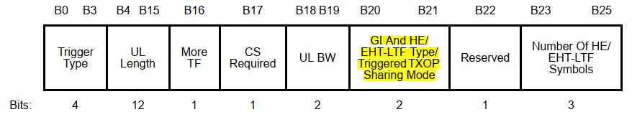
The following figure shows a part of the EHT variant Common Info field:
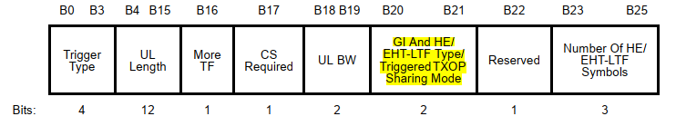
Triggered TXOP Sharing Mode subfield encoding:
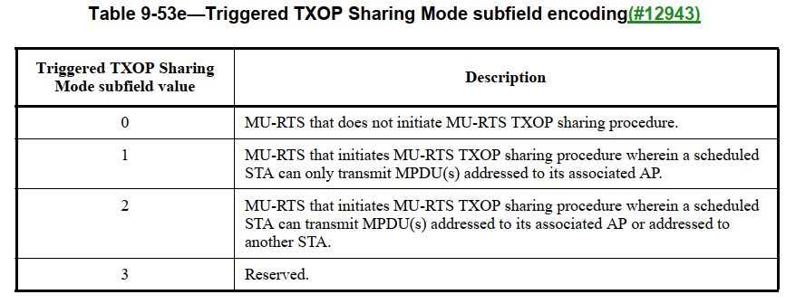
Discussion ends.

CID 14011
Page.  Line | Clause Number | Comment | Proposed Change | Resolution
151.46 | 9.3.1.22.2 | The description of Doppler subfield of HE variant Common Info field here should be integrated with the thrid paragraph in P149L46. | As in comment. | REJECTED.  There is no need to integrate the descriptions of B53 and B23-B25. These subfields should be introduced one by one, and the similar description way was used in 802.11ax-2021.

Discussion:

The following figure shows a part of the HE variant Common Info field:
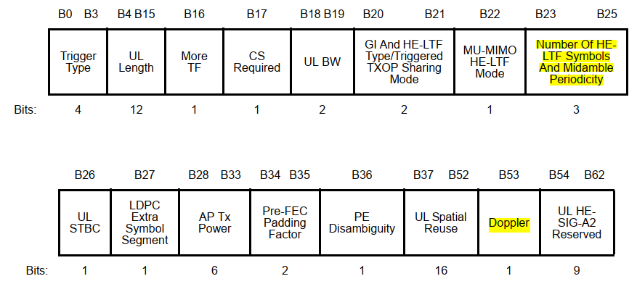
The following figure shows a part of the EHT variant Common Info field:
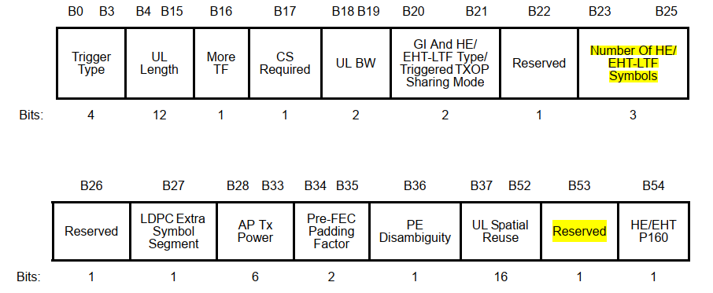
The paragraph in P149L46 is shown below (Draft 2.1.1 is the same (P152L50)):
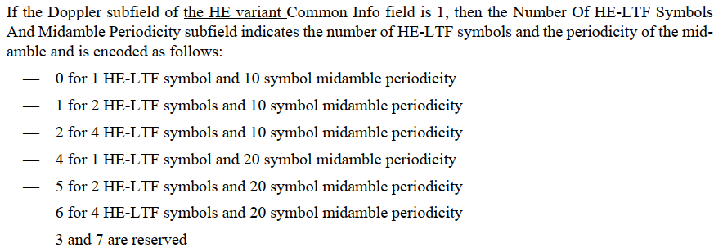
The above paragraph in P149L46 in Draft 2.0 mainly talks about the meaning of B23-B25, instead of B53. The meaning of B53 is described in P151L46 in Draft 2.0. There is no need to integrate them. These subfields should be introduced one by one. The similar description way was used in 802.11ax-2021.
Discussion ends.

CID 14012
Page.  Line | Clause Number | Comment | Proposed Change | Resolution
151.53 | 9.3.1.22.2 | The description of B53 of Common Info field here should be integrated with the second paragraph in P149L27. | As in comment. | REJECTED.  There is no need to integrate the descriptions of B53 and B23-B25. These subfields should be introduced one by one, and the similar description way was used in 802.11ax-2021.

Discussion:
The paragraph in P149L27 in Draft 2.0 is shown below:
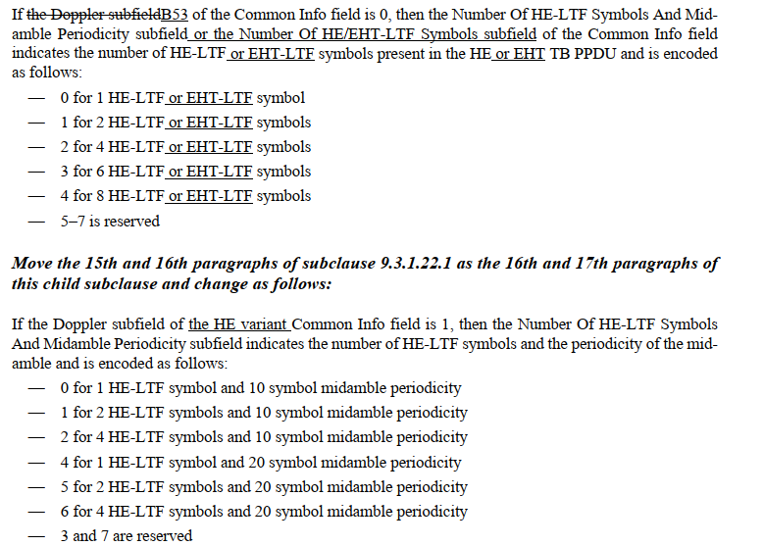
Later in Draft 2.1.1, the wording of the above first papragraph is updated, but is still related to the description of B23-B25.
Similar to the resolution of CID 14011, the paragraph in P149L27 in Draft 2.0 mainly talks about the meaning of B23-B25, instead of B53. The meaning of B53 is described in P151L46 in Draft 2.0. There is no need to integrate them. These subfields should be introduced one by one. The similar description way was used in 802.11ax-2021.
Discussion ends.

