IEEE P802.11
Wireless LANs
LB 266 Resolution for some NSTR Mobile AP related CIDs
Date: July 20, 2022
Author(s):
Name | Affiliation | Address | Phone | email
Morteza Mehrnoush | Meta |  |  | mmehrnoush@fb.com
Chunyu Hu | Meta
Binita Gupta | Meta
Chitto Ghosh | Meta
Kumail Haider | Meta

Abstract
This submission proposes resolutions for following 9 CIDs received for TGbe LB266:
10257, 10657, 11271, 11468, 11469, 11470, 12389, 10031, 14032

Revisions:
- Rev 0: Initial version of the document.
- Rev 1: Added one more CID#14032 to this doc.
- Rev 2: minor editorial fix during the call
- Rev 3: Updated the text for CIDs 10031 and 14032 based on the feedback

TGbe editor: The baseline for this document is 11be D2.2

Interpretation of a Motion to Adopt

A motion to approve this submission means that the editing instructions and any changed or added material are actioned in the TGbe Draft. This introduction is not part of the adopted material.

Editing instructions formatted like this are intended to be copied into the TGbe Draft (i.e., they are instructions to the 802.11 editor on how to merge the text with the baseline documents).

TGbe Editor: Editing instructions preceded by “TGbe Editor” are instructions to the TGbe editor to modify existing material in the TGbe draft. As a result of adopting the changes, the TGbe editor will execute the instructions rather than copy them to the TGbe Draft.

CID | Commenter | Clause | Pg/Ln | Comment | Proposed Change | Resolution
10257 | John Wullert | 35.3.19.1 | 468.52 | Subject verb agreement - given that subject is "timers" verb should be "are" | Revise to "Since TSF timers of all APs affiliated with an NSTR mobile AP MLD are the same..." | Accepted  TGbe editor: the change related to this comment is shown in doc 11-22/1357r2 tagged as 10257
10657 | Abhishek Patil | 35.3.19.1 | 468.51 | What is the value of the first sentence in NOTE 2? It can be deleted without any loose if information. | Delete the first sentence in NOTE 2 and keep the other 2 sentences in the NOTE. | Revised  Agree in principle. The sentence was not needed and also not correct as it was implying that non-AP MLD needs to follow the TSF timers of all APs affiliated with NSTR mobile AP; since the TSF timer of all APs are the same, non-AP MLD only needs to follow the TSF timer of one AP affiliated with NSTR mobile AP MLD as mentioned in the 2nd sentence. The note is updated to reflect the proposed change.  TGbe editor: please make changes as shown in doc 11-22/1357r2 tagged as 10657
11271 | Sigurd Schelstraete | 35.3.19.1 | 468.53 | change "is the same" to "are the same" (refering to TSF timers) | See comment | Accepted  TGbe editor: please apply the same resolution as CID 10257
11468 | Gaurang Naik | 35.3.19.1 | 468.30 | The statement suggests that the device type depends on the setting on the MIB variable, when in fact, it should be the other way around. Please revise the statement as suggested or similar. | Revise the statement as 'An NSTR mobile AP MLD shall set dot11EHTNSTRMobileAPMLDImplemented to true.' | Revised  Agree in principle. The text is updated as suggested by the comment.  TGbe editor: please make changes as shown in doc 11-22/1357r2 tagged as 11468
11469 | Gaurang Naik | 35.3.19.1 | 468.35 | There is no 'regular' AP defined in the spec. Please revise the statement as suggested. | Revise as '... in addition to the optional features supported by an AP affiliated with an AP MLD that is not an NSTR mobile AP MLD' | Revised  Agree in principle. The text is updated to reflect the proposed change.  TGbe editor: please make changes as shown in doc 11-22/1357r2 tagged as 11469
11470 | Gaurang Naik | 35.3.19.1 | 468.51 | The first statement in the NOTE is contradictory to the second statement. Since TSF of all APs for an NSTR mobile AP MLD is the same, why would the non-AP MLD follow TSF of all APs? | Remove the following statement from the NOTE - 'A non-AP MLD that is associated with an NSTR mobile AP MLD follows the TSF timers of all APs affiliated with an NSTR mobile AP MLD in each link.' | Revised  Agree in principle. The sentence was not needed and also not correct as it was implying that non-AP MLD needs to follow the TSF timers of all APs affiliated with NSTR mobile AP; since the TSF timer of all APs are the same, non-AP MLD only needs to follow the TSF timer of one AP affiliated with NSTR mobile AP MLD as mentioned in the 2nd sentence. The resolution is the same as the CID 10657.  TGbe editor: please make changes as shown in doc 11-22/1357r2 tagged as 10657
12389 | Rojan Chitrakar | 35.3.19.1 | 468.64 | Why is Start Time sync PPDU medium access mandatory for NSTR mobile AP MLD case, when it is optional for other NSTR MLDs? | Change shall to may: "...with an NSTR mobile AP MLD may follow the procedure defined in  35.3.16.6..." | Rejected  The “additional constraint” in this paragraph 11beD2.0/P469/L1 defines the rule for both STAs affiliated with non-AP MLD and APs affiliated with the NSTR mobile AP MLD in which the STA/AP operating on non-primary link can initiate PPDU transmission, only if the other STA/AP operating on primary link initiate PPDU as the TXOP holder with the same start time. In order to follow above rule and have the same PPDU start time, Start Time Sync PPDU medium access procedure is needed as a shall requirement. It is optional for other non-AP MLD NSTR operation, because it doesn't have such an additional constraint rules.
10031 | Morteza Mehrnoush | 35.3.19.1 | 468.30 | The power saving mechanism of the non-AP MLDs associated with the NSTR mobile AP MLD is not defined. If the STA on the primary link goes the power save (and doze state), then the STA on the non-primary link also should go the power save (and doze state) but not the other way around, because STA affiliated with non-AP MLD can only initiate PPDU transmission over the 2nd link if STA of the same non-AP MLD initiate the start time sync PPDU transmission over primary link.  Also during the PS mode, if the STA affiliated with non-AP MLD wants to poll DL buffer, send in UL, or NSTR mobile AP sending the DL buffer, it should follow the same mechanism for start time sync and end time alignment of the primary/non-primary links. | Please add text to explain these behaviors in spec. | Revised  If a STA affiliated with a non-AP MLD which is operating on the primary link enters power save mode (and doze state) and the other STA operating on nonprimary link is in Active mode, the AP affiliated with NSTR mobile AP MLD which is operating on primary link won’t transmit any PPDU in DL to it’s associated STA, so due to the PPDU start time sync rule for NSTR mobile AP MLD, the AP operating on nonprimary link won’t be able to do the PPDU start time sync and consequently AP won’t be able transmit any frame over the nonprimary link as well. Similarly, the STA affiliated with non-AP MLD which is operating on nonprimary link cannot initiate any TXOP as the primary link is in Doze state. So additional rule to define the power management operation for the nonprimary link is not needed.  Regarding the second part of the comment, a note is added for clarification to explain the behavior when either of the STAs affiliated with non-AP MLD is in PS mode and awake state.  TGbe editor: please make changes as shown in doc 11-22/1357r3 tagged as 10031
14032 | kaiying Lu | 35.3.19 | 468.25 | Nonprimary link power save management needs to be clarified. | Commenter will provide comment resolution | Revised  Agree in principle; similar resolution as CID #10031.  TGbe editor: please make changes as shown in doc 11-22/1357r3 tagged as 14032

Discussion for CID 10031 and 14032:
Explaining the issue through below example. STA1 affiliated with the non-AP MLD1 is in Active mode and STA2 affiliated with the same non-AP MLD is in PS mode and awake state. STA1 in order to initiate the PS-Poll transmission for requesting the BU from AP, it should do the PPDU start time sync and end time alignment with the PPDU of STA2. So depending on the frame sequence (PS-Poll/ACK followed by Data/ACK or PS-Poll/Data/ACK) it might not be possible and STA2 might skip the frame sequence initiation because STA1 cannot do start time sync and PPDU end time alignment.
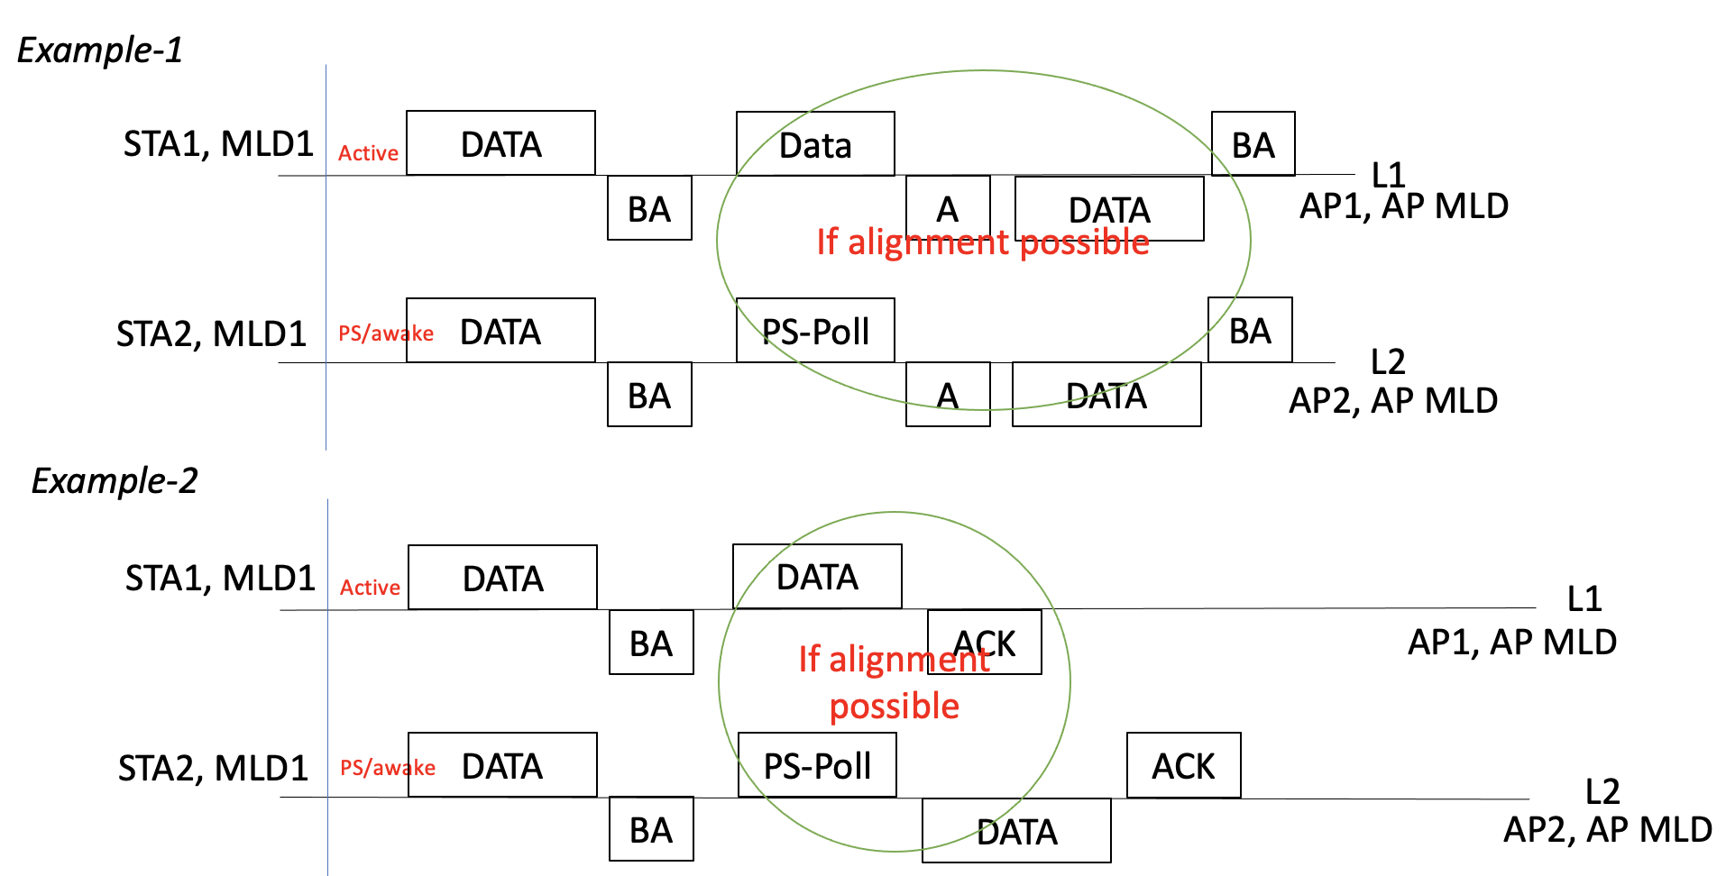

35.3.19 NSTR mobile AP MLD operation

35.3.19.1 General
TGbe editor: Please change the first paragraphs in this subclause as shown below:

An [#11468] AP MLD which is an NSTR mobile AP MLD shall set dot11EHTNSTRMobileAPMLDImplemented to true, otherwise it shall set dot11EHTNSTRMobileAPMLDImplemented to false. If dot11EHTBaseLineFeaturesImplementedOnly is equal to true, an NSTR mobile AP MLD shall have one NSTR pair of links and shall follow with the restrictions below:
— Each AP affiliated with an NSTR mobile AP MLD may optionally support the following features in
addition to the optional features supported by [#11469] an AP affiliated with an AP MLD which is not an NSTR mobile AP MLD:
• Support of DL and UL OFDMA operation
TGbe editor: Please change the fifth paragraphs in this subclause as shown below:

NOTE 2—[#10275, 10657]

Since TSF timers of all APs affiliated with an NSTR mobile AP MLD are the same, a non-AP MLD that is associated with an NSTR mobile AP MLD only needs to maintain one TSF timer for all the links.

TGbe editor: Please insert below note after the 9th paragraphs in this subclause as shown below:
[#10031, 14032]NOTE 5—If a STA affiliated with the non-AP MLD which is operating on nonprimary link enters power save mode and wants to initiate a frame sequence as PS-Poll/ACK or PS-Poll/Data/ACK to request for buffered BU from AP, it can do so if the other STA operating on the primary link initiates the PPDU as TXOP holder with the same start time and aligns the PPDU end time with the PS-Poll frame.

