IEEE P802.11
Wireless LANs
CR for CIDs related to Group addressed frame Reception in EMLSR/NSTR
Date: Nov 29, 2022
Author(s):
Name | Affiliation | Address | Phone | email
Vishnu V. Ratnam | Samsung Research America |  |  | vishnu.r@samsung.com
Boon Loong Ng
Rubayet Shafin
Peshal Nayak
Minyoung Park | Intel Corporation
Yongho Seok | MediaTek

Abstract
This submission proposes resolution for 10 CIDs received for TGbe LB266:

SP: Do you agree to the resolutions provided in doc 11-22/1335r6 for the following 8 CIDs for inclusion in the latest 11be draft?
13587 10039 10863 12726 12728 12892 13588 13813

Result: Yes/No/Abstain

Note: Motion already passed for CIDs 10434 12813 in 11-22/1335r5

Revisions:
- Rev 0: Initial version of the document.
- Rev 1: Changes based on further suggestions from Shawn Kim, Yongho Seok, Minyoung.
- Rev 2: Changes based on suggestions from Gaurang, Minyoung, Alfred, Ming, Abhi, Yongho, Shubhodeep
- Rev 3: Further editorial changes based on inputs from Shubhodeep and Sindhu, combined the CID tags with same resolution.
- Rev 4: Further editorial changes based on inputs from Liwen, Alfred, Shubhodeep.
- Rev 5: Further editorial changes based on inputs from Alfred and Yongho, changed baseline to D2.2.
- Rev 6: Removed the last 3 CIDs which were controversial.

Interpretation of a Motion to Adopt

A motion to approve this submission means that the editing instructions and any changed or added material are actioned in the TGbe Draft. This introduction is not part of the adopted material.

Editing instructions formatted like this are intended to be copied into the TGbe Draft (i.e. they are instructions to the 802.11 editor on how to merge the text with the baseline documents).

TGbe Editor: Editing instructions preceded by “TGbe Editor” are instructions to the TGbe editor to modify existing material in the TGbe draft. As a result of adopting the changes, the TGbe editor will execute the instructions rather than copy them to the TGbe Draft.

CID | Clause | Page.Line | Comment | Proposed Change | Resolution
13587 | 35.3.17 | 463.38 | "...except when the frame exchanges initiated by the initial Control frame on one of the EMLSR links overlaps with group addressed frame transmissions on the other EMLSR link where the non-AP STA intends to receive the group addressed frames."  Please add the folloing:  "In which case, the STA affiliated with the non-AP MLD does not respond to the initial Control frame and receives the group addressed frames." | As in the comment. | Revised  Agree in principle. It has been clarified in Clause 35.3.17 that a STA affiliated with an EMLSR non-AP MLD should be capable of receiving the group addressed frames that it intends to receive at their scheduled transmission time on that link. After receiving the group addressed frames, the STA(s) affiliated with the non-AP MLD that are required to be in awake state shall return to listen operation.  TGbe editor, please implement changes as shown in doc 11-22/1335r5 tagged 13587

CID | Clause | Page.Line | Comment | Proposed Change | Resolution
10039 | 35.3.17 | 463.38 | It's not clear how the non-AP MLD can receive the beacons over the EMLSR links; also the groupcast frame delivery is not explained in the spec. Please add text to cover this. | as in comment | Revised  Agree in principle. Rules to be followed by an AP MLD to avoid transmitting frames whose response overlaps with group addressed frames on other EMLSR links have been added in Clause 35.3.17. This enables the non-AP MLD to switch to the desired link to decode the group addressed frames without dropping frames on other links.  TGbe editor, please implement changes as shown in doc 11-22/1335r5 tagged 10863
10863 | 35.3.17 | 461.56 | Behavior of non-AP MLD that is in EMLSR mode for the reception on Beacon and other group addressed frames should be specified. | as in comment | Revised  Agree in principle. Rules to be followed by an AP MLD to avoid transmitting frames whose response overlaps with group addressed frames on other EMLSR links have been added in Clause 35.3.17. This enables the non-AP MLD to switch to the desired link to decode the group addressed frames without dropping frames on other links.  TGbe editor, please implement changes as shown in doc 11-22/1335r5 tagged 10863
12726 | 35.3.17 | 461.55 | EMLSR STAs shall be able to receive beacon frames on their EML links in order to determine the TWT/rTWT SPs of which they are member of | Please provide rules for an EMLSR STAs to be able to receive beacon frames on their EMLSR links. | Revised  Agree in principle. Rules to be followed by an AP MLD to avoid transmitting frames whose response overlaps with group addressed frames on other EMLSR links have been added in Clause 35.3.17. This enables the non-AP MLD to switch to the desired link to decode the group addressed frames without dropping frames on other links.  TGbe editor, please implement changes as shown in doc 11-22/1335r5 tagged 10863
12728 | 35.3.17 | 461.55 | EMLSR STAs shall be able to receive beacon frames on their EMLSR links in order to determine the TWT/rTWT SPs of which they are member of. There is an issue if an IC frame is received during a TBTT expiry on another link. | Please provide rules for an EMLSR STAs or AP, to deal with the case of initial Control frame overlapping the TBTT on other EMLSR Link . | Revised  Agree in principle. Rules to be followed by an AP MLD to avoid transmitting frames whose response overlaps with group addressed frames on other EMLSR links have been added in Clause 35.3.17. This enables the non-AP MLD to switch to the desired link to decode the group addressed frames without dropping frames on other links.  TGbe editor, please implement changes as shown in doc 11-22/1335r5 tagged 10863
12892 | 35.3.17 | 464.63 | In Note 7, it is not clear how any STA affiliated with a non-AP MLD that is operating in the EMLSR mode can receive Beacon frames, while listening operation only "includes CCA and receiving the initial Control frame of frame exchanges that is initiated by the AP MLD". | Please clarify how a STA affiliated with a non-AP MLD that is operating in the EMLSR mode can receive Beacons, if during listening it performs just CCA and reception of certain Control frames. | Revised  Agree in principle. Rules to be followed by an AP MLD to avoid transmitting frames whose response overlaps with group addressed frames on other EMLSR links have been added in Clause 35.3.17. This enables the non-AP MLD to switch to the desired link to decode the group addressed frames without dropping frames on other links.  TGbe editor, please implement changes as shown in doc 11-22/1335r5 tagged 10863
13588 | 35.3.17 | 463.40 | "...where the non-AP STA intends to receive the group addressed frames."  Based on the current spec, the non-AP STA may singal which STA will receive the group addressed frame, through 26.8.6 (Negotiation of wake TBTT and wake interval).  And, in 26.8.6, "The TBTT scheduled STA shall be in the awake state to listen to Beacon frames transmitted at negotiated wake TBTTs and shall operate as described in 26.8.3.3 (Rules  for TWT scheduled STA)."  So, during the negotiated wake TBTT, the AP shall not send the initial Control frame. Please clarify the this. | As in the comment. | Revised  Agree in principle. Rules to be followed by an AP MLD to avoid transmitting frames whose response overlaps with group addressed frames on other EMLSR links have been added in Clause 35.3.17. This enables the non-AP MLD to switch to the desired link to decode the group addressed frames without dropping frames on other links.  TGbe editor, please implement changes as shown in doc 11-22/1335r5 tagged 10863
13813 | 35.3.17 | 463.39 | Is it possible that a initial control frame is overlapped in time with group addressed frames on other links? we should avoid that | please clarify | Revised  Agree in principle. Rules to be followed by an AP MLD to avoid transmitting frames whose response overlaps with group addressed frames on other EMLSR links have been added in Clause 35.3.17. This enables the non-AP MLD to switch to the desired link to decode the group addressed frames without dropping frames on other links.  TGbe editor, please implement changes as shown in doc 11-22/1335r5 tagged 10863

Discussion:

Protecting individually addressed frames during Group addressed frame transmission:
As per current spec, a STA affiliated with an EMLSR non-AP MLD operating on an EMLSR link may not respond to an initial control frame or to a frame soliciting an immediate response, if the response overlaps with group addressed frame transmission on another EMLSR link that the non-AP MLD intends to receive. This can cause failure of the packet or can even cause loss of TXOP for the AP of the AP MLD that transmitted the frame. Therefore, to prevent such unreliable transmissions, an AP MLD should avoid transmitting individually addressed frames that solicit an immediate response (including initial control frames) to a STA affiliated with an EMLSR non-AP MLD, if the response is expected to overlap with or is less than an EMLSR transition delay before the scheduled group addressed frame transmission time on another EMLSR link that the non-AP MLD is expected to receive. The above discussion is depicted pictorially below, where a beacon frame on link 2 is used as an example for the group addressed frame to be decoded by STA2 of the non-AP MLD, and to prevent such reception from causing a packet failure, a frame exchange sequence on link 1 is terminated and an ICF restriction region (yellow) is used on links 1 and 3.
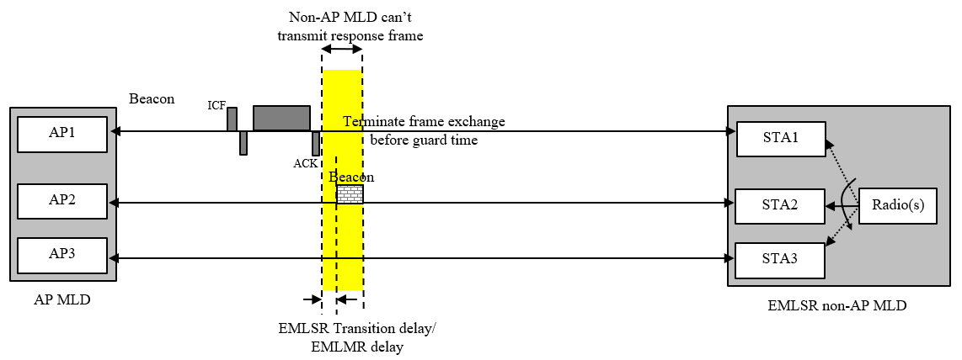
TGbe editor: Please note Baseline is 11be D2.2
35.3.17 Enhanced multi-link single radio operation
TGbe editor: Please insert the following bullets to the eighth paragraph of the subclause
When a non-AP MLD is operating in the EMLSR mode with an AP MLD supporting the EMLSR mode, the following applies:
…
- [13587] The STA affiliated with the non-AP MLD and operating on an EMLSR link that intends to receive group addressed frames should be capable of receiving the group addressed frames at their scheduled transmission time on that link. After receiving the group addressed frame(s), the STA(s) affiliated with the non-AP MLD which operate on the EMLSR links but were not able to perform listening operation during the reception of the group addressed frames shall return to the listening operation if they are required to remain in the awake state according to 11.2.3.7 (Receive operation for STAs in PS mode), 26.8.5 (Power save operation during TWT SPs).
- [10863] An AP affiliated with the AP MLD should not transmit a frame that solicits an immediate response to a STA that is affiliated with the non-AP MLD on an EMLSR link, if the transmit time of the immediate response is expected to overlap with or be within an EMLSR transition delay, indicated in the EMLSR transition delay subfield, before the transmission time of group addressed MPDUs on another EMLSR link that the non-AP MLD is expected to receive.
- When a non-AP STA affiliated with the non-AP MLD initiates a TXOP the following applies:
  - The non-AP MLD shall be switched back to the listening operation on the EMLSR links after the time duration indicated in the EMLSR Transition Delay subfield after the end of the TXOP.
  - [10863] The STA should end the TXOP at least an EMLSR transition delay, indicated in the EMLSR Transition Delay subfield, before the TBTT of another EMLSR link if the non-AP MLD intends to receive the next DTIM Beacon frame and group addressed frame(s) in the other EMLSR link that are scheduled to be transmitted at that TBTT.

