IEEE P802.11
Wireless LANs
CR on CID 10116
Date: 2022-07-28
Author(s):
Name | Affiliation | Address | Phone | email
Bo Gong | Huawei |  |  | gongbo8@huawei.com
Jian Yu | Huawei |  |  | ross.yujian@huawei.com
Ming Gan | Huawei |  |  | ming.gan@huawei.com

Abstract
This submission contains proposed comment resolutions to comments on P802.11be D2.0. The changes are based on P802.11be D2.0.

The submission provides resolutions to the following CID:
- 10116

Revisions:
- Rev 0: Initial version of the document.

CID | Page | Clause | Comment | Proposed Change | Resolution
10116 | 0.0 | 0.0 | Add a new subclause 35.18 Link adaptation using the HLA Control subfield to support EHT link adaptation. | As in the comment. | Revised  Agreed in principle. Reflect the detailed explanation.  Instructions to the editor  Please make the changes as shown in 11/21-1317r0

Discussion:

- Background of HE link adaptation

HE link adaptation is designed for obtaining a more accurate MCS for an HE PPDU.

- HE link adaptation mainly includes two procedures:

- Solicited MFB procedure:

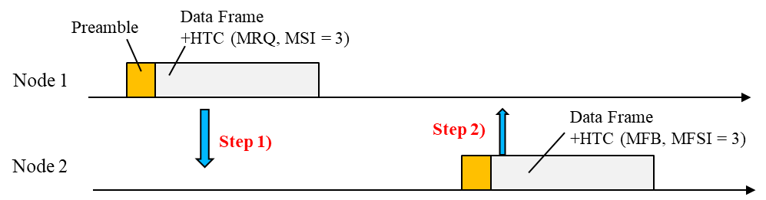

- Unsolicited MFB procedure:

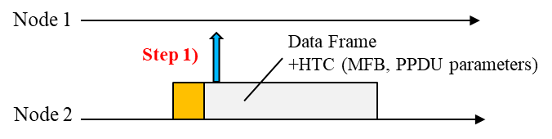

- The structure of the indication information can be summarized as follows.

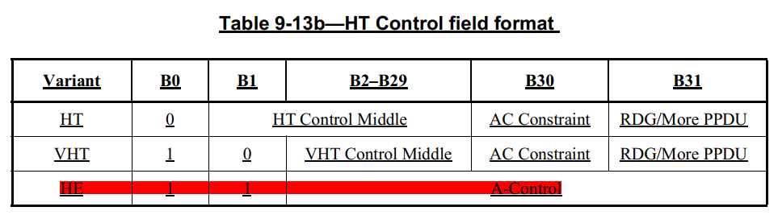
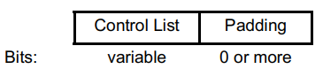

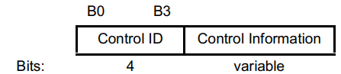 ……

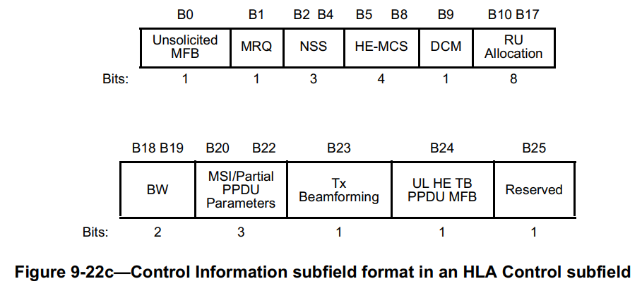

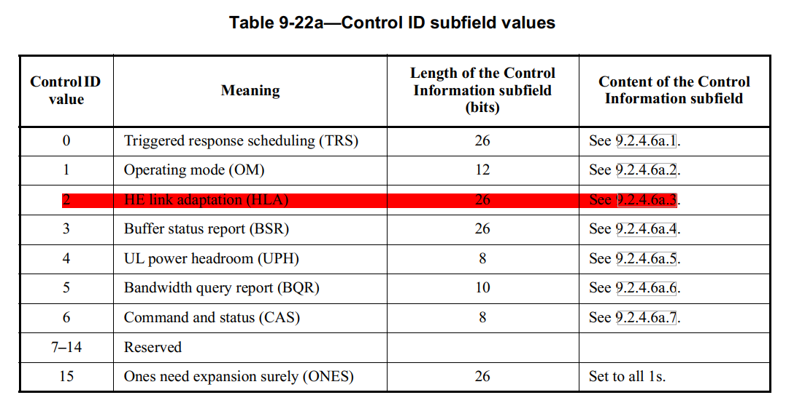

- For HE link adaptation, the meaning of the subfields can be summarized as follows.

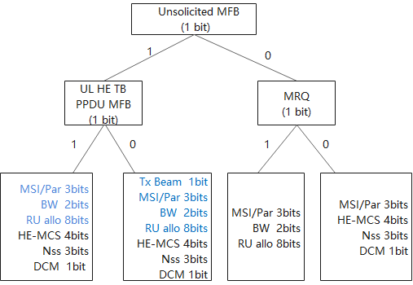

- Extension to EHT link adaptation

To exploit link adaptation for EHT PPDU, HE link adaptation should be extended to EHT link adaptation. Due to the functional similarity between HE and EHT link adaptation, sharing a common control ID is a straightforward idea. On one hand, it can save valuable control IDs for more functions; on the other hand, it is also very intuitive in terms of expression. Thus, one bit to differentiate HE and EHT link adaptation is required. In addition, for EHT PPDU parameters, the Bandwidth (BW) field requires 3 bits instead of 2 bits for an HE PPDU. The RU allocation requires 9 bits instead of 8 bits for an HE PPDU. For EHT MFB (MCS feedback), DCM indication with 1 bit is no longer required. Thus, the total numner of bits required is 27, which is 1 bit more than the 26 bits provided by the Control Information subfield. Fortunately, the MRQ subfield and the UL EHT TB PPDU MFB subfield can be compressed to 1 bit and the Control Information subfield for EHT link adaptation can be described as follows.

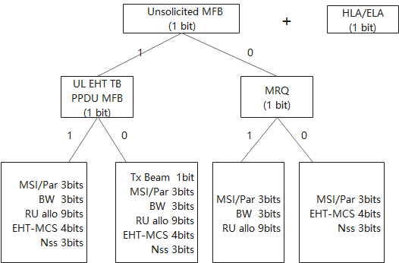

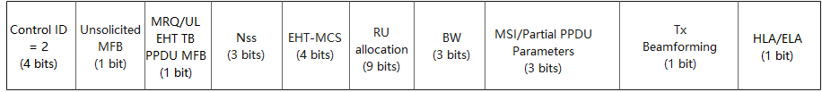

- Related illustration

- The usage of EHT link adaptation is almost the same as the usage of HE link adaptation, as described in 26.13 Link adaptation using the HLA Control subfield.

- For capability indication completeness, the EHT Link Adaptation Support subfield should be added in the EHT MAC Capabilities Information field of EHT Capabilities element. The detailed indication of EHT Link Adaptation Support subfield is the same as HE Link Adaptation Support subfield in HE MAC Capabilities Information field of the HE Capabilities element.

Instructions to the Editor:

- Please insert subclause 9.2.4.7.11 ELA Control in line 28, Page 128 in TGbe Draft D2.0:

9.2.4.7.11 ELA Control

The Control Information subfield in an ELA Control subfield contains information related to the EHT link adaptation (ELA) procedure (see 35.18). The format of the subfield is shown in Figure xxx (Control Information subfield format in an ELA Control subfield).
 | B0 | B1 | B2 B4 | B5 B8 | B9 B16 | B17 |  | B18 B20 | B21 B23 | B24 | B25
 | Unsolicited MFB | MRQ/  UL EHT TB PPDU MFB | NSS | EHT-MCS | RU Allocation |  | PS160 | BW | MSI/ Partial PPDU Parameters | Tx Beamforming | HLA/ELA
Bits: | 1 | 1 | 3 | 4 | 8 | 1 |  | 3 | 3 | 1 | 1
Figure xxx —Control Information subfield format in an ELA Control subfield

The ELA Control subfields are defined in Table xxx.

Table xxx ELA Control subfields
Subfield | Meaning | Definition
Uosolicited MFB | Unsolicited MFB indicator | Set to 1 if the ELA control is an unsolicited MFB.  Set to 0 if the ELA control is an MRQ or a solicited MFB.
MRQ/  UL EHT TB PPDU MFB | ELA feedback request indicator/UL EHT TB PPDU MFB  indication | Set to 1 and set Unsolicited MFB subfield to 0 to request an ELA feedback.  Set to 0 and set Unsolicited MFB subfield to 0 to respond to an ELA request.  If the Unsolicited MFB subfield is equal to 1, a value of 1 in this  subfield indicates that the NSS, EHT-MCS, BW and  RU Allocation fields represent the recommended MFB for  the EHT TB PPDU sent from the STA as defined in 35.18.
N_{SS} | Recommended number of spatial stream | If the Unsolicited MFB subfield is equal to 1 and the MRQ/UL EHT TB  PPDU MFB subfield is equal to 0 or if the Unsolicited MFB  subfield is equal to 0 and the MRQ/UL EHT TB PPDU MFB subfield is equal to 0, the N_{SS} subfield indicates the recommended number of spatial streams to the PPDU sent to the STA, N_{SS}, and is set to N_{SS} – 1.  If the Unsolicited MFB subfield is equal to 1 and the MRQ/UL EHT TB  PPDU MFB subfield is equal to 1, the N_{SS} subfield indicates the  recommended number of spatial streams to the EHT TB  PPDU sent from the STA, N_{SS}, and is set to N_{SS} – 1.  Otherwise, this subfield is reserved
EHT-MCS | Recommended EHT-MCS | If the Unsolicited MFB subfield is equal to 1 and the MRQ/UL EHT TB  PPDU MFB subfield is equal to 0 or if the Unsolicited MFB  subfield is equal to 0 and the MRQ/UL EHT TB PPDU MFB subfield is equal to 0, the EHT-MCS subfield indicates the recommended EHT-MCS of the PPDU sent to the STA, and is set to the EHT-MCS index (see 36.5).  If the Unsolicited MFB subfield is equal to 1 and the MRQ/UL EHT TB  PPDU MFB subfield is equal to 1, the EHT-MCS subfield indicates  the recommended EHT-MCS of the EHT TB PPDU sent from  the STA, and is set to the EHT-MCS index (see 36.5).  Otherwise, this subfield is reserved.
PS160 | Indication of primary 160MHz channel or second 160MHz channel that the RU or MRU allocation applies to | If the Unsolicited MFB subfield is equal to 1, or the Unsolicited MFB subfield is equal to 0 and the MRQ/UL EHT TB PPDU MFB subfield is equal to 1, the PS160 subfield is set to 0 to indicate the RU or MRU allocation applies to the primary 160 MHz channel and set to 1 to indicate the RU or MRU allocation applies to the secondary 160 MHz channel with the size of RU or MRU smaller than or equal to 2×996 tone. The PS160 subfield is used to indicate the RU or MRU index along with the RU Allocation subfield with the size of RU or MRU larger than 2×996 tone.  Otherwise, this subfield is reserved.
RU Allocation | RU or MRU of the recommended EHT-MCS/RU or MRU specified by MFB requester to get feedback | If the Unsolicited MFB subfield is equal to 1 and the MRQ/UL EHT TB  PPDU MFB subfield is equal to 0, the RU Allocation subfield and the PS160 jointly indicate the RU or MRU for which the recommended EHT-MCS applies to the PPDU sent to the STA, as defined in 35.18.  If the Unsolicited MFB subfield is equal to 0 and the MRQ/UL EHT TB  PPDU MFB subfield is equal to 1, the RU Allocation subfield and the PS160 jointly indicate the RU or MRU requested by the MFB requester to get feedback. The RU Allocation subfield and the PS160 subfield are interpreted with the BW subfield to specify the RU or MRU. The RU or MRU index encoding is as defined in Table 9-53a.  If the Unsolicited MFB subfield is equal to 1 and the MRQ/UL HE TB  PPDU MFB subfield is equal to 1, the RU Allocation subfield and the PS160 jointly indicate the RU or MRU for which the recommended EHT-MCS applies to the EHT TB PPDU sent from the STA, as defined in 35.18 and that the actual allocation of the RU can be ignored by the recipient.  Otherwise, this subfield is reserved
BW | Bandwidth of the recommended EHT-MCS/ Bandwidth specified by MFB requester to get feedback | If the Unsolicited MFB subfield is equal to 1 and the MRQ/UL EHT TB  PPDU MFB subfield is equal to 0, the BW subfield indicates the  bandwidth for which the recommended EHT-MCS applies to  the PPDU sent to the STA, as defined in 35.18.  If the Unsolicited MFB subfield is equal to 1 and the MRQ/UL EHT TB  PPDU MFB subfield is equal to 1, the BW subfield indicates the  bandwidth for which the recommended EHT-MCS applies to  the EHT TB PPDU sent from the STA, as defined in 35.18.  If the Unsolicited MFB subfield is equal to 0 and the MRQ/UL EHT TB  PPDU MFB subfield is equal to 1, the BW subfield indicates the bandwidth requested by the MFB requester to get feedback.  Set to 0 for 20 MHz.  Set to 1 for 40 MHz.  Set to 2 for 80 MHz.  Set to 3 for 160 MHz.  Set to 4 for 320 MHz.  Values 5, 6 and 7 are Validate.  Otherwise, this subfield is reserved.
MSI/PPDU-Type | Partial parameters of the measured PPDU/ MRQ sequence identifier | If the Unsolicited MFB subfield is equal to 0 and the MRQ/UL EHT TB  PPDU MFB subfield is equal to 1, the MSI/Partial PPDU Parameters subfield contains a sequence number in the range 0 to 6 that identifies the  specific EHT-MCS feedback request.  If the Unsolicited MFB subfield is equal to 0 and the MRQ/UL EHT TB  PPDU MFB subfield is equal to 0, the MSI/Partial PPDU Parameters subfield contains a sequence number in the range 0 to 6 that responds to the specific solicited EHT-MCS feedback request.  If the Unsolicited MFB subfield is equal to 1, the MSI/Partial PPDU Parameters subfield contains the PPDU Format and Coding Type subfields as shown in Figure xxx (MSI/Partial PPDU Parameters subfield when the Unsolicited MFB subfield is 1).
Tx Beamforming | Transmission type of the measured PPDU | If the Unsolicited MFB subfield is equal to 1 and the MRQ/UL HE TB PPDU MFB subfield is equal to 0, then the Tx Beamforming subfield indicates whether the PPDU from which the unsolicited MFB was estimated is beamformed.  Set to 0 for non-beamformed PPDU.  Set to 1 for beamformed PPDU.  Otherwise, this subfield is reserved.
HLA/ELA | HE/EHT link adaptation indication | Set to 1 if the Control Information subfield is an ELA control subfield.  Set to 0 if the Control Information subfield is an HLA control subfield.

The format of the MSI/Partial PPDU Parameters subfield is defined in Figure xxx (MSI/Partial PPDU Parameters subfield when the Unsolicited MFB subfield is 1).
B0 B1 |  | B2
Reserved | PPDU Format | Coding Type
Bits: 1 | 1 | 1
Figure XXX MSI/Partial PPDU Parameters subfield when the Unsolicited MFB subfield is 1

The PPDU Format subfield indicates the format of the PPDU from which the unsolicited MFB was estimated:
— Set to 0 for an EHT MU PPDU.
— Set to 1 for an EHT TB PPDU.
The Coding Type subfield contains the coding information of the PPDU from which the unsolicited MFB was estimated:
— Set to 0 for BCC.
— Set to 1 for LDPC.

- Please insert subclause 35.18 EHT Link adaptation using ELA Control subfield in Line 57, Page 540 in TGbe Draft D2.0:

35.18 EHT link adaptation using ELA Control subfield

This subclause applies to frame exchange sequences that include PPDUs containing an HE variant HT Control field.

An EHT STA shall set the EHT Link Adaptation Support subfield, in the EHT Capabilities Information field in the EHT Capabilities element it transmits to, the value of dot11EHTMCSFeedbackOptionImplemented.

A STA that supports EHT link adaptation using the ELA Control subfield shall set the EHT Link Adaptation Support subfield in the EHT Capabilities Information field in the EHT Capabilities element to 2 or 3, depending on its own link adaptation feedback capability. A STA shall not send an MRQ to a STA that has not set the EHT Link Adaptation Support subfield to 3 in the EHT Capabilities Information field in the EHT Capabilities element. A STA shall not send an unsolicited MFB in any frame that contains an ELA Control subfield to a STA that has not set the EHT Link Adaptation Support subfield to either 2 or 3 in the EHT Capabilities Information field in the EHT Capabilities element.

The HLA/ELA subfield should be set to 1 in the ELA Control subfield of a frame to indicate the ELA Control subfield.

The MFB requester may set the MRQ/UL EHT TB PPDU MFB subfield to 1 and Unsolicited MFB subfield to 0 in the ELA Control subfield of a frame to request a STA to provide link adaptation feedback. In each request, the MFB requester shall set the MSI field to a value ranging from 0 to 6. For the MFB requester, how to choose the MSI value is implementation dependent.

The appearance of more than one instance of an ELA Control subfield with the MRQ/UL EHT TB PPDU MFB subfield equal to 1 and Unsolicited MFB subfield equal to 0 within a single PPDU shall be interpreted by the receiver as a single request for link adaptation feedback.

The MFB requester shall specify the RU or MRU index and bandwidth requesting the link adaptation feedback.

On receipt of an ELA Control subfield with the the MRQ/UL EHT TB PPDU MFB subfield equal to 1 and Unsolicited MFB subfield equal to 0, an MFB responder computes the EHT-MCS and NSS of the RU or MRU and bandwidth specified in the MRQ, and these estimates are based on the same RU or MRU of the PPDU carrying the MRQ. The PPDU carrying MRQ shall include the RU or MRU requested for MFB. The MFB responder labels the result of this computation with the MSI value from the ELA Control subfield in the received frame carrying the MRQ. The MFB responder may include the received MSI value in the MSI field of the corresponding response frame. In the case of a delayed response, this allows the MFB requester to associate the MFB with the soliciting MRQ.

An MFB responder that sends a solicited MFB shall set the Unsolicited MFB subfield to 0 and MRQ/UL EHT TB PPDU MFB subfield to 0 in the ELA Control subfield.

The STA receiving MFB may use the received MFB to compute the appropriate EHT-MCS and N_{SS}.

The MFB responder may send a solicited response frame with any of the following combinations of EHT-MCS, N_{SS}, and MSI:
— EHT-MCS = 15, N_{SS} = 7, MSI = 0–6: the responder will not provide feedback for the request that had the MSI value.
— EHT-MCS = valid value, N_{SS} = valid value, MSI = 0–6: the responder is providing feedback for the request that had the MSI value. The MSI value in the response frame matches the MSI value of the MRQ request.

A STA sending an unsolicited MFB using the ELA Control subfield shall set the Unsolicited MFB subfield to 1.

Unsolicited EHT-MCS, N_{SS}, bandwidth, and RU or MRU estimates reported in an ELA Control subfield sent by a STA are computed based on the most recent PPDU received by the STA that matches the description indicated by the PPDU format, Tx Beamforming, and Coding Type subfields in the same ELA Control subfield.

In an unsolicited MFB response the PPDU Formats, Coding Type, and Tx Beamforming subfields are set according to the RXVECTOR parameters of the received PPDU from which the EHT-MCS, RU or MRU, bandwidth, and N_{SS} are estimated, as follows:
— The PPDU format subfield is set and encoded as follows:
— 0 if the parameter FORMAT is equal to EHT_MU
— 1 if the parameter FORMAT is equal to EHT_TB
— The Coding Type subfield is set to 0 if the parameter FEC_CODING is equal to BCC_CODING and set to 1 if that parameter is equal to LDPC_CODING.
— The Tx Beamforming subfield is set to 1 if the parameter BEAMFORMED is equal to 1 and set to 0 if that parameter is equal to 0.
— The BW subfield shall indicate a bandwidth less than or equal to the bandwidth indicated by the parameter CH_BANDWIDTH.
— The RU or MRU subfield and the PS160 subfield jointly indicate the RU or MRU at which the recommended EHT-MCS is applied. The recommended RU or MRU shall be within an RU or MRU or a bandwidth in which the received EHT PPDU is located.

For either a solicited or an unsolicited response, the recommended EHT-MCS and N_{SS} subfields of the ELA Control subfield shall be selected from the EHT-MCS and N_{SS} set supported by the recipient STA.

The EHT-MCS subfield of ELA Control subfield is the recommended data rate, for given transmission properties carried in the RXVECTOR of the PPDU used for MFB estimation, which results in an estimated frame error rate of 10% or lower for an MPDU length of 3895 octets.

NOTE—Some EHT PPDU might not be able to carry 3895 octets due to PPDU duration limitations.

If the MFB requester sets the Unsolicited MFB subfield to 0 and the MRQ/UL EHT TB PPDU MFB subfield to 1 and sets the MSI subfield to a value that matches the MSI subfield value of a previous request for which the responder has not yet provided feedback, the responder shall discard or abandon the computation for the MRQ that corresponds to the previous use of that MSI subfield value and start a new computation based on the new request.

A STA may respond immediately to a current request for MFB with a frame containing an MSI field value and N_{SS} and EHT-MCS subfields that correspond to a request that precedes the current request.

A non-AP EHT STA may set the Unsolicited MFB subfield to 0 and the MRQ/UL EHT TB PPDU MFB to 1 in the ELA Control field it transmits to the AP to indicate that the N_{SS}, EHT-MCS, bandwidth, and RU allocation in the ELA Control field represent the recommended MFB for the EHT TB PPDU sent from the non-AP EHT STA. The AP should not exceed the recommended RU or MRU size indicated in the most recently received RU Allocation and PS160 subfield of the ELA Control field when it sends a triggering frame addressed to the STA.

- Please make the following changes in subclause 9.2.4.6.4 HE variant in Line 42, Page 122 in TGbe Draft D2.0

Change Table 9-25 (Control ID subfield values) as follows:

Table 9-25—Control ID subfield values

Control ID value | Meaning | Length of the Control Information subfield (bits) | Content of the Control Information subfield
0 | Triggered response scheduling (TRS) | 26 | See 9.2.4.6a.1 (TRS Control)
1 | Operating mode (OM) | 12 | See 9.2.4.6a.2 (OM Control)
2 | HE link adaptation (HLA)/EHT link adaptation (ELA) | 26 | See 9.2.4.6a.3 (HLA Control)/9.2.4.7.11(ELA Control)
3 | Buffer status report (BSR) | 26 | See 9.2.4.6a.4 (BSR Control)
4 | UL power headroom (UPH) | 8 | See 9.2.4.6a.5 (UPH Control)
5 | Bandwidth query report (BQR) | 10 | See 9.2.4.6a.6 (BQR Control)
6 | Command and status (CAS) | 8 | See 9.2.4.6a.7 (CAS Control)
7 | EHT operating mode (EHT OM) | 6 | See 9.2.4.7.8 (EHT OM Control)
8 | Single response scheduling (SRS) | 10 | See 9.2.4.7.9 (SRS Control)
9 | AP assistance request (AAR) | 20 | See 9.2.4.7.10 (AAR Control)
10–14  7–14 | Reserved
15 | Ones need expansion surely (ONES) | 26 | Set to all 1s

- Please make the following changes in subclause 10.8 HT Control field operation in Line 1, Page 293 in TGbe Draft D2.0.

A STA in which at least one of dot11RDResponderOptionImplemented, dot11MCSFeedbackOptionImplemented, and dot11AlternateEDCAActivated is equal to true shall set dot11HTControlFieldSupported or dot11VHTControlFieldOptionImplemented or both equal to true. A STA that has at least one of dot11TRSOptionImplemented, dot11OMIOptionImplemented, dot11HEBSRControlImplemented, dot11HEBQRControlImplemented, dot11RDResponderOptionImplemented, and dot11SRResponderOptionImplemented equal to true or has at least one of dot11HEMCSFeedbackOptionImplemented and dot11EHTMCSFeedbackOptionImplemented greater than zero shall set dot11HEControlFieldOptionImplemented to true. An HE/EHT AP shall set dot11HEControlFieldOptionImplemented to true.

Table 10-12—Conditions for including Control subfield variants

Control subfield variant | Condition
TRS | The transmitting AP expects an HE TB PPDU that follows the TRS information as described in 26.5.2.2 (Rules for soliciting UL MU frames) and the recipient non-AP STA has set the TRS Support subfield in the HE MAC Capabilities Information field in the HE Capabilities elements it transmits to 1.  The transmitting AP expects an EHT TB PPDU that fol-lows the TRS information as described in 35.5.2.2 (Rules for soliciting UL MU frames)and the recipient non-AP STA has set the EHT TRS Support subfield in the EHT MAC Capabilities Information field in the EHT Capabilities elements it transmits to 1.
OM | The transmitting STA changes its operating mode, as described in 26.9 and the recipient STA has set the OM Control Support subfield in the HE MAC Capabilities Information field in the HE Capabilities elements it transmits to 1
HLA | The transmitting STA follows the HE link adaptation procedure, as described in 26.13 and the recipient STA has set the HE Link Adaptation Support subfield in the HE MAC Capabilities Information field in the HE Capabilities elements it transmits to a nonzero value.
ELA | The transmitting STA follows the EHT link adaptation procedure, as described in 35.18 and the recipient STA has set the EHT Link Adaptation Support subfield in the EHT MAC Capabilities Information field in the EHT Capabilities elements it transmits to a nonzero value.
BSR | The transmitting non-AP STA follows the corresponding buffer status report procedure, as described in 26.5.5 and the recipient AP has set the BSR Support subfield in the HE MAC Capabilities Information field in the HE Capabilities elements it transmits to 1.
UPH | The transmitting non-AP STA follows the UL MU operation procedure, as described in 26.5.2.3.
BQR | The transmitting non-AP STA follows the bandwidth query report procedure, as described in 26.5.2 and the recipient AP has set the BQR Support subfield in the HE MAC Capabilities Information field in the HE Capabilities elements it transmits to 1.
CAS | The transmitting STA follows either:  — The reverse direction protocol procedure described in 10.29 and the recipient STA has set the RD Responder in the HT Extended Capabilities field in the HT Capabilities elements it transmits to 1, or  — The PSR procedure described in 26.10.3 and the recipient STA has set the SR Responder subfield of the HE MAC Capabilities Information field in the HE Capabilities elements it transmits to 1.
ONES | The transmitting STA may include a ONES Control subfield in an MPDU that is not carried in an HE TB PPDU (see 26.5.2.4 (A-MPDU contents in an HE TB PPDU)) or an EHT TB PPDU when there is nothing to report in A-Control subfield.

- Please make the following changes in 9.4.2.313.2 EHT MAC Capabilities Information field in Line 7, Page 229, in TGbe Draft D2.0.
B0 B1 B2 B3 B4
EPCS Priority Access Supported | EHT OM Control Support | Triggered TXOP Sharing Mode 1 Support | Triggered TXOP Sharing Mode 2 Support | Restricted TWT Support

Bits: | 1 |  | 1 |  | 1 | 1 | 1
 | B5 | B6 |  | B7 | B8 | B9 | B10

SCS Traffic Description Support | Maximum MPDU Length | Maximum  A-MPDU Length Exponent Extension | EHT TRS Support | TXOP Return Support In TXOP Sharing Mode 2
Bits: 1 2 1 1 1

B11 B12 B13 B15
Reserved
EHT Link Adaptation Support
Bits: 2 3
Figure 9-1002af—EHT MAC Capabilities Information field format

Table 9-401k—Subfields of the EHT MAC Capabilities Information field

Subfield | Definition | Encoding
… | … | …
EHT Link Adaptation Support | Indicates support for link adaptation using the ELA Control subfield. | If the +HTC-HE Support subfield in HE MAC Capabilities Information field in HE Capabilities element is equal to 1:  Set to 0 (No feedback) if the STA does not provide EHT MFB.  Set to 2 (Unsolicited) if the STA can receive and provide only unsolicited EHT MFB.  Set to 3 (Solicited and unsolicited) if the STA is  capable of receiving and providing EHT MFB in response to EHT MRQ and if the STA can receive and provide unsolicited EHT MFB.  The value 1 is reserved.  EHT MFB and EHT MRQ are MFB and MRQ using ELA Control subfield, respectively.  Reserved if the +HTC-HE Support subfield in HE MAC Capabilities Information field in HE Capabilities element is 0.

- Please make the following changes in Line 51, Page 823 in TGbe Draft D2.0.

Dot11EHTStationConfigEntry ::=
SEQUENCE {
dot11EHTPPEThresholdsRequired TruthValue,
dot11TIDtoLinkMappingActivated TruthValue,
dot11EHTEPCSPriorityAccessActivated TruthValue,
dot11MSDTimerDuration Unsigned32,
dot11MSDTXOPMAX Unsigned32,
dot11EHTMCSFeedbackOptionImplemented INTEGER}

Please insert the following text in Line 7, Page 825 in TGbe Draft D2.0.

dot11EHTMCSFeedbackOptionImplemented OBJECT-TYPE
SYNTAX INTEGER {none(0), unsolicited(2), solicitedandunsolicited(3)}
MAX-ACCESS read-only
STATUS current
DESCRIPTION
"This is a capability variable.
Its value is determined by device capabilities.

This attribute indicates the EHT-MCS feedback capability supported by the station implementation."
DEFVAL { 0 }
::= { dot11EHTStationConfigEntry <ANA>}

