IEEE P802.11
Wireless LANs
LB266 CR for 36.3.7 Overview of the PPDU Encoding Process
Date: 2022.08.09
Author(s):
Name | Company | Address | Phone | email
Mengshi Hu | Huawei Technologies | H3, Huawei Base, Bantian, Longgang, Shenzhen, Guangdong, China, 518129 |  | humengshi@huawei.com
Ross Jian Yu
Ming Gan
Shimi Shilo
Abstract
This submission contains the proposed comment resolutions of the following 9 CIDs in 22/0971 IEEE 802.11be LB266 comments, in the subclause 36.3.7 Overview of the PPDU encoding process.

CIDs 11349, 11350, 11351, 12842, 12843, 12844, 12845, 13566, 13567.

Revision Notes
R0 | Initial revision

CID 11349
Page.  Line | Clause Number | Comment | Proposed Change | Resolution
618.52 | 36.3.7.6 | Change "Insert pilots as described in 17.3.5.9 (Pilot subcarriers)." to "Insert pilots as described in 36.3.12.7 (U-SIG) | as in the comment | REVISED.  Change it into “Insert pilots as described in 36.3.12.7.3 (Encoding and modulation)”

Discussion:
618.52 (the text in 36.3.7.6 Construction of U-SIG):
e) Pilot insertion: Insert pilots as described in 17.3.5.9 (Pilot subcarriers).
Discussion ends.

CID 11350
Page.  Line | Clause Number | Comment | Proposed Change | Resolution
618.57 | 36.3.7.6 | Change "subblocks" to "subblock" | as in the comment | ACCEPTED.

Discussion:
NOTE 2—20, 40, and 80 MHz EHT PPDUs have one 20, 40, and 80 MHz frequency subblock, respectively. 160 and 320 MHz EHT PPDUs have two and four 80 MHz frequency subblocks, respectively.
Discussion ends.

CID 11351
Page.  Line | Clause Number | Comment | Proposed Change | Resolution
619.30 | 36.3.7.7 | Change "Insert pilots as described in 17.3.5.9 (Pilot subcarriers)." to "Insert pilots as described in 36.3.12.8 (EHT-SIG) | as in the comment | REVISED.  Change the text to “Insert pilots as described in 36.3.12.8.6 (Encoding and modulation)”

Discussion:
619.30 (the text in 36.3.7.7 Construction of EHT-SIG):
e) Pilot insertion: Insert pilots as described in 17.3.5.9 (Pilot subcarriers).
Discussion ends.

CID 12842
Page.  Line | Clause Number | Comment | Proposed Change | Resolution
618.34 | 36.3.7.6 | The text "each frequency subblock" should be clarified as "each 20 MHz, 40 MHz, or 80 MHz frequency subblock" | Change "each frequency subblock" to "each 20 MHz, 40 MHz, or 80 MHz frequency subblock" | REJECTED

Discussion:
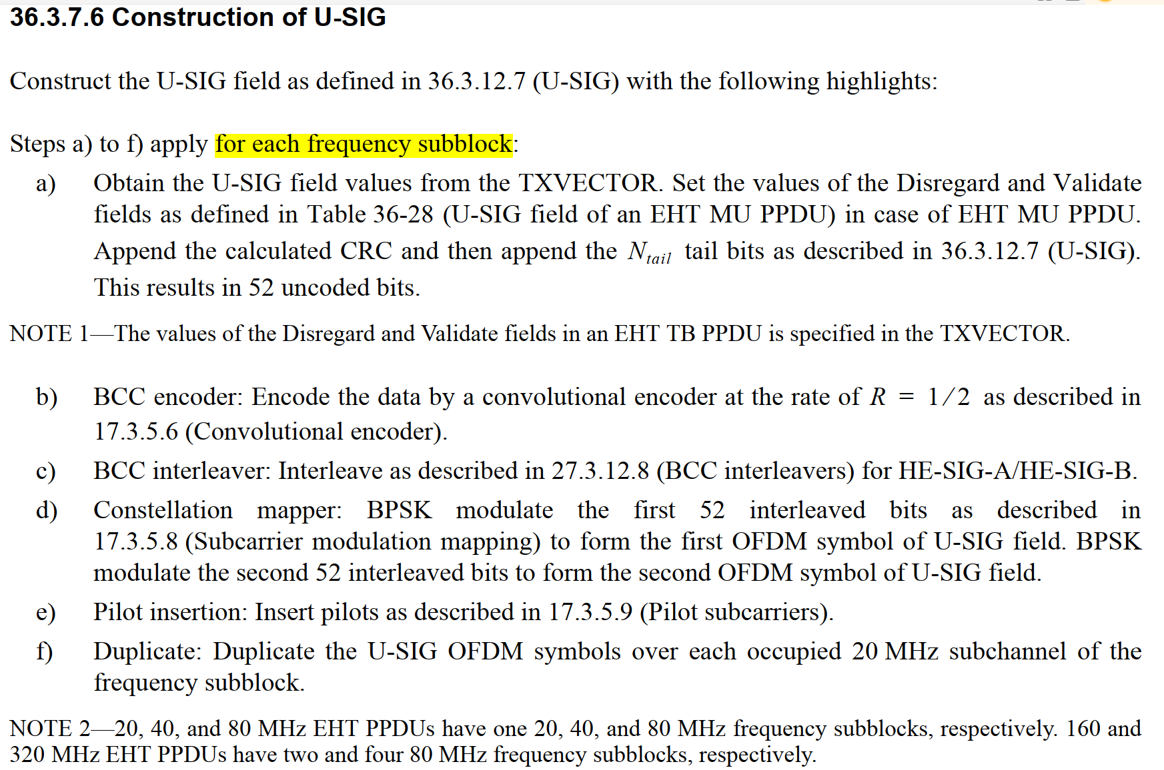
Discussion ends.

CID 12843
Page.  Line | Clause Number | Comment | Proposed Change | Resolution
620.62 | 36.3.7.9 | The text "two frequency subblocks" should be clarified as "two 80 MHz frequency subblocks" | Change "two frequency subblocks" to "two 80 MHz frequency subblocks" | ACCEPTED.

Discussion:
[Text related to 620.62 (in 36.3.7.10 Construction of Data field in an EHT PPDU)]
In a 320 MHz EHT MU PPDU using EHT-MCS 14, the output of the stream parser is divided into two 80 MHz frequency subblocks as described in 36.3.13.5 (Segment parser). Segment parser is bypassed in an 80 MHz or 160 MHz EHT MU PPDU using EHT-MCS 14.

[Text in 36.3.13.5 Segment parser]
The segment parser operation is applied to each 80 MHz frequency subblock.
…
NOTE—For MCS 14, the RU size refers to the RU size before duplication. Specifically, this means that segment parsing with MCS 14 is only required using 320 MHz.

[Text in 618.56]
20, 40, and 80 MHz EHT PPDUs have one 20, 40, and 80 MHz frequency subblocks, respectively. 160 and 320 MHz EHT PPDUs have two and four 80 MHz frequency subblocks, respectively.
Discussion ends.

CID 12844
Page.  Line | Clause Number | Comment | Proposed Change | Resolution
621.12 | 36.3.7.10 | The text "merge the multiple frequency subblocks" should be clarified as "merge the multiple 80 MHz frequency subblocks". | Change "merge the multiple frequency subblocks" to "merge the multiple 80 MHz frequency subblocks". | ACCEPTED.

Discussion:
[Text related to 621.12]
In a 2×996-tone RU, 4×996-tone RU, 996+484-tone MRU, 996+484+242-tone MRU, 2×996+484-tone MRU, 3×996-tone MRU, or 3×996+484-tone MRU using EHT-MCS 0 to 13 or 15, merge the multiple 80MHz frequency subblocks into one frequency segment as described in 36.3.13.9 (Segment deparser).

[Text in 36.3.13.5 Segment parser]
The segment parser operation is applied to each 80 MHz frequency subblock.
[Text in 618.56]
20, 40, and 80 MHz EHT PPDUs have one 20, 40, and 80 MHz frequency subblocks, respectively. 160 and 320 MHz EHT PPDUs have two and four 80 MHz frequency subblocks, respectively.
Discussion ends.

CID 12845
Page.  Line | Clause Number | Comment | Proposed Change | Resolution
621.15 | 36.3.7.10 | The text "merge the two frequency subblocks to" should be clarified as "merge the two 80 MHz frequency subblocks to". | Change "merge the two frequency subblocks to" to "merge the two 80 MHz frequency subblocks to". | ACCEPTED.

Discussion:
[Text related to 620.62]
In a 320 MHz EHT MU PPDU using EHT-MCS 14, the output of the stream parser is divided into two 80 MHz frequency subblocks as described in 36.3.13.5 (Segment parser). Segment parser is bypassed in an 80 MHz or 160 MHz EHT MU PPDU using EHT-MCS 14.

[Text in 36.3.13.5 Segment parser]
The segment parser operation is applied to each 80 MHz frequency subblock.

[Text in 618.56]
20, 40, and 80 MHz EHT PPDUs have one 20, 40, and 80 MHz frequency subblocks, respectively. 160 and 320 MHz EHT PPDUs have two and four 80 MHz frequency subblocks, respectively.
Discussion ends.

CID 13566
Page.  Line | Clause Number | Comment | Proposed Change | Resolution
619.32 | 36.3.7.7 | Clarify that the duplicate is within 80MHz frequency subblock. | Add a note similar as the one for construction of U-SIG | REJECTED.  See the discussion below.  NOTE to the Editor: Please copy and paste the rejection reason as shown in the discussion part under CID 13566 in 11-22/1309r1 to the comment database

Discussion:
The following summary is based on the subclause 36.3.12.8.6 Encoding and modulation in EHT-SIG:
For the OFDMA transmission, and the non-OFDMA transmission to multiple users:
20 MHz: No duplication
40 MHz: No duplication
80 MHz: CC1 CC2 duplication
160 and 320 MHz: CC1 CC2 duplication (EHT-SIG content channels with the same index c may carry different information in different 80 MHz subblocks in the OFDMA transmission)
For the non-OFDMA transmission to a single user or the EHT sounding NDP:
An EHT MU PPDU has a single EHT-SIG content channel regardless of the PPDU bandwidth, which is duplicated on every 20 MHz subchannel.

Different from the U-SIG (duplicated per 20 MHz), according to the above text, the description of EHT-SIG duplication is a little bit complex (several variants). The text in 36.3.7.6 Construction of U-SIG is shown below. From the text below, it is easy to describe the duplication (only one variant, instead of several variants)
Steps a) to f) apply for each frequency subblock:
- Obtain the U-SIG field values from the TXVECTOR…
…
f) Duplicate: Duplicate the U-SIG OFDM symbols over each occupied 20 MHz subchannel of the frequency subblock.
g) Phase rotation: Apply the appropriate phase rotation for each occupied 20 MHz subchannel as described in 36.3.11 (Mathematical description of signals) and 36.3.11.4 (Transmitted signal).
h) …
…
Thus, I think it is fine to keep the existing wording in 36.3.7.7 Construction of EHT-SIG as shown below:
Duplicate and phase rotation: Duplicate EHT-SIG OFDM symbols as described in 36.3.12.8.6 (Encoding and modulation). Apply the appropriate phase rotation for each 20 MHz subchannel as described in 36.3.11 (Mathematical description of signals) and 36.3.11.4 (Transmitted signal).
The reference is clear enough to provide the information on how to duplicate.
Discussion ends.

CID 13567
Page.  Line | Clause Number | Comment | Proposed Change | Resolution
620.62 | 36.3.7.9 | There is no need to mention segment parser is bypassed in an 80MHz PPDU | Replace an 80MHz with a | REJECTED.  See the discussion below.  NOTE to the Editor: Please copy and paste the rejection reason as shown in the discussion part under CID 13567 in 11-22/1309r1 to the comment database.

Discussion:
[Text related to 620.62]
In a 320 MHz EHT MU PPDU using EHT-MCS 14, the output of the stream parser is divided into two 80 MHz frequency subblocks as described in 36.3.13.5 (Segment parser). Segment parser is bypassed in an 80 MHz or 160 MHz EHT MU PPDU using EHT-MCS 14.

I understand the commenter’s suggestion on deleting “80MHz” because it is obvious that 80 MHz PPDU will not use the segment parser. Thus, only mentioning the case of 160 MHz PPDU appears to be is enough. However, since the PPDU using EHT-MCS 14 only has three supported BW types: 80, 160, and 320 MHz, it makes it clearer to list all the remaining values (80 MHz and 160 MHz).

In addition, in 11ax, all the cases of PPDU BWs are also listed when we are talking about “bypassed”.
- For a 20 MHz, 40 MHz, 80 MHz, 160 MHz and 80+80 MHz transmission with a 26-, 52-, 106-, 242-, 484- or 996-tone RU, the segment parser is bypassed and the output bits are as specified in Equation (27-92).
Discussion ends.

