IEEE P802.11
Wireless LANs
LB266 Resolution for CID 10705
Date: July 24, 2022
Author(s):
Name | Affiliation | Address | Phone | email
Liangxiao Xin | Sony |  |  | Liangxiao.Xin@sony.com
Li-Hsiang Sun |  |  |  | Li-Hsiang.Sun@sony.com

Abstract
This submission proposes resolutions for following 1 CID received for TGbe LB266:
10705

Revisions:
- Rev 0: Initial version of the document.

Interpretation of a Motion to Adopt

A motion to approve this submission means that the editing instructions and any changed or added material are actioned in the TGbe Draft. This introduction is not part of the adopted material.

Editing instructions formatted like this are intended to be copied into the TGbe Draft (i.e. they are instructions to the 802.11 editor on how to merge the text with the baseline documents).

TGbe Editor: Editing instructions preceded by “TGbe Editor” are instructions to the TGbe editor to modify existing material in the TGbe draft. As a result of adopting the changes, the TGbe editor will execute the instructions rather than copy them to the TGbe Draft.

PART A: Signaling length of Common Info field and STA Info field
CID | Commenter | Clause | Comment | Proposed Change | Resolution
10705 | Liangxiao Xin | 9.4.2.316 | One purpose of QoS characteristics element is to help R-TWT schedule. However, there is no part for that. | add R-TWT request field in QoS Characteristic element to indicate whether SCS traffic stream requires R-TWT scheduling. Commenter will bring the contribution. | Revised  Agree with the commenter.  TGbe editor, please incorporate changes as shown in 11-22/XXXXr0 tagged 10705

Discussion
Currently, we have two tools for improving latency performance in TGbe
- SCS procedure: differentiate latency sensitive traffic stream under a QoS characteristics from other regular traffic or other latency sensitive traffic stream under different QoS characteristics in a same TID
- R-TWT procedure: channel reservation for latency sensitive traffic
The above two tools play different roles, and they should interact to achieve the best latency performance. R-TWT can use QoS characteristics of SCS traffic stream(s) for scheduling. SCS traffic stream might need R-TWT to provide channel resource reservation service.
However, the interaction between R-TWT and SCS is not well defined.
- The current draft does not define how to use SCS information for R-TWT scheduling
- The current draft does not define if SCS information is required before/during the R-TWT setup
We discuss adding parameters to facilitate the SCS and R-TWT interoperation

Gap between R-TWT and SCS: R-TWT is link level signalling while SCS is ML level signalling.
- A SCS traffic stream is established on any link first. Then, the QoS Characteristics element of the SCS traffic stream can be used for the R-TWT scheduling.
- When the non-AP STA initiates the R-TWT membership negotiation with the AP, it does not know which link to request R-TWT membership.
- Therefore, it is better for AP to assign R-TWT membership for the SCS traffic stream on one link.

Proposal: Add R-TWT Request field in QoS Characteristics element to indicate whether SCS traffic stream requires R-TWT scheduling. When STA sets the “R-TWT Request” to 1 in a SCS request frame, it requires AP to schedule R-TWT for the SCS traffic stream within R-TWT setup timeout. AP assigns a R-TWT membership to STA for the SCS traffic stream.

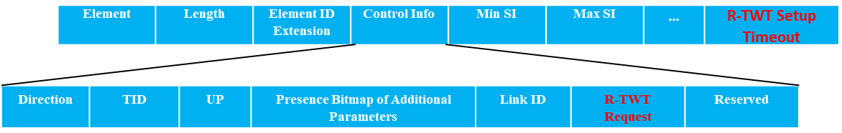
Figure 1: QoS Characteristics element with “R-TWT request” field
Benefit of “R-TWT request” field is to let AP MLD schedule R-TWT SPs easier over multiple links. Note that R-TWT is link level signaling while SCS is ML level signaling. When the non-AP STA initiates the R-TWT membership negotiation with the AP for a SCS traffic stream, it does not know which link to request R-TWT membership. Therefore, it is better for AP to assign R-TWT membership for the SCS traffic stream on one link.
Example: STA1 sends a SCS request frame to AP1 with “R-TWT request” set to 1 in the QoS characteristics element. After AP1 accepts the SCS request, AP2 can send an unsolicited R-TWT membership to STA2 for the SCS. Then, the SCS will be scheduled to transmit during the R-TWT SPs scheduled by AP2.

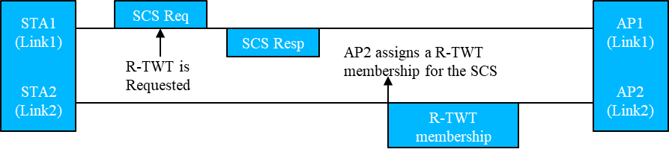
Figure 2: example of AP MLD scheduling R-TWT SPs over multiple links by receiving “R-TWT request” field

With “R-TWT request” field, the R-TWT and SCS are still two independent mechanisms.
- If one of the non-AP MLD and the AP MLD does not support R-TWT, the R-TWT request bit is reserved and shall always be set to “0”.
- If both the non-AP MLD and the AP MLD support R-TWT or TWT, then the R-TWT request bit is either set to “1” to indicate the non-AP MLD wants to let the AP MLD schedule it with setting up R-TWT or set to “0” to indicate the non-AP MLD wants to let the AP MLD schedule it without setting up R-TWT.

TGbe editor: The baseline for this document is 11be D2.0

9.4.2.316 QoS Characteristics element
TGbe editor: Modify Figure 9-1002ar (QoS Characteristics element format) as follows:

 | Element ID | Length | Element ID Extension | Control Info | Minimum Service Interval | Maximum Service Interval | Minimum Data Rate | Delay Bound
Octets | 1 | 1 | 1 | 4 | 4 | 4 | 3 | 3
 | Maximum MSDU Size | Service Start Time | Mean Data Rate | Burst Size | MSDU Lifetime | MSDU Delivered Ratio | MSDU Count Exponent | Medium Time
Octets | 0 or 2 | 0 or 4 | 0 or 3 | 0 or 4 | 0 or 2 | 0 or 1 | 0 or 1 | 0 or 1
 | R-TWT Setup Timeout
Octets | 0 or 3
Figure 9-1002ar – QoS Characteristics element format
TGbe editor: Modify Figure 9-1002al (Control Info field format) as follows:

 | B0 B1 | B2 B5 | B6 B8 | B9 B24 | B25 B28 | B29 | B30 B31
 | Direction | TID | User-Priority | Presence Bitmap of Additional Parameters | LinkID | R-TWT Request | Reserved
Bits | 2 | 4 | 3 | 16 | 4 | 1 | 76
Figure 9-1002as – Control Info field format
TGbe editor: Add the below paragraph to the end of the definition of the Control Info field:

- The R-TWT Request field indicates whether R-TWT should be scheduled for the SCS traffic stream under the QoS Characteristics element. The R-TWT Request field set to 1 indicates that the non-AP MLD requests the AP MLD to schedule R-TWT for the SCS traffic stream under the QoS Characteristics element and one of the APs affiliated with the AP MLD on any enabled link should schedule an R-TWT for the SCS traffic stream and send unsolicited TWT response frame to assign the R-TWT membership to the corresponding non-AP STA affiliated with the non-AP MLD. The R-TWT Request field set to 0 indicates that the non-AP MLD does not request the AP MLD to schedule R-TWT for the SCS traffic stream under the QoS Characteristics element. The STAs affiliated with the non-AP MLD should send TWT initiating frame to request a R-TWT membership for the SCS traffic stream if needed. If either the non-AP MLD or the AP MLD does not support R-TWT, the R-TWT request bit is reserved and shall be set to “0”.
TGbe editor: Add the below paragraph to the end of subclause 9.4.2.316:

The R-TWT Setup Timeout field contains the duration, in TUs, after which the SCS is established successfully, the AP MLD should assign the R-TWT membership to the non-AP MLD within this duration. The field is set to 0 to disable the timeout. This field is present only if the R-TWT Request field is set to 1.

35.3.22 Multi-link SCS procedure
TGbe editor: Add the below paragraph to the end of the subclause:

The non-AP EHT STA affiliated with the non-AP MLD may send an SCS request that contains a QoS characteristics element whose R-TWT request field is set to 1 to its associated EHT AP affiliated with the AP MLD only if the non-AP EHT STA is an R-TWT scheduled STA and the EHT AP is an R-TWT scheduling AP (see 35.8 (Restricted TWT (r-TWT))). If the requested SCS with R-TWT request field set to 1 in the QoS Characteristics element is accepted by the EHT AP, one of the EHT APs affiliated with the AP MLD that is an R-TWT scheduling AP (see 35.8 (Restricted TWT (r-TWT))) on any enabled link should schedule an R-TWT for the SCS traffic stream and send an unsolicited TWT response frame to assign the membership of the R-TWT to the corresponding non-AP STA affiliated with the non-AP MLD that is an R-TWT scheduled STA (see 35.8 (Restricted TWT (r-TWT))) before R-TWT setup timeout. Before the timeout or receiving the unsolicited TWT response frame, all the non-AP EHT STAs affiliated with the non-AP MLD shall not initiate the R-TWT membership negotiation with the EHT APs affiliated with the AP MLD for the SCS traffic stream.

