IEEE P802.11
Wireless LANs
Resolutions for Editorial Comments in CC40 - Part 9
Date: 2022-08-15
Author(s):
Name | Affiliation | Address | Phone | email
Claudio da Silva | Meta Platforms, Inc |  |  | claudiodasilva@fb.com
Abstract
This submission proposes resolutions to editorial comments submitted in CC40. The text used as reference is D0.2.

CIDs: 682, 684, 226, 688, 689, 690, 41, 58, 334, 599, 600, 267, 256

CID | Clause | Page | Comment | Proposed change
682 | 9.4.2.319 | 37 | The word "minimum" seems superfluous. What is difference between minumum resolution and resolution | remove the word "minimum"
684 | 9.4.2.319 | 37 | The word "minimum" seems superfluous. What is difference between minumum resolution and resolution | remove the word "minimum"

Proposed resolution: Rejected

Discussion: Paragraph referred to by the commenter:
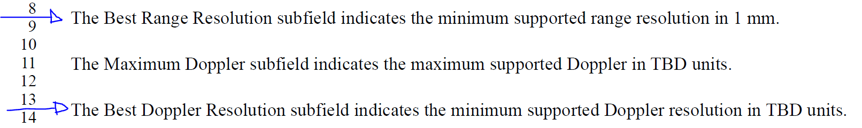
The range/Doppler resolution achieved by the system depends on parameters of the signal used to obtain measurements, such as its bandwidth. The “best” values signaled in these subfields indicate the “best”, or the “minimum resolution”, that could be achieved by the STA when an appropriate configuration is used.

CID | Clause | Page | Comment | Proposed change
226 | 9.4.2.320 | 37 | On page, it is a Beam "Description" element. On page 83, Line 38, when crossreferencing, it says Beam "Descriptor" elements. | Change "Description" it to "Descriptor".

Proposed resolution: Revised

Discussion: Paragraph referred to by the commenter:
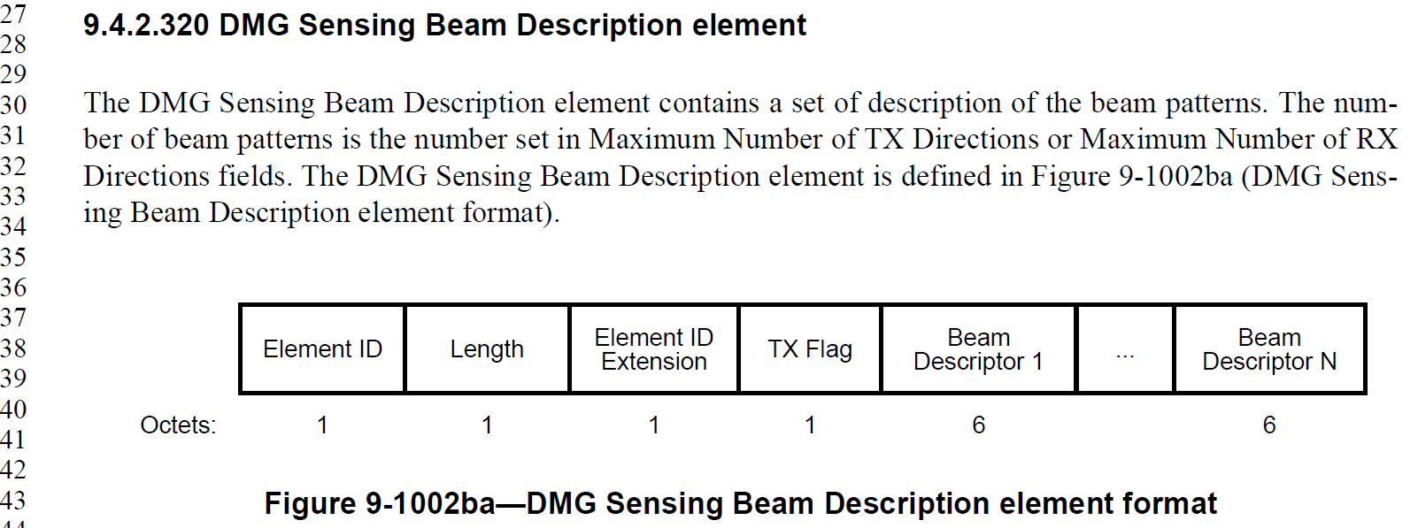
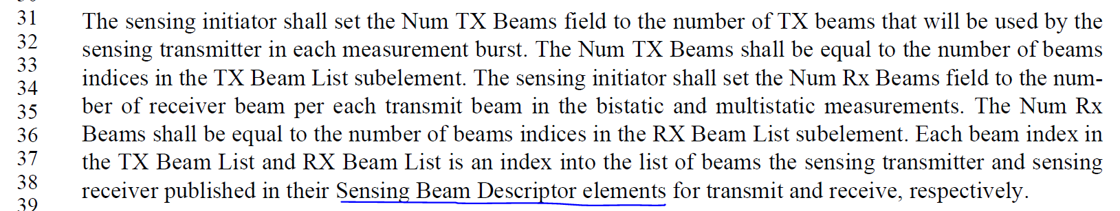

Modifications: Editor – In 99.48, replace “Sensing Beam Descriptor” with “DMG Sensing Beam Description element”.
Note to editor: This is the same as comment resolution for CID 363 (22/09966r1), which was approved by motion 115.

CID | Clause | Page | Comment | Proposed change
688 | 9.4.2.321 | 38 | Sounds strage that the beacon has "an optional location" | I expect the intention is that it is optional to provide the location of the AP that sends the beacon? If so, please rephrase accordingly.

Proposed resolution: Revised

Discussion: Paragraph referred to by the commenter:
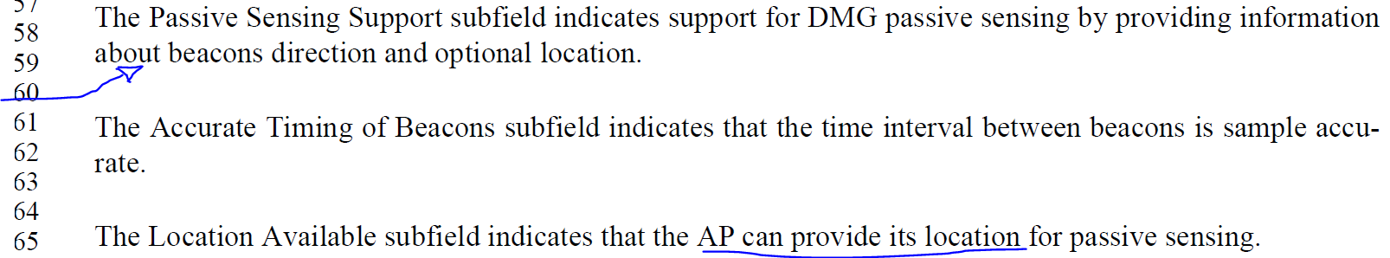

Modifications: Editor – Change 50.22-24 as follows:
The Passive Sensing Support subfield indicates support for DMG passive sensing by providing information about beacons direction and optional location. on the direction in which beacons are transmitted and optionally on the AP’s location.

CID | Clause | Page | Comment | Proposed change
689 | 9.4.2.321 | 39 | change coordinate to coordinates | As in comment.

Proposed resolution: Accepted

Discussion: Paragraph referred to by the commenter:

CID | Clause | Page | Comment | Proposed change
690 | 9.4.2.321 | 39 | change STA to STA's | As in comment.

Proposed resolution: Revised

Discussion: Paragraph referred to by the commenter:

Modifications: Editor – Change 50.33-34 as follows:
If it is set to zero(#227), azimuth and elevation are relative to an arbitrary STA coordinate system.

CID | Clause | Page | Comment | Proposed change
41 | 9.4.2.327 | 53 | The length of UID/AID is not 1 octet, the length of Measurement Setup ID, Measurement Burst ID and Sensing Instance Number shoule be TBD | As in comment.

Proposed resolution: Rejected

Discussion: Similar comments were considered in 22/0985r3,
- CID 36: “The length of Measurement Setup ID, Measurement Burst ID and Sensing Instance Number is TBD.”
- CID 37: “The length of Measurement Setup ID, Measurement Burst ID and Sensing Instance Number is TBD.”
- CID 38: “The length of Measurement Setup ID is TBD.”
and the group has agreed to reject the proposed changes (motion 112).
Also, the group has agreed to mark as “ready for motion” the resolution of CIDs 75, 260, 378, and 515 in 22/1168r5 that propose to define the length of the Measurement Setup ID subfield to be equal to 1 octet.

CID | Clause | Page | Comment | Proposed change
58 | 9.6.7.49 | 58 | MS ID is not only used by sub-7 sensing. | Change to "a Measurement Setup ID that identifies assigned parameters in the Sensing Measurement Parameters Element or assigned parameters in the DMG Sensing Measurement Setup Element"

Proposed resolution: Revised

Discussion: As indicated by the commenter, both the DMG Sensing Measurement Setup Request frame and the DMG Sensing Measurement Setup Response frame contain a Measurement Setup ID, which is defined “as shown in Figure 9-1138b (Measurement Setup ID field format)”. Figure 9-1138b defines a field within the (sub-7 GHz) Sensing Measurement Setup Request frame. One of the unintended consequences of mixing sub-7 GHz and 60 GHz definitions is that it may lead to writing problems such as the one pointed out by the commenter. The goal of the suggested modifications below is to break this connection between sub-7 GHz and 60 GHz definitions.

Modifications: Editor – Change the following paragraph in 9.6.21.8 (DMG Sensing Measurement Setup Request frame format) as follows:

The Measurement Setup ID field in the DMG Sensing Measurement Setup Request frame indicates a Measurement Setup ID that identifies assigned parameters in the DMG Sensing Measurement Setup element to be used in the corresponding DMG sensing measurement instances as shown in Figure 9-1138b (Measurement Setup ID field format). The length of the Measurement Setup ID field is 1 octet.

Change the following paragraph in 9.6.21.9 (DMG Sensing Measurement Setup Response frame format) as follows:

The Measurement Setup ID field in the DMG Sensing Measurement Setup Response frame is shown in Figure 9-1138b (Measurement Setup ID field format) and is set to the value in the corresponding DMG Sensing Measurement Setup Request frame.

CID | Clause | Page | Comment | Proposed change
334 | 9.6.7.51 | 58 | The definition of the frame after the Public Action field shall be equal to the definition of the frame in the 9.6.36.2 Protected Sensing Measurement Report frame. No need to duplicate the definition. | Modify the text as follows: Replace "The format of the Sensing Measurement Report frame Action field is defined in Figure 9-1139d (Sensing Measurement Report frame Action field format)" by "The format of the Sensing Measurement Report frame after the Public Action field is equal to the format of the Protected Sensing Measurement Report frame (9.6.36.2 Protected Sensing Measurement Report frame)" Remove Figure 9-1139d and remainder of the text that starts with "The Dialog Token field is defined ..."
599 | 9.6.36.2 | 63 | Redundant clause for Protected Sensing Measurement Report frame | Delete the clause and add a description in Table 9-623k saying "The format of the frame after the action field is identical to the format of the Sensing Measurement Report Public Action frame."

Proposed resolution: Revised

Discussion: Agree with both commenters that there is no need to duplicate the definition. Propose to use the public frame to be the “baseline”, and refer to it when defining the protected frame. Table 9-623k defines the “Protected Sensing Action field values”, validity of defining a frame in this Table can be argued.
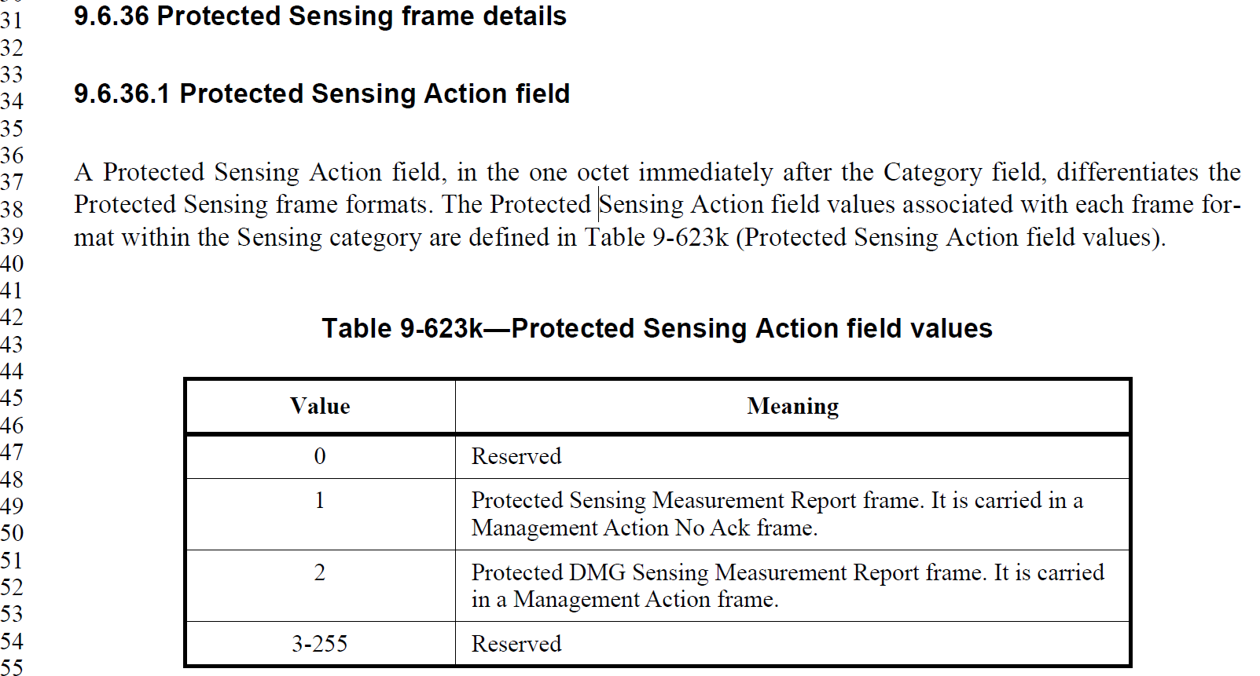

Modifications: Editor – Change the first paragraph of 9.6.36.2 (Protected Sensing Measurement Report frame) as follows:

The Protected Sensing Measurement Report frame is an Action or an Action No Ack frame of category Protected Sensing transmitted to provide WLAN sensing measurements. The format of the Protected Sensing Measurement Report frame is defined in Table 9-623l (Protected Sensing Measurement Report frame format). frame after the Protected Sensing Action field is identical to the format of the Sensing Measurement Report Public Action frame (9.6.7.51 (Sensing Measurement Report frame format)).

Editor – Delete Table 9-623l (Protected Sensing Measurement Report frame format).

CID | Clause | Page | Comment | Proposed change
600 | 9.6.36.3 | 63 | Redundant clause for Protected DMG Sensing Measurement Report frame | Delete the clause and add a description in Table 9-623k saying "The format of the frame after the action field is identical to the format of the Sensing Measurement Report unprotected DMG frame."

Proposed resolution: Rejected

Discussion: For reference:

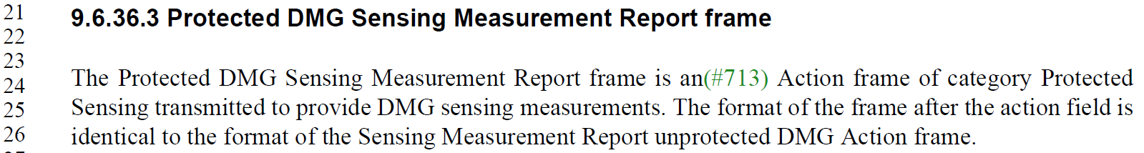

Current text doesn’t duplicate text. Also, Table 9-623k defines the “Protected Sensing Action field values”, validity of defining a frame in this Table can be argued.

CID | Clause | Page | Comment | Proposed change
267 | 9.6.7.54 | 60 | In the figure 9-1139g the length of the status code field is 2 bytes, but in the figure Figure 9-1139c the length of the status code is TBD, please make consistently | as in comment

Proposed resolution: Revised

Discussion: The length of the Status Code field is defined in the baseline to be 2 octets:
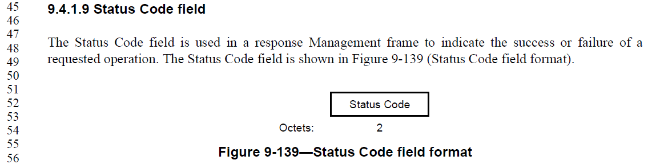

Modifications: Editor – Change the length of the Status Code field in Figure 9-1139c (Sensing Measurement Setup Response frame Action field format) to be 2 octets.

CID | Clause | Page | Comment | Proposed change
256 | 9.4.2.318 | 34 | In figure 9-1002aw the length of the Sensing Measurement Report Type field is TBD, but in the talbe 9-401s the range value of the field is 0 to 255, please make the both consistent. | as in comment

Proposed resolution: Revised

Discussion: For reference,
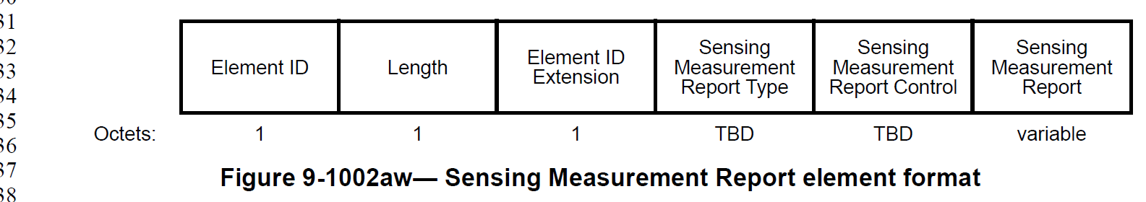

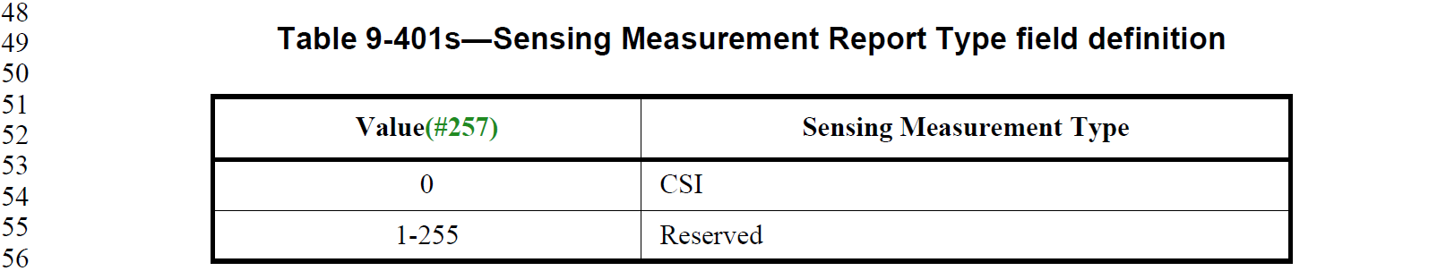

Modifications: Editor – In 45.35-36 (D2.0), replace TBD under the “Sensing Measurement Report Type” field with 1.

