IEEE P802.11
Wireless LANs
CR for Power Boost Factor CIDs
Date: 2022-07-28
Author(s):
Name | Affiliation | Address | Phone | email
Hanqing Lou | InterDigital Inc. | 111 West 33rd Street  Suite 1420  New York, NY, USA | +1-631-622-4012 | Hanqing.lou@interdigital.com
Rui Yang
Alfred Asterjadhi | Qualcomm

Abstract
This submission proposes resolutions for the CIDs 10944, 10945, 10946, 10947, 11868.

The baseline for this comment resolution document is 802.11be Draft 2.0.

Revisions:
- Rev 0: Initial version of the document
- Rev 1: Minor editorial changes and green tags
- Rev 2: Based on Bin Tian’s comment, for a non-OFDMA EHT MU PPDU transmitted to more than one user, the value of POWER_BOOST_FACTOR is set to 1.
- Rev 3: Based on Brian Hart and Rui Yang’s comments, add MR to Table 36-1.

CID | Clause | Page | Comment | Proposed Change | Resolution
10944 | 35.12.1.2 | 515.37 | "r-th" in the first sentence of this paragraph does not serve any purpose. Also, it is not clear what are "these constraints". They should be more specific. The overall statements of this subclause can be stated more clearly. | Change the content of this subclause to:  "For an OFDMA EHT MU PPDU, the power boost factor POWER_BOOST_FACTOR for an occupied RU or MRU shall be in the range of [1/sqrt(2), sqrt(2)] if the Power Boost Factor Support subfield of the EHT PHY Capabilities Information field in the EHT Capabilities element from any recipient STA of the PPDU equals 0; otherwise it shall be in the range of [0.5, 2].  For a non-OFDMA EHT MU PPDU transmitted to a single user, POWER_BOOST_FACTOR shall be set to 1.  For a non-OFDMA EHT MU PPDU transmitted to more than one users, the value of POWER_BOOST_FACTOR is implementation specific.  For TB PPDU POWER_BOOST_FACTOR is not presented in TXVECTOR" | Revised  Agree with the commenter in principle. “the r-th” has been removed and detailed descriptions has been added.  Tgbe editor please implement changes as shown in doc 11-22/1270r3 tagged as #10944.
10945 | 36.3.11.4 | 633.44 | The sentences after "i.e." are the same as the ones in subclause 35.12.1.2. No need to repeat here. | Remove all sentences after "is constrained as defined in 35.12.1.2 (POWER_BOOST_FACTOR)" | Revised  Agree with the commenter in principle. The sentence has been simplified.  Tgbe editor please implement changes as shown in doc 11-22/1270r3 tagged as #10945.
10946 | 36.2.2 | 559.42 | The description for the value of POWER_BOOST_FACTOR is incomplete. It can just simply refer to 35.12.1.2 without any additional statement. | Change the Value for "FORMAT is EHT_MU" to:  "For an RU or MRU, set to the power boost factor of the RU or MRU according to  35.12.1.2 (POWER_BOOST_FACTOR)." | Revised  Agree with the commenter in principle. The sentence has been simplified.  Tgbe editor please implement changes as shown in doc 11-22/1270r3 tagged as #10946.
10947 | 36.2.2 | 559.42 | The "MU" under TXVECTOR is defined at the end of Table 36-1 as:  "MU is only present in the TXVECTOR column for an EHT MU PPDU and indicates that the TXVECTOR parameter is present per user. Parameters specified to be present per user are conceptually supplied as an array of values indexed by u, where u takes values 0 to the number of users minus 1."  However, POWER_BOOST_FACTOR is defined per occupied RU/MRU, which may be allocated to multiple users. In other words, it is conceptually supplied as an array of values of indexed by r, where r takes values for 0 to the number of occupied RU/MRU minus 1. | Define a new notation for multiple resources, e.g., "MR" and add a note at the end of Table 36-1 as:  "MR is only present in the TXVECTOR column for an EHT MU PPDU and indicates that the TXVECTOR parameter is present per RU/MRU. Parameters specified to be present per RU/MRU are conceptually supplied as an array of values indexed by r, where r takes values 0 to the number of RU/MRU minus 1." | Revised  Agree with the commenter in principle. “MU” has been replaced by “MR”. A note for MR is added at the end of the Table 36-1  Tgbe editor please implement changes as shown in doc 11-22/1270r3 tagged as #10947.
11868 | 35.12.2 | 515.45 | Subject to the constraints above the setting of the Power Boost factor is clearly regulated, hence not implementation specific. I guess this just needs to say that if the STA is not under these constraints then the value is implementation specific. | As in comment. | Revised  “Subject to the constraints above” means “other than the above PPDUs.” The paragraph has been modified to cover all the cases explicitly.  Agree with the commenter when a power setting is implementation specific, it should also be regulated.  Tgbe editor please implement changes as shown in doc 11-22/1270r3 tagged as #11868.
CID 10944, 11868
Discussion
The sentence of “subject to these constraints…” has ambiguity. It is not clear how the POWER_BOOST_FACTOR parameter should be set for non-OFDMA EHT MU PPDU transmitted to more than one user, and NDP PPDU. The following paragraphs are reorganized and modified to have clear description for POWER_BOOST_FACTOR for all types of EHT MU PPDU.
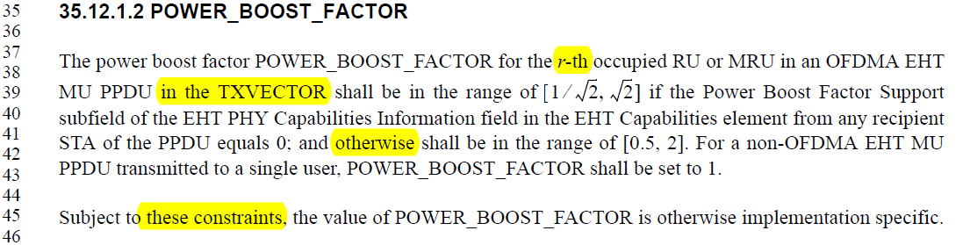
End of Discussion

35.12.1.2 POWER_BOOST_FACTOR
TGbe editor: Please incorporate the following changes between L37 and L46, in P515 of 802.11be D2.0
For an OFDMA EHT MU PPDU, the The power boost factor POWER_BOOST_FACTOR parameter in the TXVECTOR for the r-th an occupied RU or MRU in an OFDMA EHT MU PPDU shall be in the range of $[1/\sqrt{2}, \sqrt{2}]$ if the Power Boost Factor Support subfield of the EHT PHY Capabilities Information field in the EHT Capabilities element from any recipient STA of the PPDU equals 0; and otherwise the POWER_BOOST_FACTOR shall be in the range of [0.5, 2]. For a non-OFDMA EHT MU PPDU transmitted to a single user, POWER_BOOST_FACTOR shall be set to 1.
Subject to these constraints, the value of POWER_BOOST_FACTOR is otherwise implementation specific.
For a non-OFDMA EHT MU PPDU, the POWER_BOOST_FACTOR shall be set to 1.
For an EHT sounding NDP PPDU, the POWER_BOOST_FACTOR shall be set to 1.

NOTE-- For an EHT TB PPDU, the POWER_BOOST_FACTOR is not present in the TXVECTOR. (#10944)
CID 10945
Discussion
The note below is simplified to avoid repeating the rule defined in 35.12.1.2.
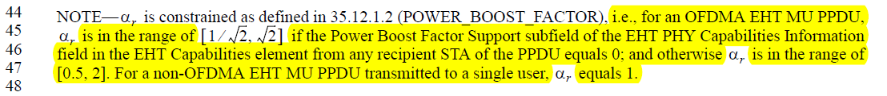
End of Discussion
36.3.11.4 Transmitted signal
TGbe editor: Please incorporate the following changes between L44 and L48, in P633 of 802.11be D2.0
NOTE— $α_{r}$is set to the value of POWER_BOOST_FACTOR in the TXVECTOR constrained as defined in 35.12.1.2 (POWER_BOOST_FACTOR), i.e., for an OFDMA EHT MU PPDU, is in the range of $[1/\sqrt{2}, \sqrt{2}]$ if the Power Boost Factor Support subfield of the EHT PHY Capabilities Information field in the EHT Capabilities element from any recipient STA of the PPDU equals 0; and otherwise $α_{r}$ is in the range of [0.5, 2]. For a non-OFDMA EHT MU PPDU transmitted to a single user, $α_{r}$ equals 1. (#10945)
CID 10946
Discussion
The description of POWER_BOOST_FACTOR should be modified to follow the rule defined in 35.12.1.2 (POWER_BOOST_FACTOR).
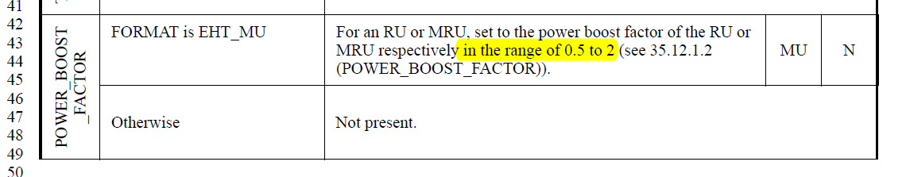
End of Discussion

36.2.2 TXVECTOR and RXVECTOR parameters
TGbe editor: Please incorporate the following changes in the “Value” column for POWER_BOOST_FACTOR in Table 36-1 between L42 and L45 in P559 of 802.11be D2.0.
For an RU or MRU, set the power boost factor of the occupied RU or MRU respectively in the range of 0.5 to 2 (see according to the rules in 35.12.1.2 (POWER_BOOST_FACTOR)). (#10946)

CID 10947
Discussion
In 802.11be D2.0, the TXVECTOR parameter POWER_BOOST_FACTOR is defined when the PPDU format is EHT_MU and the parameter is present per user.

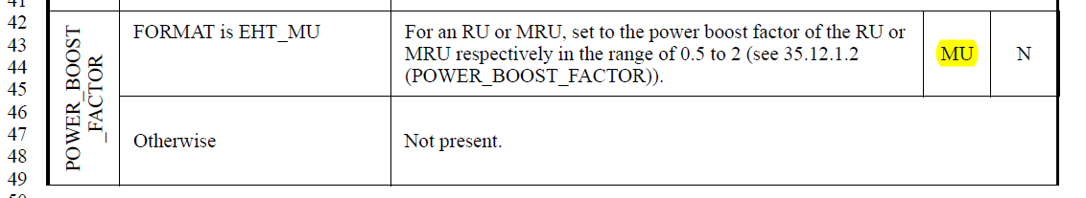
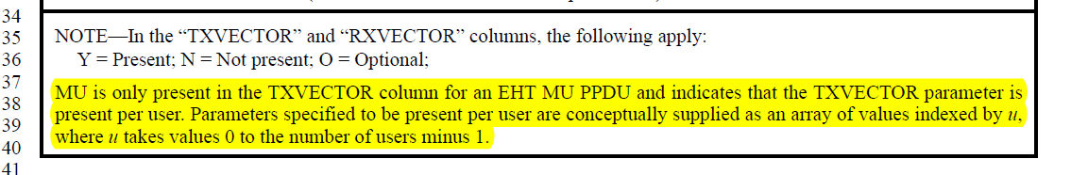
Based on Equation (36-9) in P632 of 802.11be D2.0, the power boost factor $α_{r}$, which is set based on POWER_BOOST_FACTOR parameter, is not per user but per RU or MRU.

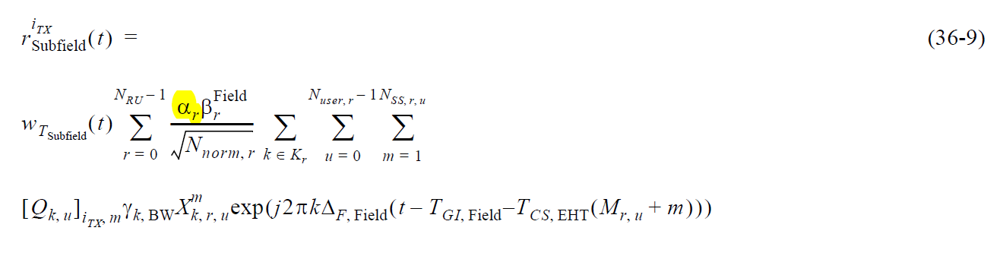

Therefore, the MU note is inconsistent with Equation (36-9).

In the proposed resolution, POWER_BOOST_FACTOR parameter is defined for EHT_MU format, including OFDMA MU, non-OFDMA MU to single user and non-OFDMA MU to multiple user cases. Thus, the parameter is included in the TXVECTOR when the FORMAT is EHT_MU. We could use “Y” instead of “MU”.

In 35.12.1.2, detailed explanation that POWER_BOOST_FACTOR is per RU or MRU is added.
End of Discussion

36.2.2 TXVECTOR and RXVECTOR parameters
TGbe editor: Please incorporate the following changes in the “TXVECTOR” column for POWER_BOOST_FACTOR in Table 36-1 L43 in P559 of 802.11be D2.0.
Table 36-1—TXVECTOR and RXVECTOR parameters
POWER_BOOST_FACTOR | FORMAT is EHT_MU | For an RU or MRU, set the power boost factor of the occupied RU or MRU respectively in the range of 0.5 to 2 (see according to the rules in 35.12.1.2 (POWER_BOOST_FACTOR)). (#10946) | MU  MR (#10947) | N
 | Otherwise | Not present
TGbe editor: Please add the following note to the end of Table 36-1, in P560 of 802.11be D2.0
Note
MR is only present in the TXVECTOR column for an EHT MU PPDU and indicates that the TXVECTOR parameter is present per RU/MRU. Parameters specified to be present per RU/MRU are conceptually supplied as an array of values indexed by r, where r takes values 0 to the number of RU/MRU minus 1. (#10947)

