IEEE P802.11  
Wireless LANs

|  |  |  |  |  |
| --- | --- | --- | --- | --- |
| Resolutions for Editorial Comments in CC40 - Part 8 | | | | |
| Date: 2022-08-08 | | | | |
| Author(s): | | | | |
| Name | Affiliation | Address | Phone | email |
| Claudio da Silva | Meta Platforms, Inc |  |  | claudiodasilva@fb.com |
|  |  |  |  |  |

Abstract

This submission proposes resolutions to editorial comments submitted in CC40. The text used as reference is D0.2.

CIDs: 632, 174, 566, 176, 010, 117, 382, 383, 384, 134, 387, 582, 873, 135, 677

|  |  |  |  |  |
| --- | --- | --- | --- | --- |
| **CID** | **Clause** | **Page** | **Comment** | **Proposed change** |
| 632 | 11.21.18.6.5 | 71 | Add "SIFS after the reception of the Frame A" after "in the assigned RU" | As commented. |

**Proposed resolution**: Revised

**Discussion**: Paragraph referred to by the commenter:

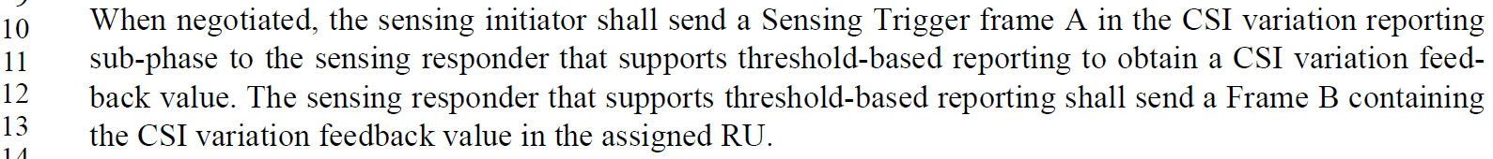

Interval between the frames is defined in Figure 11-41e:

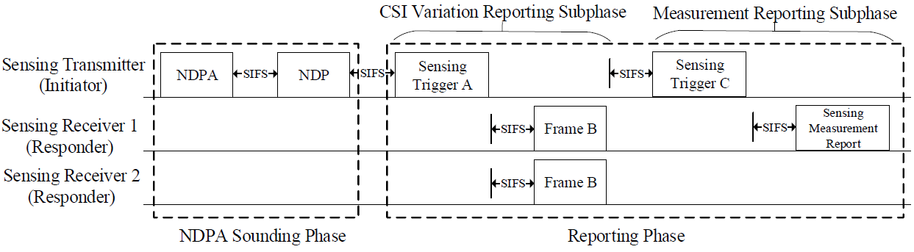

**Modifications**: Editor – Change 87.16-17 (D0.2) as follows:

“The sensing responder that supports threshold-based reporting shall send a Frame B containing

the CSI variation feedback value a SIFS after receiving Sensing Frame A in the assigned RU.

|  |  |  |  |  |
| --- | --- | --- | --- | --- |
| **CID** | **Clause** | **Page** | **Comment** | **Proposed change** |
| 174 | 11.21.18.7 | 72 | Since the non-AP STA is the only STA in Figure 11-41f, it may be convenient to use the label 'STA' instead of 'STA1' | Remove '1' from 'STA1' in Figure 11-41f |
| 566 | 11.21.18.7 | 72 | Delete the color of R2I NDP in the figure 11-41f. | As in Comment. |

**Proposed resolution**: Accepted

**Discussion**: Proposed change doesn’t lead to text changes. After the proposed change, Figure 11-41f will be:



|  |  |  |  |  |
| --- | --- | --- | --- | --- |
| **CID** | **Clause** | **Page** | **Comment** | **Proposed change** |
| 176 | 11.21.19.2 | 73 | "To establish an SBP procedure, the SBP initiator shall send an SBP Request frame to an SBP responder  capable AP. ...: The sentence does not read well, especially the ""SBP responder capable AP". | Change the sentence to "To establish an SBP procedure, the SBP-capable initiator shall send an SBP Request  frame to an SBP-capable responder..." |

**Proposed resolution**: Revised

**Modifications**: **Editor – Change 11.21.19.1 as follows:**

**11.21.19.1 General**

SBP is a procedure that allows a non-AP STA to request an AP to perform WLAN sensing (see 11.21.18 (WLAN sensing procedure)(#455)) on its behalf.

Implementation of SBP is optional for a WNM STA. A STA in which dot11SBPImplemented is true is defined as a STA that supports SBP.

A STA in which dot11SBPImplemented is true shall set the SBP field of the Extended Capabilities element to 1.

A STA in which dot11SBPImplemented is false shall set the SBP field of the Extended Capabilities element to 0.

A non-AP STA may act as SBP initiator when dot11SBPImplemented is true.

An AP may act as SBP responder when dot11SBPImplemented is true.

**Change 11.21.19.2 as follows:**

**11.21.19.2 SBP procedure setup**

To establish an SBP procedure, the SBP initiator shall send an SBP Request frame to an SBP responder ~~capable AP~~. Upon receipt of an SBP Request frame, the SBP responder either:

**Delete 11.21.19.6:**

~~11.21.19.6 SBP dependencies~~

~~Implementation of SBP is optional for a WNM STA. A STA in which dot11SBPImplemented is true is defined as a STA that supports SBP.~~

~~A STA in which dot11SBPImplemented is true shall set the SBP field of the Extended Capabilities element to 1.~~

~~A STA in which dot11SBPImplemented is false shall set the SBP field of the Extended Capabilities element to 0.~~

|  |  |  |  |  |
| --- | --- | --- | --- | --- |
| **CID** | **Clause** | **Page** | **Comment** | **Proposed change** |
| 10 | 9.4.2.326.3 | 10 | There are 3 format options for 2 axis | Replace axis with 'axes' also in figure on the same page. |

**Proposed resolution**: Revised

**Discussion**: Correct page number is 50.

**Modifications**: Editor – Change 61.15-18 as follows:

There are 3 format options for 2 ~~axis~~ axes (Figure 9-1002bw (Reflection subelement format for 2 ~~axis~~ axes)), 3 ~~axis~~ axes (Figure 9-1002bx (Reflection subelement format for 3 ~~axis~~ axes)), and 4 ~~axis~~ axes (Figure 9-1002by (Reflection subelement format for 4 ~~axis~~ axes)).

|  |  |  |  |  |
| --- | --- | --- | --- | --- |
| **CID** | **Clause** | **Page** | **Comment** | **Proposed change** |
| 117 | 6.3.134.14.3 | 13 | Change "to request a non-TB sensing measurement instance to be performed with an AP" to "to request that a non-TB sensing measurement instance be performed with an AP" | See comment |

**Proposed resolution**: Rejected

**Discussion**: The TG considered the comment and did not agree with the proposed change on the basis that the sentence in page 26.13-14 (D0.1) is grammatically correct.

|  |  |  |  |  |
| --- | --- | --- | --- | --- |
| **CID** | **Clause** | **Page** | **Comment** | **Proposed change** |
| 382 | 3.2 | 16 | In the definition of an SBP responder, it is sufficient to mention that, an SBP responder is an AP that is the intended receiver of an SPB request frame. There is no need to define an SBP responder as an AP that 'receives' an SBP request frame, since multiple APs may receive this frame without being an SBP responder | Delete the words 'receives or' in the definition of an SBP responder |

**Proposed resolution**: Accepted

**Discussion**: Text referred to by the commenter:



|  |  |  |  |  |
| --- | --- | --- | --- | --- |
| **CID** | **Clause** | **Page** | **Comment** | **Proposed change** |
| 383 | 3.2 | 16 | A definition of the term 'WLAN sensing procedure' can be added to Subclause 3, since it is used to define other terms, such as 'sensing initiator' and 'sensing responder' | Add a definition of the term 'WLAN sensing procedure' in Subclause 3 |

**Proposed resolution**: Revised

**Discussion**: Definitions found in D0.2:

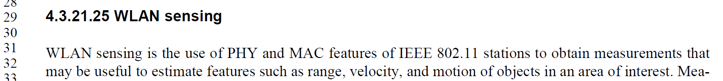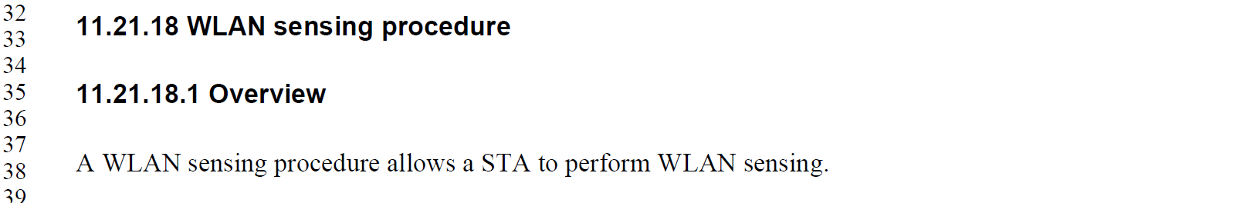

**Modifications**: Editor – Insert the following into 3.2:

wireless local area network (WLAN) sensing: The use of physical layer (PHY) and medium access control (MAC) features of stations (STAs) to obtain measurements that may be useful to estimate features such as range, velocity, and motion of objects in an area of interest.

wireless local area network (WLAN) sensing procedure: A procedure that allows a station (STA) to perform WLAN sensing.

|  |  |  |  |  |
| --- | --- | --- | --- | --- |
| **CID** | **Clause** | **Page** | **Comment** | **Proposed change** |
| 384 | 3.2 | 16 | In the definitions of 'sensing receiver' and 'sensing transmitter', the terms 'sensing' and 'measurement' provide the same meaning | Change 'sensing measurements' to 'channel measurements' or 'channel sensing' |

**Proposed resolution**: Revised

**Modifications**: Editor – Change the following definitions in 3.2 as follows:

sensing receiver: A station (STA) that receives PPDUs sent by a sensing transmitter and ~~performs sensing~~ obtains measurements in a WLAN sensing procedure.

sensing transmitter: A station (STA) that transmits PPDUs used for ~~sensing~~ measurements in a WLAN sensing procedure.

|  |  |  |  |  |
| --- | --- | --- | --- | --- |
| **CID** | **Clause** | **Page** | **Comment** | **Proposed change** |
| 134 | 4.3.21.25 | 17 | "With the execution ..." | change the text in the comment to "After the execution ..." |

**Proposed resolution**: Revised

**Discussion**: The sentences/paragraphs pointed out by the commenter (in 4.3.21.25 and 11.21.18.1) were modified (4.3.21.25) by the resolution of comments 111, 370, and 412 (motion 103).

**Modifications**: Editor – In 4.3.21.25, replace

“WLAN sensing enables a STA to obtain sensing measurements of the channel(s) between two or more STAs and/or the channel between a receive antenna and a transmit antenna of a STA. With the execution of the WLAN sensing procedure, it is possible for a STA to obtain sensing measurements useful for detecting and tracking changes in the environment.”

with

“WLAN sensing is the use of PHY and MAC features of IEEE 802.11 stations to obtain measurements that may be useful to estimate features such as range, velocity, and motion of objects in an area of interest. Measurements obtained with WLAN sensing may be used to enable applications such as presence detection and gesture classification.”

Note to editor: This is the same as comment resolution for CIDs 111, 370, and 412.

|  |  |  |  |
| --- | --- | --- | --- |
| **CID** | **Clause** | **Comment** | **Proposed change** |
| 387 | 4.3.21.26 | The definition of SBP indicates '...the channel between an AP and one or more non-AP STAs', which does not include the case when an SBP responder AP performs responder-to-responder NDP measurements as part of the sensing procedure | Modify the definition of SBP to include the case described by the editor's note in Subclause 11.21.19.2 |
| 582 | 4.3.21.26 | Unnecessary duplicate description with 4.3.21.25. | Change the first sentence to "SBP enables a non-AP STA to obtain sensing measurements of a WLAN sensing procedure" |
| 873 | 4.3.21.26 | Change "channel" to "channel(s)" | as in comment |
| 135 | 4.3.21.26 | "With the execution ..." | change the text in the comment to "After the execution ..." |
| 677 | 4.3.21.26 | Can't really know that these measurments are "necessary" | Remove the word "necessary" |

**Proposed resolution**: Revised

**Discussion**: For reference,

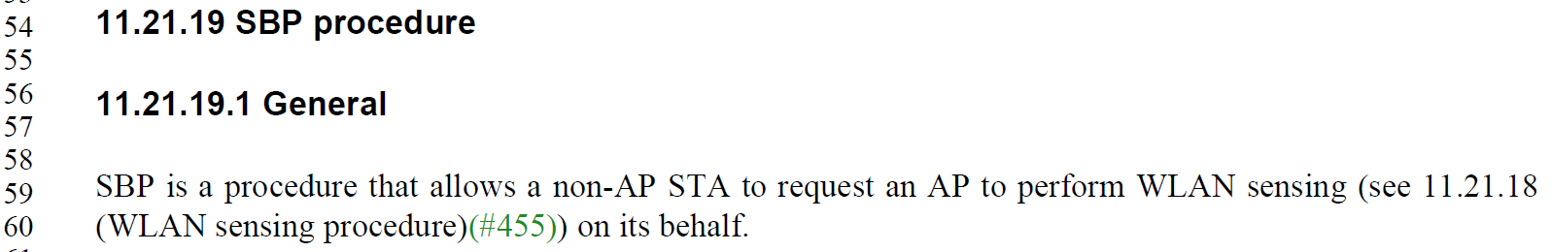

**Modifications**: Editor – Change 4.3.21.26 as follows:

SBP enables a non-AP STA to ~~obtain sensing measurements of the channel between an AP and one or more non-AP STAs or between a receive antenna and a transmit antenna of an AP. With the execution of the SBP procedure, it is possible for a non-AP STA to obtain sensing measurements useful to estimate features such as range, velocity, and motion of objects in an area of interest(#111).~~ request an AP to perform WLAN sensing on its behalf.