IEEE P802.11  
Wireless LANs

|  |  |  |  |  |
| --- | --- | --- | --- | --- |
| Resolutions for Editorial Comments in CC40 - Part 7 | | | | |
| Date: 2022-08-02 | | | | |
| Author(s): | | | | |
| Name | Affiliation | Address | Phone | email |
| Claudio da Silva | Meta Platforms, Inc |  |  | claudiodasilva@fb.com |
|  |  |  |  |  |

Abstract

This submission proposes resolutions to editorial comments submitted in CC40. The text used as reference is D0.2.

CIDs: 386, 398, 185, 017, 191, 024, 613, 881, 753, 475, 288, 615, 614, 026, 170, 171, 173, 546,

159, 162, 862, 864, 476, 621, 630, 631, 786, 160

|  |  |  |  |  |
| --- | --- | --- | --- | --- |
| **CID** | **Clause** | **Page** | **Comment** | **Proposed change** |
| 386 | 4.3.21.25 | 17 | In the definition of WLAN sensing, the term 'channel(s) between two or more STAs' is not precise | Change the definition of WLAN sensing as follows: WLAN sensing enables an STA to obtain measurements of the channel between one or more pairs of STAs or between a receive antenna and a transmit antenna of an STA |
| 398 | 11.21.18.1 | 64 | The term 'channel(s) between two or more STAs' is not precise | Modify the definition of a WLAN sensing procedure as suggested in my comment on Subclause 4.3.21.25 |

**Proposed resolution**: Revised

**Discussion**: The sentences/paragraphs pointed out by the commenter (in 4.3.21.25 and 11.21.18.1) were modified (4.3.21.25) and deleted (11.21.18.1) per the resolution of comments 111, 370, and 412 (motion 103) and 874 (motion 106).

**Modifications**: Editor – In 4.3.21.25, replace

“WLAN sensing enables a STA to obtain sensing measurements of the channel(s) between two or more STAs and/or the channel between a receive antenna and a transmit antenna of a STA. With the execution of the WLAN sensing procedure, it is possible for a STA to obtain sensing measurements useful for detecting and tracking changes in the environment.”

with

“WLAN sensing is the use of PHY and MAC features of IEEE 802.11 stations to obtain measurements that may be useful to estimate features such as range, velocity, and motion of objects in an area of interest. Measurements obtained with WLAN sensing may be used to enable applications such as presence detection and gesture classification.”

Also, change the first paragraph of 11.21.18.1 as follows:

A WLAN sensing procedure allows a STA to perform WLAN sensing. ~~WLAN sensing is a service that enables a STA to obtain sensing measurements of the channel(s) between two or more STAs and/or the channel between a receive antenna and a transmit antenna of a STA.~~

Note to editor: This is the same as comment resolution for CIDs 111, 370, 412, and 874.

|  |  |  |  |  |
| --- | --- | --- | --- | --- |
| **CID** | **Clause** | **Page** | **Comment** | **Proposed change** |
| 185 | 11.21.18.1 | 64 | Change "operational attributes associated with a sensing measurement instance are set" to "operational attributes associated with the sensing measurement instance(s) corresponding to the sensing measurement setup are set". | As in comment. |
| 17 | 11.21.18.1 | 64 | One or more sensing measurement setups may be esablished between a sensing intiator and a senisng responder. | It is better to include, measurement setup ID here for completeness of text. Here, it is only evident if one goes and look into the example. Something like, 'One or more sensing measurement setups identified by sensing measurement setup IDs may be established...' |

**Proposed resolution**: Revised

**Discussion**: The sentences referred to by the commenters are:



**Modifications**: Editor – Change the third paragraph of 11.21.18.1 (D0.2) as follows:

In the sensing session setup, a sensing session is established, and in the sensing measurement setup, operational parameters associated with sensing measurement instance(s) are set(#429, #665, #848, #852, #853, #854, #856, #858, #859, #841). ~~One or more sensing measurement setups may be established between a sensing initiator and a sensing responder.~~ A sensing measurement instance is a time interval when sensing measurements are obtained, and it can be one of two variants(#605): Trigger-based (TB) sensing measurement instance (see 11.21.18.6 (TB sensing measurement instance))(#186) or non-TB sensing measurement instance (see 11.21.18.7 (Non-TB sensing measurement instance))(#186). A sensing measurement instance is active until terminated in a sensing measurement setup termination. In the sensing session termination, a sensing session is terminated.

Change the fifth paragraph of 11.21.18.1 (D0.2) as follows:

As defined in 11.21.18.4 (Sensing measurement setup)(#188, #231, #342, #745), operational parameters associated with sensing measurement instance(s) of a given Measurement Setup ID are set in the sensing measurement setup(#429, #665, #848, #852, #853, #854, #856, #858, #859, #841, #185). One or more sensing measurement setups may be established between a sensing initiator and a sensing responder that are assigned different Measurement Setup IDs (#17).

(Note – Alternatives: “…sensing measurement instance(s) with an assigned Measurement Setup ID are set…”, “…sensing measurement instance(s) that are assigned the same Measurement Setup ID are set…”, and “…sensing measurement instance(s) that have the same Measurement Setup ID are set…”.)

|  |  |  |  |  |
| --- | --- | --- | --- | --- |
| **CID** | **Clause** | **Page** | **Comment** | **Proposed change** |
| 191 | 11.21.18.4 | 67 | Change "operational attributes associated with a sensing measurement instance" to "operational attributes associated with the sensing measurement instance(s) corresponding to the sensing measurement setup". | As in comment. |

**Proposed resolution**: Revised

**Discussion**: Text referred to by the commenter:



**Modifications**: Editor – Change the first paragraph of 11.21.18.4 as follows:

Sensing measurement setup allows for a sensing initiator and a sensing responder to exchange and agree on operational parameters associated with sensing measurement instance(s)(#429, #665, #848, #852, #853,#854, #856, #858, #859, #841) of a given Measurement Setup ID(#191).

|  |  |  |  |  |
| --- | --- | --- | --- | --- |
| **CID** | **Clause** | **Page** | **Comment** | **Proposed change** |
| 24 | 11.21.18.4 | 67 | like session setup, it is good to mention that measurement setup is pair-wise. | Add a sentence "A measurement setup is pair-wise". |

**Proposed resolution**: Revised

**Discussion**: Text referred to the commenter (sensing session setup) is:

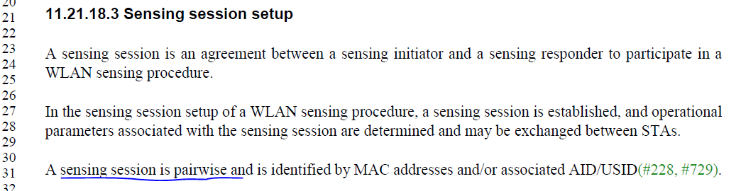

And in 11.21.18.4, we have

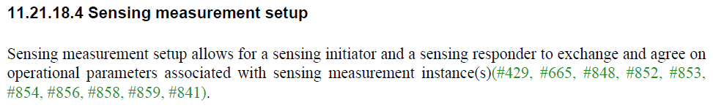

In 11.21.18.4, the fact that the sensing measurement setup is “pairwise” is defined with “… allows for a sensing initiator and a sensing responder to exchange…”. Similar sentence is found in 11.21.18.3 (“A sensing session is an agreement between a sensing initiator and a sensing responder…”), which makes the pairwise statement unnecessary.

**Modifications**: Editor – Change the third paragraph of 11.21.18.3 (D0.2) as follows:

A sensing session ~~is pairwise and~~ is identified by MAC addresses and/or associated AID/USID(#228, #729).

|  |  |  |  |  |
| --- | --- | --- | --- | --- |
| **CID** | **Clause** | **Page** | **Comment** | **Proposed change** |
| 613 | 11.21.18.4 | 67 | "Shall" precludes the "may" case. | Change the text to "Otherwise, the sensing responder shall set the Status Code field to DENIED_SENSING_MEASUREMENT_SETUP or PREFERRED_MEASURMENT_SETUP_PARAMETERS_SUGGESTED in the Sensing Measurement Setup Response frame. When the Status Code is set to PREFERRED_MEASURMENT_SETUP_PARAMETERS_SUGGESTED, the sensing responder provides its preferred sensing measurement parameters in the Sensing Measurement Setup Response frame." |

**Proposed resolution**: Revised

**Discussion**: Text referred to the commenter

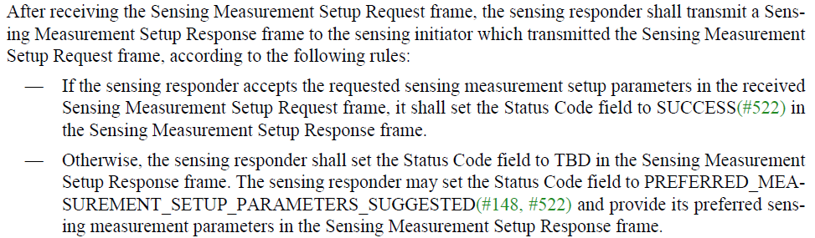

And for reference:

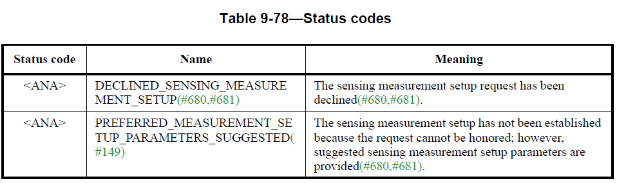

**Modifications**: Editor – Change 82.61-65 (D0.2) to:

Otherwise, the sensing responder shall set the Status Code field to ~~TBD~~ DECLINED_SENSING_MEASUREMENT_SETUP or PREFERRED_MEASUREMENT_SETUP_PARAMETERS_SUGGESTED in the Sensing Measurement Setup Response frame. ~~The sensing responder may set the Status Code field to PREFERRED_MEASUREMENT_SETUP_PARAMETERS_SUGGESTED(#148, #522) and provide~~ If the Status Code field is set to PREFERRED_MEASUREMENT_SETUP_PARAMETERS_SUGGESTED, the sensing responder shall provide its preferred sensing measurement parameters in the Sensing Measurement Setup Response frame.

|  |  |  |  |  |
| --- | --- | --- | --- | --- |
| **CID** | **Clause** | **Comment** | **Proposed change** | **Proposed resolution** |
| 881 | 11.21.18.4 | This sentence is very confusing: "If a Sensing Measurement Setup Request frame assigns the role of either sensing receiver or sensing transmitter and sensing receiver to the sensing responder". Please rephrase. | delete "and sensing receiver" in the sentence | Revised |
| 753 | 11.21.18.4 | Add comma in the text as shown | Text would read as 'sensing receiver, or sensing transmitter and sensing receiver' | Revised |
| 475 | 11.21.18.4 | "it also defines whether the sensing responder shall send or not send Sensing Measurement Report frames in sensing measurement instances that result from the sensing measurement setup." | Should be changed to "it also defines whether the sensing responder shall send or shall not send Sensing Measurement Report frames in sensing measurement instances that result from the sensing measurement setup." | Accepted |

**Discussion**: Recall from pages 44 and 45 (D0.2),

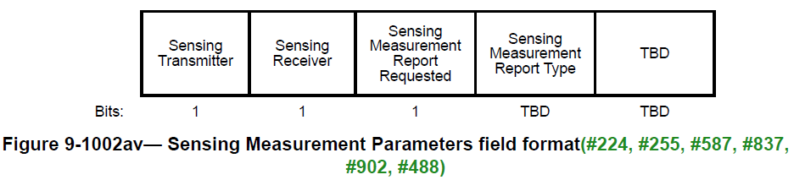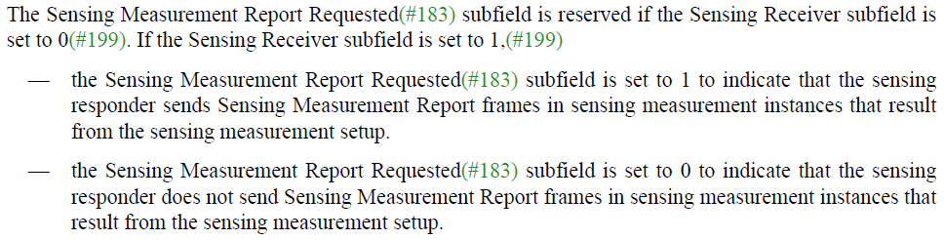

**Modifications**: Editor – Change 83.18-23 as follows:

If a Sensing Measurement Setup Request frame assigns the role of ~~either sensing receiver or sensing transmitter and~~ sensing receiver to the sensing responder, it also defines whether the sensing responder shall send or shall not send Sensing Measurement Report frames in sensing measurement instances that result from the sensing measurement setup.

|  |  |  |  |  |
| --- | --- | --- | --- | --- |
| **CID** | **Clause** | **Page** | **Comment** | **Proposed change** |
| 288 | 11.21.18.6 | 68 | There seems to have a suggestion that if there exist some subclauses under a clause, all of the paragraphs in this clause should also belong to a certain subclause. Thus a subclause name for the first several paragraphs is needed. For example, can use "11.21.18.6.1 General" to describe it. | As in the comment. |

**Proposed resolution**: Accepted

**Discussion**: What the commenter referred to is called a “hanging paragraph,” and it is not allowed as defined in the 802.11 Style Guide.

|  |  |  |  |  |
| --- | --- | --- | --- | --- |
| **CID** | **Clause** | **Page** | **Comment** | **Proposed change** |
| 615 | 11.21.18.6 | 68 | Replace "The WLAN sensing procedure initiated by an AP" with "The TB measurement instance" | As commented. |

**Proposed resolution**: Revised

**Discussion**: Text referred to by the commenter is:

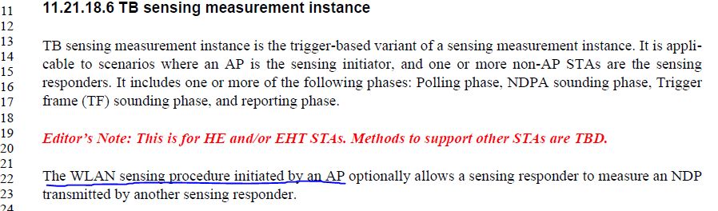

**Modifications**: Editor – Change the second paragraph of 11.21.18.6 as follows:

The ~~WLAN sensing procedure~~ TB sensing measurement instance initiated by an AP optionally…

|  |  |  |  |  |
| --- | --- | --- | --- | --- |
| **CID** | **Clause** | **Page** | **Comment** | **Proposed change** |
| 614 | 11.21.18.5 | 68 | Replace "the same tuple" with "the same measurement setup identified by the tuple" | As commented. |

**Proposed resolution**: Revised

**Discussion**: Text referred to by the commenter is:



which has been changed and now (D0.2) look like:



**Modifications**: Editor – Change 83.47-50 as follows:

The Measurement Instance ID may be used to identify ~~the~~ sensing measurement instance(s) that ~~has~~ have the same sensing measurement setup identified by the ~~tuple~~ <Sensing Initiator’s MAC address, Measurement Setup ID> tuple(#429, #665, #848, #852, #853, #854, #856, #858, #859, #841, #614).

|  |  |  |  |  |
| --- | --- | --- | --- | --- |
| **CID** | **Clause** | **Page** | **Comment** | **Proposed change** |
| 26 | 11.21.18.6 | 68 | in the text, make the reference to different phases of TB same as shown in Fig.41d | "an NDPA sounding phase, and a TF sounding phase": swap the order of the two to be consistent with the figure. |

**Proposed resolution**: Accepted

**Discussion**: Text and figured referred to by the commenter:

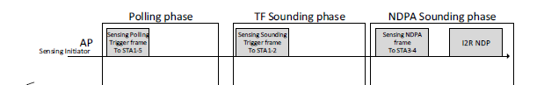

|  |  |  |  |  |
| --- | --- | --- | --- | --- |
| **CID** | **Clause** | **Page** | **Comment** | **Proposed change** |
| 170 | 6.3.134.14.4 | 26 | I2R' is not spelled out in the first use | Spell out I2R in the first use as "Initiator-to-Responder" |
| 171 | 11.21.18.6 | 68 | R2I' is not spelled out in the first use | Spell out 'R2I' in the first use as "Responder-to-Initiator" |

**Proposed resolution**: Revised

**Discussion**: I2R and R2I are defined in the 11az amendment as:



where



**Modifications**: Editor – Insert the following into 3.4:

SI2SR: sensing initiator to sensing responder

SR2SI: sensing responder to sensing initiator

Editor – Replace I2R with SI2SR and R2I with SR2SI throughout the draft.

Change 6.3.134.14.4 as follows:

On receipt of this primitive, the MLME constructs an NDPA frame to be transmitted to the AP followed by an ~~I2R~~ sensing initiator to sensing responder (SI2SR) NDP after SIFS.

Change 84.41-43 as follows:

In the TF sounding phase, the AP sends a Sensing Sounding Trigger frame to STA1 and STA 2 to solicit ~~R2I~~ sensing responder to sensing initiator (SR2SI) NDP transmissions.

|  |  |  |  |  |
| --- | --- | --- | --- | --- |
| **CID** | **Clause** | **Comment** | **Proposed change** | **Proposed resolution** |
| 173 | 11.21.18.6 | Figure 11-41d is an interesting figure to show how the TB measurement instances should look like. However, the figure may need some editing to clean it up | 1- Align the 'STAn' labels to avoid having some numbers crossing with the vertical line  2- Align the 'Sensing Responder' label and make the distance between the label and the horizontal lines equal  3- Align the 'CTS-to-self' boxes and adjust them to the same width.  4- Align the 'R2I NDP' boxes and adjust them to the same width. | Accepted |
| 546 | 11.21.18.6 | STA1 to STA4 sends the CTS to self frame to AP. so, we don't need to indicate differently the CTS to self frame from STA3 and STA4 in figure 11-41d. Remove the color of the CTS to self frame from STA3 and STA4. | As in comment | Revised |

**Proposed resolution**: Accepted

**Discussion**: Change proposed in 546 was extended to all boxes.

**Modifications**: Editor – Replace Figure 11-41d



|  |  |  |  |  |
| --- | --- | --- | --- | --- |
| **CID** | **Clause** | **Page** | **Comment** | **Proposed change** |
| 159 | 11.21.18.6 | 69 | Extra space between "STA" and the number | There are multiple occurrences in page 68 Lines 61 to 65. Remove the extra space to be consistent with Figure 11-41d |

**Proposed resolution**: Accepted

**Discussion**: Example:



|  |  |  |  |  |
| --- | --- | --- | --- | --- |
| **CID** | **Clause** | **Page** | **Comment** | **Proposed change** |
| 162 | 11.21.18.6.1 | 69 | " ... in all TB sensing measurement instances for the measurement  setup. ... ". 'for' is not the suitable preposition" | change the sentence to " ... in all TB sensing measurement instances of the measurement  setup. ... ". Change 'for' to "of" |

**Proposed resolution**: Accepted

**Discussion**: Paragraph referred to by the commenter

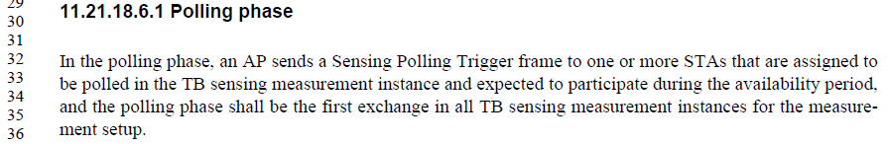

|  |  |  |  |  |
| --- | --- | --- | --- | --- |
| **CID** | **Clause** | **Page** | **Comment** | **Proposed change** |
| 862 | 11.21.18.6.2 | 69 | Grammatical Improvements | Change text to: "In the NDPA sounding phase, the AP, which is a sensing transmitter, sends a NDP to one or more STAs, on which the one or more STAs perform sensing measurements." |
| 864 | 11.21.18.6.3 | 70 | Grammatical Improvements | Change text to: "In the TF sounding phase, the AP, which is a sensing receiver, solicits NDP transmission from one or more STAs, on which to perform sensing measurements." |

**Proposed resolution**: Accepted

**Discussion**: Sentences referred to by the commenter:

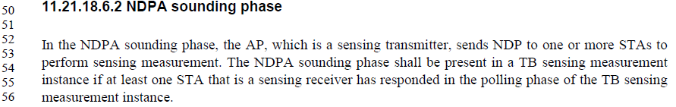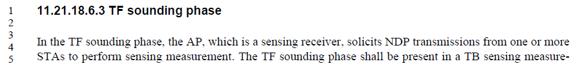

|  |  |  |  |  |
| --- | --- | --- | --- | --- |
| **CID** | **Clause** | **Comment** | **Proposed change** | **Proposed resolution** |
| 476 | 11.21.18.6.2 | The STA Info fields within the Sensing NDP Announcement frame specify all the STAs that will use the NDP sent by the AP | The STA Info fields within the Sensing NDP Announcement frame specify all the STAs that will receive the NDP sent by the AP | Revised |
| 621 | 11.21.18.6.2 | Change "all the STAs that will use the NDP sent by the AP" to "all the STAs that will use the I2R NDP which is sent by the AP SIFS after this NDPA" | As commented. | Rejected |

**Discussion**: Paragraph referred to by the commenter:

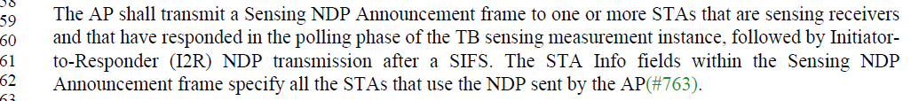

Two points for discussion:

* Due to the broadcast nature of the wireless medium, it could be argued that not all STAs that receive the NDP are its intended recipients.
* Sentence immediately before the sentence under consideration already defines that an NDP is transmitted after SIFS.

**Modifications**: Editor – Change 85.58-63 as follows:

The STA Info fields within the Sensing NDP Announcement frame specify ~~all the STAs that will use the NDP sent by the AP.~~ the intended recipients of the NDP that follows.

|  |  |  |  |  |
| --- | --- | --- | --- | --- |
| **CID** | **Clause** | **Page** | **Comment** | **Proposed change** |
| 630 | 11.21.18.6.5 | 71 | Change "for each sensing responder" to "for each sensing receiver" | As commented. |

**Proposed resolution**: Revised

**Discussion**: Paragraph referred to by the commenter (as long with an extra one for reference):

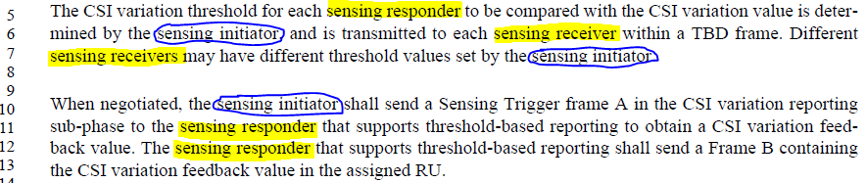

As seen above, the text is consistent in the use of “sensing initiator” (“sensing transmitter” is not used). But at the same time, sensing responder/sensing receiver is used interchangeably – which is technically correct, but not appropriate. Suggest to use “sensing responder” since “sensing initiator” is used.

**Modifications**: Editor – Replace “sensing responder” with “sensing receiver” in 11.21.18.6.5 where appropriate.

|  |  |  |  |  |
| --- | --- | --- | --- | --- |
| **CID** | **Clause** | **Page** | **Comment** | **Proposed change** |
| 631 | 11.21.18.6.5 | 71 | Change "to the sensing responder that supports threshold-based reporting to obtain a CSI variation feedback value" to "the sensing responder(s) that support threshold-based reporting to obtain CSI variation feedback value(s)" | As commented. |

**Proposed resolution**: Accepted

**Discussion**: Paragraph considered in the comment:



|  |  |  |  |  |
| --- | --- | --- | --- | --- |
| **CID** | **Clause** | **Page** | **Comment** | **Proposed change** |
| 786 | 11.21.18.6 | 68 | Capitalize "sounding" and "reporting" here as well as in rest of this section. | As in comment. |
| 160 | 11.21.18.6 | 69 | Inconsistent use of terminology for the terms "TF Sounding phase" and "NDPA Sounding phase". In some occurrences, "Sounding" starts with a capital letter, and in other occurrences "sounding" starts with a small letter. | Keep the terminology consistent with Figure 11-41d or change the terminology used in the figure. |

**Proposed resolution**: Revised

**Discussion**: As defined in the 802.11 Style Guide, (1) technical terms, such as “TF sounding phase”, are not capitalized and (2) frame names, such as Sensing Sounding Trigger frame, are capitalized. While the text in the draft is consistent with the 802.11 Style guide, Figures 11-41d and 11-41e are not.

**Modifications**: Editor – Change Figures 11-41d and 11-41e to meet the 802.11 Style Guide (2.6 Capitalization).

