IEEE P802.11
Wireless LANs
Resolutions for Instance Comments in CC40 - Part 2
Date: 2022-08-02
Author(s):
Name | Affiliation | Address | Phone | email
Cheng Chen | Intel |  |  | cheng.chen@intel.com
Abstract
This submission proposes resolutions to editorial comments submitted in CC40. The text used as reference is D0.2.

CIDs: 273 161 432 192 616 618 619 274 348

Revision history:
R0: Original version.
R1: Minor editorial changes to proposed resolutions based on feedback received.
R2: Revised the resolution to CID 192 616 618 619 based on comments received offline.
R3: Refined the resolution to CID 192 616 618 619 based on comments received at the TGbf call.
R4: Included two additional CIDs 161, 432 and refined the resolutions.

Discussion:
The following CIDs are all related to functions of Sensing Trigger frames, including Sensing Polling Trigger frame and Sensing Sounding Trigger frame currently defined in IEEE 802.11bf D0.2.

Currently, the detailed formats of these Sensing Trigger frames are not finalized. That is, we have not designed each of the fields in these frames.

However, since we already agree that Sensing Trigger frames are variants of a Trigger frame, based on the Trigger frame format defined in IEEE 802.11REVme D1.3, there are already some fields that we can safely assume to be in the final format of these Sensing Trigger frames, which basically include those fields that apply to all Trigger frame variants.

The proposed resolutions of the following CIDs are all based on using these fields in the Trigger frame. The understanding is that they anyways will end up in the finalized format of Sensing Trigger frames.

IEEE 802.11REVme D1.3, Section 9.3.1.22 Trigger frame format.
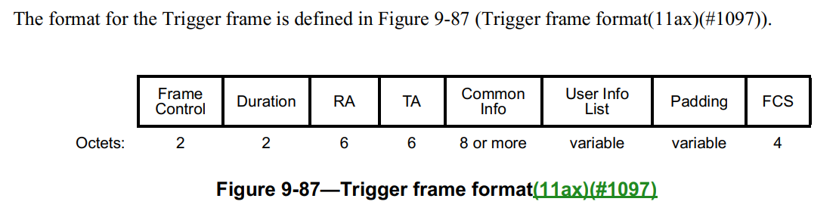
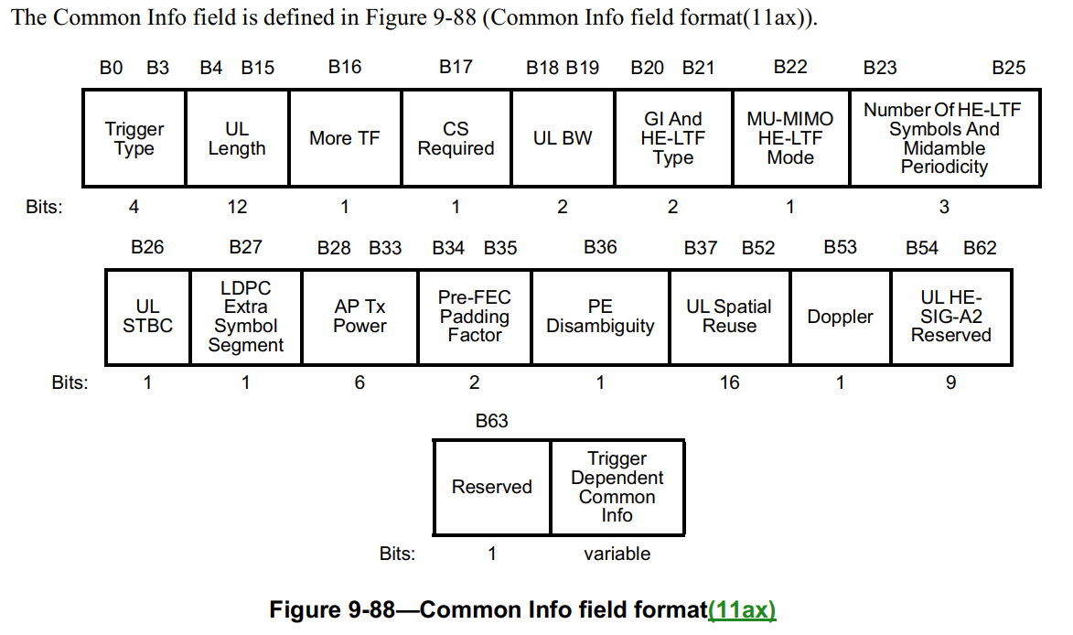
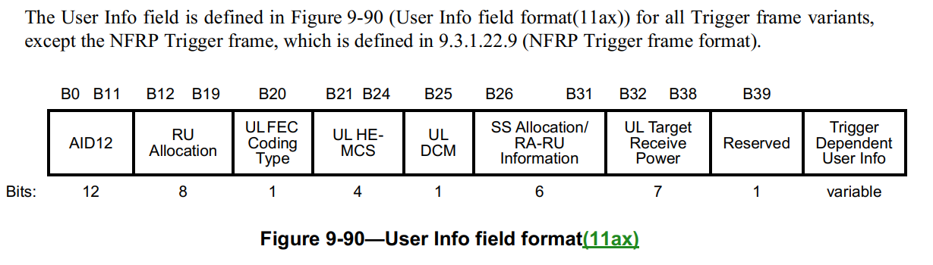

CID | Clause | Page | Comment | Proposed change
273 | 11.21.18.6.1 | 69.42 | need to define mechnism to interpret how the STA addressed by a user info field. | as in comment

Proposed resolution: Rejected

Discussion: It is already clear how a STA is addressed by a user info field. Because based on the format of a Trigger frame, every Sensing Trigger frame will include one or more User Info field, each of which corresponding to one STA. Each User Info field will include an AID12 subfield, which indicates the corresponding AID of a specific STA. Therefore, there is no need to define another mechanism.

CID | Clause | Page | Comment | Proposed change
161 | 11.21.18.6.1 | 69.33 | "availability period" is not defined in the draft or in the 802.11 specs. | Define the "availability period" term or use a more commonly used term.
432 | 11.21.18.6.1 | 69.33 | "during the availability period" - what is an "availability period", where was is discussed in reference to sensing, when is it negotiated? | define "availability period" or point to where it is defined
192 | 11.21.18.6.1 | 69.41 | In some scenarios, the AP may not be able to poll all responders using one Sensing Polling Trigger frame and therefore needs to send multiple Sensing Polling Trigger frames. The "More TF" subfield in the Common Info field could be used to indicate to those responders that are not scheduled in the first Sensing Polling Trigger frame that more Sensing Polling Trigger frames are coming. | Add a few sentences specifying the behavior of sending multiple Sensing Polling Trigger frame and the use of "More TF" subfield.
616 | 11.21.18.6.1 | 69.32 | "one or more STAs", does this mean there maybe multiple polling phases in a single instance? Could a STA be polled multiple times in a single instance? | Add a clarification: There is at most one polling phase in a single instance, each STA may be polled at most once in the polling phase. A TXOP may contain multiple instances.
618 | 11.21.18.6.1 | 69.47 | What if all the responders do not respond, should the instance be terminated? | Add a clarification: if all the responders do not respond, the instance is terminated.
619 | 11.21.18.6.1 | 69.47 | If there are hundreds of responders, the available uplink resources may not be enough for one trigger. | Add a clarification: If the number of scheduled sensing responders exceeds the available uplink resources, multiple sequential trigger  frames can be transmitted within the acquired TXOP

Proposed resolution: Revised to all

Discussion:
- CID 161, 432
  - We can use the term “sensing availability window” instead.
- CID 192:
  - Agree that the “More TF” subfied in the Sensing Polling Trigger frame can be used to indicate more Sensing Polling Trigger frames may follow if the Sensing Polling Trigger frame of the first sensing measurement instance within the same availability window does not poll all STAs. This will make sure the STA will keep awake and wait for the Sensing Polling Trigger frame in the next TB sensing measurement instance within the same availability window. Moreover, a STA can use the indication of the “More TF” subfield to determine whether it may be polled and therefore involved in the following NDPA and/or TF sounding phase, which will help the STA to enter doze and save power if it knows it will not be polled in this availability window.
- CID 616:
  - Agree that there may be multiple TB sensing measurement instances within the same availability window, each of which may consist of a polling phase.
  - It is up to the AP to decide which STAs to poll in a polling phase. Each polling phase consists of at most one Sensing Polling Trigger frame, so a STA cannot be polled more than once in a polling phase.
- CID 618
  - It is pretty clear that the presence of NDPA sounding phase and TF sounding phase will largely depend on the response results of the polling phase. If no STAs respond in the polling phase, the AP can either choose to poll again or do not proceed with NDPA sounding phase or TF sounding phase. As long as the protocol is well defined, there is no need to specifically call out the scenario where no STAs respond in the polling phase.
  - Moreover, we do not have the concept of “sensing measurement instance termination”. If we want to add the behavior, we will have to define this new concept, which is not necessary.
  - We already have the following sentence in the spec “It includes one or more of the following phases: Polling phase, NDPA sounding phase, Trigger frame (TF) sounding phase, and reporting phase.” So, a TB sensing measurement instance can just include one polling phase if no STAs respond in the polling phase.
- CID 619:
  - Agree that multiple Sensing Polling Trigger frames can be transmitted if the number of responders is large. However, the Polling Trigger frames should not be sequential for the following reasons:
    - Once a STA responds in the polling phase, the AP needs to proceed with the subsequent NDPA and/or TF sounding phase with the responded STA. As a result, a polling phase is typically followed by an NDPA and/or TF sounding phase within SIFS.
    - If an AP is not able to poll all STAs at one time, it can first poll some STAs and proceed with NDPA and/or TF sounding and then start another polling phase with another set of STAs.
    - Having multiple polling + NDPA and/or TF sounding combinations in multiple TB sensing measurement instances can help the AP to group STAs with different sensing parameters in different measurement instances. For example, the AP can first poll 20 MHz-only STAs and group them in the first measurement instance with 20 MHz-only sensing and then poll 80 MHz STAs and group them in the second measurement instance to conduct 80 MHz sensing.

Modifications: Editor - Add the following paragraph in 11.21.18.6
TB sensing measurement instance is the trigger-based variant of a sensing measurement instance. It is applicable to scenarios where an AP is the sensing initiator, and one or more non-AP STAs are the sensing responders. It includes one or more of the following phases: Polling phase, NDPA sounding phase, Trigger frame (TF) sounding phase, and reporting phase.

A sensing availability window is a period of time during which an AP and one or more STAs are scheduled to participate in TB sensing measurement instance(s). All TB sensing measurement instances shall take place within an availability window. Each availability window may consist of one or more TXOPs, and each TXOP may consist of one or more TB sensing measurement instances.

Editor – Add/Revise the following paragraphs in 11.21.18.6.1.
In the polling phase, an AP sends a Sensing Polling Trigger frame to one or more STAs that are assigned to be polled in the TB sensing measurement instance and expected to participate during the sensing availability window, and the polling phase shall be the first exchange in all TB sensing measurement instances for the sensing measurement setup. The AP shall send a Sensing Polling Trigger frame to one or more STAs and shall allocate each RU in the Polling Trigger frame to only one STA. Any STA addressed by a User Info field in a Sensing Polling Trigger frame can request to participate in the TB sensing measurement instance by responding with a CTS-toself frame in its designated RU allocation as identified in the Sensing Polling Trigger frame.

TB sensing measurement instance shall begin with a polling phase when at least one STA is assigned to be polled. In a TB sensing measurement instance with a polling phase, if an AP sends a Sensing Polling Trigger frame and receives a CTS-to-self response from at least one STA, it shall proceed to the NDPA sounding and/or TF sounding phase after a SIFS time and if reporting is required, it shall proceed to the reporting phase a SIFS after the NDPA sounding and/or TF sounding phase.

If the AP does not poll all STAs assigned to be polled in the sensing availability window using a single Sensing Polling Trigger frame, the AP shall attempt to schedule one or more extra TB sensing measurement instances where each measurement instance begins with a polling phase within the same sensing availability window. The AP shall indicate the extra TB measurement instance by setting the More TF subfield in the Common Info field to 1 and the RA field to the broadcast address in the Sensing Polling Trigger frame. The extra TB measurement instance may occur in the same TXOP within the same sensing availability window (see example in Figure 1-a), or in a separate TXOP within the same sensing availability window (see example in Figure 1-b). If the AP had set the More TF subfield to 1 in the Sensing Polling Trigger fame of the preceding TB sensing measurement instance, and if there are no additional TB measurement instance within the same sensing availability window, the AP shall set the More TF subfield in the Common Info field to 0 and the RA field to the broadcast address in the next Sensing Polling Trigger frame. Upon receipt of such a frame, a STA that has not been addressed by a User Info field in the Sensing Polling Trigger frame may enter doze state if no other condition requires this STA to remain awake.

Figure 1-a: Example of a sensing availability window with two TB sensing measurement instances of polling/NDPA souning/TF sounding/Reporting phase within a single TXOP.

Figure 1-b: Example of a sensing availability window with two TB sensing measurement instances of polling/NDPA souning/TF sounding/Reporting phase in separate TXOPs.

CID | Clause | Page | Comment | Proposed change
274 | 11.21.18.6.3 | 70.17 | need to define a mechanism to indicate the multiple sequential trigger frames can be transmitted within the acquired TXOP. | as in comment
348 | 11.21.18.6.3 | 70.18 | "NOTE--If the number of available sensing transmitters exceeds the available uplink resources, multiple sequential trigger frames can be transmitted within the acquired TXOP." The text in the note about multiple sequential trigger frames is about normative behavior. There is no such normative text presented. Propose to make the text in the NOTE normative. | Replace the text with "The AP may transmit a Sensing Sounding Trigger frame to solicit Responder to-Initiator (R2I) NDP transmission(s) multiple times within the acquired TXOP.  NOTE--AP can transmit multiple sequential trigger frames within the acquired TXOP if the number of available sensing transmitters exceeds the available uplink resources."

Proposed resolution: CID 274: Revised. CID 348: Revised.

Discussion:
- CID 274: If a STA is assigned and polled in a TB sensing measurement instance with positive response (i.e., the STA responds in the poll), the AP will need to perform NDPA sounding and/or TF sounding with the STA. What the STA needs to do is simply waiting to be addressed by a Sensing NDPA frame and/or Sensing Soudning Trigger frame. If the AP transmits multiple Sensing Sounding Trigger frames, the STA will be able to understand when it will be addressed by looking at the User Info list in the Sensing Sounding Trigger frames.
- CID 348: Agree with the comment in general.

Modifications: Editor – Add the following paragraph in 11.21.18.6.3 and delete the Note as follows:
If the number of available sensing transmitters exceeds the available uplink resources, the AP may perform the frame exchange of transmitting a Sensing Sounding Trigger frame and soliciting the R2I NDP transmission(s) multiple times during the TF sounding phase in a TB sensing measurement instance.

SP

Do you support the proposed resolutions to the following CIDs and incorporate the text changes into the latest TGbf draft: CID 273 161 432 192 616 618 619 274 348?

Y/N/A

