IEEE P802.11
Wireless LANs
CR on CID 11298
Date: 2022-08-01
Author(s):
Name | Affiliation | Address | Phone | email
Shimi Shilo | Huawei |  |  | shimi.shilo@huawei.com

Abstract
This submission contains proposed comment resolutions to comments on P802.11be D2.0.
The changes are based on P802.11be D2.1.

This submission provides a resolution to the following CID:
- 11298

Revisions:
- Rev 0: Initial version of the document.

CID | Page/Line | Clause | Comment | Proposed Change | Resolution
11298 | 740.23 | 36.3.18 | Rearrange sentence for clarity | Change to "An EHT sounding NDP is indicated by setting the PPDU Type And Compression Mode field to 1, the EHT-SIG MCS field to 0 and the Number Of EHT-SIG Symbols field to 0 in the U-SIG field." | Accepted.  Note to editor: P752L23 in D2.1.

Discussion:
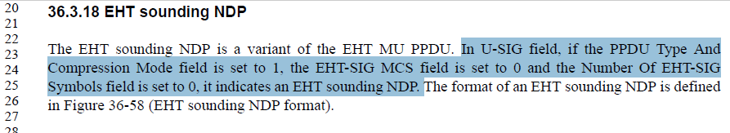
End of discussion

