IEEE P802.11
Wireless LANs
CR for CIDs in 35.7.2 Part II
Date: 2022-07-25
Author(s):
Name | Affiliation | Address | Phone | email
Zinan Lin | InterDigital |  |  | Zinan.lin@interdigital.com
Xiaogang Chen | Zeku
Sigurd Schelstraete | MaxLinear
Abstract

This submission present proposed resolutions for the following 8 CIDs:
10172, 10171, 10815, 10170, 10816, 11668, 12009, 12556

The proposed changes are based on 802.11be/D2.0.

Revision history:

r0 – initial version
r1- updates based on comments in the meeting

CID | Clause | Page | Comment | Proposed Change | Resolution
10172 | 35.7.2 | 496.19 | after the rules defining non-TB and TB sounding for 80MHz STA, there are repeated rules regardless of TB or non-TB for 80MHz STA. Why it's necessary? | explain the reason of repeating the rules or remove the repeated portion. Same for 160MHz STA | Rejected  P496L1-L10 depicts the mandatory support of SU feedback for an 80 MHz operating EHT beamformee in an EHT non-TB sounding sequence. P496 L13-17 depicts the optional support of SU feedback for an 80 MHz operating EHT beamformee in an EHT TB sounding sequence. P496L19 depicts the mandatory support of MU feedback when the EHT beamformee operating bandwidth is 80 MHz. Therefore, P496L19 does not repeat the rules for 80 MHz operating EHT beamformee.  Similar explanation is applied to 160 MHz operating EHT beamformee.  Therefore, the texts as mentioned in the comment are necessary in the specs.
10171 | 35.7.2 | 497.16 | "may support MU feedback for the combinations of RU or MRU (if the MRUs are full bandwidth feedback) size and NDP announcement bandwidth below:" "full" should be "partial" this is refering to the optional modes which are for partial BW MU feedback | as in the comment | Revised: agree in principle with the comment  There is no confusion that it is a partial feedback when MRU size is 484+242 when Operating channel width of the EHT beamformee is 160 MHz and the bandwidth the PPDu carrying the EHT NDPA frame is 160 MHz. Therefore, to be consistent with other expression, (P) is removed after 484+242 when Operating channel width of the EHT beamformee is 160 MHz and the bandwidth the PPDU carrying the EHT NDPA frame is 160 MHz.  TGbe editor: please incorporate changes shown in 11-22/1232r1 under the tag 10171
10815 | 35.7.2 | 497.17 | Change "full" to "partial" | As in the comment. | Revised  It is similar to CID 10171.  TGbe editor: please incorporate changes shown in 11-22/1232r1 under the tag 10171
10170 | 35.7.2 | 498.17 | "may support MU feedback for the combinations of RU or MRU (if the MRUs are full bandwidth feedback) size and NDP announcement bandwidth below:" "full" should be "partial" this is refering to the optional modes which are for partial BW MU feedback | as in the comment | Revised: agree in principle with the comment  There is no confusion that it is a partial feedback when MRU size is 484+242 when Operating channel width of the EHT beamformee is 320 MHz and the bandwidth the PPDU carrying the EHT NDPA frame is 160 MHz. Therefore, to be consistent with other expression, (P) is removed after 484+242 when Operating channel width of the EHT beamformee is 320 MHz and the bandwidth the PPDU carrying the EHT NDPA frame is 160 MHz.  TGbe editor: please incorporate changes shown in 11-22/1232r1 under the tag 10170
10816 | 35.7.2 | 498.17 | Change "full" to "partial" | As in the comment. | Revised: agree in principle with the comment  It is similar to CID 10170.  TGbe editor: please incorporate changes shown in 11-22/1232r1 under the tag 10816
11668 | 35.7.2 | 499.03 | It is indicated P495L20 that "A 320 MHz EHT beamformer shall not send a 320 MHz EHT NDP Announcement frame solicit partial BW feedback from an EHT beamformee with 20 MHz operating channel width." But Table 35-3 indicates that when the bandwidth of PPDU containning the EHT NDP Annoucement frame 320 MHz, it is optional to have the SU/MU feedback (TB sounding) with 242-tone | Make the following rows as "N/A": optional for MU feedback (TB sounding), optional for SU feedback (TB sounding) and optional for CQI feedback (TB sounding) across with 320 MHz bandwidth of PPDU containing the EHT NDPA annoncement frame | Revised:  TGbe editor: please incorporate changes shown in 11-22/1232r1 under the tag 11668
12009 | 35.7.2 | 499.07 | For 20 MHz operating STA, 320 MHz sounding feedback is not supported. | Delete the 320 MHz column or change "242" to "N/A" in the 320 MHz column. | Revised:  It is a similar comment to CID 11668. Please refer to the resolution in CID 11668  TGbe editor: please incorporate changes shown in 11-22/1232r1 under the tag 12009
12556 | 35.7.2 | 499.04 | Make the use of language consistent | Change "Bandwidth of PPDU containing the EHT NDP Announcement frame" to "Bandwidth of the PPDU carrying the EHT NDP Announcement frame" | Accepted

TGbe editor: please make the following change in subclause 35.7.2
P497L16:
A 160 MHz operating EHT beamformee may support MU feedback for the combinations of RU or MRU ((#10171) (#10815) if the MRUs are partial bandwidth feedback) size and NDP announcement bandwidth below:

P498L16:
A 320 MHz operating EHT beamformee may support MU feedback for the combinations of RU or MRU ((#10170) (#10816) if the MRUs are partial bandwidth feedback) size and NDP announcement bandwidth below:

Table 35-3, P499 – P503:
TGbe editor: (#12556) please change the first row of “Bandwidth of PPDU containing the EHT NDP Announcement frame (MHz)” in Table 35-3 to “Bandwidth of the PPDU carrying the EHT NDP Announcement frame”
Table 35-3, P499:
TGbe editor: (#11668) (#12009) Please change the circled part into “N/A”

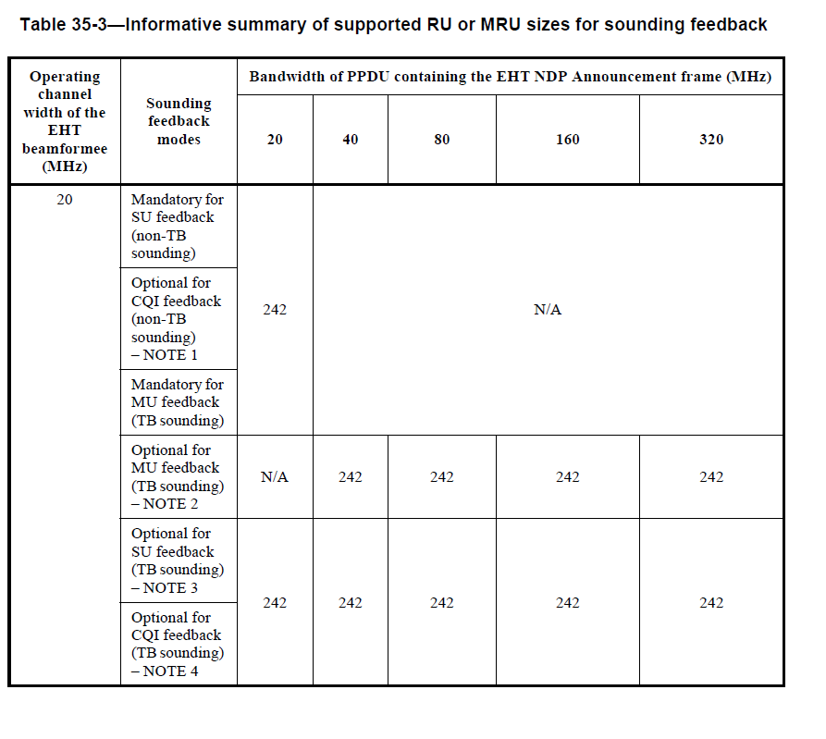
Table 35-3, P502:
TGbe editor: (#10171) (#10815) Please remove the highlighed “(P)” with yellow color

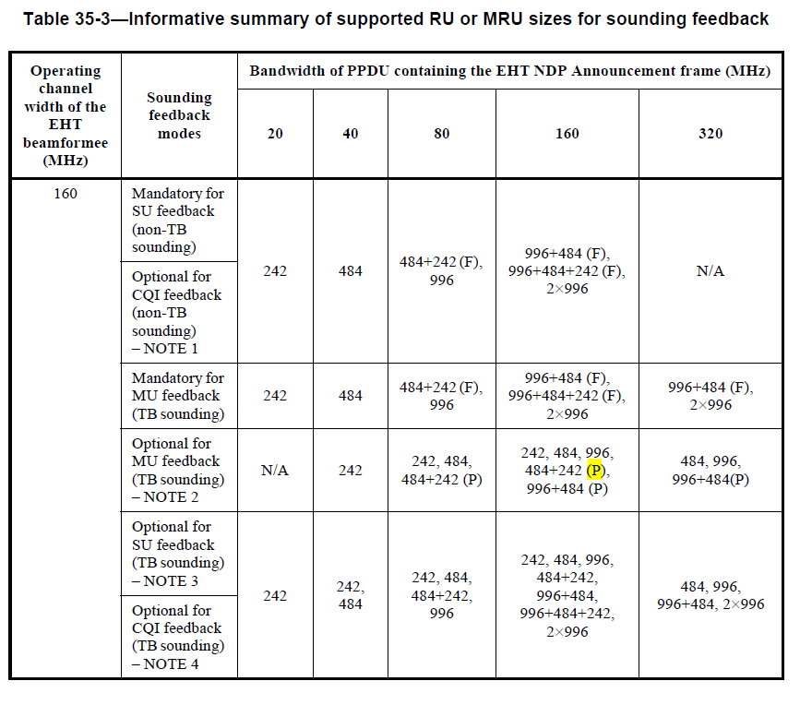
Table 35-3, P503:
TGbe editor: (#10170) (#10816) Please remove the highlighed “(P)” with yellow color

