IEEE P802.11
Wireless LANs
LB266 Comment Resolutions for Equations in 36.3.12.9 EHT-STF
Date: 2022-08-01
Author(s):
Name | Affiliation | Address | Phone | Email
Eunsung Park | LG Electronics | 19, Yangjae-daero 11gil, Seocho-gu, Seoul 137-130, Korea |  | esung.park@lge.com
Dongguk Lim |  |  |  | dongguk.lim@lge.com
Jinyoung Chun |  |  |  | jiny.chun@lge.com
Jinsoo Choi |  |  |  | js.choi@lge.com

Abstract
This submission proposes a resolution for the following 2 CIDs:
11208, 12022

Revisions:
- Rev 0: Initial version of the document.

Interpretation of a Motion to Adopt

A motion to approve this submission means that the editing instructions and any changed or added material are actioned in the TGbe D2.0 Draft. This introduction is not part of the adopted material.

Editing instructions formatted like this are intended to be copied into the TGbe D2.0 Draft (i.e. they are instructions to the 802.11 editor on how to merge the text with the baseline documents).

TGbe Editor: Editing instructions preceded by “TGbe Editor” are instructions to the TGbe editor to modify existing material in the TGbe draft. As a result of adopting the changes, the TGbe editor will execute the instructions rather than copy them to the TGbe Draft.

CID 11208
CID | Clause | PP.LL | Comment | Proposed Change | Resolution
11208 | 36.3.12.9 | 694.10 | Eq (36-35) for EHT STF of an EHT MU PPDU should be changed to use spatial mapping matrix "[Q_k,u]_{i_TX,m}" instead of "[Q_k]_{i_TX,M_r,u+m}" to be consistent with eq (36-9). | As in comment | Revised  The current equation is also correct but to make it consistent, we propose to modify the equation as the commenter’s suggestion.  TGbe editor to make the changes shown in 11-22/1226r0.

Discussion
Equation (36-9)
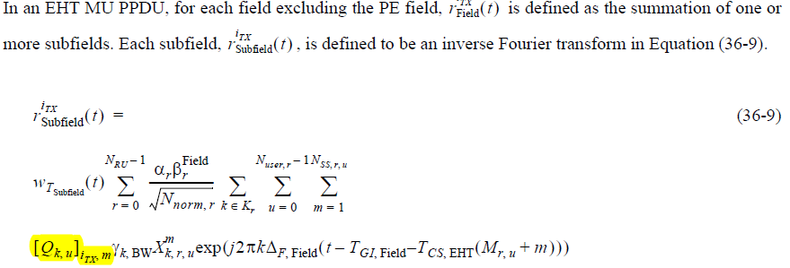

It is based on each user’s Q matirx

Equation (36-35)
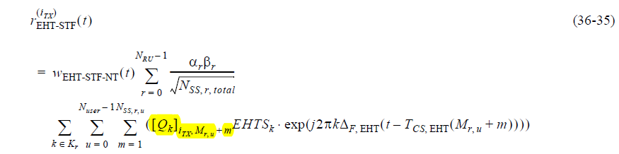

It is based on a whole Q matix.

TGbe Editor: Please replace Equation (36-35) of D2.0 with the following eqaution:
$$r_{\text{EHT-STF}}^{\left(i_{TX}\right)}\left(t\right)=w_{T_{\text{EHT-STF-NT}}}\left(t\right)\sum_{r=0}^{N_{RU}-1}{\frac{{α_{r}β}_{r}}{\sqrt{N_{SS,r,total}}}} (36\text{-}35)$$
$$\sum_{k∈K_{r}}{\sum_{u=0}^{N_{user}-1}{\sum_{m=1}^{N_{SS,r,u}}{\left({\left[Q_{k,u}\right]}_{i_{TX}, m}EHTS_{k}∙\text{exp}\left(j2πk∆_{F,EHT}\left(t-T_{CS, \text{EHT}}\left(M_{r,u}+m\right)\right)\right)\right)}}}$$

CID 12022
CID | Clause | PP.LL | Comment | Proposed Change | Resolution
12022 | 36.3.12.9 | 694.46 | Based on 36.3.11.4 Transmitted signal, N_{SS,r,total} should be N_{SS,r,u} in Equation (36-36). | As in comment. | Revised  Agree in principle with the commenter.  TGbe editor to make the changes shown in 11-22/1226r0.

Discussion
36.3.11.4 Transmitted Signal
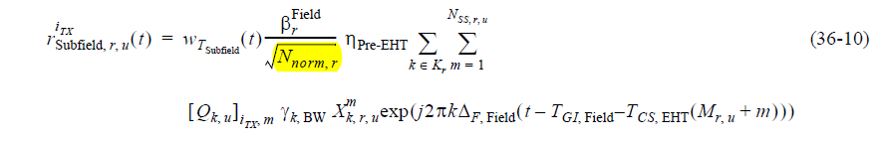
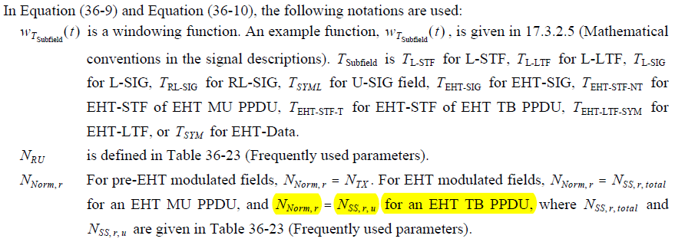

Equation (36-36)
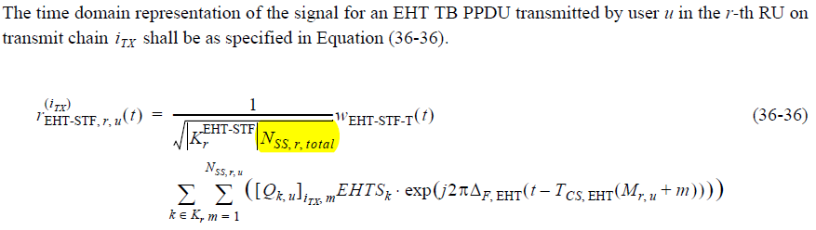

TGbe Editor: Please replace Equation (36-36) of D2.0 with the following eqaution:
$$r_{\text{EHT-STF},r,u}^{\left(i_{TX}\right)}\left(t\right)=\frac{1}{\sqrt{\left|K_{r}^{\text{EHT-STF}}\right|N_{SS,r,u}}}w_{T_{\text{EHT-STF-T}}}\left(t\right) \text{(36-36)}$$
$$\sum_{k∈K_{r}}{\sum_{m=1}^{N_{SS,r,u}}{\left({\left[Q_{k,u}\right]}_{i_{TX},m}EHTS_{k}∙\text{exp}\left(j2π∆_{F,EHT}\left(t-T_{CS, \text{EHT}}\left(M_{r,u}+m\right)\right)\right)\right)}}$$

