IEEE P802.11
Wireless LANs
[CR for CC40 Instance TTT]
Date: 2022-06-12
Author(s):
Name | Affiliation | Address | Phone | email
Junghoon Suh | Huawei |  |  | junghoon.suh@huawei.com
Stephen McCann | Huawei |  |  | stephen.mccann@huawei.com
Abstract
This submission proposes resolutions for the follwing 9 CC40 CIDs: 65, 119, 123, 124, 136, 193, 194, 477, and 550. The proposed changes are based on IEEE 802.11bf D0.1 [1].

Revisions:

- Rev 0: Initial version of the document.
- Rev 1: Addition of one sentence for CR of CID 136, 194, 477

CID 65, 119, 123, 124, 136, 193, 194, 477, and 550

CID | Page | Clause | Comment | Proposed Change | Resolution
65 | 34.15 | 9.4.2.318 | The length of field "Sensing Measurement Report Type" shall be 1 octet | Length shall be 1 octet based on Table 9-401s | Accepted
119 | 34.15 | 9.4.2.318 | Why is the length of the "Sensing Measurement Report Type" subfield TBD? Table 9-491s appears to show 256 possible values (1 byte). | See comment | Revised  Change the Length to 1 octet based on Table 9-401s  Note to editor: Please incorporate the changes in https://mentor.ieee.org/802.11/dcn/22/11-22-1224-01-00bf-cr-for-cc40-instance.docx
123 | 69.52 | 11.21.18.6.2 | "sends NDP to one or more STAs to perform sensing measurement.". NDP does not have address. | Replace with e.g. "sends an NDP to allow one or more STAs to perform sensing measurement." | Accepted
124 | 69.52 | 11.21.18.6.2 | There appears to be quite a bit of overlap between the first and second paragraphs of 11.21.18.6.2. | Clean up description in first and second paragraphs. | Rejected  The second paragraph is necessary to distinguish the NDPA Sounding phase from the Trigger Frame Sounding phase.
136 | 31.12 (?)  70.12 | 11.21.18.6.3 | In the TF sounding phase, it is stated that "The Sensing Sounding Trigger frame shall allocate uplink resources for one or more STA's R2I NDP transmission covering the full bandwidth. ..." It is not clear if the uplink resource covering the entire bandwidth is allocated to one and only one STA or one or more STAs as stated in the sentence. It reads as if the uplink resource can be assigned to many STAs which would mean that partial bandwidth sensing is supported, | Either we state that partial bandwidth is not supported in 11bf and cleanup this sentence to explicitly state this, or we may have more discussion on whether the TGbf group should consider this feature (partial bandwidth sensing) | Revised  “The Sensing Sounding Trigger frame shall allocate uplink resources for one or more STA’s R2I NDP transmission covering the full bandwidth.” can be revised to “The Sensing Sounding Trigger frame shall allocate the spatial resources for one or more STA’s R2I NDP transmission covering the full bandwidth.”  Note to editor: Please incorporate the changes in https://mentor.ieee.org/802.11/dcn/22/11-22-1224-01-00bf-cr-for-cc40-instance.docx
193 | 69.52 | 11.21.18.6.2 | Since we do not have OFDMA NDP defined so I2R NDP can only be multiplexed in the spatial domain. We need to specify this point in the spec so that people do not get confused. | Specify that I2R NDP can only be multiplexed in the spatial domain. | Rejected  The I2R NDP is not multiplexed either in spatial domain or in the freq. domain. It is broadcast when it is transmitted to the multiple STAs.
194 | 70.03 | 11.21.18.6.3 | Since we do not have OFDMA NDP defined so R2I NDP can only be multiplexed in the spatial domain. We need to specify this point in the spec so that people do not get confused. | Specify that R2I NDP can only be multiplexed in the spatial domain. | Revised  “The Sensing Sounding Trigger frame shall allocate uplink resources for one or more STA’s R2I NDP transmission covering the full bandwidth.” can be revised to “The Sensing Sounding Trigger frame shall allocate the spatial resources for one or more STA’s R2I NDP transmission covering the full bandwidth.”  Note to editor: Please incorporate the changes in https://mentor.ieee.org/802.11/dcn/22/11-22-1224-01-00bf-cr-for-cc40-instance.docx
477 | 70.12 | 11.21.18.6.3 | "The Sensing Sounding Trigger frame shall  allocate uplink resources for one or more STA's R2I NDP transmission covering the full bandwidth" | "The Sensing Sounding Trigger frame shall  allocate uplink spatial resources for one or more STA's R2I NDP transmission covering the full bandwidth" | Revised  Note to editor: Please incorporate the changes in https://mentor.ieee.org/802.11/dcn/22/11-22-1224-01-00bf-cr-for-cc40-instance.docx
550 | 70.13 | 11.21.18.6.3 | The PPDU solicited by the trigger frame can be transmitted by using the partial BW in the current 11spec. So, It is not clear the meaning of the full bandwidth in this text. Clarify it. | As in comment. | Rejected  We need to have further discussion on this topic, since the Ranging based NDPA/NDP does not support the partial BW CSI report whereas the 11be supports this. However, let me reject it for now until we reach consensus on this topic.

Propose:

TGbf editor: please modify the following Figure 9-1002aw in D0.1
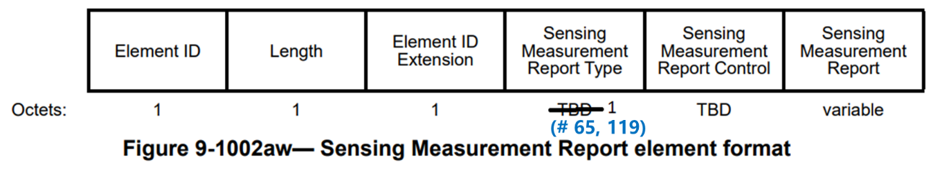

TGbf editor: please modify the senstence between P70L12 and P70L13 in D0.1 as follows
The Sensing Sounding Trigger frame shall allocate uplink spatial resources for one or more STA’s R2I NDP transmissions covering the full bandwidth. The R2I NDP may be transmitted with more than 1 spatial streams. (#136, #194, #477)

References:
[1] 802.11bf D0.1

