IEEE P802.11
Wireless LANs

LB266 CR on CID 10754, 10757
Date: 2022-07-29
Author(s):
Name | Affiliation | Address | Phone | email
Yapu Li | OPPO |  |  | liyapu1@oppo.com
Lei Huang | OPPO

Abstract
This submission contains proposed comment resolutions to the following CID on P802.11be D2.0.

CID 10754, 10757

Revisions:

- Rev 0: Initial version of the document.
-

CID 10754

CID | Page.  Line | Clause | Comment | Proposed Change | Resolution
10754 | 684.27 | 36.3.12.8.6 | The supscript l has been defined as i_80FS in P655L15 | Unify the notation for the same definition. | Revised  Agree in principle.  For the sake of consistency, replace $i_{80FS}$ with l.  Instructions to the editor:  Please make the changes to the spec as shown in 11/22-1215r0

Discussion

P802.11 D2.0
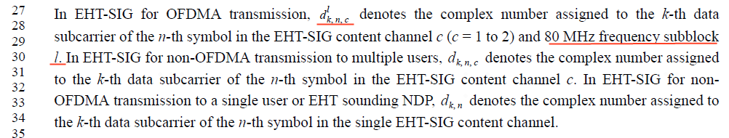

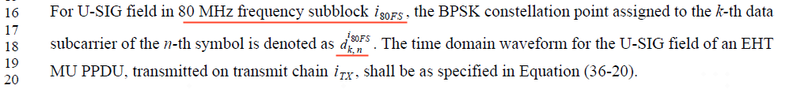

By searching the spec, we find 80MHz subblock is represented by l. For the sake of consistency, replace $i_{80FS}$ with l.

TGbe editor:
Please make the following changes in Page 655 Line 16-18 in D2.0:

36.3.12.7.3 Encoding and modulation

For U-SIG field in 80 MHz frequency subblock l, the BPSK constellation point assigned to the k-th data subcarrier of the n-th symbol is denoted as dk,nl.

CID 10757

CID | Page.  Line | Clause | Comment | Proposed Change | Resolution
10757 | 686.56 | 36.3.12.8.6 | The phrase "according to Equation (36-24)" seems odd because the equation does not elaborate the content channel issue. In fact, the equation is the result of expressing the content channel design. The same comment applies to the repeated occurrence on P687L53. | Remove "Equation (36-24) and" or provide more specific clarification. | Rejected  The equation (36-24) also describes how each of the two EHT-SIG content channels in each 80MHz subblock are duplicated. It would be better to keep reference to this equation.

Discussion

P802.11 D2.0
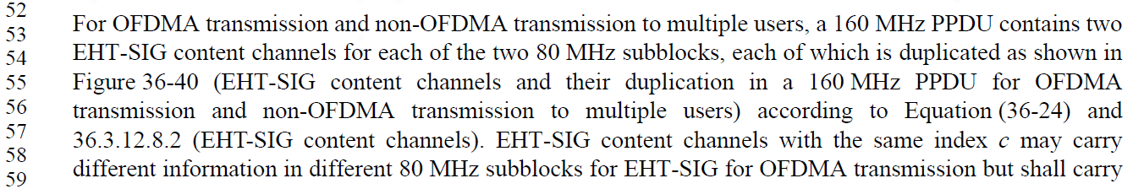

We can get how each of the two EHT-SIG content channels in each 80MHz subblock are duplicated from the item ${(i}_{BW}mod 2)+1$ in parameter $D_{k,n,i_{BW}}$ in the equation (36-24).

