IEEE P802.11
Wireless LANs
LB266 Reducing the size of ML traffic indication element
Date: 2022.07.14
Author(s):
Name | Company | Address | Phone | email
Vishnu Ratnam | Samsung Research America |  |  | vishnu.r@samsung.com
Boon Loong Ng
Rubayet Shafin
Peshal Nayak

Abstract
This submission proposes resolution for 1 CIDs received for TGbe LB266:

SP 1: Do you agree to the resolutions provided in doc 11-22/1202r1 for the following CIDs for inclusion in the latest 11be draft?
11578

Result: Yes/No/Abstain

SP 2: Do you agree with the need to reduce the size of the multi-link traffic indication element.

Result: Yes/No/Abstain

Revisions:
- Rev 0: Presentation version of the document.
- Rev 1: PDT version of the document.

Interpretation of a Motion to Adopt

A motion to approve this submission means that the editing instructions and any changed or added material are actioned in the TGbe Draft. This introduction is not part of the adopted material.

Editing instructions formatted like this are intended to be copied into the TGbe Draft (i.e. they are instructions to the 802.11 editor on how to merge the text with the baseline documents).

TGbe Editor: Editing instructions preceded by “TGbe Editor” are instructions to the TGbe editor to modify existing material in the TGbe draft. As a result of adopting the changes, the TGbe editor will execute the instructions rather than copy them to the TGbe Draft.

CID | Section | Page.Line | Comment | Proposed Change | Resolution
11586 | 35.3.12.4 | 433.11 | Even with a non-default TID-to-link mapping, the AP may sometimes have BUs for a non-AP MLD that can be fetched from any enabled link e.g. MMPDUs, BUs of TID which are mapped to all links. The spec needs to provide a mechanism for AP MLD to indicate if the currently buffered BUs can be fetched on any enabled link. Similarly with default TID-to-link mapping, if the AP MLD has no specific link recommendation, a mechanism to indicate the same is required. | To indicate that the buffered BUs can be fetched on any enabled link, the AP MLD shall: (i) set the bit corresponding to AID of nonAP MLD to 1 in the partial virtual bitmap of TIM (ii) Set all bits corresponding to this AID in the per-link traffic indication bitmap of multi-link traffic indication element to 0. | REVISED  Agreed in principle.  TGbe editor to make the changes shown in 22/1202r1 under all headings that include CID 11586.

Discussion:

Consider an AP MLD operating with $L$ links and having one or more associated non-APs MLDs with non-default TID-to-link mapping (T2LM). For indicating the per-link buffered traffic, the spec provides a ‘multi-link traffic indication’ element which is included in beacon frames. However, as per current spec, the ‘per-link traffic indication list’ subfield of the ‘multi-link traffic indication’ element has to provide traffic indication for all the AIDs with buffered traffic, starting from an AID $k$. The value of $k$ is indicated in the ‘AID offset’ subfield of the ‘ML traffic indication control’ field of the ‘multi-link traffic indication’ element. Thus, the size of this bitmap can be $LM$, where $M$ is number of AIDs after AID $k$ with the corresponding bit in the partial virtual bitmap of the TIM element set to 1 (i.e., the AIDs with buffered traffic). This is depicted pictorially below:
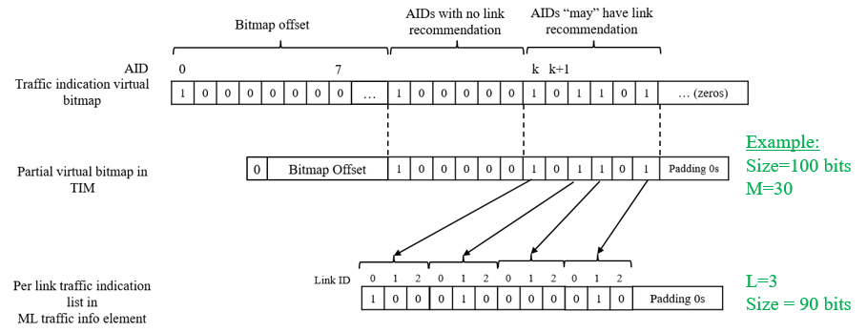

Baseline operation of ML Traffic Indication element

Since $M$ can be typically large, this indication mechanism can increase the size of the ML traffic indication element significantly, causing a beacon bloat issue and also inefficiency in transmission.

Note however that Per-link traffic indication may not be required for many of these $M$ AIDs:
- Many of these AIDs can have default T2LM. Note that T2LM mapping can be changed with time, so contiguous AIDs for non-default T2LM can’t be guaranteed.
- Even for AIDs with non-default T2LM, link recommendation is not always required. For example, link recommendation is not required if the buffered traffic is MMPUs or belongs to TIDs mapped to all enabled links. Similarly, link recommendation is not required if there exists at least on link with all TIDs mapped to it.
Thus, there are many wasted bits in current ‘per-link traffic indication list’, which if removed, can significantly shrink the size of the ML traffic indication element and improve efficiency. Number of wasted bits is $\left(M-N\right)L$, where $N$ is number of AIDs for which the AP MLD intends to provide a link recommendation. This can be significantly large, especially in future where number of links can potentially be increased beyond 3.

Example: Consider scenario with $L=3$ links and a Partial Virtual bitmap (in TIM element) with a size of 100 bits and with 30 AID bits set to 1 after AID $k$ in it. Of these, say only $N=5$ AIDs need link recommendation. However, size of Per Link Traffic Indication List in ML Traffic Indication element is $90$ bits.

Proposed solution:
Include in the ML Traffic Indication element, an optional ‘Recommendation Partial Virtual Bitmap’ field. The presence of this field is indicated using a Recommendation Bitmap Present subfield of the ML Traffic Indication Control field as shown below.
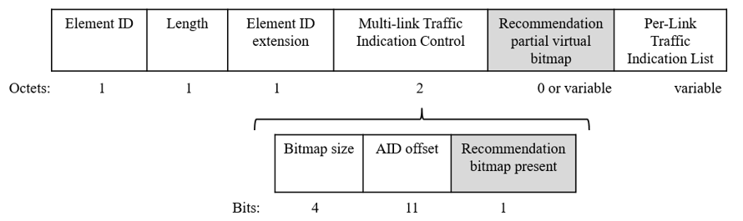
Suggested format of ML Traffic Indication Element

When present in the ML Traffic Indication element, the Recommendation Partial Virtual Bitmap identifies, among the AIDs starting from the AID $k$ with the corresponding bit in the partial virtual bitmap of the TIM element set to 1, the AIDs for which the AP MLD desires to provide a per-link traffic indication/link recommendation, as shown in the figure below. Correspondingly, when the Recommendation Partial Virtual Bitmap is present, the Per-link Traffic Indication List only indicates link recommendations for the AIDs identified by this bitmap, i.e., size of the Per-link Traffic Indication List is reduced to $LN$. When the Recommendation Partial Virtual Bitmap is not present, the Per-link Traffic Indication List includes link recommendations for all AIDs starting from the AID $k$ with the corresponding bit in the partial virtual bitmap of the TIM element set to 1 (i.e., baseline operation). Size of the indication becomes $min⁡\left\{M+LN+1,ML+1\right\}$, which is usually smaller than $ML$.

Let a non-AP MLD with AID $a$ be such that it is the $m$-th AID after AID $k$ with the bit in Partial Virtual Bitmap of TIM element set to 1. Then the non-AP MLD can check the $m$-th bit in the Recommendation Partial Virtual Bitmap of the ML Traffic indication element to identify if there is a link recommendation for it.
- If this bit is set to 0, then there is no link recommendation and the non-AP MLD can use any enabled link with all TIDs mapped to it, to retrieve the buffered traffic.
- If this bit is set to 1, and it is the $n$-th bit in the Recommendation Partial Virtual Bitmap that is set to 1, then the bits $nL-L+1$ to $nL$ of the Per Link Traffic Indication list in the ML Traffic Indication element provides the link recommendation for it. In this case, non-AP MLD should use the recommended link to retrieve the buffered traffic from the AP MLD.

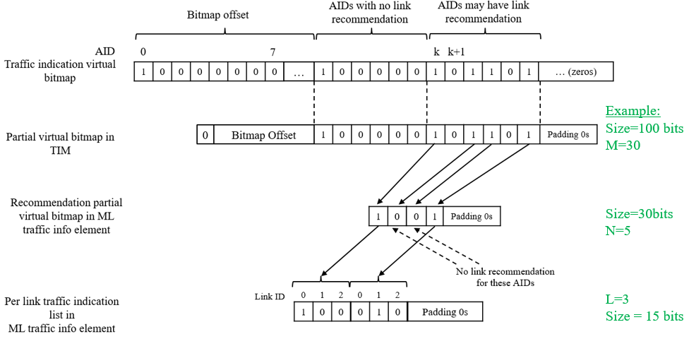
Suggested operation of the ML Traffic Indication element

Example: Consider scenario with $L=3$ links and a Partial Virtual bitmap size of 100 bits with 30 AID bits set to 1 after AID $k$ in it. Of these, say only $N=5$ AIDs need link recommendation. Therefore, size of Recommendation Partial Virtual Bitmap in ML Traffic Indication List is of size 30 bits, and only the bits corresponding to the $5$ AIDs are set to 1. Then the Per Link Traffic Indication List in ML Traffic Indication element only has a size of $15$ bits.
TGbe editor: Please note Baseline is 11be D2

      - Multi-Link Traffic indication element
TGbe editor: Please change the figure as follows

Element ID | Length | Element ID Extension | Multi-Link Traffic Indication Control | Recommendation Partial Virtual Bitmap | Per-Link Traffic Indication List
Octets: 1 1 1 2 variable variable
Figure 9-1002ao—Multi-Link Traffic Indication element format

TGbe editor: Please change the figure as follows
B0 B3 B4 B14 B15
Bitmap Size | AID Offset | Recommendation Partial Virtual Bitmap present
Bits: 4 11 1
Figure 9-1002ap—Multi-Link Traffic Indication Control field format
TGbe editor: Add the following paragraphs after the sixth paragraph
The Recommendation Partial Virtual Bitmap present subfield is set to 1 to indicate the presence of the Recommendation Partial Virtual Bitmap field in the Multi-Link Traffic Indication element. Otherwise, it is set to 0.
The Recommendation Partial Virtual Bitmap field, when present, is a bitmap corresponding to the AIDs of the non-AP MLDs and STAs starting from the bit numbered k of the traffic indication virtual bitmap. The Recommendation Partial Virtual Bitmap field contains n bits, where n is the number of bits that correspond to the AIDs of the non-AP MLDs and STAs and are set to 1, counting from the bit numbered k of the traffic indication virtual bitmap, in the Partial Virtual Bitmap subfield of the TIM element that is included in the Beacon frame with the Multi-Link Traffic Indication element.
TGbe editor: Change the seventh paragraph as follows
The Per-Link Traffic Indication List field is defined in Figure 9-1002aq (Per-Link Traffic Indication List field format). The Per-Link Traffic Indication List field contains Per-Link Traffic Indication Bitmap sub-fields that correspond to the AIDs of the non-AP MLDs and STAs starting from the bit numbered k of the traffic indication virtual bitmap. When the Recommendation Partial Virtual Bitmap field is present, the Per-Link Traffic Indication List field contains $l$ Per-Link Traffic Indication Bitmap subfields, where $l$ is the number of the bits that correspond to the AIDs of the non-AP MLDs and STAs and set to 1, in the Recommendation Partial Virtual bitmap of the Multi-Link Traffic Indication element. When the Recommendation Partial Virtual Bitmap field is not present, the construction of the Per-Link Traffic Indication List shall be as if there was a Recommendation Partial Virtual bitmap of length n bits, in which all of bits are set to 1, i.e., l=n.
The Per-Link Traffic Indication List field contains $l$ Per-Link Traffic Indication Bitmap subfields, where $l$ is the number of the bits that correspond to the AIDs of the non-AP MLDs and STAs and set to 1, in the Recommendation Partial Virtual bitmap of the Multi-Link Traffic Indication element.
      - Traffic indication
TGbe editor: Change the sixth paragraph of the subclause as follows:

An AP affiliated with an AP MLD shall include the Multi-Link Traffic Indication element (see 9.4.2.315 (Multi-Link Traffic Indication element)) in a Beacon frame it transmits if at least one of the associated non- AP MLD has successfully negotiated a TID-to-link mapping (see 35.3.7.1.3 (Negotiation of TID-to-link mapping)) with the AP MLD for DL or bidirectional traffic, wherein no link has all TIDs mapped to it, and the AP MLD has buffered BU(s) for the non-AP MLD. The Multi-Link Traffic Indication element includes Per-Link Traffic Indication Bitmap subfield(s) in the Per-Link Traffic Indication Bitmap List field to provide traffic indication or link recommendations to its associated non-AP MLD(s). The Multi-Link Traffic Indication element includes a Recommendation Partial Virtual Bitmap field if the Recommendation Partial Virtual Bitmap present bit in the Multi-Link Traffic Indication Control field is set to 1. Otherwise, the Recommendation Partial Virtual Bitmap field is not present in the Multi-Link Traffic Indication element. When the Recommendation Partial Virtual Bitmap field is present, the Recommendation Partial Virtual Bitmap field corresponds to the AID(s) of the non-AP MLD(s) or STA(s), starting from the bit number k of the traffic indication virtual bitmap. The AID Offset subfield of the Multi-Link Traffic Indication Control field of the Multi-Link Traffic Indication element contains the value k. The order of the bits in the Recommendation Partial Virtual Bitmap field follows the order of the bits that are set to 1 in the Partial Virtual Bitmap subfield of the TIM element that corresponds to the AID(s) of the non-AP MLD(s) or STA(s). A bit corresponding to an AID is set to 1 in the Recommendation Partial Virtual Bitmap if the AP includes a Per-Link Traffic Indication Bitmap subfield for the non-AP MLD associated with that AID in the Per-link Traffic Indication List field. Otherwise, the bit corresponding to an AID is set to 0. When the Recommendation Partial Virtual Bitmap field is present, the Per-Link Traffic Indication Bitmap subfield(s) corresponds to the AID(s) of the non-AP MLD(s) or STA(s), starting from the AID corresponding to the first bit set to 1 in the Recommendation Partial Virtual Bitmap. The order of the Per-Link Traffic Indication Bitmap subfield(s) follows the order of the bits that are set to 1 in the Recommendation Partial Virtual Bitmap field of the Multi-Link Traffic Indication element. When the Recommendation Partial Virtual Bitmap field is not present, the construction of the Per-Link Traffic Indication List field shall be as if there is a Recommendation Partial Virtual Bitmap with all bits set to 1. If a non-AP MLD has successfully negotiated a TID-to-link mapping with an AP MLD with a nondefault mapping, the bit position $i$ of the Per-Link Traffic Indication Bitmap subfield that corresponds to the link with the link ID that is equal to $i$ on which a STA of the non-AP MLD is operating, shall be set to 1 if the AP MLD has buffered BU(s) with TID(s) that are mapped to that link or MMPDU(s) for that non-AP MLD, otherwise the bit shall be set to 0. If a non-AP MLD is in the default mapping mode (see 35.3.7.1.2 (Default mapping mode)), the bit position $i$ of the Per-Link Traffic Indication Bitmap subfield that corresponds to the link with the link ID equals to $i$ on which a STA affiliated with the non-AP MLD is operating may be set to 1 to indicate to the non-AP MLD a link on which buffered BU(s) should be retrieved. An example of the construction of the Multi-Link Traffic Indication element, when the Recommendation Partial Virtual Bitmap is present, is shown in Figure 35-16a (Example of Multi-Link Traffic Indication element construction when Recommendation Partial Virtual Bitmap is present). An example of the construction of the Multi-Link Traffic Indication element, when the Recommendation Partial Virtual Bitmap is not present, is shown in Figure 35-16b (Example of Multi-Link Traffic Indication element construction when Recommendation Partial Virtual Bitmap is not present). A non-AP MLD that successfully negotiated a TID-to-link mapping with an AP MLD with a nondefault mapping shall determine which AP has buffered BU(s) with TID(s) or MMPDU(s) by interpreting a Multi-Link Traffic Indication element.

Figure 35-16a—Example of Multi-Link Traffic Indication element construction when Recommendation Partial Virtual Bitmap field is present

Figure 35-16b—Example of Multi-Link Traffic Indication element construction when Recommendation Partial Virtual Bitmap field is not present

TGbe editor: Change the seventh paragraph of the subclause as follows:

When a non-AP MLD detects that the bit corresponding to its AID is 1 in the TIM element and either the Multi-Link Traffic Indication element is not present in the beacon frame or it is present and the bit corresponding to its AID in the Recommendation Partial Virtual Bitmap of the Multi-Link Traffic Indication element is set to 0, any STA affiliated with the non-AP MLD that has all TIDs mapped to it may issue a PS-Poll frame, or a U-APSD trigger frame if the STA is using U-APSD and all ACs are delivery enabled, to retrieve buffered BU(s) from the AP MLD.
TGbe editor: Change the eighth paragraph of the subclause as follows:
When a non-AP MLD that is in the default mapping mode (see 35.3.7.1.2 (Default mapping mode)) detects that the bit corresponding to its AID is 1 in the TIM element and the Multi-Link Traffic Indication element is present in a Beacon frame and the Multi-Link Traffic Indication element includes a Per-Link Traffic Indication Bitmap subfield that corresponds to the non-AP MLD, any STA affiliated with the non-AP MLD that operates on the link(s) indicated as 1 in the Per-Link Traffic Indication Bitmap subfield should issue a PS-Poll frame, or a U-APSD trigger frame if the STA is using U-APSD and all ACs are delivery enabled, to retrieve buffered BU(s) from the AP MLD.

