IEEE P802.11
Wireless LANs
LB266 ML traffic indication using A-control
Date: 2022.07.14
Author(s):
Name | Company | Address | Phone | email
Vishnu Ratnam | Samsung Research America |  |  | vishnu.r@samsung.com
Boon Loong Ng
Rubayet Shafin
Peshal Nayak

Abstract
This submission proposes resolution for 1 CIDs received for TGbe LB266:

SP 1: Do you agree to the resolutions provided in doc 11-22/1201r4 for the following CIDs for inclusion in the latest 11be draft?
11587

Result: Yes/No/Abstain

Revisions:
- Rev 0: Presentation version of the document.
- Rev 1: PDT version of the document.
- Rev 2: Updates based on offline feedback from Guogang.
- Rev 3: Generalization based on inputs from Minyoung, Yongho.
- Rev 4: Changes from Shawn and Guogang, some editorial corrections, changed baseline to D2.2

Interpretation of a Motion to Adopt

A motion to approve this submission means that the editing instructions and any changed or added material are actioned in the TGbe Draft. This introduction is not part of the adopted material.

Editing instructions formatted like this are intended to be copied into the TGbe Draft (i.e. they are instructions to the 802.11 editor on how to merge the text with the baseline documents).

TGbe Editor: Editing instructions preceded by “TGbe Editor” are instructions to the TGbe editor to modify existing material in the TGbe draft. As a result of adopting the changes, the TGbe editor will execute the instructions rather than copy them to the TGbe Draft.

CID | Section | Page.Line | Comment | Proposed Change | Resolution
11587 | 35.3.7.1.6 | 430.61 | When there are no remaining BUs for a nonAP MLD that mapped to the current link, the AP MLD sets the "More Data" subfield to 0 in a downlink PPDU, or transmits a QoS null data frame in response to a PS poll. The spec should provide a mechanism for the AP to also indicate, in the response frame, presence of pending traffic for the non-AP MLD that is mapped to other links. The AP should also utilize such a mechanism to indicate a need to check the beacon for critical update. | Define a mechanism where using either a new element or subfield in the response frame, or by transmitting an individually addressed frame, an AP MLD can indicate to an STA of the non-AP MLD if there is buffered traffic for another STA of the non-AP MLD or if there is a need to check the beacon for a critical updates. | REVISED  Agreed in principle.  TGbe editor to make the changes shown in 22/1201r4 under all headings that include CID 11587.

Discussion:

Consider a non-AP MLD operating in power save mode on 2 links. Upon receiving a TIM element indicating buffered traffic, the associated STA on link 1 may wake up and transmit a PS poll to fetch traffic. However, if the load on link 1 very high and/or if there is a lot of pending traffic for the non-AP MLD that can’t fit in one TXOP, the AP MLD may want to suggest the non-AP MLD to also transition to active mode on link 2, to fetch at least a part of the buffered traffic. Such an indication from the AP MLD to the non-AP MLD within the frame exchange sequence initiated by the PS poll on link 1 is currently not possible. Note that fetching all the BUs only on link 1 may cause a long decoding latency and/or also power consumption.

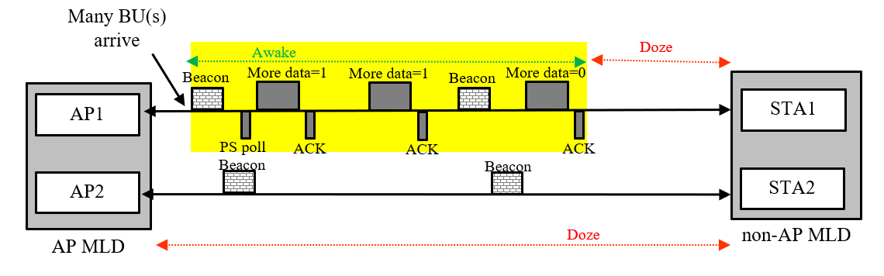
Figure depicting scenario 1

In this scenario (and many other scenarios when non-default TID-to-link mapping is considered), it is beneficial if the AP MLD can indicate, within the frame exchange sequence initiated by a STA affiliated with a non-AP MLD, if it has buffered traffic that is mapped to and is recommended to be retrieved by other STA(s) affiliated with the same non-AP MLD.

Q: Why can’t we use ML Traffic indication element?
A: Although such an indication can also be provided in the ML traffic indication element, a unicast indication is more effective and causes less beacon bloating. More importantly, the AP MLD is not aware of which is the last beacon received by the non-AP MLD and so such an indication should also be provided within the frame exchange sequence initiated by the PS poll.

Q: Why can’t we use Link Recommendation frame?
A: The purpose of link recommendation frame is to provide a long-term recommendation of link(s) to use for uplink and downlink transmissions to one or more non-AP MLDs. It can’t be used to wake up additional links to receive the currently buffered BUs at AP MLD.

Proposed solution:
Introduce a new variant of A-control sub-field called link indication (LI) that can be used by an AP MLD to indicate a set of links to a non-AP MLD, with a structure as shown below.
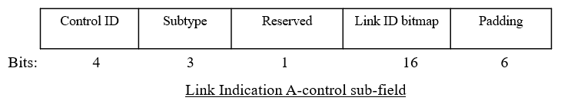
One sub-type of the LI-variant A-control field shall be for individually addressed Wakeup request (WR). An AP of an AP MLD may optionally include an LI-variant A-control subfield of subtype WR in the HE-variant HT control field of an individually addressed frame that it transmits to an affiliated STA of a non-AP MLD, to indicate that the AP MLD has pending BUs that are mapped to and are recommended to be retrieved by other STAs of the non-AP MLD that are in power save mode. The AP shall set the bit $i$ of the Link ID bitmap of the LI-variant A-control subfield of subtype WR to 1 if the AP MLD has buffered BU(s) for the non-AP MLD that are mapped to link ID i and are recommended to be retrieved by the STA operating on link ID i. This subtype of LI-variant A-control field shall not be transmitted by a non-AP MLD. Upon receipt of a QoS Data frame or a QoS null data frame from an AP of the AP MLD with the LI-variant A-control subfield of subtype WR in the HT control field with the bit $i$ of the link ID bitmap set to 1, the STA operating on link ID $i$ of the non-AP MLD affiliated with the recipient STA should issue a PS-Poll frame, or a U-APSD trigger frame if the STA is using U-APSD and all ACs are delivery enabled, to retrieve buffered BU(s) from the AP MLD. This operation is illustrated below pictorially.

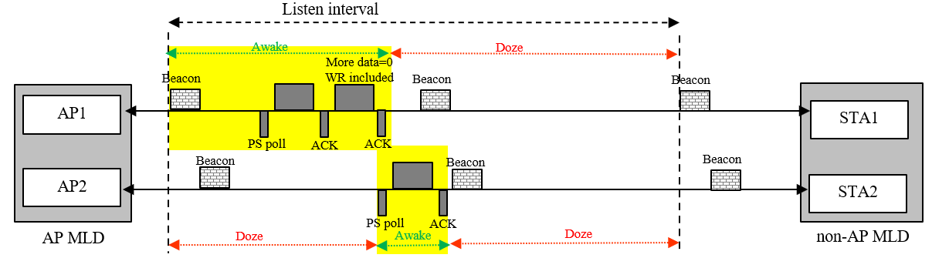

TGbe editor: Please note Baseline is 11be D2.2
        - HE variant
TGbe editor: Please change the table as follows

Table 9-25—Control ID subfield values
Control ID Value | Meaning | Length of the Control Information subfield (bits) | Content of the Control Information subfield
9 | AP assistance request (AAR) | 20 | See 9.2.4.7.10 (AAR Control)
10 | (#11587)Link Indication (LI) | 20 | See 9.2.4.7.11 (LI Control)
11-14 | Reserved
15 | One needs expansion surely (ONES) | 26 | Set all 1s

TGbe editor: Please insert the following clause

        - (#11587) LI Control
9.2.4.7.11.1 (#11587) General
(#11587)The Control Information subfield in an LI Control subfield is used by the MLD, with which the transmitting STA is affiliated, to indicate to the recipient MLD a set of the link identifiers(s) of the STA(s) affiliated with either the transmitting MLD or receiving MLD, and a purpose for the link identifier indication.
(#11587)The format of this subfield is as shown in Figure 9-33d (Control Information subfield format in an LI Control subfield).
B0 B2 B3 B4 B19
Subtype | Reserved | Link ID Bitmap
Bits: 3 1 16
Figure 9-33d—Control Information subfield format in LI Control subfield(#11587)

(#11587)The Subtype subfield indicates the purpose of the Link ID bitmap, and the encoding of this subfield is described in Table 9-33d (Subtype values in LI Control subfield)

Table 9-33d—Subtype values in LI Control subfield(#11587)
Subtype value | Meaning | Content of the Control Information subfield
0 | Wakeup Request (WR) | See 9.2.4.7.11.2 (WR subtype)
1-7 | Reserved

(#11587)The Link ID Bitmap indicates a set of link identifier(s) of the STA(s) affiliated with either the transmitting or receiving MLD. A value of 1 in bit position i indicates that link ID i is an indicated link and a value of 0 indicates that link ID i is not an indicated link.
9.2.4.7.11.2(#11587) WR subtype
(#11587)When transmitted by a STA affiliated with an AP MLD to a STA affiliated with a non-AP MLD, the LI Control subfield of WR subtype indicates the link identifiers(s) of the STA(s) affiliated with the non-AP MLD which are recommended to wake up and retrieve the BU(s) that are currently buffered at the AP MLD. A value of 1 in bit position i of the Link ID Bitmap indicates that the AP MLD has BU(s) that are recommended to be retrieved by the STA affiliated with the non-AP MLD operating on the link with link ID equal to i.

(#11587)An LI Control subfield of subtype WR shall not be transmitted by a non-AP MLD.

          - Common Info field of the Basic Multi-Link element
TGbe editor: Please change the figure as follows
B0 B3 B4 B5 B6 B7 B11 B12 B13 B14 B15
Maximum Number of Simultaneous Links | SRS Support | TID-To-Link Mapping Negotiation Supported | Frequency Separation For STR/AP MLD Type Indication | AAR Support | WR Support  (#11587) | Reserved
Bits: 4 1 2 5 1 1 2
Figure 9-1002l—MLD Capabilities and Operations subfield format
TGbe editor: Please add the following row to the end of the table
Figure 9-401i—Subfields of the MLD Capabilities and Operations field
Subfield | Definition | Encoding
WR Support (#11587) | An AP MLD indicates support for transmitting, and a non-AP MLD indicates support for receiving a frame with the WR Control subfield | For an AP MLD:  Is set to 1 if the AP MLD supports transmission of a frame with the WR Control subfield and is set to 0 otherwise.  For a non-AP MLD:  Is set to 1 if the non-AP MLD supports reception of a frame with the WR Control subfield and is set to 0 otherwise.

      - Traffic Indication

TGbe editor: Change the third paragraph of the subclause as follows:

An AP MLD may use Multi-Link Traffic Indication element and TIM element carried in a Beacon frame, (#11587)or the LI-control field of subtype WR carried in an individually addressed frame, to recommend a non-AP MLD to use one or more enabled links to retrieve individually addressed buffered BU(s). An AP MLD may also use Multi-Link Traffic Indication element and AID Bitmap element in a Link Recommendation frame to recommend a non-AP MLD to use one or more enabled links for all exchanges both for DL and UL. The AP’s indication may be carried in a broadcast or a unicast frame.

TGbe editor: Please insert the following paragraphs at the end of the subclause:

(#11587)An AP MLD may also indicate to a non-AP MLD to wake up on one or more links to retrieve BU(s) buffered at the AP MLD, by transmitting the LI Control subfield of subtype WR in individually addressed frames that it transmits, as described in 9.2.4.7.11.2 (WR subtype). An AP MLD that supports transmission an LI control subfield of subtype WR in the HE-variant HT control field of individually addressed frames that it transmits shall set the dot11WROptionImplemented to true. A non-AP MLD that supports receiving an LI control subfield of subtype WR in the HE-variant HT control field of individually addressed frames shall set the dot11WROptionImplemented to true. A STA affiliated with an MLD with dot11WROptionImplemented that is equal to true shall set the WR Support subfield in the MLD Capabilities and Operations field in the Basic Multi-link element it transmits to 1; otherwise the STA shall set the WR Support subfield to 0.

(#11587)An AP affiliated with an AP MLD with dot11WROptionImplemented set to true may include an LI control subfield of subtype WR in the HE-variant HT control field of an individually addressed frame that it transmits to a STA affiliated with a non-AP MLD, if the
- AP MLD has received from the non-AP MLD a Basic Multi-Link element with the WR Support subfield of the MLD Capabilities and Operations field set to 1.
The AP shall set the bit in position i of the Link ID Bitmap subfield of the LI Control subfield of subtype WR to 1 to indicate that the AP MLD has buffered BU(s) with TID(s) mapped to the link with link ID equal to i or MMPDU(s) for that non-AP MLD that are recommended to be retrieved by the STA affiliated with that non-AP MLD operating on the link with link ID equal to i. Otherwise the bit shall be set to 0.

(#11587)When a STA of a non-AP MLD with dot11WROptionImplemented set to true receives a frame from the AP with the LI Control subfield of subtype WR present in the HE-variant HT control field, then the following applies:
- The STAs of the non-AP MLD operating on the link(s) indicated as 1 in the Link ID bitmap subfield of the LI control subfield, should issue a PS-Poll frame, or a U-APSD trigger frame if the STA is using U-APSD and all ACs are delivery enabled, to retrieve buffered BU(s) from the AP MLD.
- The STAs of the non-AP MLD operating on the link(s) indicated as 0 in the Link ID bitmap subfield of the LI control subfield do not need to issue a PS-poll or a U-APSD trigger frame, even if recommended to do so by a Multi-Link Traffic Indication element previously transmitted by the AP MLD.

