IEEE P802.11
Wireless LANs
LB266 ML traffic indication using A-control
Date: 2022.07.14
Author(s):
Name | Company | Address | Phone | email
Vishnu Ratnam | Samsung Research America |  |  | vishnu.r@samsung.com
Boon Loong Ng
Rubayet Shafin
Peshal Nayak

Abstract
This submission proposes resolution for 1 CIDs received for TGbe LB266:

SP 1: Do you agree to the resolutions provided in doc 11-22/1201r3 for the following CIDs for inclusion in the latest 11be draft?
11578

Result: Yes/No/Abstain

SP 2: Do you agree to combine AAR control subfield as a subtype of the proposed Link Indication (LI) control subfield?

Result: Yes/No/Abstain

Revisions:
- Rev 0: Presentation version of the document.
- Rev 1: PDT version of the document.
- Rev 2: Updates based on offline feedback from Guogang.
- Rev 3: Generalization based on inputs from Minyoung, Yongho.

Interpretation of a Motion to Adopt

A motion to approve this submission means that the editing instructions and any changed or added material are actioned in the TGbe Draft. This introduction is not part of the adopted material.

Editing instructions formatted like this are intended to be copied into the TGbe Draft (i.e. they are instructions to the 802.11 editor on how to merge the text with the baseline documents).

TGbe Editor: Editing instructions preceded by “TGbe Editor” are instructions to the TGbe editor to modify existing material in the TGbe draft. As a result of adopting the changes, the TGbe editor will execute the instructions rather than copy them to the TGbe Draft.

CID | Section | Page.Line | Comment | Proposed Change | Resolution
11587 | 35.3.7.1.6 | 430.61 | When there are no remaining BUs for a nonAP MLD that mapped to the current link, the AP MLD sets the "More Data" subfield to 0 in a downlink PPDU, or transmits a QoS null data frame in response to a PS poll. The spec should provide a mechanism for the AP to also indicate, in the response frame, presence of pending traffic for the non-AP MLD that is mapped to other links. The AP should also utilize such a mechanism to indicate a need to check the beacon for critical update. | Define a mechanism where using either a new element or subfield in the response frame, or by transmitting an individually addressed frame, an AP MLD can indicate to an STA of the non-AP MLD if there is buffered traffic for another STA of the non-AP MLD or if there is a need to check the beacon for a critical updates. | REVISED  Agreed in principle.  TGbe editor to make the changes shown in 22/1201r3 under all headings that include CID 11587.

Discussion:

Consider the following scenarios:
Scenario 1:
Consider a non-AP MLD with a non-default TID-to-link mapping operating in power save mode on 2 links as shown. Upon decoding a beacon on link ID 1 (with TIM element and ML traffic indication element), non-AP MLD identifies that STA1 is a recommended link to fetch BUs from Link ID 1. By sending a PS poll, STA1 initiates a frame exchange with AP1 to fetch the BUs. During this time (between traffic indication and the frame exchange on link1), the AP may have buffered new BU(s) of a TID that is not mapped to STA1, as shown in figure below. As per baseline spec, there is no mechanism to indicate the presence of such new BU(s) in an individually addressed frame to STA1 of non-AP MLD. Upon delivering all BU(s) mapped to STA1, the More Data subfield is set to 0, the non-AP MLD may go to doze state for a listen interval. The new BU(s) are only delivered after the non-AP decodes the next TIM element and ML traffic indication element, which can cause a high latency.

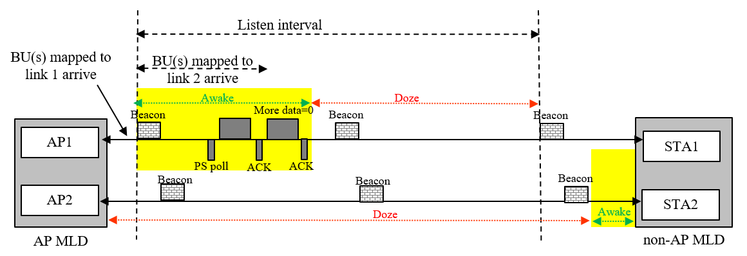
Figure depicting scenario 1

Scenario 2:
Consider a non-AP MLD with a non-default TID-to-link mapping operating in power save mode on 2 links. For latency sensitive traffic mapped to both link ID 1 and 2, the AP may indicate both link ID 1 and 2 as the recommended links in the per-link traffic indication bitmap subfield of the ML traffic information element. This is for faster channel access and delivery. By sending a PS poll on one of the links, say link ID 1, STA1 of non-AP MLD may retrieve the BUs from the AP MLD. After observing more data=0, it may not know if STA2 operating on link ID 2 also needs to send a PS poll. Without an indication of whether there are additional BUs for other links, the STA2 of non-AP MLD may unnecessarily stay awake and also send another PS poll on link ID 2 as shown in the figure below.

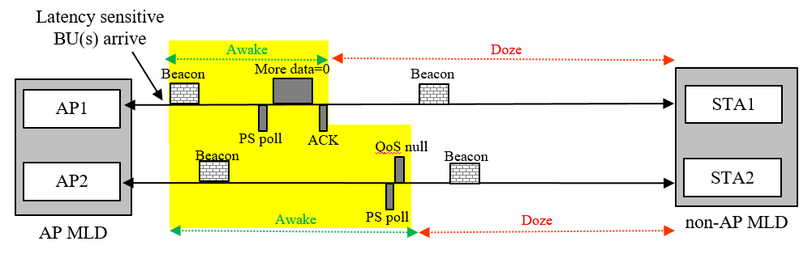
Figure depicting scenario 2

Scenario 3:
Consider a non-AP MLD with a non-default TID-to-link mapping operating in power save mode on 2 links. A STA affiliated with the non-AP MLD can wake up for any reason, e.g. P2P communication, and then also send a PS poll to the AP to fetch downlink BUs (if any) without decoding the TIM element or ML traffic indication element. In such a scenario, the STA can only fetch BU(s) mapped to it and cannot know about BU(s) mapped to other links. It has to wait a receive the ML traffic indication element for the same.

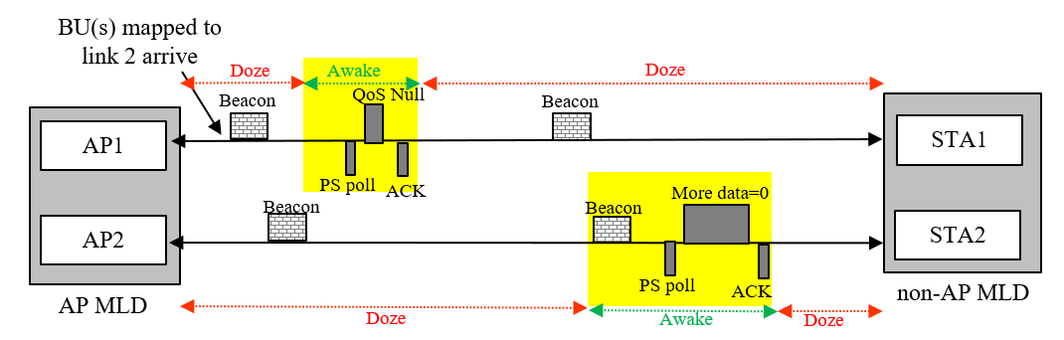
Figure depicting scenario 3

Scenario 4:
Consider a non-AP MLD with a default TID-to-link mapping operating in power save mode on 2 links. Upon receiving a TIM element indicating buffered traffic, the associated STA on link 1 may wake up and transmit a PS poll to fetch traffic. However, if at that moment the load on link 1 is much more than link 2 or if the pending traffic for the non-AP MLD is significantly high, the AP MLD may want to suggest the non-AP MLD to also transition to active mode on link 2, to fetch at least a part of the buffered traffic. Such an indication from the AP MLD to the non-AP MLD within the frame exchange sequence initiated by the PS poll on link 1 is currently not possible. Note that fetching all the BUs only on link 1 may cause a long decoding latency and/or also power consumption.
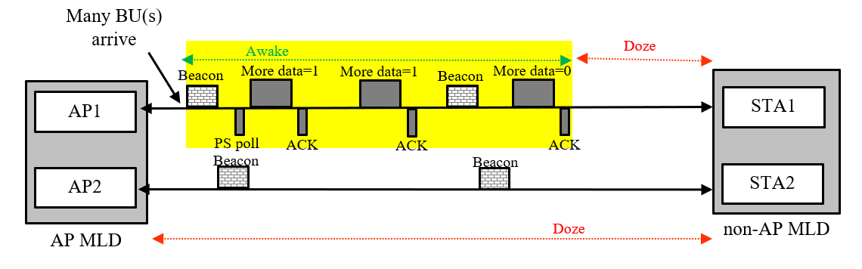
Figure depicting scenario 4

In all these scenarios (and many more), it is beneficial if the AP MLD can indicate, within the frame exchange sequence initiated by a STA affiliated with a non-AP MLD, if it has buffered traffic that is mapped to and is recommended to be retrieved by other STA(s) affiliated with the same non-AP MLD.

Proposed solution:
Introduce a new variant of A-control sub-field called link indication (LI) that can be used by an AP MLD to indicate a set of links to a non-AP MLD, with a structure as shown below.
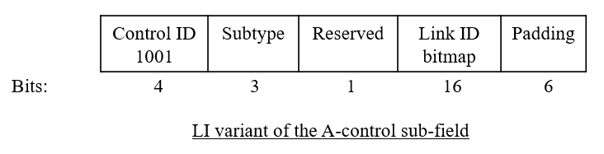
One sub-type of the LI-variant A-control field shall be for individually addressed multi-link traffic indication (MLTI). An AP of an AP MLD may optionally include an LI-variant A-control subfield of subtype MLTI in the HE-variant HT control field of an individually addressed QoS Data frame or a QoS null data frame that it transmits to an affiliated STA of a non-AP MLD, to indicate that the AP MLD has pending BUs that are mapped to and are recommended to be retrieved by other STAs of the non-AP MLD that are in power save mode. The AP shall set the bit $i$ of the Link ID bitmap of the LI-variant A-control subfield of subtype MLTI to 1 if the AP MLD has buffered BU(s) for the non-AP MLD that are mapped to link ID i and are recommended to be retrieved by the STA operating on link ID i. This subtype of LI-variant A-control field shall not be transmitted by a non-AP MLD. Upon receipt of a QoS Data frame or a QoS null data frame from an AP of the AP MLD with the LI-variant A-control subfield of subtype MLTI in the HT control field with the bit $i$ of the link ID bitmap set to 1, the STA operating on link ID $i$ of the non-AP MLD affiliated with the recipient STA should issue a PS-Poll frame, or a U-APSD trigger frame if the STA is using U-APSD and all ACs are delivery enabled, to retrieve buffered BU(s) from the AP MLD. This operation is illustrated below pictorially.

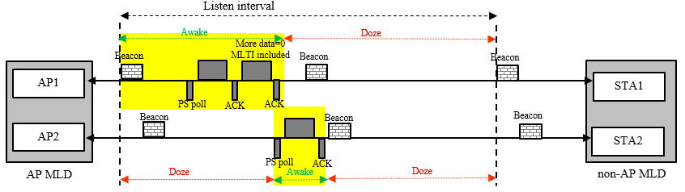

Optional:
Note that Control ID 1001 of A-control sub-field is for AAR which has a very similar format as the proposed LI-variant A-control. Currently AAR is only transmitted by an NSTR non-AP MLD to indicate the link(s) which have lost medium synchronization and have buffered traffic, to solicit a trigger frame from the associated APs for UL transmission. The AAR control field cannot be transmitted by an AP. At a high level, AAR is used by the non-AP MLD to indicate the links where it recommends the AP MLD to initiate uplink frame exchange, i.e., it falls within the purview of link indication. Since number of Control IDs for A-control are limited (only 5 left), one option is to add AAR as another subtype of LI-variant A-control and assign the control ID 1001 to LI-variant A-control.

TGbe editor: Please note Baseline is 11be D2
        - HE variant
TGbe editor: Please change the table as follows

Table 9-25—Control ID subfield values
Control ID Value | Meaning | Length of the Control Information subfield (bits) | Content of the Control Information subfield
9 | AP assistance request (AAR) | 20 | See 9.2.4.7.10 (AAR Control)
10 | (#11587)Link Indication (LI) | 20 | See 9.2.4.7.11 (LI Control)
11-14 | Reserved
15 | One needs expansion surely (ONES) | 26 | Set all 1s

TGbe editor: Please insert the following clause

        - (#11587) Link Indication
9.2.4.7.11.1 (#11587) General
(#11587)The Control Information subfield in an LI Control subfield is used by the MLD, with which the transmitting STA is affiliated, to indicate to the recipient MLD a set of the link identifiers(s) of the STA(s) affiliated with either the transmitting MLD or receiving MLD, and a purpose for the link identifier indication.
(#11587)The format of this subfield is as shown in Figure 9-33d (Control Information subfield format in an LI Control subfield).
B0 B2 B3 B4 B19
Subtype | Reserved | Link ID Bitmap
Bits: 3 1 16
Figure 9-33d—Control Information subfield format in LI Control subfield(#11587)

(#11587)The Subtype subfield indicates the purpose of the Link ID bitmap, and the encoding of this subfield is described in Table 9-33d (Subtype values in LI Control subfield)

Table 9-33d—Subtype values in LI Control subfield
Subtype Value | Meaning | Content of the Control Information subfield
0 | (#11587)Multi-link Traffic Indication (MLTI) | See 9.2.4.7.11.2 (MLTI subtype)
1-7 | Reserved

(#11587)The Link ID Bitmap indicates a set of link identifier(s) of the STA(s) affiliated with either the transmitting or receiving MLD. A value of 1 in bit position i indicates that link ID i is an indicated link and a value of 0 indicates that link ID i is not an indicated link.
9.2.4.7.11.2(#11587) Multi-Link Traffic Indication
(#11587)When transmitted by a STA affiliated with an AP MLD to a STA affiliated with a non-AP MLD, the LI Control subfield of MLTI subtype indicates the link identifiers(s) of the STA(s) affiliated with the non-AP MLD which are recommended to retrieve the MMPDU(s) or individually addressed BU(s) that are currently buffered at the AP MLD. A value of 1 in bit position i of the Link ID Bitmap indicates that the AP MLD has individually addressed MMPDU(s) or BU(s) that are recommended to be retrieved by the STA affiliated with the non-AP MLD operating on link ID i.

(#11587)An LI Control subfield of subtype MLTI shall not be transmitted by a non-AP MLD.
      - Traffic Indication
TGbe editor: Please insert the following clause
        - (#11587) General
TGbe editor: Change the third paragraph of the subclause as follows:

An AP MLD may recommend a non-AP MLD to use one or more enabled links to retrieve individually addressed buffered BU(s). The AP’s indication may be carried in a broadcast or a unicast frame, (#11587) as described in 35.3.12.4.2 (Traffic Indication using individually addressed frames).

TGbe editor: Please insert the following subclause
        - (#11587)Traffic Indication using individually-addressed frames
(#11587)This is a service provided by an AP MLD to indicate to a non-AP MLD the link(s) to retrieve individually addressed BU(s) buffered at the AP MLD, by transmitting the LI Control subfield of subtype MLTI in individually-addressed frames that it transmits, as described in 9.2.4.7.11.2 (Multi-Link Traffic Indication).

(#11587)An AP affiliated with an AP MLD may include an LI control subfield of subtype MLTI in the HE-variant HT control field of an individually addressed QoS Data frame or a QoS null data frame that it transmits to a STA affiliated with a non-AP MLD, if the AP MLD has BU(s) buffered for the non-AP MLD and intends to provide link indication to the non-AP MLD for retrieving the BUs. The AP shall set the bit in position i of the Link ID bitmap of the LI control subfield of subtype MLTI to 1 to indicate that the AP MLD has MMPDU(s) or buffered BU(s) for the non-AP MLD that have TID(s) mapped to link ID i and are recommended to be retrieved by the STA affiliated with the non-AP MLD operating on link ID i. Otherwise the bit shall be set to 0.

(#11587)When a STA of a non-AP MLD receives a frame from the AP with the LI control subfield of subtype MLTI present in the HE-variant HT control field, then the following applies:
- The STAs of the non-AP MLD operating on the link(s) indicated as 1 in the Link ID bitmap subfield of the LI control subfield, should issue a PS-Poll frame, or a U-APSD trigger frame if the STA is using U-APSD and all ACs are delivery enabled, to retrieve buffered BU(s) from the AP MLD.
- The STAs of the non-AP MLD operating on the link(s) indicated as 0 in the Link ID bitmap subfield of the LI control subfield do not need to issue a PS-poll or a U-APSD trigger frame, if recommended to do so by a multi-link traffic indication element previously transmitted by the AP MLD.

