IEEE P802.11
Wireless LANs
LB266 ML traffic indication using A-control
Date: 2022.07.14
Author(s):
Name | Company | Address | Phone | email
Vishnu Ratnam | Samsung Research America |  |  | vishnu.r@samsung.com
Boon Loong Ng
Rubayet Shafin
Peshal Nayak

Abstract
This submission proposes resolution for 1 CIDs received for TGbe LB266:

SP 1: Do you agree to the resolutions provided in doc 11-22/1201r1 for the following CIDs for inclusion in the latest 11be draft?
11578

Result: Yes/No/Abstain

SP 2: Do you agree to combine AAR control subfield with the proposed Multi-Link Traffic Indication (MLTI) control subfield?

Result: Yes/No/Abstain

Revisions:
- Rev 0: Presentation version of the document.
- Rev 1: PDT version of the document.

Interpretation of a Motion to Adopt

A motion to approve this submission means that the editing instructions and any changed or added material are actioned in the TGbe Draft. This introduction is not part of the adopted material.

Editing instructions formatted like this are intended to be copied into the TGbe Draft (i.e. they are instructions to the 802.11 editor on how to merge the text with the baseline documents).

TGbe Editor: Editing instructions preceded by “TGbe Editor” are instructions to the TGbe editor to modify existing material in the TGbe draft. As a result of adopting the changes, the TGbe editor will execute the instructions rather than copy them to the TGbe Draft.

CID | Section | Page.Line | Comment | Proposed Change | Resolution
11587 | 35.3.7.1.6 | 430.61 | When there are no remaining BUs for a nonAP MLD that mapped to the current link, the AP MLD sets the "More Data" subfield to 0 in a downlink PPDU, or transmits a QoS null data frame in response to a PS poll. The spec should provide a mechanism for the AP to also indicate, in the response frame, presence of pending traffic for the non-AP MLD that is mapped to other links. The AP should also utilize such a mechanism to indicate a need to check the beacon for critical update. | Define a mechanism where using either a new element or subfield in the response frame, or by transmitting an individually addressed frame, an AP MLD can indicate to an STA of the non-AP MLD if there is buffered traffic for another STA of the non-AP MLD or if there is a need to check the beacon for a critical updates. | REVISED  Agreed in principle.  TGbe editor to make the changes shown in 22/1201r1 under all headings that include CID 11587.

Discussion:

Consider the following scenarios:
Scenario 1:
Consider a non-AP MLD with a non-default TID-to-link mapping operating in power save mode on 2 links as shown. Upon decoding a beacon on link ID 1 (with TIM element and ML traffic indication element), non-AP MLD identifies that STA1 is a recommended link to fetch BUs from Link ID 1. By sending a PS poll, STA1 initiates a frame exchange with AP1 to fetch the BUs. During this time (between traffic indication and the frame exchange on link1), the AP may have buffered new BU(s) of a TID that is not mapped to STA1, as shown in figure below. As per baseline spec, there is no mechanism to indicate the presence of such new BU(s) in an individually addressed frame to STA1 of non-AP MLD. Upon delivering all BU(s) mapped to STA1, the More Data subfield is set to 0, the non-AP MLD may go to doze state for a listen interval. The new BU(s) are only delivered after the non-AP decodes the next TIM element and ML traffic indication element, which can cause a high latency.

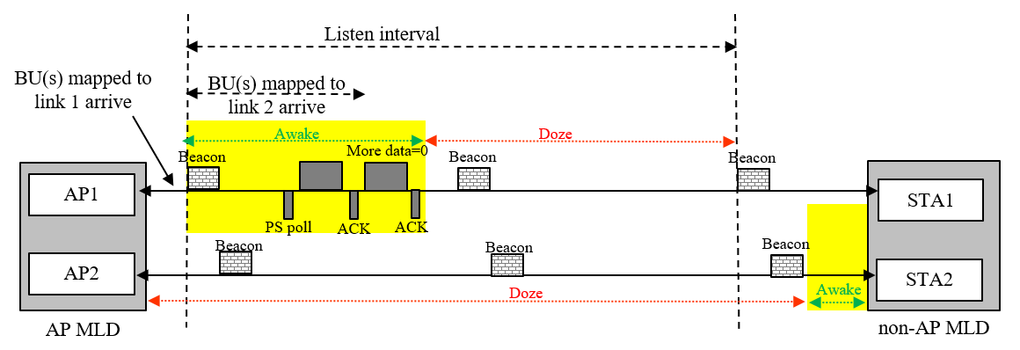
Figure depicting scenario 1

Scenario 2:
Consider a non-AP MLD with a non-default TID-to-link mapping operating in power save mode on 2 links. For latency sensitive traffic mapped to both link ID 1 and 2, the AP may indicate both link ID 1 and 2 as the recommended links in the per-link traffic indication bitmap subfield of the ML traffic information element. This is for faster channel access and delivery. By sending a PS poll on one of the links, say link ID 1, STA1 of non-AP MLD may retrieve the BUs from the AP MLD. After observing more data=0, it may not know if STA2 operating on link ID 2 also needs to send a PS poll. Without an indication of whether there are additional BUs for other links, the STA2 of non-AP MLD may unnecessarily stay awake and also send another PS poll on link ID 2 as shown in the figure below.

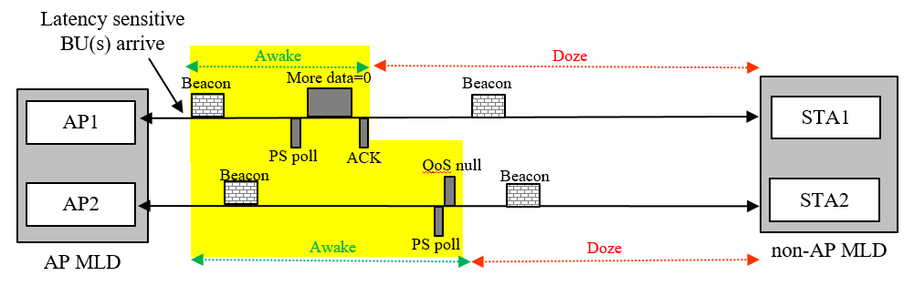
Figure depicting scenario 2

Scenario 3:
Consider a non-AP MLD with a non-default TID-to-link mapping operating in power save mode on 2 links. A STA affiliated with the non-AP MLD can wake up for any reason, e.g. P2P communication, and then also send a PS poll to the AP to fetch downlink BUs (if any) without decoding the TIM element or ML traffic indication element. In such a scenario, the STA can only fetch BU(s) mapped to it and cannot know about BU(s) mapped to other links. It has to wait a receive the ML traffic indication element for the same.

Scenario 4:
Consider a non-AP MLD with a default TID-to-link mapping operating in power save mode on 2 links. Upon receiving a TIM element indicating buffered traffic, the associated STA on link 1 may wake up and transmit a PS poll to fetch traffic. However, if at that moment the load on link 1 is much more than link 2 or if the pending traffic for the non-AP MLD is significantly high, the AP MLD may want the suggest the non-AP MLD to also transition to active mode on link 2, to fetch at least a part of the buffered traffic. Such an indication from the AP MLD to the non-AP MLD within the frame exchange sequence initiated by the PS poll on link 1 is currently not possible.

In all these scenarios (and many more), it is beneficial if the AP MLD can indicate, within the frame exchange sequence initiated by a STA affiliated with a non-AP MLD, if it has buffered traffic recommended to be received by other STA(s) affiliated with the same non-AP MLD.

Proposed solution:
An AP of an AP MLD may optionally include a Multi-Link Traffic Indication (MLTI) control subfield in the HE-variant HT control field of an individually-addressed QoS Data frame or a QoS null data frame that it transmits to an affiliated STA of a non-AP MLD, to indicate that the AP MLD has pending BUs that are recommended to be received by other STAs of the non-AP MLD that are in power save mode. The structure of this MLTI-control subfield is as below:
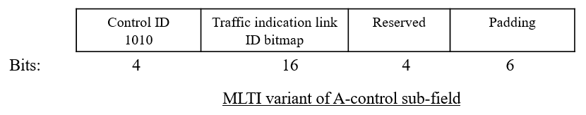
The AP shall set the bit $i$ of the Traffic Indication Link ID bitmap of the MLTI control subfield to 1 if:
- the AP has at least one BU for the non-AP MLD whose TID is mapped to link ID $i$ and the AP MLD intends to recommend the non-AP MLD to retrieve the BU(s) from link ID i.
- The link ID $i$ is not the same as the link on which the recipient STA operates.
Upon receipt of a QoS Data frame or a QoS null data frame from an AP of the AP MLD with the MLTI control subfield present in the HT control field with the bit $i$ of the Traffic Indication Link ID bitmap set to 1, the STA operating on link ID $i$ of the non-AP MLD affiliated with the recipient STA shall issue a PS-Poll frame, or a U-APSD trigger frame if the STA is using U-APSD and all ACs are delivery enabled, to retrieve buffered BU(s) from the AP MLD. This operation is illustrated below pictorially.

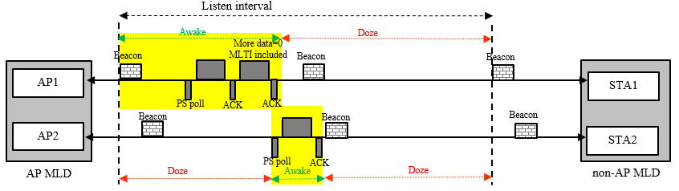

Optional:
Note that Control ID 1001 of A-control sub-field is for AAR which has a very similar format as the proposed MLTI. Currently AAR is only transmitted by an NSTR non-AP MLD to indicate the link(s) which have lost medium synchronization and have buffered traffic, to solicit a trigger frame from the associated APs for UL transmission. The AAR control field cannot be transmitted by an AP. At a high level, AAR is used by the non-AP MLD to indicate the links where it recommends the AP MLD to initiate uplink frame exchange, i.e., similar purpose as the proposed MLTI. Since number of Control IDs for A-control are limited (only 5 left), one option is to rename and generalize AAR to MLTI. One of the reserved bits can be used to indicate if the purpose is for AAR or for MLTI.
Note: When transmitted by an NSTR non-AP MLD, the functionality shall remain as in baseline (unchanged).
TGbe editor: Please note Baseline is 11be D2
        - HE variant
TGbe editor: Please change the table as follows

Table 9-25—Control ID subfield values
Control ID Value | Meaning | Length of the Control Information subfield (bits) | Content of the Control Information subfield
9 | AP assistance request (AAR) |  | See 9.2.4.7.10 (AAR Control)
10 | (#11587)Multi-Link Traffic Indication (MLTI) |  | See 9.2.4.7.11 (MLTI Control)
11-14 | Reserved
15 | One needs expansion surely (ONES) | 26 | Set all 1s

          - Common Info field of the Basic Multi-Link element
TGbe editor: Please change the figure as follows
B0 B3 B4 B5 B6 B7 B11 B12 B13 B14 B15
Maximum Number of Simultaneous Links | SRS Support | TID-To-Link Mapping Negotiation Supported | Frequency Separation For STR/AP MLD Type Indication | AAR Support | MLTI Support  (#11587) | Reserved
Bits: 4 1 2 5 1 1 2
Figure 9-1002l—MLD Capabilities and Operations subfield format
TGbe editor: Please add the following row to the end of the table
Figure 9-401i—Subfields of the MLD Capabilities and Operations field
Subfield | Definition | Encoding
MLTI Support (#11587) | A non-AP MLD indicates support for receiving a frame with the MLTI Control subfield | For an AP MLD this subfield is reserved.  For a non-AP MLD:  Is set to 1 if the non-AP MLD supports reception of a frame with the MLTI Control subfield and is set to 0 otherwise.

TGbe editor: Please insert the following clause
        - (#11587) Multi-Link Traffic Indication
(#11587)The Control Information subfield in the MLTI Control subfield contains information on the link identifiers(s) of the STA(s) affiliated with the non-AP MLD that are recommended to retrieve individually addressed BU(s) from the AP MLD.
(#11587)The format of this subfield is as shown in Figure 9-33d (Control Information subfield format in a MLTI Control subfield).
B0 B15 B16 B19
Traffic Indication Link ID Bitmap | Reserved
Bits: 16 4
Figure 9-33d—Control Information subfield format in MLTI Control subfield(#11587)

(#11587)The Traffic Indication Link ID Bitmap indicates the link identifier(s) of the STA(s) affiliated with the non-AP MLD that are recommended to retrieve the individually-addressed BU(s) from the AP MLD. A value of 1 in bit position i of the Traffic Indication Link ID Bitmap indicates that the STA affiliated with the non-AP MLD operating on link ID i is recommended to retrieve the individually-addressed BU(s) from the AP it is associated with. A value of 0 in bit position i indicates that the STA affiliated with the non-AP MLD operating on link ID i is not recommended to retrieve individually addressed BU(s) from the AP it is associated with.

(#11587)The bit in the Traffic Indication Link ID Bitmap corresponding to the link ID of the AP that is transmitting the MLTI Control field is set to 0.
      - Traffic Indication
TGbe editor: Please insert the following clause
        - (#11587) General
TGbe editor: Change the third paragraph of the subclause as follows:

An AP MLD may recommend a non-AP MLD to use one or more enabled links to retrieve individually addressed buffered BU(s). The AP’s indication may be carried in a broadcast or a unicast frame, (#11587) as described in 35.3.12.4.2 (Traffic Indication using individually addressed frames).

TGbe editor: Please insert the following subclause
        - (#11587)Traffic Indication using individually-addressed frames
(#11587)This is a service provided by an AP MLD to indicate to a non-AP MLD the recommended link(s) to retrieve individually addressed BU(s) buffered at the AP MLD, using the MLTI Control subfield of individually-addressed frames that it transmits, as described in 9.2.4.7.11 (Multi-Link Traffic Indication).

(#11587)An AP MLD that is capable of providing multi-link traffic indication via the MLTI-Control subfield of the HE-variant HT control field of individually addressed frames that it transmits shall set the dot11MLTIOptionImplemented to true. A non-AP MLD that supports receiving multi-link traffic indication via the MLTI-Control subfield of the HE-variant HT control field of individually addressed frames shall set the dot11MLTIOptionImplemented to true. A STA affiliated with a non-AP MLD with dot11MLTIOptionImplemented that is equal to true shall set the MLTI Support subfield in the MLD Capabilities and Operations field in the Basic Multi-link element it transmits to 1; otherwise the STA shall set the MLTI Support subfield to 0.

(#11587)An AP affiliated with an AP MLD with dot11MLTIOptionImplemented set to true may include an MLTI control subfield in the HE-variant HT control field of an individually addressed QoS Data frame or a QoS null data frame that it transmits to a STA affiliated with a non-AP MLD, if all of the following conditions are satisfied:
- The AP MLD has received from the non-AP MLD a Basic Multi-Link element with the MLTI Support subfield of the MLD Capabilities and Operations field set to 1.
- The AP MLD either has BU(s) buffered for the non-AP MLD and intends to provide link recommendations(s) to the non-AP MLD for retrieving the BUs, or the AP MLD has no remaining BU(s) for the non-AP MLD.

(#11587)An AP affiliated with an AP MLD that transmits an MLTI Control field in an individually addressed frame to a STA affiliated with a non-AP MLD shall set the bit in position i of the Traffic Indication Link ID bitmap of the MLTI control subfield to 1 if all of the following conditions are satisfied:
- the AP MLD has MMPDU(s) or buffered BU(s) with TID(s) that are mapped to link ID i for that non-AP MLD, and link ID i is a recommended link to retrieve the BU(s).
- The link ID $i$ is not the link ID corresponding to the AP transmitting the frame.
Otherwise the bit shall be set to 0.

(#11587)Note: To indicate to a non-AP MLD that there are no remaining individually addressed BU(s) addressed to it, an AP affiliated with the AP MLD may transmit a frame with an MLTI control field to a STA affiliated with the non-AP MLD, with all bits in the Traffic Indication Link ID bitmap subfield of the MLTI control field to 0.

(#11587)The link recommendation(s) provided in a MLTI-Control subfield to the recipient non-AP MLD shall replace any traffic indication and link recommendation(s) provided for the non-AP MLD in the TIM element and multi-link traffic indication element previously transmitted by the AP MLD.

(#11587)When a STA of a non-AP MLD with dot11MLTIOptionImplemented set to true receives a frame from the AP with the MLTI control subfield present in the HE-variant HT control field the STAs of the non-AP MLD operating on the link(s) indicated as 1 in the Traffic Indication Link ID bitmap subfield of the MLTI control subfield, should issue a PS-Poll frame, or a U-APSD trigger frame if the STA is using U-APSD and all ACs are delivery enabled, to retrieve buffered BU(s) from the AP MLD.

